Topic: All-you-can-eat sushi
Instructor: | Level: | Age: | Number of Students: | Length:
KIM EUNJAE(LIA) | Pre-intermediate | Adults | 15 | 20minutes
Materials:
white board, makers,
15 copies of Role play and discussion work sheet
15 copies of the article and match paragraph
A picture of sprint triathlon
Aims:
Students will be able to express ideas related to buffet
Students will be able to explain their diet
Language Skills:
Speaking; Sharing opinion of this topic
Listening: Conversation with partner
Writing: Matching paragraphs,homwork
Reading: Reading the article and
Language Systems:
Phonology-Right pronunciation of Buffet – [ba’fei]
Lexis- New vocabulary , Ban, Ironman diet
Function-Advising and complaining
Discourse-Discussing dealing with certain situation
Grammar- none
Assumptions:
Students are pre-intermediate levels,
students are used to discuss
Anticipated Errors and Solutions
* My sister’s all the books have been stolen X
* All my sister’s books have been stolen O
* This opinion is preferable than any other X
* This opinion is preferable to any other O
References:
All-you-can-eat-sushi(september20,2018),In Breaking New English. Retrieved from
https://breakingnewsenglish.com/1809/180920-all-you-can-eat-sushi-2.html

Notes:

Pre-Task: Eliciting
Aims : |  |  | Materials: whiteboard, makers ,The picture#
Time | Set Up | Student |  | Teacher
1min.  2min. | Whole  Whole | Listening, Greeting  Looking picture |  | (Greeting)  Good morning~ How are you today?  Did you have good sleep, last night?  Yea, Good!  .  (Eliciting)  Let’s look at this picture. #1  What do you see in the picture?  What are they called?  Do you think they eat a lot?  Today’s topic is all-you-can-eat sushi  (write title on the board) and we are going to discuss it later.  Before we start it  We are going to check a few things.
Note:
Task Preparation: Match paragraph
Aims: |  |  | Materials:  worksheet, whiteboard, markers, Worksheet
Time | Set Up | Student |  | Teacher
2min.  5min. | whole  Pair work | Looking at the board  Answering |  | (Hand out the article and writing on the board)  Let’s look at the board.  How do you pronounce Buffet?  Buffet – [ba’fei]  Great.  * My sister’s all the books have been stolen X  * All my sister’s books have been stolen O  * This opinion is preferable than any other X  * This opinion is preferable to any other O  Now, we are going to do pair work.  Did everybody get the paper?  I’ll give you 5minuts, to read the article quickly and match paragraphs with your partners.  (ICQ)  How many minutes do you have?  Let’s get started.  Did you finish your work?
Notes: Notes:
Target sentences
1.A sushi restaurant banned a customer.
2.The customer ate a lot because of his ironman diet
3.The waiter did not want to accept it
Task Realization:
Discussion
Aims |  |  | Materials:  Worksheet, whiteboard, makers
Time | Set Up | Student |  | Teacher
8min | 4groups | Discussion |  | Alright  (Hand out discussion worksheet)  Now, It’s time to discuss this topic for 8 minutes. I’m going to divide into 4 groups and I’ll give you for 8minutes.  (ICQ)  How many minutes do you have?  (Monitoring with note)
Notes:
Post Task:
Error correction
Aims: |  |  | Materials:  White board, markers
Time | Set Up | Student |  | Teacher
2min. | Groups | Answering,  Listening |  | (Writing some errors, If none wrap up the class)  Ok  Time’s up.  (CCQ)  Do you think the restaurant owner did right to the customer?  How would you feel if a restaurant banned you?  Why do you think the waiter didn’t accept the tip, from him?  I liked to hear all of your opinions.  Do you have any question?  Ok,  Thank you for your participation today. See you next class!
Notes:

All-you-can-eat Sushi
A sushi restaurant in Germany banned a customer because he ate too much. The customer was an ironman athlete. He ate at the restaurant in Bavaria last weekend. He paid $18.50 for an all-you-can-eat meal and ate nearly 100 plates of sushi. When he paid for his meal, the owner asked him not to return to the restaurant because of how much he ate. The customer told a local newspaper: "I'm banned...because I ate too much." He said the owner's left him feeling "stunned". The customer ate a lot because of his ironman diet. He does not eat for 20 hours and then he eats until he is full. He never had problems eating at the restaurant before. This time, the owner told a German news agency that the customer ate enough "for five people" and that was "not normal". The restaurant waiter did not accept a tip from the customer. He said: "When I went to the checkout, I wanted to leave a tip, but the waiter did not want to accept it."
Match Paragraph
1. | banned | a. | A meal that has of several dishes from which guests serve themselves and put the food on their plate themselves.
2. | Customer | b. | A flat dish on which food is eaten or put on.
3. | athlete | c. | Officially or legally stopped someone from doing something.
4. | Buffet | d. | Happening at the same patterns in time.
5. | plate | e. | A person or organization that buys goods or services from a store or business.
6. | decision | f. | A person who is very good in sports and other forms of physical exercise.
7. | regular | g. | A conclusion reached after thinking about something.

8. | Diet | h. | Very, very nice to taste.
9. | full | i. | A special course of food that someone eats, either to lose weight or for medical reasons.
10. | previous | j. | Eaten or drunk so much that you don't want to eat or drink any more.
11. | normal | k. | Some money given to someone (like a waiter or taxi driver) as a reward for their services.
12. | Tip | l. | Usual, typical, or as expected.
13. | Accept | m. | Being or happening at a time before.
14. | delicious | n. | Agree to something that is offered.

Discussion

*How would you feel if a restaurant banned you?

*What advice do you have for this guy?

*Have you ever been on a diet?

*What would happen if you didn't eat for 20 hours?

*What questions would you like to ask the restaurant owner?

*Why do you think the waiter didn’t want to accept a tip from him?

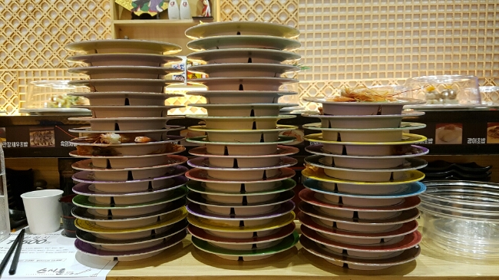

All-you-can-eat Sushi
A sushi restaurant in Germany banned a customer because he ate too much. The customer was an ironman athlete. He ate at the restaurant in Bavaria last weekend. He paid $18.50 for an all-you-can-eat meal and ate nearly 100 plates of sushi. When he paid for his meal, the owner asked him not to return to the restaurant because of how much he ate. The customer told a local newspaper: "I'm banned...because I ate too much." He said the owner's left him feeling "stunned". He told reporters that he was a regular customer at the restaurant.
The customer ate a lot because of his ironman diet. He does not eat for 20 hours and then he eats until he is full. He never had problems eating at the restaurant before. This time, the owner told a German news agency that the customer ate enough "for five people" and that was "not normal". The restaurant waiter did not accept a tip from the customer. He said: "When I went to the checkout, I wanted to leave a tip, but the waiter did not want to accept it." The customer must now find another restaurant that provides delicious and good value meals

Role play
Role A – Sushi
You think sushi is the best food. Tell the others three reasons why. Tell them what is wrong with their food. Also, tell the others which is the least tasty of these (and why): curry, pizza, or chicken
Role B – Curry
You think curry is the best food. Tell the others three reasons why. Tell them what is wrong with their food. Also, tell the others which is the least tasty of these (and why): pizza, sushi or chicken
Role C – Pizza
You think pizza are the best food. Tell the others three reasons why. Tell them what is wrong with their food. Also, tell the others which is the least tasty of these (and why): curry, sushi or chicken.
Role D –chicken
You think chicken is the best food. Tell the others three reasons why. Tell them what is wrong with their food. Also, tell the others which is the least tasty of these (and why): curry, sushi or

