Topic: The world's most confusing flags
Instructor: | Level: | Age: | Number of | Length:
KIM EUNJAE (Lia) | Pre-intermediate | Adults | Students: 15 | 20minutes
Materials: White board, markers, pictures, worksheet
Aims:
SWBAT practice -ed, -ing adjectives properly through Drill
SWBAT express ideas of their own country’s flag
Language Skills:
Reading: Reding the text
Writing: writing their own opinions
Speaking: Sharing ideas in a group
Listening: Listening to teacher’s instruction and classmate’s ideas
Language Systems:
Phonology- pronunciation of excited –[id]
Lexis- Key vocabulary in the text
Function-Correcting
Discourse- Discussion
Grammar- -ed, -ing adjectives
Assumptions:
Ss are pre-intermediate levels
Ss are familiar with discussion
Anticipated Errors and Solutions:
The noise from upstairs is annoyed X
The noise from upstairs is annoying O
The world's most confusing flags by National Post published on 25. Jul. 2018. On Youtube.Com. Retrieved 13. Feb. 2019, from
https://www.youtube.com/watch?v=kbfhv1CxmfE
New Zealand tells Australia: Stop 'copying' our flag By Sheena McKenzie, CNN July 26, 2018
Retrieved 13. Feb. 2019, from
https://edition.cnn.com/2018/07/25/australia/new-zealand-australia-flag-row-intl/index.html
Notes:

Presentation: Lead-in
Aims: |  |  | Materials:  White board, makers, pictures
Time | Set Up | Student |  | Teacher
3min. | Whole class | Greeting  Guessing &  Answering |  | (Greeting)  Good morning, how are you today?  Did you sleep well last night? Ok,  Gary? Are you excited to have a baby ?  Yea, He is excited, because the most exciting moment is coming soon to him.  (Showing Ss pictures)  What comes to mind?  Today, we are going to discuss these flags with -en, ing adjectives,  (Writing ed-ing)  When we talk about ‘ed ‘adjectives then  we describe a feeling.  And, the things like a table a chair, a flag, they don’t have feeling ,they cause a feeling  Ex) The noise from upstairs is annoying  (error correction)  Is the noise from upstairs annoyed?  No, It’s not annoyed,  It’s annoying and we are annoyed.
Notes:
Practice: pre-activity
Aims: |  |  | Materials:  White board, markers, Drill pictures
Time | Set Up | Student |  | Teacher
5min. | Whole  Individually | Repeat,  Make sentences |  | Writing Drill  *My husband is tired because he had tiring day.  *I was scared because the movie was scary.  *She is bored because her work is boring.  *I’m shocked because the news was shocking.  (Showing the p.p)  We are going to make sentences with our words.
Notes:
Production: Main-activity
Aims: |  |  | Materials:  Worksheet,
Time | Set Up | Student |  | Teacher
8min | Group work | discussion |  | (Giving instruction and handout)  Now we are going to discuss the flags.  Read the topic quickly and discuss the issues. I’m going to divide into 3groups and I’ll give you 8min.
Notes:
Post Production:
Aims: |  |  | Materials:
Time  4min | Set Up  Group work | Student  Discussion |  | Today we talked about These two flags.  Did the Australia designed their flag first? No  Did New Zealand want to keep their flag? Yes.  Ok are you still confused with the flags?  That’s it for today.  Thank you ‘ll see you in next class
>:?
Notes: Filler
Geographic Vocabulary game.

The world's most confusing flags
New Zealand's acting Prime Minister Winston Peters says Australia copied his country's 116-year -old flag, and it’s time for redesign. He said that “They (Australia) should actually change their flag and honor the fact that we got there first with this design”. This is not first time that two flags have caused confusion. The flags are indeed similar. Both are based on the British ensign, with a dark blue background, a United Kingdom Union Flag in the top left corner and the Southern Cross star constellation. Among the few distinguishing features is that Australia's stars are white, rather than red and the flag also features an extra star with seven points representing the Australian states and territories.
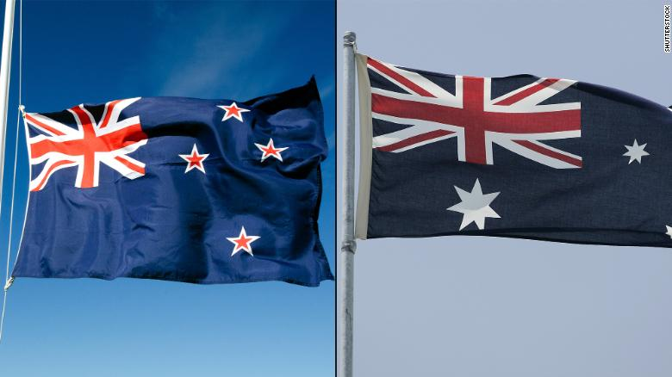
Discuss
1. Do you think Australia should change their flag? Why?
2. What other countries have confusing flags?
3. Think about your country’s flag. What comes to mind?
4. What is the most fascinating flag in the world? Why?
5. How would you feel if a country copies your own flag?
6.What advice do you have for two countries?

(Using adjectives)
amused/amusing satisfied/satisfying disgusted/disgusting
confused/confusing annoyed / annoying pleased /pleasing
exhausted/exhausting exhausted/exhausting excited / exciting
frightened/frightening embarrassed/embarrassing puzzled/puzzling
amazed/amazing interested/interesting tired/tiring
frustrated/frustrating alarmed/alarming stunned/stunning
fascinated/fascinating depressed/depressing encouraged/encouraging

