Listening Speaking Reading Grammar Writing

Topic: Tourist Places

Instructor:  Claire Park | Level:  Intermediate | Students:  6 | Length:  30 Minutes

Materials:
Computer
Screen
PPT file
World map, pictures
Work sheet #A, B- Fill in the blanks
White board and board markers

Aims:
- Main aims: Ss will be able to improve their speaking skills by sharing information and thoughts with their classmates
- Secondary Aims: Ss will be able to improve writing skills by familiarizing with grammar and sentences dealt in the activities.
Personal Aim: I want to be organized and prepared during the class

Language Skills:
- Reading: Ss will read sentences during information gap activity.
- Listening: Ss will listen to teacher’s voice or their group
- Speaking: Ss will talk and share their information on their worksheet.
- Writing: Ss will write the information they got during the activity.

Language Systems:
- Phonology: /z/, /v/
- Lexis: New vocabularies about traveling spots, cities
- Grammar: Wh questions, Future tense ‘be going to’
- Function: Giving information
- Discourse: Q&A

Assumptions:
Students already know
- How the class is organized and operated (3 at each table)
- Which partner /group they belong to in for partner

Anticipated Errors and Solutions:
- If students need some information-> I will let them use their phone to search.
- If students need linguistic support-> I will introduce them to look at the context clue, and then provide them definition and examples.
- If students find difficult on using future tense ->I will show example sentences from the main activity.
- If students don’t understand instruction clearly -> I will show them an demonstration.

References:
Traveling video from youtube
https://www.youtube.com/watch?v=qNsgR0uZRJI
Images from US travel news

Lead-In
Materials:
Time | Set Up | Student Activity | Teacher Talk
1min |  | Answering to the teacher’s questions | Good afternoon, everyone! How’s weather today? Spring is coming.  Would anyone like to go somewhere?

Pre-Activity
Materials: TV screen, computer
Board markers, White board, World map
Time | Set Up | Student Activity | Teacher Talk
4min  4min  1min | Whole class  Groups  Whole class | Discussing about the probable topic of today’s class  Students check answers | 1.prediction  Elicit  Please look at this TV screen  We will watch the video together  And please figure out the probable topic.  (Watch the video for 1min)  What did you see from the video?  (Ss might answer : tourist attraction, nature, tourists…)  Can you guess the topic now??  Model  (Write the topic: ‘Tourist Places’)  Today’s topic is “Tourist Places”  CCQ  When is the perfect season to go there?  Do you prefer to go there alone or with someone?  2.Matching game  Instruction  Let’s play small activity.  We are going to match the countries, with tourist attractions.  If you found it, please come out and put it in the world map  Demonstration  Now here’s an example.  I have a card ‘Eiffle tower’, I will attach it to france.  Now I will give you some flash cards  (Hand out flashcards)  Work together with your groups.  I will give you 4minutes to finish.  ICQ  How much time do you have?  Are you working in groups?  Let’s start  Monitoring  (Quietly walk around the classroom.  Check to see if the students are on track. Answer to questions.)  (Give time warnings: you now have 1 minute left)  Time’s up  Check answers  Let’s check the answers together

Main Activity
Materials: worksheet #A, #B (12copies)
Time | Set Up | Student Activity | Teacher Talk
2min  6min  2min | Whole class | Students read sentences  Students complete worksheet #A,B | 1.Practicing Sentences  Instruction  Now we are going to practice some sentences together. Please look at the screen.  ICQ  So, are we working together?  Let’s start  (practice sentences)  2.Information gap game  Instruction  Now you will talk about ‘Tourist Destinations’ with your partner. Fill out your blanks when you get some information. I will give you 6 minutes.  (Hand out worksheet #A,B)  .  Demonstration  Look at this dialogue.  Let’s assume it is ‘Paris’.  (read dialogues with answers)  ICQ  Are you working in pairs right now?  How much time we have?  You may start now  Monitoring  (Quietly walk around the classroom.  Check to see if the students are on track. Answer to questions.)  (Give time warnings: you now have 1 minute left)  Time’s up  Check answer  (Check your answers with your partner)

Post-Activity
Materials: Flash Cards
Time | Set Up | Student Activity | Teacher Talk
9mins  1min | Whole class | Students share their ideas | 1.‘Tell us why’ game  Instruction  Now I will show you pictures of tourist places  Each team is going to tell us why they want to go that place  with 3 reasons. If you pass, you will get 1 point. You may use your phone to search any information.  We’ll divide into 2 groups.  ICQ  Are we working in groups?  Can we use our phone to search information?  Let’s start  Sharing  Each group share their ideas about tourist attractions.  Check the score  Now the winner is team______  Congratulations.  2.Conclusion  (Conclude today’s lesson by checking their understanding of the topic.)  Let’s review some point  I’ve found some pronunciation errors  In /v/ sound.  Let’s read this world again  (visit, vacation, valley)  and try /z/ again (zakynthos).  All of you did a good job. Hope we can go to somewhere nice this year. Cause we deserve it. Thanks.

SOS Activity
Materials: papers
Time  5min  5min | Set Up  Group  Whole class | Student Activity  Students | Teacher Talk  1.Make a poster  Instruction  Now we are going to make a poster about ‘where do you want to go?’. Talk with your group and write 3 places.  I’ll give you 5minutes.  ICQ  Are you working in groups?  How much time we have?  Monitoring  (Quietly walk around the classroom.  Check to see if the students are on track. Answer to questions.)  (Give time warnings: you now have 1 minute left)  Sharing  Presenters of each group, please come up to the front. Please present your group’s conclusion.
I

A:Where are you going to go on your vacation?  B:I am going to go to _________.  A:What are you going to do there?  B: I am going to visit, see, try, __________.  A:That sounds fun! Have a good time~ | 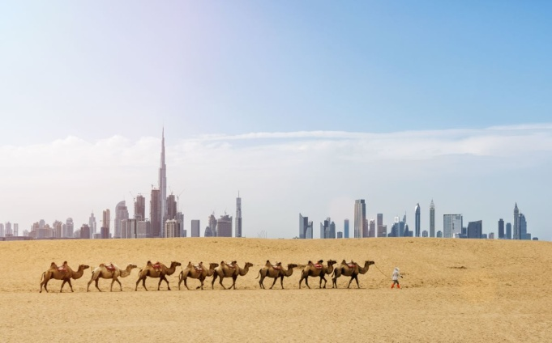Dubai  - Country: United Arab Emirates  - Things to do: Burj Khalifa, dubai mall , traditional market (Souq) , Desert safari tour, Arabic food and tea
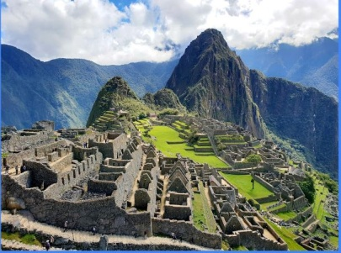 machu picchu ‘Lost city of Incas ’  - Country: Peru  - Things to do: Hiking the trails of Machu picchu, Sacred valley tour, Cusco city tour | 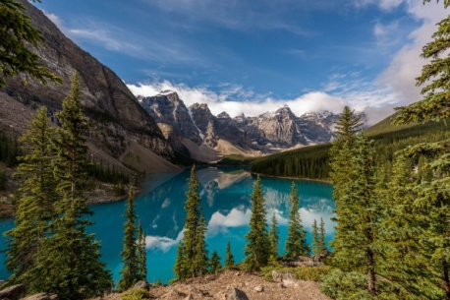Banff ‘Canadian vacation spot’  - Country:  - Language:  - Things to do:
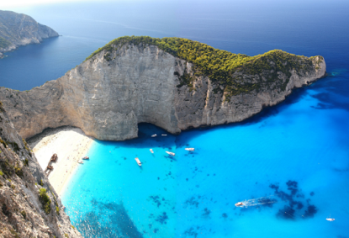Zakynthos Island  - Country :  - Things to do: | 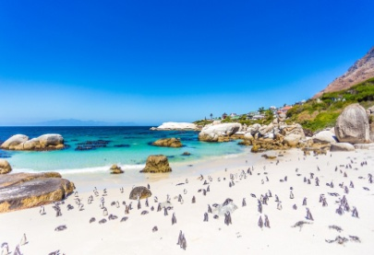 Cape town  - Country: South Africa  - Things to do: Boulders beach (to see penguins), Shark cage diving, Table mountain, good wines and food.
Tourist Destinations A

Tourist Destinations B
A:Where are you going to go on your vacation?  B:I am going to go to _________.  A: Which country is it?  B: It’s ________________.  A:What are you going to do there?  B: I am going to visit, do, try, __________.  A:That sounds fun! Have a good time~ | Dubai  - Country:  - Things to do:
machu picchu ‘Lost city of Incas ’  - Country:  - Things to do: | Banff ‘Canadian vacation spot’  - Country: Alberta, Canada  - Language: English, French  - Things to do:, Lake louise, Sunshine village (skiing, snowboarding) , Rocky mountain
Zakynthos Island  - Country : Greece  - Things to do: Shipwreck beach, boat tour, amazing beach and nature, greek food | Cape town  - Country:  - Things to do:

