Background Information Sheet
Name | Class | Date | Lesson Type | Length
Diane | 191st | 27-03-2019 | Listening | 40 min

Lesson
Topic | How much is that doggie in the window? (Song)
Main Aim | Ss will practice their listening comprehension.
Secondary Aim | Ss will practice their pronunciation and their speaking fluency. By listening and singing the song, they can find more interests, motivation and self-confidence in English learning.
Materials and References
https://learnenglishkids.britishcouncil.org/songs/how-much-doggie-the-window
Animal picture cards, picture #1, Question work sheet, PC with speaker, white board, colored markers, eraser, lyric sheet

Student Profile
Level | Intermediate
Age | 10 | Number of Students | 10
Detail | There are 5 girls and 5 boys. Each kid has different nationality. They joined this vacation English camp just few days ago. They are not familiar with classmates and teacher yet. They not only want to improve their English skills also need more cozy and friendly atmosphere as well. Regarding their age and emotion, establishing close rapport should be considered.
Assumptions about students’ knowledge as required for this lesson:
They might have heard this song. The word and expressions are not hard to intermediate students. Some of the students have experiences of raising pet. Expect this song - with dog barking sound and story about raising dog - can draw students’s attention and interest. All the students enjoy sharing their experiences.

Anticipated Difficulties and their Solutions:
•Disturbance – Young learners can be distracted easily. To keep their attention to listening, do not show the video monitor until applied comprehension questions step. Use gestures and silence for keeping their attention.
•Technical issue 1 - If cannot connect the website temporarily. Go to https://youtu.be/iApAn0whVZE.
It also shows the same recording.
•Technical issue 2 – If the speaker doesn’t work. Play the song with mobile phone and Bluetooth speaker.

My Personal Aim
What I hope most to demonstrate in this lesson is the ability to help the students talk freely and think actively. In addition, By writing out the detailed lesson plan, I can set my goal more practically such as what kind of teacher I want to be and who I am going to teach.
Stage Name: Lead-in
Purpose of this stage: to relax both the students and the teacher; to start the lesson in a natural way; to focus the attention of the students; to involve students and allow them to share ideas related to the topic.
Materials: Animal picture cards, board, markers
Timings | Interactions | Procedure
1 min  3 min  30 sec | T  S-S  T-S | “Hello everyone. I want you to be divide into two groups. Five people will be one team and stand in a row.  [Check if they understood and followed the instruction well. Help students to make it. Draw their attention by clapping hands or keep silence for a while before giving instructions.]  “Good~! When the game start one person in each group comes and stand in front of the board. I will give an animal picture card to rest of the team members. Then one by one, go to the front and describe that animal in one sentence to your team member. The person will write the animal on the board as fast as possible. I will give another animal card to her/him. You join the team and another student comes in the front instead. The team that finish writing five animals faster wins.  ICQs : Can only one student do the writer during the whole game? (No.) Can you tell more than a sentence at a time? (No.) Can you say the name of animal? (No. We should describe the picture.)  “Are you ready? (Yes.) “Start!”  [Going around the class. Check if everyone is doing the game without problems.][A team (or both team, if there’s time left) finishes writing the five words.]  “Everyone now take your seat. What kind of animals were there?” [Indicate the words on the board and read.] “Let’s read it together.”  [Read the other words on the board together.]

Stage Name: Presentation
Purpose of this stage: to help students understand main idea or topic. Teaching a few key words. To give students time for concentrating on and getting ready for today’s lesson.
Materials: picture #1, board, markers
Timings | Interactions | Procedure
4 min  2 min  1 min | T-S  S-S  T-S | [Write on the board. ‘I d some money for buying mother’s birthday present.’] “Can you guess the blank? What should I do to buy mother’s birthday present?” [Wait for a seconds. Give clear feedback if anyone tells any answer. If no one tells the word ‘save’ then teacher can say it]  CCQs : “Did I spend all the money?(No.) Is there some money left?(Yes.) Do I need the money later? (Yes.) “All right.” “Everyone say save” [Students repeat ‘save’] [Name 2-3 student and ask to repeat.] “I saved some money. Everyone~” [Practice in sentence 2-3 times] [Write the word ‘save’ on the board.] “How many syllables are there? (One) where is the stress? (on a)[Mark the accent] What part of speech is it?(verb)“  Guiding question given. Ss may discuss with a partner or brainstorm ideas as a class. (May not be necessary to write ideas down.)  “Here is a picture. What is she doing? What is she thinking about? Work in pairs. Talk to your partner for one minute.”  [Hand out pictures every two students telling them who is partner.]  [Name a student and ask] “What do you and you partner think?” [Ask to a few more students. Share their thought with the class]

Stage Name: Practice Detailed Listening – Literal Comprehension
Purpose of this stage: Ss practice listening to details. Checking their accuracy is needed.
Materials: PC with speaker, question worksheet
Timings | Interactions | Procedure
2min  2 min  2 min  2 min | T  S  S-S  T-S | [Hand out the question work sheet.] “Scan the questions quickly. I’ll give you one minute. [After 1 min passed] “First, listen to the song and write the answer from number 1 to 5.”  ICQs : “Can you talk while listening?(No.) Should you write the answer on your worksheet?(Yes.) Do you need to write the answer of number 6? (No. We are doing only number 1 to 5 now.)  [Play the song.][Wait about 30 seconds more after the record finished.]  “Did you write all the answer? Do you need to listen again?” [If most of the students finished their answer, go ahead. If there are many students who want to listen again, play the song once more.]  “Compare your answer with your partners.”  [Go around the classroom and listen to students’ conversation. But don’t interrupt.]  “Let’s check the answer with the whole class. [Read question number 1.] “The answer is……?”[If some of the students read their answer, make eye contact and give feedback right away. If no one tells the answer, name the student who have the right answer based on you’ve heard.] “Have any different ideas? Everyone agrees?” (Yes.)  [In the same way, check the answer from number 2 to 5.]
Stage Name: Practice More Detailed Listening – Interpretive Comprehension
Purpose of this stage: Ss listen thoughtfully to interpret meaning. Accuracy focused.
Materials: PC with speaker, question worksheet
Timings | Interactions | Procedure
30 sec  3 min  3min  2 min | T  S  S-S  T-S | “I will play the song one more time. This time, you will answer number 6 and 7. Listen more carefully focusing on the meaning and story.”  ICQs : “Which number Should you answer? (Number 6 and 7)”  [Play the song.][Wait about 1 minute more after the record finished.]  “Did you write all the answer? Do you need to listen again?” [If most of the students finished their answer, go ahead. If there are many students who want to listen again, play the song once more.]  “Compare your answer with your partners.”  [Go around the classroom and listen to students’ conversation. Checking in which part students feel difficulties or what is the hardest point to understand.]  “It’s ok if you miss some parts or don’t understand perfectly. Let’s talk about the answer. What do you think about question number 6? [If some of the students read their answer, make eye contact and give feedback right away. If no one tells the answer, name the student who have the right answer based on you’ve heard.] “Have any different ideas? Everyone agrees?” (Yes.) [In the same way, check the answer number 7.]

Stage Name: Production – Applied Comprehension
Purpose of this stage: Ss practice speaking. Fluency focused stage. Teacher mainly monitors and may offer necessary support.
Materials: Paper and pen for teacher.
Timings | Interactions | Procedure
1-2 min  5-6 min  2 min | T-S  S-S  T-S | “When I was a child. I have a small dog. I loved him so much but one day he suddenly disappeared…… If I got a chance again, this time, I want to have a cat. Cats are pretty and so cool!”  “Have you got a dog or another pet? What pet would you like? And why do you like it? Talk to your partner. You don’t need to write the answer.”  [Go around the classroom and monitor students’ conversation. Check and write a memo for you to mention later. If a student feel difficulties in making conversation, teacher can help or join them for seconds.]  [Sit on the chair among the students. Name a student and ask]  “(Name), can you tell us what your partner said? Did she/he have a pet? (Student answers) Does she/he want to have any pet? (Student answers)[Give as positive and clear feedback as possible. You can help student to finish their sentences or remind some word based on what you’ve heard in their conversation.]

Stage Name: Wrap-up
Purpose of this stage: To end the lesson on a positive feeling, and to handle any classroom management matters before Ss go home.
Materials: Lyric sheet, board, markers, video screen (or PC with speaker)
Timings | Interactions | Procedure
2-3 min | T | “You all did good job. Thank you. Did you enjoy the song? (Students answer) I can feel how (name of Student 1) felt sad when you have to say good-bye to your dog. And (name of student 2) likes cat a lot……. [Mentioning some of students’ ideas. You can correct the errors by saying their ideas in right sentences or words.] “I am happy to know which animal you like and why. Now we know more about each other.”  [Hand out the lyric sheet.]”Do you have any question about lyric? Anything that you don’t understand or about the meaning of the word?”[If there’s a question, respond, give feedback.] “Then, let’e sing along all together.”  [Play the song or video screen if possible and sing along with the whole class.]
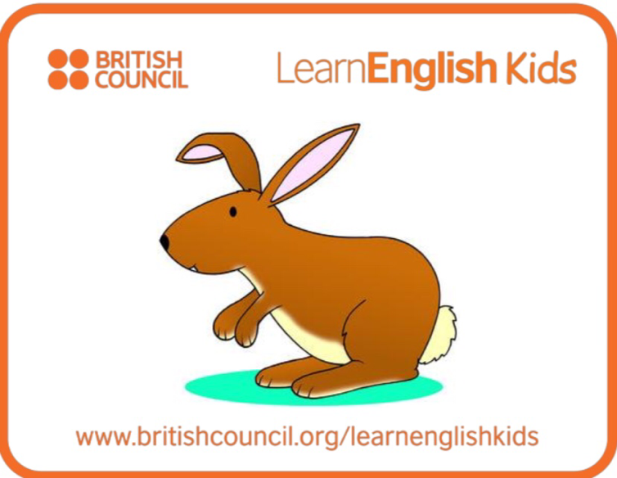
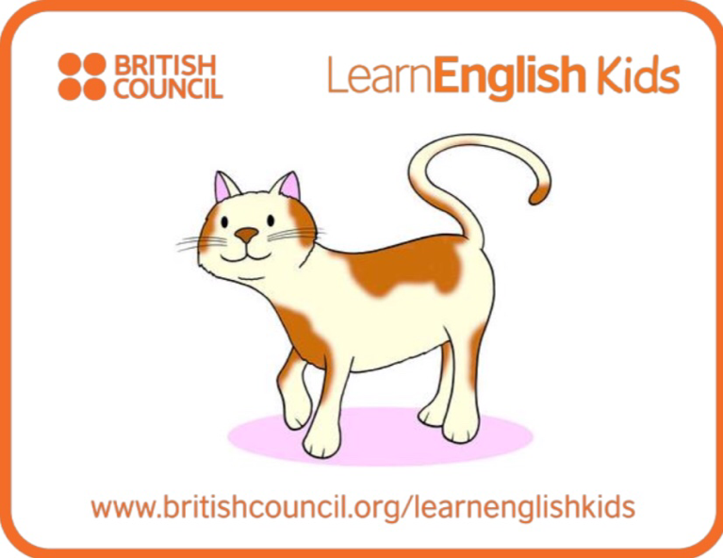
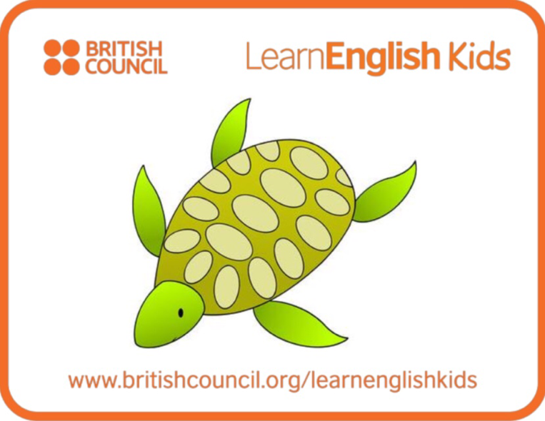
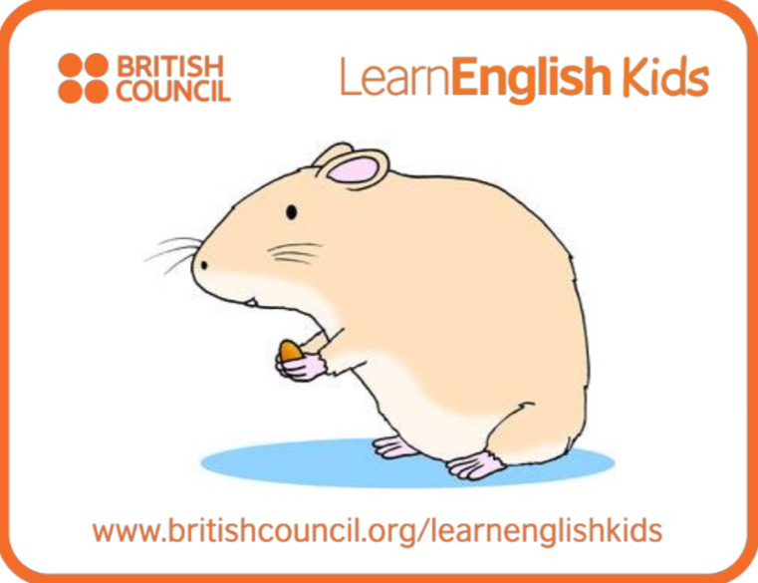
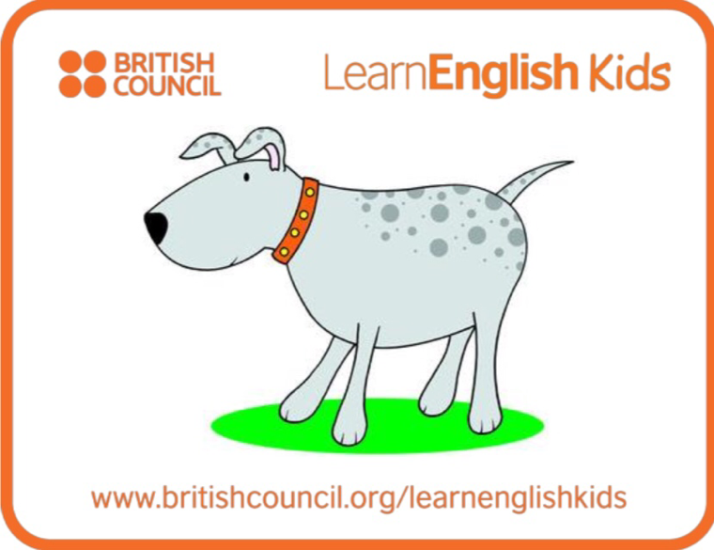
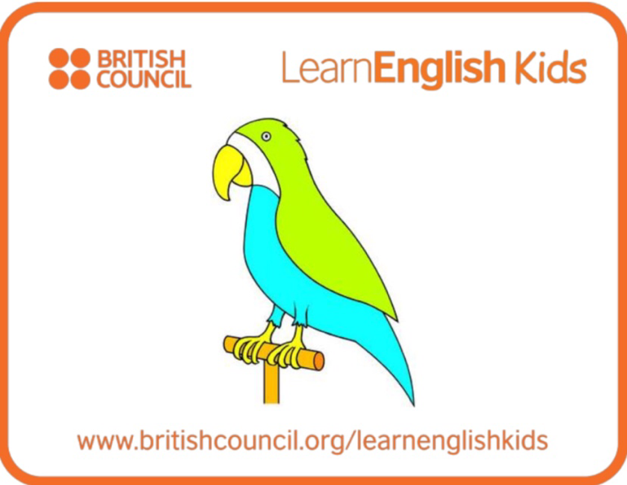
Animal cards

Animal cards
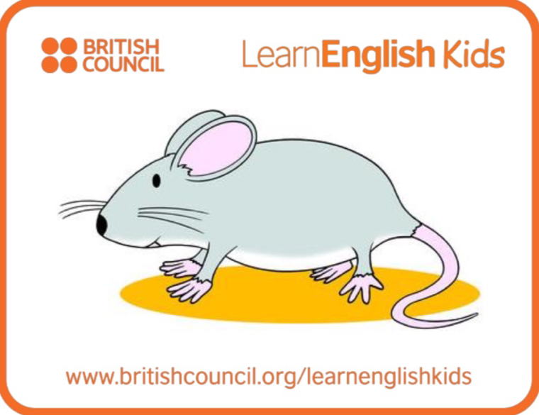
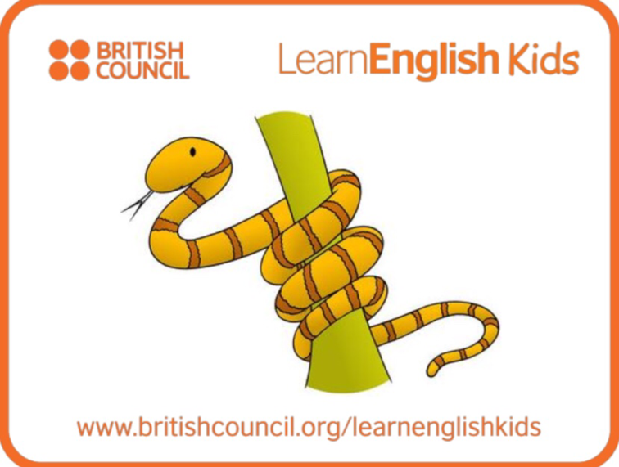

(Delete 2 animal picture cards because of the file size. The one uploaded in the café is the original with full contents.)

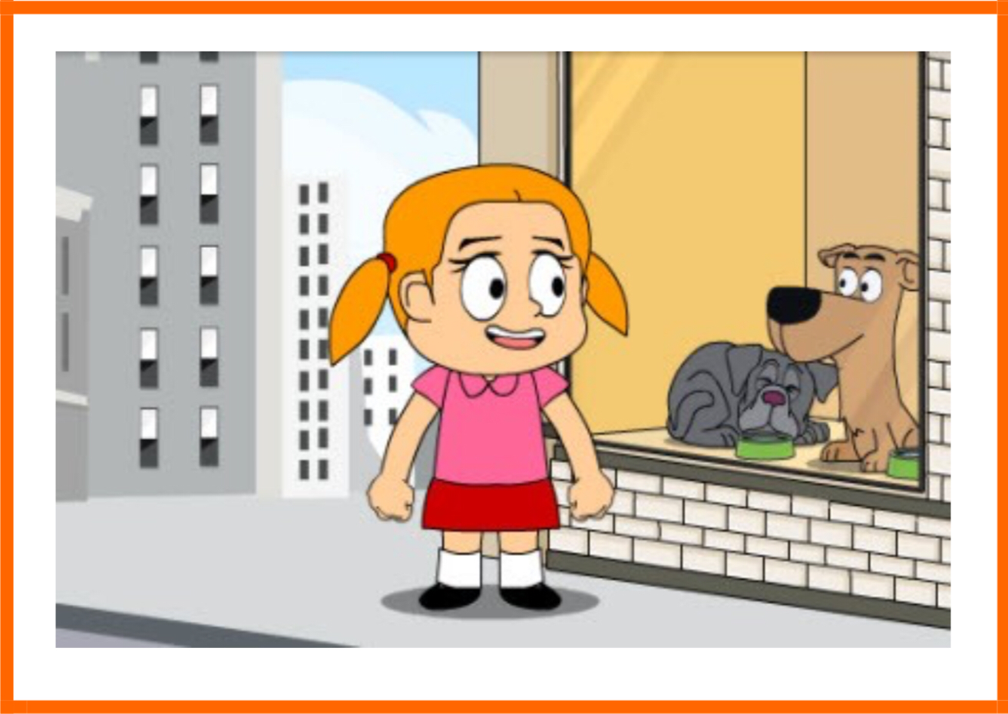
Picture #1

Question Worksheet

Q1. Is there one dog that she have I mind?
(Yes, she want to buy the dog with a waggley tail.)

Q2. Does she want a bunny? (No, she doesn’t.)

Q3. What animal does she want the most? (She want to buy a dog most.)

Q4. Did she save some money? (Yes, she did.)

Q5. What does she want to do with a dog?
(She want to give a good home.)
(She will wash, feed, walk and give the dog all that he needs.)

Q6. Could she buy the dog she mentioned?
(It’s not sure. First, she didn’t get answer whether the dog is for sale or not.
Second, the amount of money she saved could not be enough to buy the dog.)

Q7. Does she know what to do if she raise a dog? Why do you think that?
(Yes, she considered about raising a dog. She know what to do because she mentioned wash, feed and take a walk with the dog.)

Lyric sheet

How much is that doggie in the window?

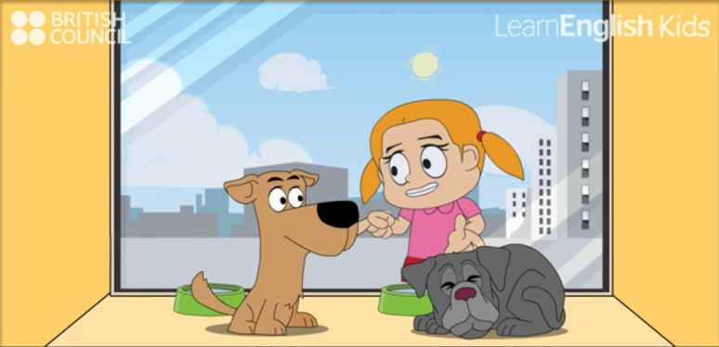
How much is that doggie in the window?
The one with the waggley tail.
How much is that doggie in the window?
I do hope that doggie’s for sale.

I don’t want a bunny or a kitty
I don’t want a parrot that talks
I don’t want a bowl of little fishes
I can’t take a fish for a walk.
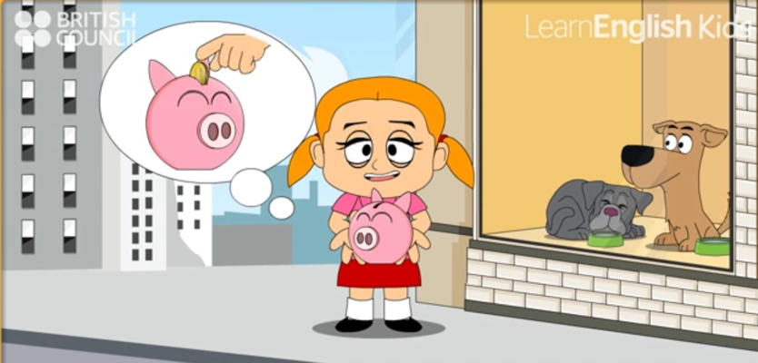
How much is that doggie in the window?
The one with the waggley tail.
How much is that doggie in the window?
I do hope that doggie’s for sale.

I’ve saved up all of my pocket money.
I want to give him a good home.
I’ll wash, feed, walk, give him all that he needs.
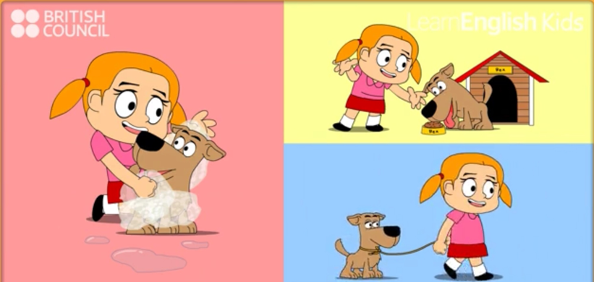
Can’t wait to feed him a big bone.
(Stop playing here. Running time 1:26)
……

Listen to this song
https://learnenglishkids.britishcouncil.org/en/songs/how-much-doggie-the-window
www.britishcouncil.org/learnenglishkids
Instructor’s Comments and Assessment
Pros
Cons
Change
Overall Comments
Grade
Above Standard 85%-100% | Standard 70%-84% | Below Standard 69%-0%
Instructor | Student Signature | Date
Taute, David

