Background Information Sheet
Name | Class | Date | Lesson Type | Length
Carli | 191st | 03-27-2019 | Listening | 40 min

Lesson
Topic | Ordering a Meal (Conversation)
Main Aim | Ss will practice their listening comprehension
Secondary Aim | Ss will practice their speaking fluency
Materials and References
https://www.teachingenglish.org.uk/dialogues
Fill in the gap worksheet, whiteboard, Smartphones, earphones, pen/pencil, eraser

Student Profile
Level | Intermediate
Age | 13 | Number of Students | 10
Detail | There are 6 female and 4 male students. Golnaz is Persian and the rest are native Koreans. Everyone can speak Korean. Most students are outgoing. Danny and Jessica are more reserved and shy but they are just as capable.  All the students seem to be keen on learning the English language and eager to actively participate in class activities.
Assumptions about students’ knowledge as required for this lesson:
This class has listened to few dialogues. All of their English skills fit the intermediate level. They are capable of operating smartphones, taking notes, and working in pairs or groups. They have learned about different types of questions, such as, ICQ (instruction checking questions) and CCQ (concept checking questions). They all show eagerness to learn and seem interested in new activities.

Anticipated Difficulties and their Solutions:
Absence, lateness – this activity is planned around 5groups of 2 Depending on the number of absent and late students, I would need to change the groups. Maybe have one group of 3. If there is a latecomer the he or she will join another group.
Technical issues - In case the class audio does not work, I will bring my cellphone. Also, the students are required to bring and use their smartphones to listen to the dialogue as well. I will send a message on our group chat and tell them to bring their phone charger and earphones to class.
Use of L1 – Remind the students to speak in English throughout the lesson.

My Personal Aim
What I hope most to demonstrate in this lesson is the ability to write a detailed lesson plan.
Stage Name: Lead-in
Purpose of this stage: to relax both the students and the teacher; to start the lesson in a natural way; to focus the attention of the students; to involve students and allow them to share ideas related to the topic.
Materials: List all materials that will be needed in this stage.
Timings | Interactions | Procedure
1 min  1 min | T  T-S | Greeting  “Hello everyone! How are you today? Yesterday I went to a delicious Thai restaurant with a friend. I really enjoyed the food there. Has anyone else gone to a good restaurant lately?”  (Ss answer)  “Ok that’s great.”  Warm up  “What type of food do you like ordering when you go to a restaurant?”

Stage Name: Presentation
Purpose of this stage: To pre-teach the keyword of the dialogue: expensive
Materials: List all materials that will be needed in this stage.
Timings | Interactions | Procedure
2 min  30 sec  2 min  1 min | T-S  T  S-S  T-S | Pre-teach keyword – expensive  Elicit & CCQ:  Show a picture of a Mcdonalds hamburger then show a picture of a steak served in an expensive restaurant.  “Which food is more cheap?” a hamburger  “What is the opposite word of cheap?” Expensive  “Repeat after me. Expensive.”  (Ss answer)  Drill:  Make students repeat the word as a class twice. Then make 5 of the students on the right side of the class repeat the word and the left side to repeat the word once each. Then pick 1 student who has a good English pronunciation to say the word once again.  Board:  Write the word on the board  “How many syllables does this word have?”  “What part of speech is this word?”  Guiding question – What type of food do you like to eat?  Pair the students with a partner.  “Share your answers with your partner. I will give you 1 minute)  “Ok time is up” (Clap twice for to get their attention)  “What answers did you come up with?” (Ask each pair of students to answer the question)  Give students feedback after hearing their answers.

Stage Name: Practice Detailed Listening – Literal Comprehension
Purpose of this stage: Ss practice listening to details. Checking their accuracy is needed.
Materials: List all materials that will be needed in this stage.
Timings | Interactions | Procedure
30 sec  30 sec  1 min  30 sec  3 min  30 sec  2 min  2 min  30 sec  1 min  2 min  1 min | T  T-S  T  S  T  S-S  T-S  T-S  T  S  S-S  T-S | Instructions:  “We will listen to a 1 minute conversation between 2 people who are ordering a meal in a restaurant.”  ICQ  “What conversation will we be listening to?” A conversation between 2 people in a restaurant  “How long will the conversation be?” 1 minute  “Ok. I will now play audio”  Students listen for the 1st time.  Hand out a fill in the blank sheet of the dialogue  Instructions  “I will play the audio one more time. Please fill in the blanks in the handouts I gave you. Listen carefully.”  Students listen for the 2nd time. They do the fill in the blank activity  “Now I want you to share your answers with the same partner that you worked with before.”  Ss pair check.  Go over each answer with the students. Correct the wrong answers, explain the reason, and then give feedback.  Literal Questions:  “Where did the women sit?” In the corner  “Why did one of the women not eat meat?” It makes her ill  “What did the waiter repeat the women’s order?” To check their order  “That is correct! I just asked you a few literal questions. A literal question is a straightforward question that you can answer by looking at the conversation.”  Instructions:  “Now I want each of you to make your own literal question using this dialogue. You will do this individually. I will give you 1 minute.”  (Ss make their own literal question)  “Ok. Time is up. Ask your partner your literal question. Then answer your partner’s question as well. Take turns questioning and answering each others questions.”  (Ss work in pairs)  Ask each pair their answers. Correct them if their question is not a literal question. Explain why the question is not considered a literal question. Give Feedback to the students.
Stage Name: Practice More Detailed Listening – Interpretive Comprehension
Purpose of this stage: Ss listen thoughtfully to interpret meaning. Accuracy focused.
Materials: List all materials that will be needed in this stage.
Timings | Interactions | Procedure
2 min  5 min  1 min  30 sec  1 min  2 min  1 min | T  T-S  T-S  T  S  T  S-S  T-S | “Lets review the dialogue one more time!”  Interpretive Questions  “What type of meal are the women having?” Breakfast. Lunch! The waiter says ‘good evening. So it must be in the day time”  “What mood do the women seem to be in?” They seem to be in a good mood. They don’t say anything negative.  Ask one of the shy students for an answer as well.  “Carli, what do you think?”  Go over the answers with the students. Give them feedback.  “Ok great. You all just answered two interpretive questions. Interpretive questions may have more than one answer and can be guessed by the conversation of the dialogue.”  Instructions:  “Now as we did before with the literal questions. I want each of you to make your own interpretive question. Work individually.”  (Ss write their interpretive question)  “Has everyone made 1 question? Ask your question to your partner and answer your partner’s question!”  (Ss do pair work)  Ask each pair their question and answer. Correct them if their question is not an interpretive question. Give the students feedback.

Stage Name: Production – Applied Comprehension
Purpose of this stage: Ss practice speaking. Fluency focused stage. Teacher mainly monitors and may offer necessary support.
Materials: List all materials that will be needed in this stage.
Timings | Interactions | Procedure
1 min  5 min | T  S-S  T  T-S  T  T-S  T | Instructions:  Split the class into 2 groups.  “I want 5 of you to be one group and 5 of you to be in one group”  Applied Questions  “What are polite ways to order a meal? Are the women ordering the meal in a polite way? Explain why”  “I want you all to discuss this question as a group. Come up with the best answer. I will give you 5 minutes to discuss your answers. You will role play your answers later so make your answers into a script. For example ‘the waiter said….the man said…..’ You can begin now.”  (Ss work as a group)  “Ok time is up. Which group will go first? Ok group 1 will go first then.”  (Group 1 role plays their script and I give them feedback)  “Now group 2, please come in front of the class.”  (Group 2 role plays their script and I give them feedback)  “You all did very well. The question you just role-played is called an applied question.”

Stage Name: Wrap-up
Purpose of this stage: To end the lesson on a positive feeling, and to handle any classroom management matters before ss go home.
Materials: List all materials that will be needed in this stage.
Timings | Interactions | Procedure
2 min | T-S  T | Give Lesson Feedback  Give students homework  “At the end of today’s class you role-played your answers to an applied question type. I want you all to research on the internet what an applied question is. We will talk more about this question type tomorrow”

Instructor’s Comments and Assessment
Pros
Cons
Change
Overall Comments
Grade
Above Standard 85%-100% | Standard 70%-84% | Below Standard 69%-0%
Instructor | Student Signature | Date
Taute, David

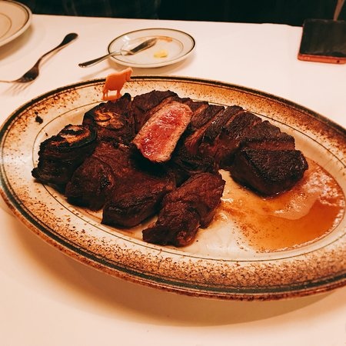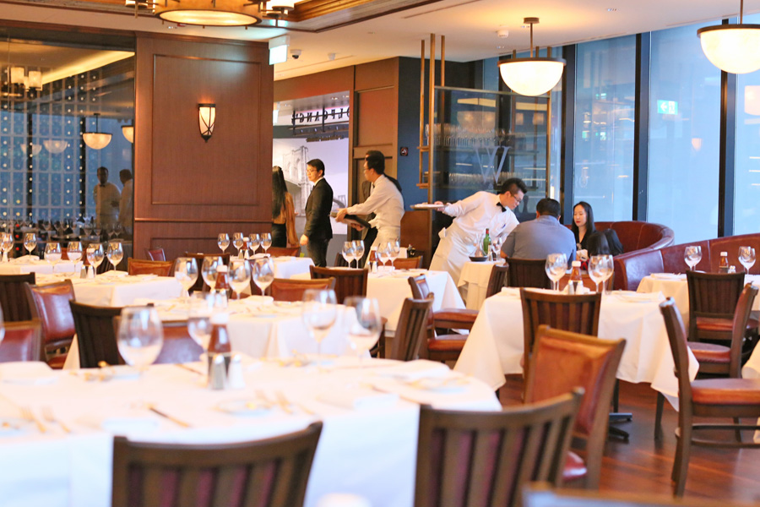

Dialogue 7: Ordering a meal.

Jean: Where shall we sit? Look! There are some free seats in the corner.
Jill: The seats by the window are better. It'll be cooler there.
Jean: Okay. What would you like to eat?
Jill: I'm really hungry. I think I'll have chicken and chips with baked beans.
Why don't you have chicken too?
Jean: I don't eat meat. It makes me ill. I'll have a cheese sandwich instead.
Jill: And what about drinks? I think I'll have some mint tea.
Jean: No that's really expensive! Its three dollars sixty cents! I'll have a coffee; it’s much cheaper.
Waiter: Good evening.
Jill: Good evening. We'll have one chicken and chips with baked beans and one cheese sandwich please.
Waiter: No problem! What would you like to drink?
Jean: A mint tea and a coffee please. Oh - and please bring me some cream
for the coffee.
Waiter: Okay. let me repeat your order. One chicken and chips with beans, one cheese sandwich, a mint tea and a coffee with cream.

www.teachingenglish.org.uk

Dialogue 7: Ordering a meal.

Jean: Where shall we sit? Look! There are some free seats in the ( ).
Jill: The seats by the window are better. It'll be ( ) there.
Jean: Okay. What would you like to eat?
Jill: I'm really (hungry). I think I’ll have chicken and chips with ( ).
Why don't you have chicken too?
Jean: I don't eat meat. It makes me ( ) I’ll have a ( ) instead.
Jill: And what about drinks? I think I'll have some mint tea.
Jean: No that's really ( )! Its three dollars sixty cents! I'll have a coffee; it’s much cheaper.
Waiter: Good evening.
Jill: ( ). We'll have one chicken and chips with baked beans and one ( ) please.
Waiter: ( )! What would you like to drink?
Jean: A mint tea and a coffee please. Oh - and please bring me some cream for the coffee
Waiter: Okay. let me ( ) your order. One chicken and chips with beans, one cheese sandwich, a mint tea and a coffee with ( ).

