Background Information Sheet

Name | Class | Date | Lesson Type | Length
Jin & Daniel | 191st | 03-04-2019 | Speaking | 30 min

Lesson
Topic | An interview with a celebrity (Role-play)
Main Aim | Students will practice their speaking fluency and confidence.
Secondary Aim | Students will practice their creativity.
Materials and References
https://www.youtube.com/watch?v=BhQxTr_ylBg

Student Profile
Level | Advanced
Age | Adults | Number of Students | 8
Detail | There are 7 females and 1 male. Eli is Korean-American and the rest of the students is native Korean. Their English capability is good enough. All the students are active and full of passion.
Assumptions about students’ knowledge as required for this lesson:
The students will be very interested in the topic “celebrity”. So when students share their opinions they can communicate a lot. They have done this activity before (role-play). All the students show active participation during the discussion and the activity.

Anticipated Difficulties and their Solutions:
- Absence, lateness- this activity is planned around 2 groups of 4. In case I make a group by 3 and 4.
- Use of L1. Solution: Remind students to use English only.

My Personal Aim
What I hope most to demonstrate in this lesson is to give good instruction and managing the time according to the time table.

Stage Name: Pre Task
Purpose of this stage: Create interest in the topic. Brainstorm ideas which will be useful for the next stage. Students may be given a communicative task e.g. discuss, arrange/sort, create a list, etc.
The aim is to relax students, activate their background information, and gather useful ideas for the lesson.
Materials: ppt( photos and video)
Timings | Interactions | Procedure
5 min | T-S | Hello everyone! How are you today? Is there anything you like or interested in? <Elicit> Can everybody look at the screen? What can you see in this picture? What do we call those people? (celebrity) What kind of people are called celebrity? (comedian, singer, actor, a sports player)  (Ask the student) ex) Who’s your favorites comedian? Have you guys ever watched an interview with a celebrity?  Let’s watch a short video. So from now on, you are going to make your own role-play with your group.  I’m going to split you guys into 2teams. The first team is going to be Carli, Young, Jerry, and Diane. The second team is Eli, Rosa, Sue, and Jinny.  Can you guys now all sit together and discuss your role-playing. I’m going to give you guys 10 minutes to prepare and 5minutes to perform in front of the class. (Hand out a paper with a description)

Stage Name: Task Preparation
Purpose of this stage: This is a student centered stage, to give students time to prepare and practice a speaking task which they will perform in Task Realization. Clear detailed instructions or a demonstration must be provided so students know what is expected. Prepared materials may be provided to assist their preparation. Monitor and offer brief tips if necessary.
Materials: Hand-out (descriptions, introduction)
Timings | Interactions | Procedure
10 min | S-S | Students gather around with their groups to prepare the role-play. The teacher is going to monitor the students and give them some help.  In the instruction, the teacher mentions that all the students should have opportunities to speak equally. So each group has to decide who asking the question and who answer it before the interview running.

Stage Name: Task Realization
Purpose of this stage: This is a very student centered stage to allow for maximum speaking fluency. Monitor discretely and assess students’ performance to specify the winner. Also, take note of incorrect language. Students perform their task without interruptions from the teacher.
Materials: Note
Timings | Interactions | Procedure
10 min | S-S | Students perform their interviews with chosen celebrities. All the participants equally speak.  Monitor quietly and Keep note of any major language errors. Students practice oral fluency. Learning effectively takes place in such the fun activities. The world of the classroom is broadened to include the outside world - thus offering a much wider range of language opportunities.  End each interview after 5 minutes.

Stage Name: Post Task
Purpose of this stage: To end the lesson with a final student centered task such as voting, summarizing, discussing, deciding etc. The teacher may offer delayed error correction to the previous stage, as well as mention positives and points to improve for next time such as useful strategies.
Materials: 2 piece of paper
Timings | Interactions | Procedure
5min | T-S | They are going to have a vote for best actors and actress.  Each group has to discuss and choose the best actor and actress in other team. Each team covertly has to write the chosen winner on the piece of paper and give it to the teacher (the opposing group must unaware of the chosen winner.). When the vote is over and the winner is determined, the name of the winners will be announced and they will come and receive their prizes.

Instructor’s Comments and Assessment
Pros
Cons
Change
Overall Comments
Grade
Above Standard 85%-100% | Standard 70%-84% | Below Standard 69%-0%
Instructor | Student Signature | Date

An interview with a celebrity!!
Group1: Carli, Young, Jerry, Diane
Character: Kim Yuna and her coach, Host 1, 2.
Kim Yuna: She is a famous figure skater.
e.g. Host1: How is your training going on?
Notice: Everyone need to take part equally.

An interview with a celebrity!!
Group2: Eli, Rosa, Sue, Jinny
Character: Psy and Hyuna , Host 1, 2
Psy: He is a singer and rapper.
Hyuna: She is a singer and dancer.
e.g. Host1: Tell us about your coming album.
Notice: Everyone need to take part equally.

Kim Yuna

Coach

Host1

Host2

Psy

Hyuna

Host1

Host2

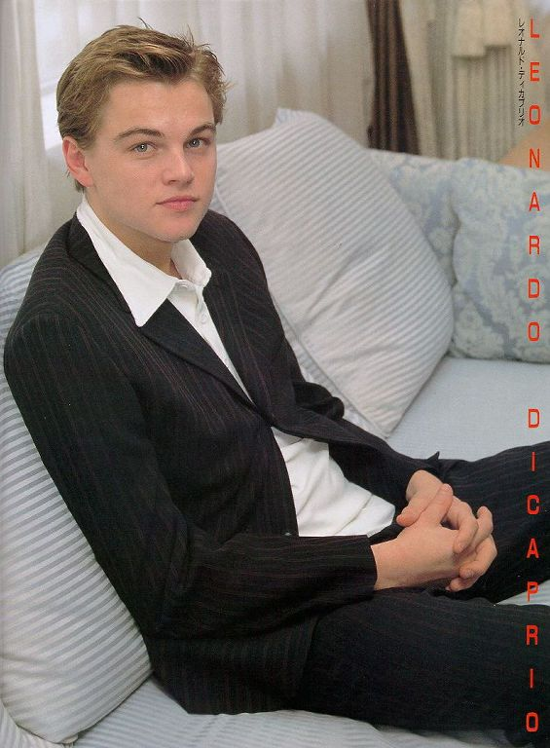

Celebrity
A famous or well-known person, especially in entertainment or sport.

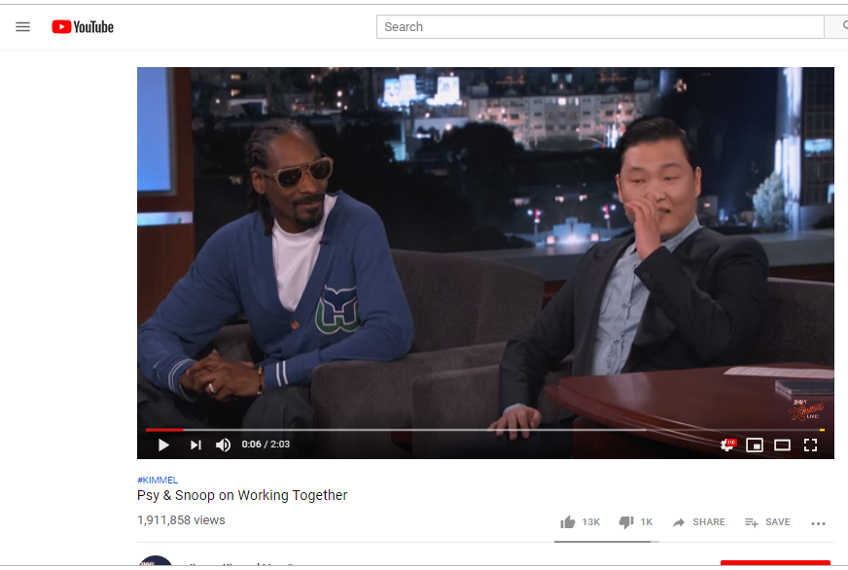
Group work!!
- Carli , Young , Jerry , Diane

- Eli , Rosa, Sue , Jinny

