Background Information Sheet
Name | Class | Date | Lesson Type | Plan type | Length
Carli Chung | Tesol | 2019.04.10 | Grammar | PPP | 25 min

Lesson
Topic | Grammar Micro Teaching: Present Simple Tense  Topic: My Daily Routine  Model Sentence: “I go to bed at 9pm”
Main Aim | Students will learn English grammar using the Present Simple tense.
Secondary Aim | Students will learn reading, writing, and speaking about ‘Daily routine’ activities using the Present Simple tense.

Materials and References
Whiteboard, colored markers, PPT, Daily routine fill in the blank worksheet (including pictures) & answer sheet, Daily routine question worksheet & answer sheet

Student Profile
Level | Lower Intermediate
Age |  | Number of Students | 9
Detail | Native Korean students, 2 boys and 7 girls. The age difference between students vary from their 20’s to their 40’s, but all students get along very well. Jin is one of the shy students that require more motivation in active participation in class. Eli and Sue are the 2 most outgoing students in class. All students have a strong desire to enhance their English grammar skills.
Assumptions about students’ knowledge as required for this lesson:
The students know the how to use the Verb “To Be” and can form sentences using simple vocabulary. However, they have not learned how to form sentences in the Present Simple tense.

Anticipated Difficulties and their Solutions:
Absence, lateness – Students being late for class may disrupt the class atmosphere and student’s concentration in class. Therefore, I will acknowledge the late student, but continue teaching, so the flow the lesson is not interrupted. Also, if a student is absent, I will have to pair the students differently for their activity. I was planning to pair the students in 3 groups of 2 and 1 group of 3. Depending on how many students are absent, I will have to change groupings.

My Personal Aim
What I hope most to demonstrate in this lesson is the ability to present the target language using a situational presentation.

Stage Name: Lead-in
Purpose of this stage: To relax both the teacher and students. To focus attention on the lesson. Create a situation for students to experience or think about, and then to elicit the target language.
Materials: PPT(picture)
Timings | Interactions | Procedure
1 min  1 min | T-S  T-S | Greetings  “Hello Everyone, how is everyone today? Did you do anything interesting yesterday?”  Ss answer  “Ss name, what did you do yesterday?”  Ss answer  “Thank you for sharing! In today’s grammar class we are going to learn how to use the present simple tense”  Show PPT  Show students a picture of a bed with a clock that shows it is 9pm  Mime ‘walking’ to the bed  Elicit from students what the English sentence is by referring to the situation (picture)  T: “What is this picture showing?”  S: “A bed, a clock!”  Mime walking to the bed  T: “What am I doing?”  S: “Walking”  T: “Where am I going?”  S: “To bed”  T: “So I am….?”  Ss answer

Stage Name: Presentation
Purpose of this stage: Make the students think about the situation. To clarify the meaning, form, and pronunciation features of the target language.
Materials: Whiteboard, colored markers, PPT
Timings | Interactions | Procedure
30 sec  2 min  2 min  1 min | T-S  T-S  T-S  T-S | Board the model sentence – “I go to bed at 9pm”  (if students are unable to say the correct sentence, just board it).  CCQ (concept checking questions)  - At 9pm, Am I lying in bed? (Yes)  - Am I getting ready to sleep? (Yes)  - At 9pm, Do I fall asleep? (Most likely yes. But maybe not)  Show the ‘Meaning’ of the model sentence (using PPT)  Present Simple Tense - used when an action is happening right now. Also, used to describe the truth, routines, habits and unchanging situations.  - I lie down in bed to sleep  - To prepare for sleep  - To actually go to sleep/fall asleep  Show the ‘Form’ of the model sentence (using PPT)  Present Simple Tense – Subject + Simplest Form (Base Form) of a verb (For E.X. I go, I play, I eat), depending on the person, it is formed by adding -s or -es at the end.  Affirmative Model Sentence: “I go to bed at 9pm”  Negative Sentence: “I do not go to bed at 9pm”  Question Form: “Do I go to bed at 9pm?”  Drill  T: “Listen & Repeat after me, “I go to bed at 9pm”  S: “I go to bed at 9pm”  (x2)  T: “I Go to bed”  S: “I Go to bed”  T: “Ss on the right side, I go to bed at 9pm, Ss on the left side, I go to bed at 9pm”  Ss on each side of the class repeat the sentence  Ask 2 students to say the sentence out loud  T: “Ss name, could you write the sentence on the board?”  A student comes in front of the class and writes the sentence  T: “Where is the stress? What about the intonation?”

Stage Name: Controlled Practice
Purpose of this stage: students practice working with the form. Accuracy must be checked.
Materials: worksheet, whiteboard, colored markers
Timings | Interactions | Procedure
30 sec  1 min  2 min  1 min | T  S  S-S  T-S | Give Instructions while holding up the handout.  “I will give you a fill in the blank worksheet (point to the handout), fill in the blanks using the words here. I will give you 1 minute.  Students do a worksheet.  Ss Pair check their answers (3 groups of 2, 1 group of 3)  “Work with the person next to you…”  Give Feedback to check accuracy.  “Let’s go over the answers together!”

Stage Name: Less Controlled Practice
Purpose of this stage: students practice working with the meaning. Accuracy must be checked.
Materials: Worksheet
Timings | Interactions | Procedure
30 sec  2 min  2 min  1 min | T  S  S-S  T-S | Give Instructions while holding up the handout.  “This handout has 10 questions asking about your everyday, daily routine. Write short answers using ONLY the Present Simple Tense. Raise your hands if you have any questions. I will give you 2 minutes.”  (Write Daily Routine on the board and underline it for emphasis!)  Students do a worksheet.  Ss Pair check their answers (3 groups of 2, 1 group of 3)  “Pair check with the same partner”  Give Feedback to check accuracy.  “Let’s go over your answers together”

Stage Name: Production – Freer Practice
Purpose of this stage: is to get students to practice the grammar communicatively.
Materials: PPT
Timings | Interactions | Procedure
30 sec  4 min  1 min | T  S-S  T-S | Instructions  “Discuss as a group about ‘What your Daily Routine is.’ What does your typical day look like? What do you do every day? What do you usually do in the morning, afternoon, lunchtime and at night? I will give you 4 minutes to discuss!”  Group the Ss into 2 groups (1 group of 4 and 1 group of 5)  Students have group discussion time  T monitors from a distance  Give Feedback.  “Starting from this group, can you share your daily routine with the whole class?”

Stage Name: Wrap-up
Purpose of this stage: is to end the lesson on a positive note so that students feel they have achieved progress.
Materials: List all materials that will be needed in this stage.
Timings | Interactions | Procedure
30 sec  30 sec  30 sec | T  T – S  T | Lesson feedback. Tell the class what they did well, and what needs to improve.  Offer delayed corrections to the previous (freer) stage.  Set homework.  “Make a schedule listing your daily routine, starting from morning until you go to bed. Make it clear & simple. At our next lesson, you will each come up to the front of the class and present your schedule for 1 minutes”  Inform students about the topic for the next lesson.  “Tomorrow we will practice using the past simple tense.”

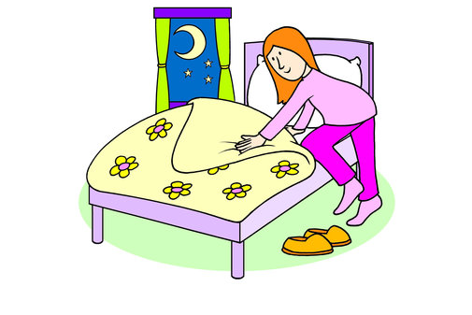

Grammar Practice
Complete the sentence in the present tense < O : affirmative, X : negative, ? : question >

1 be (O) My breakfast eggs, bacon, and bread.
2 drive (?) you always to work?
3 ride (X) My friends and I bicycles to school.
4 be (O) There many activities I like to do.
5 like (X) I to play sports.
6 drink/usually (?) your friends milk at lunch?
7 be/always (O) We happy at Christmas time.
8 talk (?) you and your family a lot at the dinner table?
9 make (X) My mom steak for dinner
10 be (X) This shirt too big on me. It fits me well!

Grammar Practice (Answer Sheet)
Complete the sentence in the present tense < O : affirmative, X : negative, ? : question >

1 be (O) My breakfast is eggs, bacon, and bread.
2 drive (?) Do you always drive to work?
3 ride (X) My friends and I do not ride bicycles to school.
4 be (O) There are many activities I like to do.
5 like (X) I do not like to play sports.
6 drink/usually (?) Do your friends usually drink milk at lunch?
7 be/always (O) We are always happy at Christmas time.
8 talk (?) Do you and your family talk a lot at the dinner table?
9 make (X) My mom does not make steak for dinner
10 be (X) This shirt is not too big on me. It fits me well!

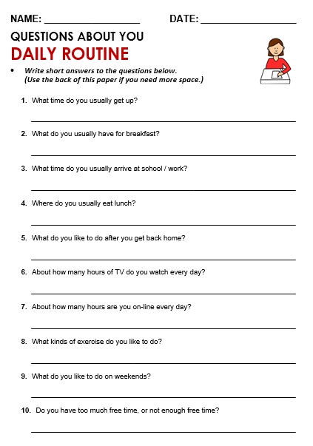
NAME: Carli Chung DATE: April 10th
QUESTIONS ABOUT YOU
DAILY ROUTINE
-Write your answers using ONLY the Present Simple Tense! (Short Answers)
1. What time do you usually get up?
I usually wake up at 9am in the morning.
2. What do you usually have for breakfast?
I usually eat pancake and milk for breakfast.
3. What time do you usually arrive at school/work?
I usually go to work at 10am in the morning.
4. Where do you usually eat lunch?
I usually eat lunch at home.
5. What do you like to do after you get back home?
I like to watch English soap operas or work out.
6. About how many hours of TV do you watch every day?
I watch approximately 1hour of television a day.
7. About how many hours are you on-line every day?
I am online for approximately 4hours every day.
8. What kinds of exercise do you like to do?
I like to do Pilates, Zumba, and SH bam.
9. What do you like to do on weekends?
I like to meet my friends and go to eat at different types of restaurants.
10. Do you have too much free time, or not enough free time?
Currently, I have enough free time and I think that I should use my free time wisely.
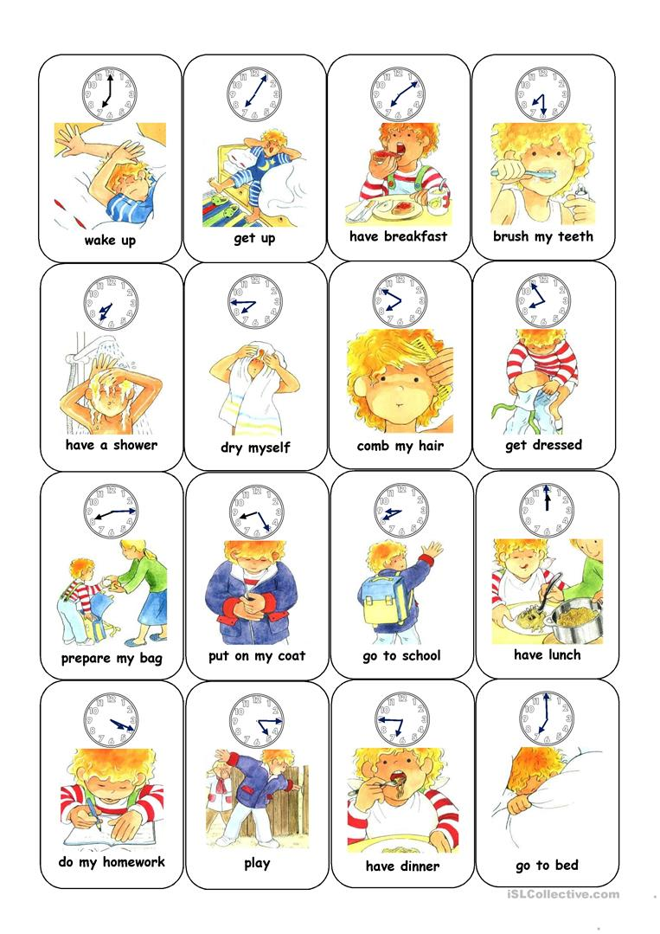

Instructor’s Comments and Assessment
Pros
Cons
Change
Overall Comments
Grade
Above Standard 85%-100% | Standard 70%-84% | Below Standard 69%-0%
Instructor | Student Signature | Date
Taute, David

