Background Information Sheet
Name | Class | Date | Lesson Type | Plan type | Length
Jinny | TESOL 191th | 17-04-19 | Reading | PPP | 25 min

Lesson
Topic | Polyglots
Main Aim | Ss practice their reading comprehension.
Secondary Aim | Ss practice their speaking fluency.

Materials and References
The Junior Times ,http://www.juniortimes.co.kr/img/common/real/624/8.jpg
White board, 3 colored markers(black, red, blue), a board eraser

Student Profile
Level | Intermediate
Age | 13 years old | Number of Students | 9
Detail | There are 7 female students and 2 male students. Daniel and Carli have lived abroad for a long time; Eli is Korean-American; the rest are native Koreans. Everyone can speak English. Most students are outgoing, only few students are shy but they can still hang out well with other students. They are usually having fun speaking English in class.
Assumptions about students’ knowledge as required for this lesson:
Except Daniel, Eli and Carli, Sue and Jin also have experiences living abroad. The rest of the students also have experience traveling abroad and are very interested in learning L2. Therefore, I think that this polyglot topic would be interesting to Ss.
So mix groups with ones who have lots of foreign experiences and ones who are not.
Make class desk arrangements into Horse-shoe shape.
(Daniel, Jerry) (Jin, Sue, Diane) (Eli, Young) (Carli, Rosa)

Anticipated Difficulties and their Solutions:
*Absence, lateness - this class is planned around 3 groups of 2 and 1 group of 3. If there is a latecomer, I will set 4 groups of 2 at first. Then, the latecomer should join with the last 3 groups of 1.
(Daniel, Jerry) (Jin, Sue, Diane) (Eli, Young) (Carli, Rosa)

*Use of L1 – Remind students of the English only rule.(Write on board before class starts.)

My Personal Aim
What I hope most to demonstrate in this lesson is the ability to reduce T.T.T.

Stage Name: Lead-in
Purpose of this stage: To relax both the teacher and students. To focus attention on the lesson. To lead in to the topic, activating background knowledge.
Materials: Board, colored markers, eraser
Timings(3min) | Interactions | Procedure
30 sec  2 min  30 sec | T  T-S/S-S  T-S | “Hello class! Hola! Ohayo! Nihao! 안녕하세요~!”  greeting class with 5 different languages.  “What am I doing now? Hello, Hola, Ohayo, Nihao, 안녕하세요!”  (Ss: “Greeting?, speaking Spanish? Japanese? Chinese? Korean? speak many languages”)  “Right~! How many languages can you speak? Talk with your partners.”  Only gesture 3 groups of 2 people and 1 group of 3 people.  Ss will talk actively with their partners and share their abilities.  Clap big hands twice to get attention. (Clap! Clap!) If not, do it again.(Clap! Clap!)  “Share with class please” point one or two students to share their discussions.(Carli, Daniel)

Stage Name: Presentation
Purpose of this stage: To pre-teach keywords if necessary, and consider guiding questions. These steps provide extra help for students to comprehend the text.
Materials: One picture, Board, 3 colored markers, an eraser.
Timings(5min) | Interactions | Procedure
3 min  10 sec  1 min  50 sec | T-S  T-S  S-S  T-S | <Pre-teach keywords>. . . . . polyglot  1. Elicit  “Look!” Show Ss a picture that shows 8 different nation flags and languages.  “How many languages are in this picture?” (Ss: 8 languages.)  “Can you speak all of them?” (Ss: No)  “Who can speak many languages like this?” (Ss: genius, polyglots etc)  2. CCQ  “Is this person can speak only 2(two) languages?” (Ss: No)  “Is this person can speak more than 3 languages?” (Ss: Yes)  “Is this person can speak many languages and understand freely too?” (Ss: Yes)  3. Drill  “Polyglot, Polyglot, Class~?” lead whole class repeat after T (Ss: Polyglot)  “One more time! Polyglot! ” (Ss: Polyglot)  Point 2 students to pronounce the word “polyglot” make sure they are doing right.  Point to (Jerry, Sue)  Make a sentence to practice pronunciation.  “Polyglots speak many languages” repeat 2 times to make Ss repeat after T.  “Polyglots speak many languages”  Point half of the class at first.  Point another half at last time.  4. Board  Board the sentence.  ‘Polyglots speak many languages.’  “Where is the stress?”  V V  Polyglots speak many languages. (Ss: Poly & language)  “What type of word is it?” draw lines around polyglot (Ss: Noun)  Guiding Question  “Discuss with your partner. Is it possible to speak more than 20 languages?  Why? or why not?”  Students discuss the question with a partner.  Feedback. Nominate 2 students to share their ideas.(Diane, Jin)

Stage Name: Practice – Literal Comprehension
Purpose of this stage: is to get students to practice reading for literal detail.
Materials: 9 sheets of Reading materials (Article from Junior Times)
Timings(4min) | Interactions | Procedure
30 sec  10 sec  1 min 30 sec  50 sec  1 min | T-S  T  S  S-S  T-S | “There are 3 T/F questions behind this. Before you read, read questions first!  And work individually!”  “Can you read the article first?” (Ss: No)  “Can you work together?” (Ss: No)  “Good.”  Hand out worksheets.  Students read the whole text for the 1st time, and circle answers on the worksheet.  Monitor  Clap twice and “Pair check please.”  Monitor  Clap twice and feedback to check accuracy.  “Number 1. Answer~?” (Ss: False)  “Number 2~?” (Ss: False)  “Number 3~?“ (Ss: True)  “Correct”

Stage Name: Practice – Interpretive Comprehension
Purpose of this stage: is to get students to get students to practice interpreting a text correctly This will require more detailed, careful reading, and thinking time to arrive at the correct answer.
Materials: 9 sheets of Reading materials (Article from Junior Times)
Timings(5min) | Interactions | Procedure
30 sec  2 min  2 min  1 min | T-S  S  S-S  T-S | “Look at the left 2 questions. Read again and answer carefully”  “Can you work together?” (Ss: No)  Students read for the 2nd time. Students write their own answers down.  Monitor  “Let’s pair check.”  Monitor  Clap twice when time finished. Feedback to check accuracy.  “Number 1” : hand gesture to (Young)  “Number 2” : hand gesture to (Rosa)

Stage Name: Production - Applied Comprehension
Purpose of this stage: is for students to practice their speaking fluency on a topic related to the lesson.
Materials: Board, markers, an eraser
Timings(6min) | Interactions | Procedure
1 min  4 min  1 min | T  S-S  T-S | Clap twice  “How many languages do you want to speak?  What if you were polyglot and everybody knew about it.  What will happen at school?  Discuss with your partner.”(Board the discussion topic.)  Students discuss actively.  Monitor  Clap twice  Feedback. Students share their ideas with the class.  Hand gesture to “(Eli) please.”

Stage Name: Wrap-up
Purpose of this stage: is to end the lesson on a positive note so that students feel they have achieved progress.
Materials: Board, 3 colored markers, an eraser
Timings(2min) | Interactions | Procedure
2 min | T | “Well done for today’s hot discussion!”  “But, please be careful with the pronunciation ‘polyglot’.” “Repeat, Polyglot” (Ss: Polyglot)  “Good job! No homework for today.”  “You can also be a polyglot! Just Never stop learning!! Thank you ”

<Picture>- Eliciting the Keyword

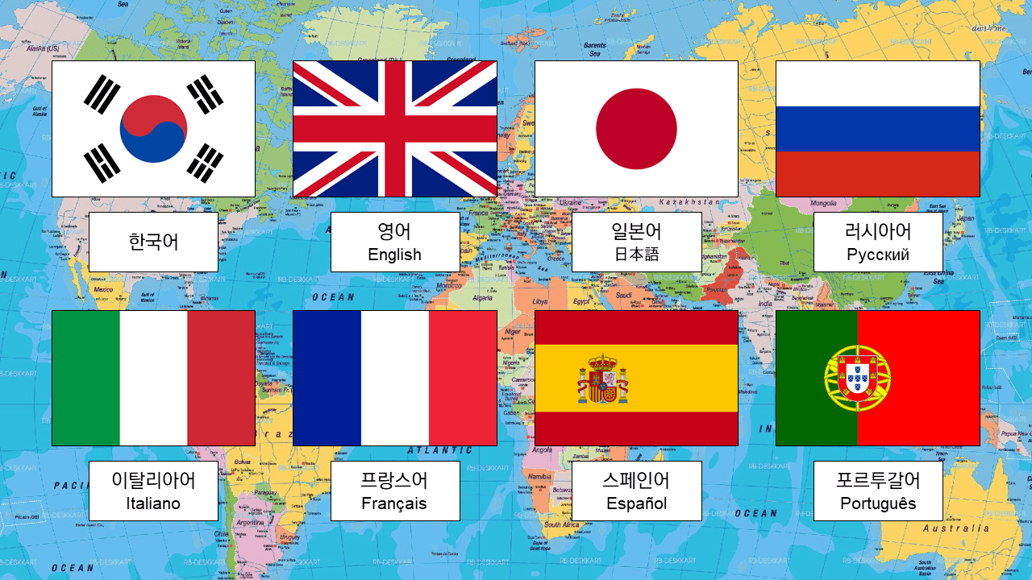

<Article>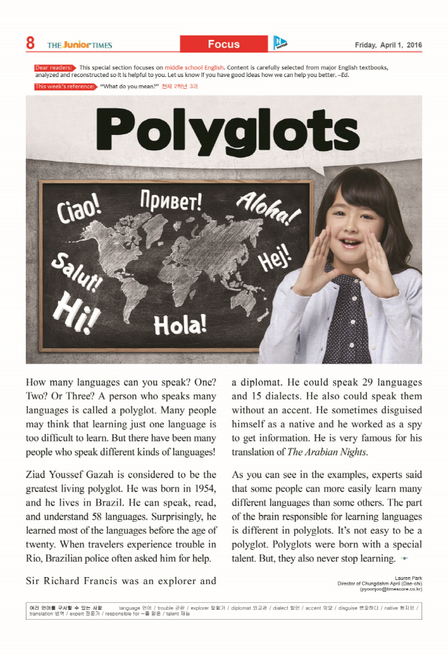

<< Fun Work Sheet in T: Jinny’s class >>
▷ Circle the right answer
1. Ziad Youssef Gazah can speak, read, and understand 59 languages.
( T / F )
2. Mr. Francis can speak 29 languages with an accent and he translated The Arabian Nights. ( T / F )
3. Is the brain responsible for learning languages different in polyglots? ( T / F )

▷ Write the possible answers.
1. Is it possible to imagine any person who can speak more than 58 languages and why?

2. What did the journalist mean when she wrote ‘The part of the brain responsible for learning languages is different in polyglots.’? Write 2 things you can know within the sentence.

<< Fun Work Sheet in T: Jinny’s class >>
with answers
▷ Circle the right answer
1. Ziad Youssef Gazah can speak, read, and understand 59 languages.
( T / )
2. Mr. Francis can speak 29 languages with an accent and he translated The Arabian Nights. ( T / )
3. Is the brain responsible for learning languages different in polyglots? ( / F )
▷ Write the possible answers.
1. Is it possible to imagine any person who can speak more than 58 languages and why?
(Yes. Because Ziad Youssef Gazah is the greatest ‘living’ polyglot, so it’s still possible to imagine the greatest polyglots among the dead.)
2. What did the journalist mean when she wrote ‘The part of the brain responsible for learning languages is different in polyglots.’? Write 2 things you can know within the sentence.
(1. There is a special part in the brain which is responsible for learning language.)
(2. Polyglots have special talents because of their brain.)
(3. Polyglots brain looks different (might be larger) than ordinary people.)

Instructor’s Comments and Assessment
Pros
Cons
Change
Overall Comments
Grade
Above Standard 85%-100% | Standard 70%-84% | Below Standard 69%-0%
Instructor | Student Signature | Date
Taute, David

