Background Information Sheet
Name | Class | Date | Lesson Type | Plan type | Length
Young | TESOL | 04/07/2019 | Reading | PPP | 25 min

Lesson
Topic | Charlie and the chocolate factory
Main Aim | Ss practice their reading comprehension.  Ss will be able to predict the main idea and answer the questions.
Secondary Aim | Ss will predict the meaning of idioms.  Ss will practice their speaking fluency having discussion with their partners.

Materials and References
A white board, color markers, an eraser, 9 copies of reading text, 9 copies of worksheet,
a computer, PPT slides, The book “Charlie and the Chocolate factory by Roald Dahl”
https://www.roalddahl.com/create-and-learn/teach/teach-the-storie https://www.youtube.com/watch?v=t7lIsKhmsVE
https://www.youtube.com/watch?v=7PJPJy00514

Student Profile
Level | Low intermediate
Age | 11-13 year old | Number of Students | 9
Detail | Ss are all native Korean. There are 4 boys, 5 girls. A few Ss have lived abroad. 4 of the Ss are very outgoing and 2 of them are a little introvert than others. Most of the Ss are just capable.
Assumptions about students’ knowledge as required for this lesson:
They are able to participate in group discussion because they already have had that experience. From this reading lesson, Ss might be enjoying reading a part of the story. Furthermore they will have interest in reading the full story of the book as the lesson goes by.

Anticipated Difficulties and their Solutions:
Ss may not understand the words. T will elicit the expression.
Some Ss may not answer the questions in time. T gives them some more time.
Some Ss may have difficulty about predicting the conclusion of the text. T encourages Ss to think further.

My Personal Aim
What I hope most to demonstrate in this lesson is the ability to reduce teacher talk, manage the lesson time properly and more importantly, have Ss enjoy their lesson.

Stage Name: Lead-in (1 min 40 sec)
Purpose of this stage: To relax both the teacher and students. To focus attention on the lesson. To lead in to the topic, activating background knowledge.
Materials: PPT , a computer
Timings | Interactions | Procedure
10 sec  1:30 min | T  T-S | Greeting.  Good morning, everyone!  T: Look at this. (Show pictures of various kinds of sweets.)  I love sweets. What about you?  What kind of sweets do you like? Why do you eat them?  Nominate 1 or 2 Ss to share their ideas.

Stage Name: Presentation (5min 30sec)
Purpose of this stage: To pre-teach keywords if necessary, and consider guiding questions. These steps provide extra help for students to comprehend the text.
Materials: PPT slides, a board, an eraser
Timings | Interactions | Procedure
3 min  30 sec  1 min  50 sec | T-S  T  S-S  T-S | Keywords  • wrap (someone) around (one’s) little finger  Elicit  ① (Show a picture using PPT)  Ask Ss some questions to elicit the keyword.  “What is he doing?” “Who is this? (maybe her boyfriend?)  “Who do you think got the more power?”  Target sentence: She had him wrap around her little finger  ( Show the PPT)  CCQ  - Does she have a control over him? (yes)  - Can she make him do whatever she wants? (yes)  Drill – choral for correct pronunciation 2 times. “Listen and repeat”  Board(PPT) – highlight special areas of pronunciation and part of speech. (Mention that it is an Idiomatic expression)  • dim-witted  Elicit  ② T: What word can be opposite for Smart /Clever?  Ss: dumb, stupid, silly, foolish  T: That’s right. Another expression for stupid or silly is dim-witted  Target sentence: He was such a dim-witted boy.  CCQ: Is he mentally bright? (no)  Drill – choral for correct pronunciation 2 times.  (dim-witted) “listen and repeat”  Board(PPT) - “What part of speech is this?” (an adjective)  (mention that this is a combined word, dim and witted,  if needed)  Guiding Question  (Show the question using PPT)  Do you have any experience in winning an event unexpectedly?  (e.g. free gift, money, toys, free tickets, anything)  “talk to your partner”  Students discuss the question with a partner. T monitor.  Nominate 1 student to share his/her idea.  “Can you share your experience shortly?”

Stage Name: Practice – Literal Comprehension (4min 30sec)
Purpose of this stage: is to get students to practice reading for literal detail.
Materials: 9 copies of reading text, 9 copies of worksheet.
Timings | Interactions | Procedure
30 sec  2 min  1 min  1 min | T  S  S-S  T-S | Instructions  Look at this worksheet. This is part 1.  After reading the text, check your answers on True/ false.  I’ll give you 2 min. Do it individually.  Hand out the reading materials and worksheets.  Students read the whole text for the 1st time, and check answers on the worksheet.  Monitor discretely to check if all Ss are on the right track.  Announce how much time is left in advance.  If Ss need more time, give them 20sec more.  “Are you done? Do you need more time? Ok. I’ll give you 20 sec more.”  Pair check. “Check the answers in pairs”  Announce how much time is left in advance.  Check accuracy by having Ss read each question and answer.  “Ok, let’s check the answers together.”  “Did everyone get the right answer?” “Did anyone get the different answer?”

Stage Name: Practice – Interpretive Comprehension (6min 30sec)
Purpose of this stage: is to get students to get students to practice interpreting a text correctly This will require more detailed, careful reading, and thinking time to arrive at the correct answer.
Materials: 9 copies of worksheet (part 2)
Timings | Interactions | Procedure
30 sec  3 min  1 min  2 min | T  S  S-S  T-S | Instructions  ( Hold up the worksheet. Point to the Part 2)  Here is worksheet part 2.  This time, write your answers after reading the text more carefully.  Do it individually. I’ll give you 3 min.  Hand out worksheets.  Students read for the 2nd time. Students write their answers down.  Monitor discretely to check if Ss are on the right track.  Announce how much time is left in advance.  Pair check. “Check the answers with your partners”  Announce how much time is left in advance.  “You have 30 sec left.”  Feedback to check accuracy.  Before let Ss know the right answer directly, listen to other’s opinions more if needed.  Nominate 2 or 3 Ss to check the answers.

Stage Name: Production - Applied Comprehension (7min)
Purpose of this stage: is for students to practice their speaking fluency on a topic related to the lesson.
Materials: 9 copies of note format, ppt slides, a short video clip
Timings | Interactions | Procedure
1 min  5 min  1 min | T  S-S  T-S | Instructions  Make Ss groups of 3  “Willy Wonka was a genius inventor.  Let’s watch this. (Show a short clip)  Now, You are the genius inventor.  Create your own sweet as a team. I’ll give you 5 min”  ICQ: Do you do the work individually or as a team? (as a team)  Students discuss.  Monitor discretely to check if all Ss are engaged in the discussion.  Feedback. Students share their ideas with the class.  Nominate one group to share their ideas with the class.  “Would you share your team’s genius idea?”

Stage Name: Wrap-up (1min)
Purpose of this stage: is to end the lesson on a positive note so that students feel they have achieved progress.
Materials: List all materials that will be needed in this stage.
Timings | Interactions | Procedure
1 min | T | Lesson feedback.  Tell the class what they did well, and what needs to improve.  “Did you enjoy your topic today?  I am glad to see all of you actively participated in every task.  Very nice.”  Next time we will read more about what adventures they are going to have in the factory. That’s all for today. Thank you.

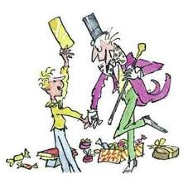
Reading is fun
Part 1 : True / False

- Read each sentence and check your answers on True / False.

- Mr. Willy Wonka hid five golden tickets at the very special places. ( T / F )

- Veruca Salt ( T / F )
She is spoiled by her parents. They do whatever their daughter wants.

- Violet Beauregarde ( T / F )
She is very smart girl and chews gum just for fun.

- Mike Teavee ( T / F )
He is a little gangster who is obsessed with television.

- Charlie Bucket ( T / F )
He is a boy who is honest and kind, brave and true, and good and ready for the adventure.

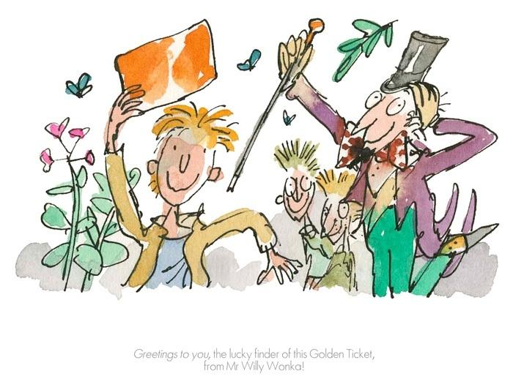
Reading is fun
Part 2

Question
Do you think all of these five children will achieve the luckiest
moments at the end of the story? Why do you think so?

Reading is fun
Part 1 : True / False

- Read each sentence and check your answers on True / False.

- Willy Wonka hid five golden tickets at the very special places. ( T / )

- Veruca Salt ( / F )
She is spoiled by her parents. They do whatever their daughter wants.

- Violet Beauregarde ( T / )
She is very smart girl and chews gum just for fun.

- Mike Teavee ( / F )
He is a little gangster who is obsessed with television.

- Charlie Bucket ( / F )
He is a boy who is honest and kind, brave and true, and good and ready for the adventure.

Reading is fun
Part 2

Question)
Do you think all of these five children will be able to achieve the luckiest
moments at the end? Why do you think so?

No. I don’t think all the five kids will deserve the luckiest moments.
Even though they all got the lucky chance to go inside Mr. Wonka’s chocolate factory at the beginning, only one child would be able to get the truly amazing moment at the end. Because it will be proved that he is truly sweet, generous and responsible person throughout the story in certain. I can assume that the rest of the kids will drop out in the middle of the tour because they will show their greedy, selfish, naughty and nasty mischief within the factory.

Instructor’s Comments and Assessment
Pros
Cons
Change
Overall Comments
Grade
Above Standard 85%-100% | Standard 70%-84% | Below Standard 69%-0%
Instructor | Student Signature | Date
Taute, David

