Background Information Sheet
Name | Class | Date | Lesson Type | Plan type | Length
Jin | TESOL | 2019/04/17 | Reading | PPP | 25 min

Lesson
Topic | Body image and Self-esteem
Main Aim | Ss practice their reading comprehension.
Secondary Aim | Ss practice their speaking fluency.

Materials and References
https://kidshealth.org/en/teens/body-image.html?view=ptr&WT.ac=t-ptr

Student Profile
Level | Intermediate
Age | Teenagers | Number of Students | 9
Detail | There are 7 girls and 2 boys. Everyone can speak English. All of the students are outgoing. Everyone is motivated to learn English.
Assumptions about students’ knowledge as required for this lesson:
Students are able to know and understand the topic, “self-esteem”.

Anticipated Difficulties and their Solutions:
Use of L1- Remind students of the English only rule.
Students may not know about the topic “self-esteem”, pre-teach the word clearly to make them understand.

My Personal Aim
What I hope most to demonstrate in this lesson is the ability to give good instructions.

Stage Name: Lead-in
Purpose of this stage: To relax both the teacher and students. To focus attention on the lesson. To lead in to the topic, activating background knowledge.
Materials: Picture
Timings | Interactions | Procedure
30 sec  1 min | T  T-S  S-S | “Hello everyone,” look at this picture.  T: Can you guys read this sentence? (I love me)  As in this picture we should love ourselves.  Brainstorm/talk to a partner.  Talk with your partner about your strengths.  Feedback if appropriate.

Stage Name: Presentation
Purpose of this stage: To pre-teach keywords if necessary, and consider guiding questions. These steps provide extra help for students to comprehend the text.
Materials: Picture, White board, Colored markers, Eraser
Timings | Interactions | Procedure
3 min  1 min  50 sec | T-S  S-S  T-S | Pre-teach keywords  Elicit – elicit/mime  Guys~ look at this picture again. What word comes to mind when you look at this picture? (self-esteem)  CCQ – check students properly understand the meaning  - Is that what I feel for myself? (Yes)  - Is it about yourself? (Yes)  - Is it related to confidence? (Yes)  Drill – choral and individual drilling for correct pronunciation  T: Follow after me, “self-esteem”.  Board – highlight special areas of pronunciation  Write the word “self-esteem” on the board.  T: How many syllables are there? (3 syllables)  Where’s the stress? Self-esteem (self, teem)  Repeat after me, “self-esteem”.  Guiding Question  T: How do you improve your self-esteem? Talk about it with your partner.  (After discussing) T: Can you guys share your ideas with the class?

Stage Name: Practice – Literal Comprehension
Purpose of this stage: is to get students to practice reading for literal detail.
Materials: Worksheet, Reading material
Timings | Interactions | Procedure
30 sec  2 min  1 min  1 min | T  S  S-S  T-S | T: First read this text and do the questions 1-3 on your worksheet.  ICQ: Where do you have to answer for this time? (1-3)  Pair check.  Feedback to check accuracy.

Stage Name: Practice – Interpretive Comprehension
Purpose of this stage: is to get students to get students to practice interpreting a text correctly This will require more detailed, careful reading, and thinking time to arrive at the correct answer.
Materials: Worksheet, Reading material
Timings | Interactions | Procedure
30 sec  3 min  1 min  2 min | T  S  S-S  T-S | T: Class~ for this time read it more carefully and answer question 4.  Students write their answers down on the worksheet.  Pair check. Monitor.  Feedback to check accuracy.

Stage Name: Production - Applied Comprehension
Purpose of this stage: is for students to practice their speaking fluency on a topic related to the lesson.
Materials: piece of papers
Timings | Interactions | Procedure
1 min  5 min  2 min | T  S-S  T-S | Discuss with your partner using these sentences. (About Me)  Hand out a piece of paper with a sentence on it.  T: First you are going to discuss with your partner with the given sentence and after the discussion finish you can change the sentence with your partner.  Students discuss.  Feedback. Students share their ideas with the class.

Stage Name: Wrap-up
Purpose of this stage: is to end the lesson on a positive note so that students feel they have achieved progress.
Materials: Board, Marker
Timings | Interactions | Procedure
2 min | T | Lesson feedback.  You guys all did well today and what was the 3 points to make yourself feel best? (Accept your body, like, take care of your body)Good job! I want you guys to remember these points. Write on the board and say it to the class (Love yourself!)  And that' all for today and bye.

Worksheet: Body image and Self-esteem

1. Fill in the blanks
: measure of how much you value, respect and feel confident about yourself.

2. What are the 3 tips for gaining confidence?
- your body
- your body
- your body

3. How can the self-esteem get better?

4. According to the passage, what do these sentences mean?
(Be less of a critic. Be more of a friend.)

Answer sheet: Body image and Self-esteem
- Self-esteem
- Accept , Like , Take care of
- It can get better with help and care.

- Don’t blame yourself, love yourself.

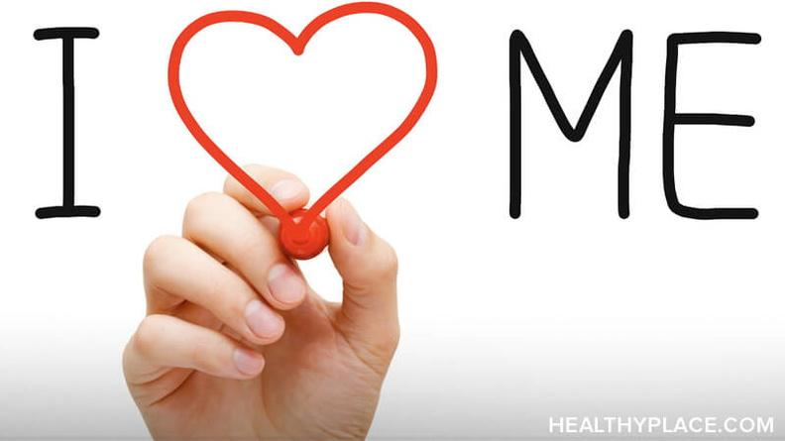

[Skip to Content]
TeensHealth.org
A safe, private place to get
doctor-approved information
on health, emotions, and life.
Body Image and Self-Esteem
Do you ever wish you could change something about your body? If so, you're not alone. Lots of people feel unhappy with some part of their looks. But when you get stuck on what you don't like, it can really bring down your self-esteem.
You don't need a perfect body to have a good body image. When you like your body as it is, right now, you boost your body image. And your self-esteem too.
But what if I need to be in better shape? Some people think, "When I get in better shape, I'll like my body. But it's best to start the other way. First, accept your body. Find things to like about it. Take good care of your body. When you like your body, it's easier to treat it right.
Want to look and feel your best? Here are some tips:

Accept Your Body
- Nobody's perfect. Everybody wants to be liked and accepted just as they are. That's true for every BODY, too! See your body the way it is. Be less of a critic. Be more of a friend.
- Don't body-shame yourself. When you make harsh comments about your own body, it hurts your self-esteem. That's true whether you say it out loud or think it to yourself. It hurts just as much as if someone else said it. Be kind. Respect yourself, even if you have things to work on.
- Build a better habit. Do you have a habit of putting your body down? To break that bad habit, build a good one in its place. Tell yourself what you like instead of what you don't. Keep doing it until it is a habit.

Like Your Body
- Find things to like about your looks. Maybe you like your hair, face, or hands. What about your shape, shoulders, or legs? Your eyes or your smile? Tell yourself what you like and why. If you get stuck, think of what your good friends like about how you look. Accept those things. Know that there's lots to like about you. Let yourself feel good.
- Focus on what your body can DO. There's more to your body than your looks. When you play a sport, walk, run, dance, swim — that's your body in action. Your body is there for you when you stretch, reach, climb, or jump for joy. When you carry things, build things, or give someone a hug. Be amazed. Be thankful.
- Be aware of your body. Don't ignore your body as you go through the day. Learn to breathe slowly and calmly as you move and stretch. Learn to tell when your body needs food or rest. Enjoy the way your body feels when you walk, run, and play.

Take Care of Your Body
- Eat healthy foods. Learn what foods are good for you, and how much is the right amount. Take your time when you eat. Really taste your food. Enjoy it. Eating right helps you look your best. It gives you the energy you need. And it boosts your body image. When you treat your body right, you feel good about yourself.
- Get good sleep. Learn how much sleep you need for your age. Get to bed on time. Turn off screens hours before bedtime so you can sleep well.
- Be active every day. Your body needs to move to be strong, fit, and healthy. You can be active by playing a sport. You can run, walk, work out, do yoga, swim, or dance. Pick activities you like. Enjoy the fun you can have.
- Keep to a healthy weight. Being a healthy weight is good for you. And it helps you feel good about your body. But don't try to diet on your own. Always talk to your parent or doctor. Your doctor can suggest ways you can keep to a weight that's right for you.

What If I Need Help With My Body Image and Self-Esteem?
Sometimes, body image or self-esteem problems are too much to handle alone. Health issues, depression, or trauma can affect how you feel about yourself. Eating disorders can cause a poor body image that isn't true.
Tell a parent, doctor, or therapist what you're going through. Ask for help. Body image and self-esteem can get better with help and care.
Reviewed by: D'Arcy Lyness, PhD
Date reviewed: August 2018
Nemours
Note: All information on TeensHealth® is for educational purposes only. For specific medical advice, diagnoses, and treatment, consult your doctor.
© 1995-2019 The Nemours Foundation. All rights reserved.
Images provided by The Nemours Foundation, iStock, Getty Images, Veer, Shutterstock, and Clipart.com.

Instructor’s Comments and Assessment
Pros
Cons
Change
Overall Comments
Grade
Above Standard 85%-100% | Standard 70%-84% | Below Standard 69%-0%
Instructor | Student Signature | Date
Taute, David

