Background Information Sheet
Name | Class | Date | Lesson Type | Plan type | Length
Rosa | TESOL | 17-04-19 | Reading | PPP | 25 min

Lesson
Topic | What is inattentional deafness?
Main Aim | Students practice their reading comprehension.  Students will be able to get the main idea and answer questions.
Secondary Aim | Students will be familiar with keyword from this article and CCQ.  Students practice their speaking fluency.

Materials and References
ppt material, computer, screen, reading text, worksheet, board, markers

Student Profile
Level | Intermediate
Age | teenager (16-19) | Number of Students | 9
Detail | There are 2 males and 7 females. Everyone is outgoing and has passion to learn English. A few students have some difficulties reading articles but they’ll try harder than others.
Assumptions about students’ knowledge as required for this lesson:
Students have used mobile phones.
Students are used to working individually and in pair.

Anticipated Difficulties and their Solutions:
Ss may not understand some words.
Some Ss may not answer the questions in time.
Some Ss may answer the questions too fast.

- I elicit the words and help them understand through CCQ.
- I give them some more time.
- I make them think of further questions

My Personal Aim
What I hope most to demonstrate in this lesson is the ability to
- get students’ attention and lead-in the text naturally.
- elicit the target language properly.
- keep students focused on the text and make them try to get the correct answer.
- try to reduce TTT, increase STT
- try to make students centered class
- manage the lesson time properly

Stage Name: Lead-in
Purpose of this stage: To relax both the teacher and students. To focus attention on the lesson.
To lead in to the topic, show a picture for students to think about activating
background knowledge.
Materials: ppt materials, computer, screen
Timings | Interactions | Procedure
10 sec  1 min  1 min | T  T-S  S-S  T-S | Hello everyone. How are you? (Ss answer)  Good!  Look at the picture on the screen, please.  Have you heard the word “Smombie”? (Ss answer)  Ok, I’ll show you one more picture.  Guess what is he doing?  (Ss answer : he is walking, he is using mobile phone, he is doing something with mobile phone)  Smartphone + Zombie = Smombie  It’s a new language from German. Since 2015.  Sometimes, do you become a smombie?  Let’s talk about it with your partner.  (Ss discuss with a partner)  Feedback briefly.

Stage Name: Presentation
Purpose of this stage: To pre-teach keywords and consider guiding questions.
These steps provide extra help for students to comprehend the text.
Materials: ppt materials, computer, screen, board, marker
Timings | Interactions | Procedure
2 min  10 sec  1 min  1 min | T-S  T-S  T-S | Pre-teach keywords  Elicit & CCQ  Let’s see another picture.  (Showing the picture)  Does he look at her? (No)  Does he listen to what she says carefully? (No)  Does he pay attention to her? (No)  When we focusing on a sports game or TV, we can’t sometimes hear mom’s call like this picture.  We call this situation “Inattentional deafness”.  Drill  (Showing the PPT)  How many syllabuses? (5&2)  Where is stress?  Could you repeat me? “Inattentional deafness”  Individual drilling for correct pronunciation  Guiding Question  Have you ever missed the station because you were doing other things on the bus or subway?  Talk about your experience with your partner  (Students discuss the question with a partner.)  Nominate a few students to share their ideas.

Stage Name: Practice – Literal Comprehension
Purpose of this stage: is to get students to practice reading for literal detail.
Materials: ppt materials, computer, screen, text, worksheet
Timings | Interactions | Procedure
10 sec  2 min  30 sec  1 min | T  S  S-S  T-S | Now, we will read the article “what is inattentional deafness? “  Read this article and do your worksheet “True or False questions.”  I’ll give you 2 minutes.  (Hand out reading text & worksheets.)  Students read the whole text for the 1st time, and write answers on the worksheet.  Time’s up! Let’s check with your partner.  (Ss pair check.)  Feedback to check accuracy.  - True or False Quiz  - We aren’t able to hear when we are focusing on visual task. ( T )  - Researchers at the University College London tested only their ability of auditory without brain process. ( F )  - The participants of this research are originally deaf. ( T )  - The researchers explain inattentional deafness is not related with the brain process. ( F )

Stage Name: Practice – Interpretive Comprehension
Purpose of this stage: is to get students to get students to practice interpreting a text correctly This will require more detailed, careful reading, and thinking time to arrive at the correct answer.
Materials: ppt materials, computer, screen, text, worksheet
Timings | Interactions | Procedure
10 sec  3 min  40 sec  2 min | T  S  T-S  S-S  T-S | Many people think that multi-tasking helps get things done more quickly. But do you think that the multi-tasking is effective after reading this article? Why or why not?  Write your answer on your worksheet.  Students read for the 2nd time. Students write their answers down.  Time’s up! Let’s check with your partner.  (Ss pair check.)  Feedback to check accuracy.

Stage Name: Production - Applied Comprehension
Purpose of this stage: is for students to practice their speaking fluency on a topic related to the lesson.
Materials: ppt materials, computer, screen
Timings | Interactions | Procedure
30 sec  7 min  1.5 min | T  S-S  T-S | We have just read about inattentional deafness.  When you are in the “inattentional deafness situation”, is it safe?  (Showing the screen)  In Hawaii, Honolulu, pedestrians who look at their mobile phones while crossing the road face fines of up to $99.  Is it reasonable or not?  Discuss about the new law of Honolulu with your partner.  (Students discuss.)  Students share their ideas with the class.  Feedback.

Stage Name: Wrap-up
Purpose of this stage: is to end the lesson on a positive note so that students feel they have achieved progress.
Materials: List all materials that will be needed in this stage.
Timings | Interactions | Procedure
1 min | T | Lesson feedback.  Tell the class what they did well, and what needs to improve.  Offer delayed corrections to the previous stage.  Set homework.  Inform students about the topic for the next lesson.
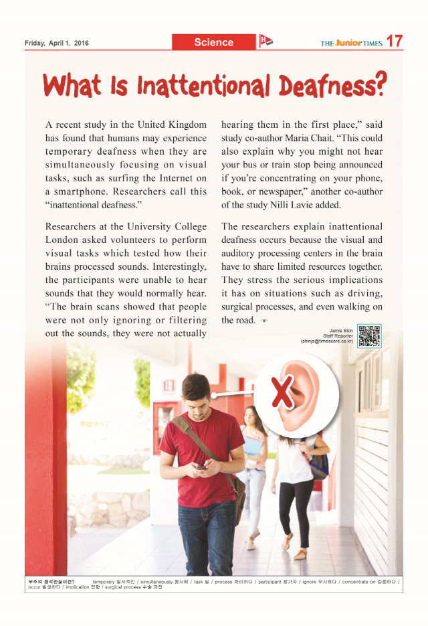

Worksheet
[ True or False Quiz ]
- We aren’t able to hear when we are focusing on visual task.

- Researchers at the University College London tested only their ability of auditory without brain process.

- The participants of this research are originally deaf.

- The researchers explain inattentional deafness is not related with the brain process.

[ Interpretive question ]
Many people think that multi-tasking helps get things done more quickly.
But do you think that the multi-tasking is effective after reading this article?
Why or why not?

Instructor’s Comments and Assessment
Pros
Cons
Change
Overall Comments
Grade
Above Standard 85%-100% | Standard 70%-84% | Below Standard 69%-0%
Instructor | Student Signature | Date
Taute, David

