Background Information Sheet
Name | Class | Date | Lesson Type | Plan type | Length
Sue | TESOL 191th | 17 April 2019 | Reading | PPP | 25 min

Lesson
Topic | High School Musical (‘Start of Something New’)
Main Aim | Ss practice their reading comprehension.
Secondary Aim | Ss practice their speaking fluency.

Materials and References
Computer, TV Screen, PPT files, Board, colored markers, picture of ‘High School Musical’, worksheets (text + questions)

Student Profile
Level | Low Intermediate
Age | 14~16 | Number of Students | 9
Detail | There are 5 females and 4 males. They are all middle school students. Mostly are talkative, outgoing, and participates well at classes. They like to study with fun and interesting factors (ex: visual, lesson using students' favorite movies, music, and books) and it motivates the student’s learning.
Assumptions about students’ knowledge as required for this lesson:
Assumed that most of the students have seen ‘High school musical.’ It would help to read and understand this article.

Anticipated Difficulties and their Solutions:
Since Ss have different text reading speed, T has to make decision whether giving Ss more time to read.
Especially for the interpretive question, Ss may not be able to answer the question in time. The teacher should make a decision whether to give more time, or answer the questions together to help their comprehension.

My Personal Aim
What I hope most to demonstrate in this lesson is the ability to reduce Teacher talking, use visuals, give students good and clear instructions by appropriate word grading, demonstrating.

Stage Name: Lead-in 2min
Purpose of this stage: To relax both the teacher and students. To focus attention on the lesson. To lead in to the topic, activating background knowledge.
Materials: None
Timings | Interactions | Procedure
30 sec  1 min  30 sec | T  T-S/S-S  T-S | [Instruction]  “What was the most interesting movie you saw when you were a teenager? Talk with your partner.”  Students talk to their partner.  “Is there anyone who can share their favorite movie?”  (Feedback if appropriate).

Stage Name: Presentation 4min30sec
Purpose of this stage: To pre-teach keywords if necessary, and consider guiding questions. These steps provide extra help for students to comprehend the text.
Materials: Computer, TV Screen, PPT files, Board, colored markers, picture of ‘High School Musical’
Timings | Interactions | Procedure
1 min  1 min  30 sec  1 min  1 min | T-S  T  S-S  T-S | [Pre-teach keywords]  Mortify  [Elicit]  show pictures to the student(PPT file)  “What do you think the people in this picture would feel when they see their picture?”  [CCQ]  - If you are mortified, are you feeling good? (no)  - If you are mortified, are you embarrassed? (yes)  [Drill] – choral and individual drilling for correct pronunciation  [Board} – highlight special areas of pronunciation  “What part of speech is this?” verb  “How many syllable?” two, mor/tify  Fizzy  [Elicit]  show pictures to the student(PPT file)  “Do you know what the bubble in this is soda is called?”  [CCQ]  - Is it containing a bubbles? (yes)  - If you drink fizzy drinks do you feel cool or refreshment? (yes)  [Drill] – choral and individual drilling for correct pronunciation  [Board} – highlight special areas of pronunciation  “What part of speech is this?” adjective  “How many syllable?” one, Fizzy  [Guiding Question]  Paste a picture of ‘High School Musical’ on the board  “Have you seen this movie?”  “Discuss with your groups about your most favorite scene in this movie or your favorite song in this movie.”  (Divide the class into two groups)  If there are students who have not seen the movie, it will be time to introduce the movie to students who have not seen it.  Students discuss the question in groups  Nominate a few students to share their ideas. Feedback.

Stage Name: Practice – Literal Comprehension 5min
Purpose of this stage: is to get students to practice reading for literal detail.
Materials: worksheets (text + questions)
Timings | Interactions | Procedure
30 sec  3 min  30 sec  1 min | T  S  S-S  T-S | [Instructions] Hold up the worksheets.(Use Gestures)  “Read the text individually and write down the answers on the literal questions part. You have 3 minutes”  Hand out the worksheets  Students read the whole text for the 1st time, and write answers on the worksheet.  “Check answers with your partner.” Pair check. Monitor.  “Let’s check the answers together.” (Students discuss answers with the class, Ask/Nominate Ss for their Answers)  Feedback to check accuracy.

Stage Name: Practice – Interpretive Comprehension 5min
Purpose of this stage: is to get students to get students to practice interpreting a text correctly This will require more detailed, careful reading, and thinking time to arrive at the correct answer.
Materials: worksheets (text + questions)
Timings | Interactions | Procedure
30 sec  2 min  30 sec  2 min | T  S  S-S  T-S | [Instructions]  “Read the text individually and answer for the interpretive question. You have 2 minutes.”  Students read for the 2nd time. Students write their answers down.  “Check answers with your partner.” Pair check. Monitor.  “Let’s check the answers together.” (Students discuss answers with the class, Ask/Nominate Ss for their Answers)  Feedback to check accuracy.

Stage Name: Production - Applied Comprehension 1min30sec
Purpose of this stage: is for students to practice their speaking fluency on a topic related to the lesson.
Materials: List all materials that will be needed in this stage.
Timings | Interactions | Procedure
30 sec  4 min  2 min  1 min | T  S-S  T-S  T-S | [Instructions]  “What would you do if you were suddenly thrown to the stage to sing with someone you don't know? Discuss with your partner. You have 4 minutes.”  Students discuss. Monitor  Presentation time (each pair takes turn) “Let's take a turn from here and talk to the class about your discussion?”  Students share their ideas with the class. Feedback.

Stage Name: Wrap-up 1min
Purpose of this stage: is to end the lesson on a positive note so that students feel they have achieved progress.
Materials: List all materials that will be needed in this stage.
Timings | Interactions | Procedure
1 min | T | Lesson feedback. Tell the class what they did well, and what needs to improve.  “Today you guys did really good job.”  Offer delayed corrections to the previous stage.  Set homework.  “After class I want you guys to see movie ’High School Musical 2”.”  Inform students about the topic for the next lesson.  “Next lesson, we will be do the reading lesson using the text and song lyrics from ‘High School Musical 2’.

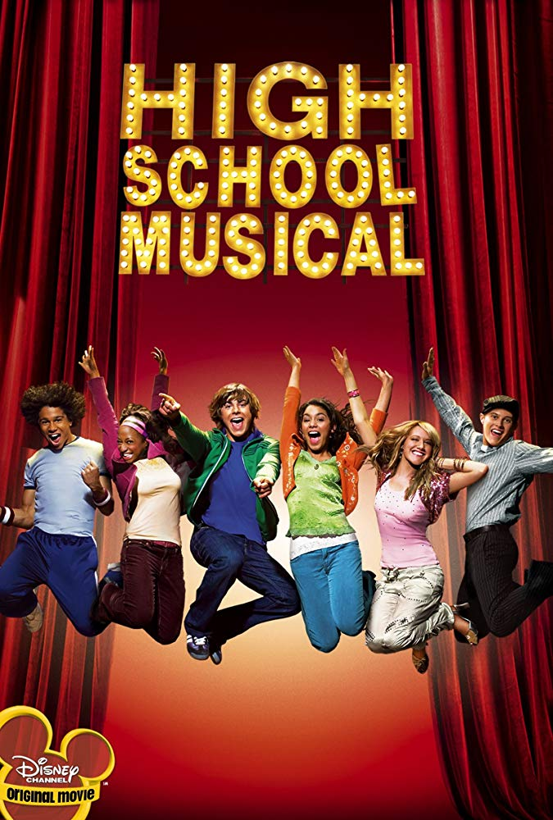

High School Musical

One spotlight was on Troy.
The other was on Gabriella.
Both looked startled, and even a little terrified. They shook their heads, but it was no use. The emcee jumped into the crowd and pulled them up onto the stage.
Troy and Gabriella were mortified. Somehow-they weren’t quite sure how it happened-microphones were put in their hand. Then they were, stuck. Onstage. The center of attention. And no way to escape.
Before either one of them could actually faint or throw up from fear, the music started.
Well, here goes, Troy thought with resignation. Might as well make the best of it…
He started singing, softly and carefully. He could barely get the words out. It was all he could do to read the lyrics on the screen of the karaoke machine and try to stay in tune. He sang:

“Livin’ in my own world
Didn’t understand
That anything can happen
When you take a chance”

No one seemed to be paying much attention to them. That was a good thing. Gabriella thought. And, after all, if this boy was willing to risk public humiliation, she might as well be a good sport and try to sing, too.
She opened her mouth and began singing. Although her voice was just above a whisper, it was sweet and pure.
She sang:

“I never believed in
What I couldn’t see
I never opened my heart
To all the possibilities”

All right, she thought. I can do this. It’s not too terrible.
Okay, Troy thought. At least people aren’t throwing things at us.
Still, they were too nervous to really belt out the song. They kept singing though, alternating the lines of the ballad.
Finally, they looked at each other, hoping for a little help from their partner in embarrassment. As they really saw each other, they both experienced something they never had before.
Troy felt a spark of electricity run over his skin. Gabriella felt a warm glow flood through her body. They smiled and, for the first time, began singing to each other. They sang more loudly, more boldly, with more self-assurance.
Suddenly, everyone in the room started to notice: there was something special going on up onstage! Kids began crowding around the edge of the stage, listening and swaying to the music. And now Troy and Gabriella were starting to enjoy themselves. Their nervousness was forgotten as they smiled into each other’s eyes
Before long, they were dancing across the stage and back again, as confident as if they were performing at an arena. As they moved to the music, they never took their eyes off each other.
When the song was over, the crowd applauded and cheered. Troy and Gabriella smiled, breathless and a little stunned by what had just happened.
Troy leaned over and said, “I’m Troy.”
Gabriella nodded. “Gabriella.”
Neither one of them could stop smiling. Both of them felt an excited, fizzy feeling inside, as if the world had just become a lot more fun. .

Literal Question

True/False
- Troy started singing roughly and loudly. ( )
- When Gabriella opened her mouth and began singing her voice was just above a whisper. ( )
- Gabriella Troy was managed to sing on the stage, but dancing was beyond their capability. ( )

Find the Answer and Highlight it on the text
- How did Troy and Gabriella both felt after singing a song?

Interpretive Question

- Who will find this article interesting and why?

Literal Question ANSWER

True/False
- Troy started singing roughly and loudly. ( F )
- When Gabriella opened her mouth and began singing her voice was just above a whisper. ( T )
- Gabriella Troy was managed to sing on the stage, but dancing was beyond their capability. ( F )

Find the Answer and Highlight it on the text
- How did Troy and Gabriella both felt after singing a song?
(Both of them felt an excited, fizzy feeling inside, as if the world had just become a lot more fun.)

Interpretive Question ANSWER

- Who will find this article interesting and why? (Teenagers, People who like songs and stories combined.)

Instructor’s Comments and Assessment
Pros
Cons
Change
Overall Comments
Grade
Above Standard 85%-100% | Standard 70%-84% | Below Standard 69%-0%
Instructor | Student Signature | Date
Taute, David

