Background Information Sheet
Name | Class | Date | Lesson Type | Length
Shirley (김은아) | 193th | 2019/04/26 | Listening | 35min
Lesson
Topic | Joining the school club
Main Aim | Ss will practice listening comprehension
Secondary Aim | Ss will practice their speaking fluency.
Materials and References
CD player, Whiteboard, 5copies of worksheets, 5copies of role play sheets, pictures, flash cards. The book “Listening Juice” (published by A List ,written by Katelyn Beck)

Student Profile
Level |  | Intermediate
Age |  | Teenagers (11-12 years old) |  | Number of Students | 5
Detail |  | They’re all Korean. They all have good rapport.
Assumptions about students’ knowledge as required for this lesson:
Students have experience of joining a club at the school and thinking about their talents

Anticipated Difficulties and their Solutions:
If Students finish their tasks earlier than expected
-> do some useful game (like hang man), role play

If the technology doesn`t work
->I’ll prepare a backup audio file on my smartphone or I will read the Dialogue by myself.

My Personal Aim
I want to increase student talk time.

Stage Name: Lead-in (3min)
Purpose of this stage: to relax both the students and the teacher; to start the lesson in a natural way; to focus the attention of the students; to involve students and allow them to share ideas related to the topic.
Materials: photo, Board and marker.
Timings | Interactions |  | Procedure
3 min | T  T -S |  | <greetings>  “Good morning Guys!  (showing Ss a picture to Elicit the topic- this can be showed on the internet or printed picture, flash card )  Look at the pictures (picture is of studying club or brain boost club, cheerleading club and drama club)  “What can you tell?  (Get Ss`s ideas and write them on the board)  What is this picture about?  “Where can we do these activities?” Yes, we can do these at the school.”  “We call these?” “Yes, club activities”  Now as you can guess, today`s topic is Joining club
Stage Name: Presentation (5min)
Purpose of this stage:
Teach a few key words found in the recording.
Materials: Board, Markers. pictures, flash cards
Timings | Interactions |  | Procedure
3 min  2min | T-S  T-S  S-S  T |  | “What `s today`s topic?” “Joining club”  join  <Eliciting>  Showing  (showing Ss 3 pictures again and ask )  Do you like drama?  Do you like cheerleading?  Do you like studying?  (A student shouting ) Yes. I Like drama!  T: So what can we do? S: We can go to the drama club.  T: Another good expression? S: We can join the drama club.  T: Wow! what`s that word? S: Join  CCQ  Ok, Listen  1) When you join a club, Are you a member? Yes  2) You join a club do you go there only once? No  Do you go many times? Yes.  Drilling  “Repeat after me “Join”  -2times all students  Boarding  Write “Join “on board using a blue marker.  (Pick 1 student and let her mark the syllables and stress)  ‘How many syllables does this word have?’ Just 1  ‘Can you mark the stress on this word?’  (Pick 1 student and let her mark the syllables and stress)  Guiding Question  Why do some people hesitate to join a club? Talk to your partner  (Students start to talk about it with their partner) (Brainstorm 3 or 4 ideas as a class).  Feed back  We learned new vocabulary” join” Ok. right .It`s time for you to listen

Stage Name: Practice Detailed Listening – Literal Comprehension (11min )
Purpose of this stage: Ss practice listening to details. Checking their accuracy is needed. Students are able to complete the Questions in time and can shre their answers in pair and share their experience with their partner
Materials: CD of Listening Juice. 5 copies of worksheets and Dictation sheets.
Timings | Interactions | Procedure
10 sec  10 sec  2min  1 min  10 sec  3 min  10 sec  3min  1min  10 sec  10sec | T  T-S  T  S-S  S  S-S  T  T  S-S  T-S  S-S  T | Instructions  “We are going to listen to a 2 mints conversation between 2 people who are hesitating to join the Drama club. Before listening, here is a worksheet.  and after you listen, answer those 3 questions” (show and point to the worksheet)  I.C.Q:  What number of questions do you answer? (1-3)  Ok now I will play the audio, listen carefully.  Monitoring  Monitor discreetly. Check if they get right answers with class. Answer Ss if they have some questions.  Give time warning 1min left  Pair check  “If you got all the answers, check with your partner.”  (Ss check in pairs their answers.)  Hand out a dictation sheet  Instructions  I will play the audio one more time, please fill in the blanks in the dictation sheet. Listen carefully.  (Students listen for I time and write answers)  Students pair check  Feed back to check accuracy  Correct the wrong answers explain the reason and then give feedback.  <Literal Q>  (show and point to the worksheet part2: Literal Comprehension)  Read those questions first.  (Write on the board to clarify the questions)  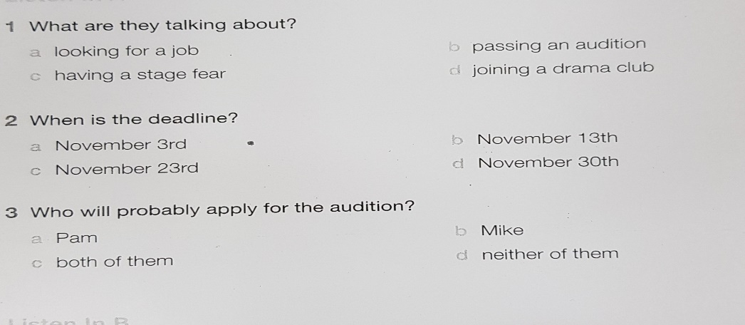  Monitoring  Check Students whether they are in the right track or not.  Pair check  Check the answers to your partner. And share your experience with your partner.  ICQ  What do you guys have for the answer?  Guiding Q  “Where can we hear this conversation? “at the school”  Feed back to check accuracy
Stage Name: Practice More Detailed Listening – Interpretive Comprehension (7 min )
Purpose of this stage: Ss listen thoughtfully to interpret meaning. Accuracy focused.
Materials: 5 copies of worksheets CD of Listening Juice.
Timings | Interactions | Procedure
30 sec  3 min  10 sec  3 min  20 sec | T  S  T-S  S-S  T | Instructions  This time, listen more carefully.  Students listen a 2nd time, more carefully than before  Divide the Ss into 2 groups.  (students listen for the second time)  < Interpretive Q>  1. Why does pam hesitate to join the drama club?  2. How did pam and Mike describe an actor?  (Describe what an actor is supposed to be like? (just write pam and Mike`s opinion)  I.C.Q “Do you work individually or in a group?”  “That’s right. Share your answers in your group. “  Monitoring  Recognize who are left behind and don’t talk in each group. While they’re talking.  Pair check  Nominate 1 Ss from each group to share the answers.  Check accuracy, pronunciation, with the class.  Feed back  Correct Grammatically wrong expressions and their sentence structure

Stage Name: Production – Applied Comprehension (8min )
Purpose of this stage: Ss practice speaking. Fluency focused stage. Teacher mainly monitors and may offer necessary support.
Materials: CD of Listening Juice. 5 copies of worksheets
Timings | Interactions | Procedure
3 min  5min | T  S-S  S-S  S-S | Instructions  Ss work in pairs.  <Applied Comprehension speaking >  When you encourage your friend what would you do?  Talk about your experience.  Changing partners /groups  Ss return to their seat. Share the answers with all the class.  Ss may take turn to read what they’ve written.  Discussion in groups  Check their pronunciation and Grammar  Feedback/ Conclusion  Correct their mistakes.  We`ve learned new vocabularies and chech them by Listening and answering the work sheets. We did role play. So I think you`ve got it.  We practice Grammar speaking listening writing with the topic
Stage Name: Wrap-up(1min)
Purpose of this stage: To end the lesson on a positive feeling, and to handle any classroom management matters before ss go home.
Materials: 5 copies of handout(role play)
Timings | Interactions | Procedure
1 min | T | Give Lesson feedback.  Assign homework  Introduce next week`s subject  -Mimic the dialog what we have learned today , record your own voice and then Upload it on the Never café  -Next week we`ll study about lesson 5(role play) Any Questions?

Pros
Instructor’s Comments and Assessment
Cons
Change
Overall Comments
Grade
Above Standard 85%-100% | Standard 70%-84% | Below Standard 69%-0%
Instructor | Student Signature | Date
David

Script

Mike: Hey, pam! Did you see this Poster? The drama club is looking for new actors. Are you auditioning?
Pam: Not really. I can`t imagine myself standing on stage.
Mike: Why not? I think you`re perfect for the job. You like singing, don`t you?
Pam: Yes, I do. But I`m shy. Besides, I get nervous when people start looking at me. What about you, Mike? Why don`t you sign up?
Mike: I will. You know, I have the loudest voice in school. I also like dancing.
Pam: Sure you do. You`re tall, too. So I think you`ll look great on stage.
Mike: Thanks, but I really want us to sign up together. Don`t you think we`d do a great job?
Pam: Do you really think I can do this? I`m not as energetic or as outgoing as you are.
Mike: No worries. I`m sure you`ll do fine.
Pam: Ok, I`ll do it. When`s the deadline?
Mike: You have to hand in the application by November 30th. Oh, No! it`s already the 30th today! Come on, we should hurry!

♬ Listen and answer
<Literal Q>

1. What are they talking about? d
a looking for a job b passing an audition
c having a stage fear d joining a drama club

2. When is the dead line? d
a November 3rd b November 13th
c November 23rd d November 30th

3. Who will probably apply for the audition? c
a Pam b Mike
c both of them d neither of them

Dictations fill in the blanks
Mike: Hey, pam! Did you see this Poster? The drama club is looking for 1)하였습니 actors. Are you auditioning?
Pam: Not really. I can`t imagine myself standing on stage.
Mike: Why not? I think you`re perfect for the job. You like 2) singing, don`t you?
Pam: Yes, I do. But I`m shy. Besides, I get nervous when people start 3) looking at me. What about you, Mike? Why don`t you sign up?
Mike: I will. You 4) know, I have the loudest 5) voice in school. I also like dancing.
Pam: Sure you do. You`re 6) tall, too. So I 7) think you`ll look great on stage.
Mike: Thanks, but I really want us to sign up together. Don`t you think we`d do a great job?
Pam: Do you really think I can do this? I`m not as energetic or as outgoing as you are.
Mike: No worries. I`m sure you`ll do fine.
Pam: Ok, I`ll do it. When`s the deadline?
Mike: You have to 8) hand in the application 9) by November 30th. Oh, No! it`s already the 30th today! Come on, we should hurry!

1)new 2)singing 3)looking 4)know 5)voice 6)tall 7)think 8)hand 9)by

♬ Listen and answer
< Interpretive Q>

- Why does pam hesitate to join the drama club?
-Because a lack of confidence.
-She thinks she is a shy girl. She gets nervous when people start looking at her
-She is not energetic and out going

2. How did pam and Mike describe an actor?
(Describe what actors are supposed to be like? (just write pam and Mike`s opinion)

-Actors are energetic and out going
-Actors like to sing and dance.
-They are looking good and have good voice

Next week <Role play - Work in pairs >
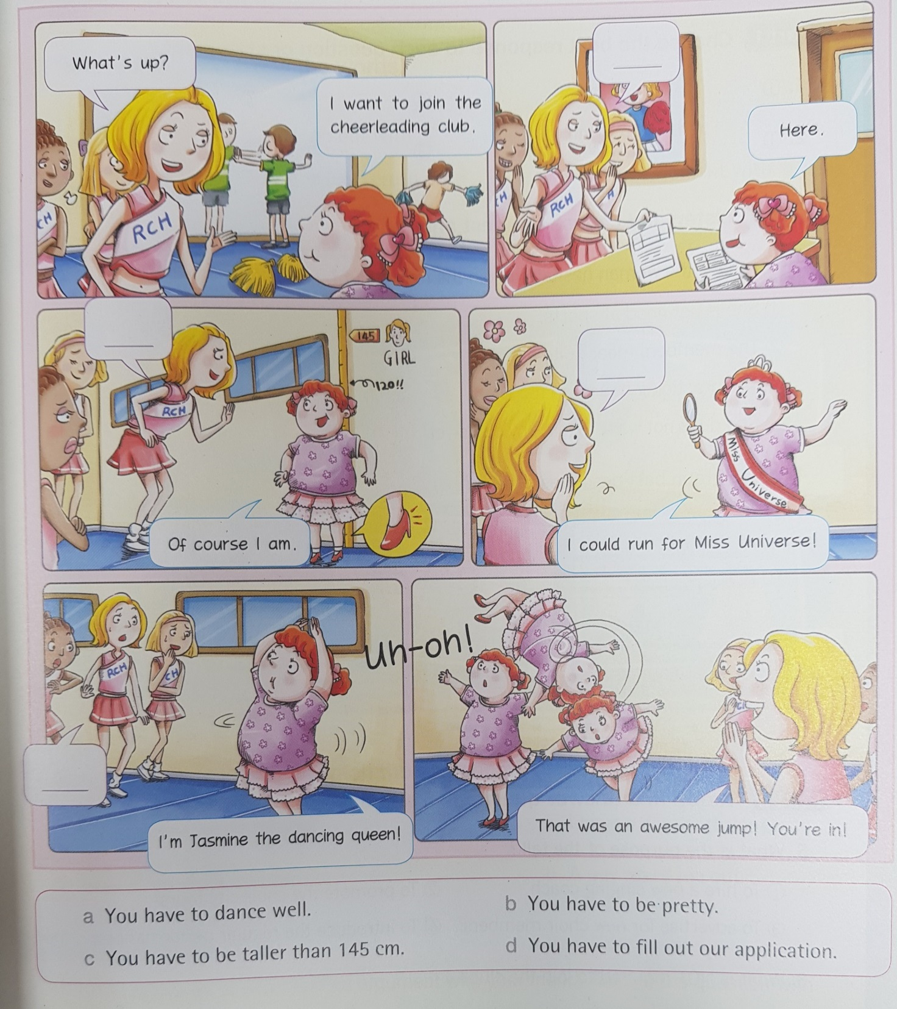
Fill in the blanks first. “One person is “interviewer and another one is an interviewee
You need to memorize the answers then we do role play in front of the student.

