Background Information Sheet
Name | Class | Date | Lesson Type | Plan type | Length
Lily | 193th TESOL | 2019/04/27 | Listening | PPP | 35 min

Lesson
Topic | Shopping for clothes
Main Aim | Ss practice their listening comprehension.
Secondary Aim | Ss practice their speaking fluency.

Materials and References
Audio file https://learnenglishteens.britishcouncil.org/skills/listening/elementary-a2-listening/shopping-clothes
Audio Transcript
Speakers, Computer and Monitor
Worksheets
Pictures
Realia
White board and Color board markers

Student Profile
Level | Pre-intermediate
Age | 14 | Number of Students | 5
Detail | There are 4 female students and 1 male student.  Everyone is Korean. They are teenagers.  They are visual and auditory learners.  They have interpersonal intelligence. They enjoy sharing their experiences and tend to get involved more in the lesson when they work together.

Anticipated Difficulties and their Solutions:
Technical failure - Prepare a backup audio file on my smartphone.
Absentee/Lateness – Adjust the desk arrangement for the group work
Use of L1 – Remind students of the rule speaking English only.

My Personal Aim
What I hope most to demonstrate in this lesson is the ability to write a detailed and accurate lesson plan.
I want to avoid echoing, helpful sentence completion and asking ‘Do you understand” when I give the instructions.

Stage Name: Lead-in
Purpose of this stage: To relax both the teacher and students. To focus attention on the lesson. To lead in to the topic, activating background knowledge.
Materials: A picture of dress, Computer, Monitor
Time  (8min) | Interaction | Procedure
1 min 30sc  30sec  4 min  2min | T-S  T  T-S  S-S  T-S | [Greeting/Lead in]  Hello everyone! How are you today? (Ss: Good! )  Great. The weather is so nice. I feel spring has already come!  So, yesterday, I went to ‘Hyundai’ department store and bought my new dress.  This is what I bought in the shop.  (Through a monitor, show students a picture of dress I bought in the department store).  Do you have your favorite clothes? When do you usually wear it?  You have 2 minutes to discuss each.  “  [I.C.Q ]  “What do you need to talk about?” (Ss : about our favorite clothes, when do we wear it)  “How long can you talk for?” (4minutes)  [Ss talk to a partner.]  Monitor the students. Alarm them the remain time.  “1 minute left”  [Warm up]  Time is up. Can you share your discussion with your class?  Nominate 2 students to share the discussion to the class.

Stage Name: Presentation
Purpose of this stage: To pre-teach keywords if necessary, and to help students be better able to understand a difficult part of the audio.
Materials: White board, Color markers , Paper doll/Paper dress
Time  (10min) | Interaction | Procedure
1 min  30sec  1min  30sec  3min  3min  1min | T-S  T-S | [Pre-teach keywords]  - Try one - miming  - Credit card – realia  - Receipt – realia  [Elicit – elicit/mime]  We will play an episode game. I’ll show you the day I bought my dress with this paper doll.  Say the name of the action or item I show you to go to the next episode.  “Yesterday Lily teacher went to a shop to buy her dress. She picked one dress and ask can I______?”  ( hold a paper doll with left hand and hold a paper dress with right hand. Mime the action of wearing by putting the dress on the doll’s body)  Ss say wear! Try! Try on! - If they can’t get to answer the word try ‘on’, follow up question. – ‘Do you wear ‘in’ your body or ‘on’ your body?’ then, where should we try? (Ss may say try on the body!) Great.”  Let’s move to the next scene. I’ve tried on the dress. I didn’t have cash in my wallet. I used ________ (showing my real credit card)  Ss say card! Plastic card! Credit card! Good.  After I pay, I get this _________ ( showing my real receipt)  Ss say paper! List! Receipt! Perfect.  [CCQ – check students properly understand the meaning]  - Why did I try on the dress before paying? ( to see/ to check if the dress is good on you)  - With a credit card, are you paying for the clothes now or later? (Later)  - What can you find in the receipt? (total amount paid/ price for the dress/ refund period/exchange period/ date you bought/ address of the shop…)  [Drill – choral and individual drilling for correct pronunciation]  I will say a word repeat after me 2 times together with a class.  1) Try – on (repeat 2 times together)  2) Credit-card (repeat 2 times together)  3) Receipt (repeat 2times together / make sure not to pronounce the sound of p)  [Board – highlight special areas of pronunciation]  Write the 3 words with black marker; try on / credit card / receipt on the white board  Ask student how many syllables, what part of speech and where to put the stress.  - How many syllables? 2  (pointing the word ‘try on’ / divide the word into two with a slash with a blue marker)  - What part of speech? [verb]  (write the word ‘verb’ in a bracket with a green marker)  - Where should we put the stress? (first part)  (draw a filled circle above the letter ‘a’ with a red marker.)  Next,  - How many syllables? 2  (pointing the word ‘credit card’ / divide the word into two with a slash with a blue marker)  - What part of speech? [noun]  (write the word ‘noun’ in a bracket with a green marker)  - Where should we put the stress? first part  (draw a filled circle above the letter ‘e’ with a red marker.)  Last,  - How many syllables? 1  (pointing the word ‘receipt’)  - What part of speech? [noun]  (write the word ‘noun’ in a bracket with a green marker)  - Where should we put the stress?  (draw a filled circle above the letter ‘e’ with a red marker.)  [Guiding Question]  E.g., Students discuss the question with a partner.  Feedback. Nominate a few students to share their ideas  What happened when you buy clothes by yourself in a shop?”  “Talk to your partner for 1 minute each  (Spare 1minute in case students need more time to talk)  [I.C.Q ]  “What do you need to talk about?” (Buying clothes by myself in a shop)  “How long can you talk for?” (1minute)  Ss talk to a partner.  [Feedback. Nominate a few students to share their ideas.]  Time is up. Can you share your experience with your class?  Nominate 2 students to share their experience to the class.

Stage Name: Practice - Literal Comprehension Listening
Purpose of this stage: to get students to practice their literal listening skill.
Materials: An audio file (1:25), A picture of British money, Worksheet
Time  (5min) | Interaction | Procedure
1min  1min  30sec  30sec  1 min  1min | T-S  S  S-S  T-S  T-S | [Instructions]  What are the things you need to check when you buy clothes?  (Ss may answer: color, size, price..etc)  “Now, we are going to listen to a dialogue about shopping for clothes.  A is a shop assistant and B is a customer. They are in England. So they use British money called pound. 1 pound is 1,500 won.  (showing a picture of British money ; 1 pound/ 1 pence / 20 pounds )_  Listen carefully. While you listen, answer the questions on the left side only. ”  [Hand out worksheet to students]  “Are you ready? Now, I will play the audio.”  [Students listen for the 1st time, and write answers on the worksheet.]  [Pair check.]  “Okay, check your answers with your partner.”  Monitor students and check how many students get correct answer.  Decide whether to listen twice or not.  [Feedback to check accuracy]  “Ok. Time is up.”  “Let’s check the answer together with class.  Read the complete sentences with answer in order  “Number 1. What size do you want?”  ”Number 2. Ok,red. Can I try it on?”  “Number3...4…5…”  [5 literal questions]  Do you have the correct answers? (Yes)  Very good. On the right side of the paper, you have 5 questions. Write the answers after we discuss. Class, in the dialogue,  - What size of T-shirt does the customer want? medium  - What color does the customer buy? Red  - Where does she try on the clothes? Changing room  - How does the customer pay? By cash  - What does the customer get after the payment? receipt  Now, please write down the answers on your paper.

Stage Name: Practice - Interpretive Comprehension Listening
Purpose of this stage: is to get students to practice their interpretive listening skill.
Materials: An audio file (1:25), Worksheet
Time  (6min) | Interaction | Procedure
30 sec  1min 30sec  1min  2 min  1 min | T  S  S-S  T-S | [Instructions.]  Now, you will listen to the audio file again. You have 2 questions to answer. Please turn over the paper. While listening, Write some keywords in the box. When you finish listening, you have 1 minute more to answer the questions in your complete sentences.  Students listen for the 2nd time.  [2 interpretive questions]  - Why does the customer ask purple color? (She prefers purple to black and red because she asked “and in purple?” to the shop assistant although he already told her “in medium we’ve got black and red.”)  - Why does the customer try on the clothes before paying?  (She wanted to check if she looks good with the medium size and the red color of that t-shirt. She doesn’t want to come to the shop again to refund or exchange.)  Monitor the time. Alarm the remained time.  30seconds left…  Pair check. Monitor. If students need, then replay the audio a 3rd time.  …Okay time is up. discuss your answer with your partner  Feedback to check accuracy.  Alright, Class. Let’s share your discussion.  Nominate 2 students to share their experience to the class.

Stage Name: Production - Applied Comprehension Speaking
Purpose of this stage: is for students to practice their speaking fluency on a topic related to the lesson.
Materials: No materials will be needed in this stage.
Time  (4min) | Interaction | Procedure
30 sec  2 min  30sec  1 min | T  S-S  T-S | [Instructions.]  Okay. I have a question for you. Do you think it is enjoyable to shop for clothes alone?  Discuss it with your partner.  [Students discuss.]  Feedback.  Students share their ideas with the class.

Stage Name: Wrap-up
Purpose of this stage: is to end the lesson on a positive note so that students feel they have achieved progress.
Materials: List all materials that will be needed in this stage.
Time  (2min) | Interaction | Procedure
1 min  1min | T | Lesson feedback. Tell the class what they did well, and what needs to improve.  “Well done. Thank you for your active participation today. We discussed about shopping for clothes today. Can you tell me the things to check when we buy clothes?  Ss: size! Color! Existence of changing room! Keeping a receipt! Different payment!  Set homework.  Inform students about the topic for the next lesson.  Next class, we will have role playing for shopping clothes. Group A will be shop assistants and Group B will be customers. Bring a picture of your favorite clothes on your smartphone. On your note, make two columns. On the left side, write questions for helping the customer as a shop assistant and on the right side, write questions for buying as a customer.  Show the sample on the board  Shop assistant Customer  - Can I help you? - What item are you looking for? - Don’t you need a skirt for that blouse? - Do you have a bigger size? - Can you check if other branch has its stock ( in case that the item is out of stock)

[A picture of dress]
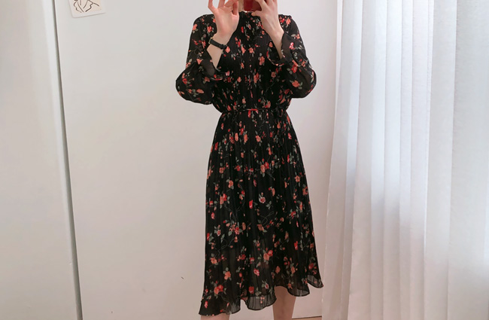
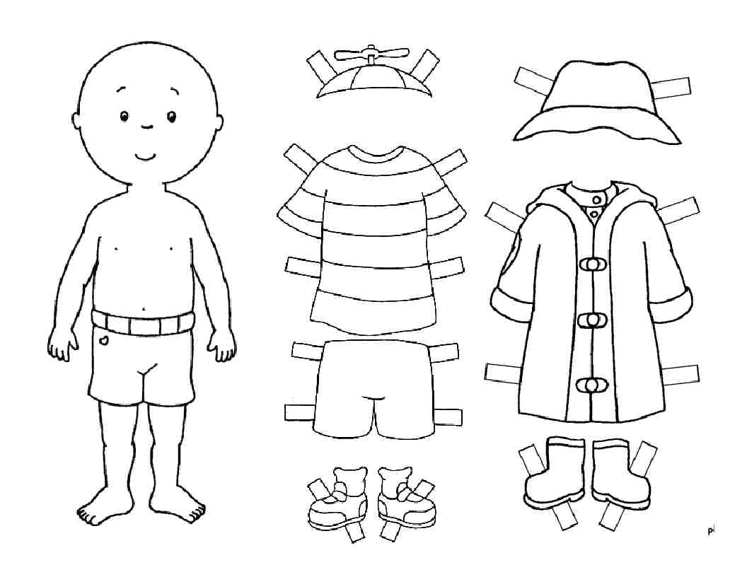
[A paper doll/paper dresses]
[British Money]

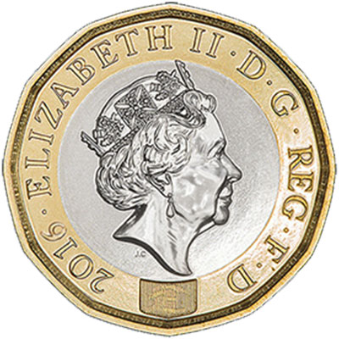

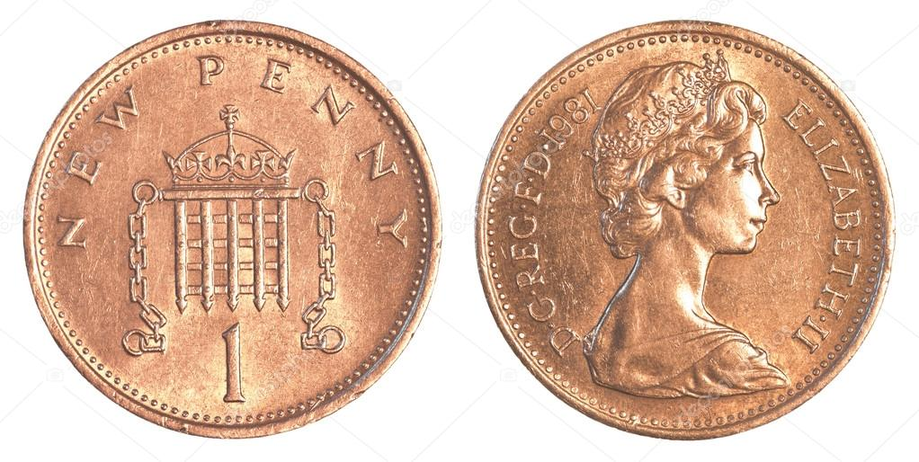

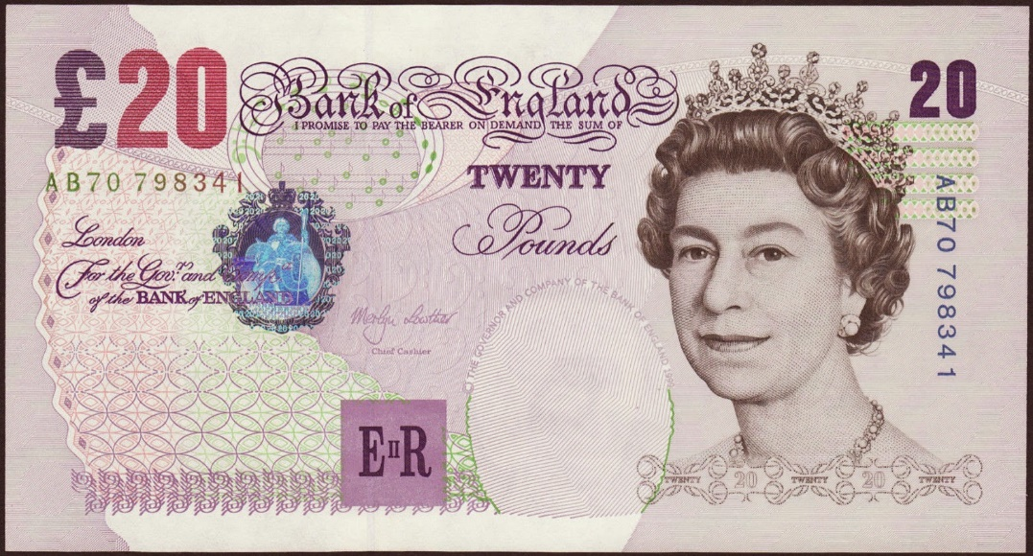

Listen carefully.
A. Fill in the blanks and number the sentences in order
B. Write your answers under the questions

- What size of T-shirt does the customer want?

- What color does the customer buy?

- Where does she try on the clothes?

- How does the customer pay?

- What does the customer get after the payment?

“OK, ”. Can I it ?”

“What do you want?”

“Here’s your
”

“Is it ?”

“Would you like to pay by
or
with ?

[Worksheet#1 / Back]

Listen again.
Write your answer and discuss it with your partner

- Why didn’t the customer choose the black or red color as her first choice?

- Why did the customer try on the clothes before paying?

[Worksheet#1 / Front] – answer key
Listen carefully.
A. Fill in the blanks and number the sentences in order
B. Write your answers under the questions

- What size of T-shirt does the customer want?

- Medium

- What color does the customer buy?

- Red

- Where does she try on the clothes?
- Changing room

- How does the customer pay?
- By cash
- What does the customer get after the payment?

- Receipt

“OK, red”. Can I try it on?”
2

“What size do you want?”
1

“Here’s your
Receipt”
5

“Is it OK/okay?”
3

4
“Would you like to pay by
Credit card or
with cash?

[Worksheet#1 / Back] – answer key

Listen again.
Write your answer and discuss it with your partner

- Why didn’t the customer choose the black or red color as her first choice?

She prefers purple to black and red because she asked “and in purple?” to the shop assistant although he already told her “in medium we’ve got black and red.”

- Why did the customer try on the clothes before paying?
She wanted to check if she looks good with the medium size and the red color of that t-shirt. She doesn’t want to come to the shop again to refund or exchange.

[Transcript for Shopping for clothes.]
Shop assistant: Can I help you?
Customer: Yes, have you got this T-shirt in other colours?
Shop assistant: We’ve got it in white, black, red and purple. What size do you want?
Customer: Medium.
Shop assistant: OK, in medium we’ve got black and red.
Customer: And in purple?
Shop assistant: No, just black and red.
Customer: OK, red. Can I try it on?
Shop assistant: Yes, of course. The changing rooms are over there.
(pause)
Shop assistant: Is it OK?
Customer: Yes, I’ll take it.
Shop assistant: That’s £10.95. Would you like to pay by credit card or with cash?
Customer: Cash please. Here’s twenty.
Shop assistant: OK, thanks, that’s nine pounds, 5p change and here’s your receipt.
Customer: Thanks. Bye.

Instructor’s Comments and Assessment
Pros
Cons
Change
Overall Comments
Grade
Above Standard 85%-100% | Standard 70%-84% | Below Standard 69%-0%
Instructor | Student Signature | Date
Taute, David

