Background Information Sheet
Name | Class | Date | Lesson Type | Plan type | Length
Ryatt / 이경호 | TESOL | 27.04.2019 | Listening | PPP | 35 min

Lesson
Topic | I’m too ill.
Main Aim | Students will practice their listening comprehension.
Secondary Aim | Students will practice their speaking fluency, pronunciation and intonation through speaking with their experience and know word of part of body.

Materials and References
Video & Audio file <I’m too ill>
https://learnenglishkids.britishcouncil.org/short-stories/im-too-ill
speakers, computer and cell phone; Listening script, worksheets(Question & Answer); board and markers.

Student Profile
Level | Intermediate
Age | 7~8 | Number of Students | 6
Detail | They are 3 girls and 3 boys. They are all korean.

Anticipated Difficulties and their Solutions:
Technical failure - Prepare a backup audio file on my smartphone.

My Personal Aim
What I hope most to demonstrate in this lesson is the ability to give clear instruction to students.

Stage Name: Lead-in (3 min)
Purpose of this stage: To relax both the teacher and students. To focus attention on the lesson. To lead in to the topic, activating background knowledge..
Materials: List all materials that will be needed in this stage.
Time | Interaction | Procedure
10 sec  3 min | T-S  T-S | [Greeting]  “Hello, everybody. How are you today?”  [Warm-up]  “Do you know this song?”  Sing a song in English with action.  “Head and shoulders, knees and toes, knees and toes~  Head and shoulders, knees and toes, knees and toes~  Head and shoulders, toes, knees and toes~  Head and shoulders, knees and ears, nose and ears~  “Okay. Let’s sing the song together.”  Sing the song once.  And then New one with action.  “Head and tummy, throat and ears, throat and ears~  Head and tummy, throat and ears, throat and ears~  Head and tummy, ears, throat and ears~  Head and tummy, throat and ears, nose and ears~”  “Okay. Let’s sing the song together.”  Sing the song once.  “Okay, Very well. Good job.”

Stage Name: Presentation(9 min)
Purpose of this stage: To pre-teach keywords if necessary, and to help students be better able to understand a difficult part of the audio.
Materials: List all materials that will be needed in this stage.
Time | Interaction | Procedure
3 min  3 min  3 min | T-S  T-S  T-S/S-S  T-S | [Pre-teach keywords]  - ill / -ache  [Eliciting]-ill  “Students, What is wrong with teacher?”  Mime ill. sit down, hunch over, put a blanket over your head and shoulders, groan, coughing, shivering  Maybe students say “sick, not well, ill, had a cold etc.”  [CCQ]  - Can I play outside?” (No)  - Do I need rest?” (Yes)  - “Do I need medicine?” (Yes)  [Drill]  “If I have got a cold, I could be ill my head.”  Drill - 3 times all students / 2 times each pairs  select 2 students and speak 2 times(other students follow one.)  [Board]  Write ‘ill’  “This word has a syllable. so it has just one stress.”  [Eliciting]-ache  Miming headache.  “Ouch, ouch, ouch! It hurts my head. What does it call?”  “Headache!”  Miming tummy ache.  “Ouch, ouch, ouch! It hurts my tummy. What does it call?”  “Tummy ache!”  [CCQ]  - If you are ill your ears, what does it call?” (earache)  - If you are ill your tooth, what does it call?” (toothache)  [Drill]  “I have got a headache, tummy ache and earache.”  Drill - 3 times all students / 2 times each pairs  select 2 students and speak 2 times(other students follow one.)  [Board]  Write ‘-ache’  “This word has a syllable. so it has just one stress.”  [Guiding Question]  “Have you ever been ill?”  Talk to your partner with your experience for 1 min.  (Teacher monitoring)  After 1 min.  “Time’s up. Who’s going to speak own experience? Tell us When I was ill, Where I was ill or something.”

Stage Name: Practice - Literal Comprehension Listening (6 min)
Purpose of this stage: is to get students to practice their literal listening skill.
Materials: List all materials that will be needed in this stage.
Time | Interaction | Procedure
30 sec  30 sec  30 sec  2 min  2 min  1 min | T  T  T-S  S  S-S  T-S | [Instruction]  Just showing worksheet.  “Here is our worksheet. Loot at Exercise A. .Total 4 Questions. The 1st question. We can see body’s picture. After listening, you can find that where he was ill and you can circle it.  Rest of questions, you will be able to answer. You have to do this work individually.”  [Literal Q]  Teacher reads.  - Where was Siriwat ill? Look for the ill part of the body and circle it.  - Who called a doctor?  - Who arrived at Siriwat’s house?  - What did doctor give Siriwat?  [I.C.Q]  “Are you going to write your answer?”  Students answer “Yes.”  Handout worksheets.  “Okay. Thank you. I’ll show you a video for 1st time.”  Play “I’m too ill” (1 min 30 sec)  -https://learnenglishkids.britishcouncil.org/short-stories/im-too-ill  Students listen for 1st time..  After watching  “Share your answers in your partner with 2 min. During sharing answers with your partner, you can help each other.”  Teacher monitoring.  Listen each pairs answer and give them some feedback.

Stage Name: Practice - Interpretive Comprehension Listening(6 min)
Purpose of this stage: is to get students to practice their interpretive listening skill.
Materials: List all materials that will be needed in this stage.
Time | Interaction | Procedure
10 sec  30 sec  2 min  2 min  1 min | T  T  S  S-S  T-S | [Instructions]  “Look at Exercise B. 2 Questions. This time, you can write your opinion. Then pair check like Exercise A.”  [Interpretive Q]  Teacher reads.  - Why did Siriwat get more ill?  - Why did the doctor check Siriwat’s temperature at first?  [I.C.Q]  “Are you going to write your answer?”  Students answer “Yes.”  “Okay. Thank you. I’ll show you a video. If you want to listen one more, could you tell me”  Play “I’m too ill” (i min 30 sec)  -https://learnenglishkids.britishcouncil.org/short-stories/im-too-ill  Students listen for 2nd time. More carefully than before.  If they want to listen one more, show again.  After watching  “Share your answers in your partner with 2 min. During sharing answers with your partner, you can help each other.”  Teacher monitoring.  Listen each pairs answer and give them some feedback.

Stage Name: Production - Applied Comprehension Speaking(9 min)
Purpose of this stage: is for students to practice their speaking fluency on a topic related to the lesson.
Materials: List all materials that will be needed in this stage.
Time | Interaction | Procedure
1 min  20 sec  2 min  2 min  2 min  2  min | T-S  T  S-S  S-S / T-S  S-S  S-S / T-S | [Instructions]  “This time, we’ll make two groups of three people.”  Rearrangement desk.  [Applied Q]  Teacher read.  - We have been ill like Siriwat. At that time, what do your parents do for you?  - What are some good foods that keep us from getting ill?  Question 1.  “Okay, Thank you. At first, you’re going to talk about question 1 with your experience in your group. give 3 min.”  Students talk share own opinion.  Teacher monitoring.  “Time’s up.”  Select 2 students of each group. Share another student’s experience.  And give them feedback.(wrong sentences, pronunciation. etc)  Question 2.  “Okay, Thank you. At first, you’re going to talk about question 2 with your experience in your group. give 3 min.”  Students talk share own opinion.  Teacher monitoring.  “Time’s up.”  Select 2 students of each group. Share another student’s experience.  And give them feedback.(wrong sentences, pronunciation. etc)

Stage Name: Wrap-up(2 min)
Purpose of this stage: is to end the lesson on a positive note so that students feel they have achieved progress.
Materials: List all materials that will be needed in this stage.
Time | Interaction | Procedure
2 min | T | Get questions from students : misunderstand things, confusing things.  Lesson feedback : talk freely together, suggestions of lesson and what needs to improve.  Check words : If don’t students know well, give them the homework.  Inform students about the topic for the next lesson.

Listening Script - I’m too ill
https://learnenglishkids.britishcouncil.org/short-stories/im-too-ill
‘I’m too ill to sleep,’ said Siriwat.
‘Have a drink,’ said his dad. ‘Ouch, it hurts! I’m too ill to drink.’

Siriwat had a sore throat.
‘Oh dear,’ said his dad. ‘Here is some medicine.’ ‘I’m too ill to take it.’

Next morning he had a headache.
‘Ouch, ouch! It hurts!’ ‘Medicine?’ ‘No, I’m too ill.’

By midday Siriwat had a tummy ache.
‘Ouch, ouch, ouch! It hurts!’ ‘Oh dear,’ said his dad.

By evening he had earache.
‘Ouch, ouch, ouch, ouch! It hurts!’
‘Oh dear,’ said his dad. ‘I’m calling the doctor.’
‘I’m too ill to see the doctor,’ said Siriwat.

But the doctor arrived. ‘High temperature!’ she said. ‘Take this medicine.’

‘Good morning, Dad!’ called Siriwat the next day. ‘I feel much better now!’

<Question>
Exercise A - Read the questions. Listen and write your answers.
- Where was Siriwat ill? Look for the ill part of the body and circle it.
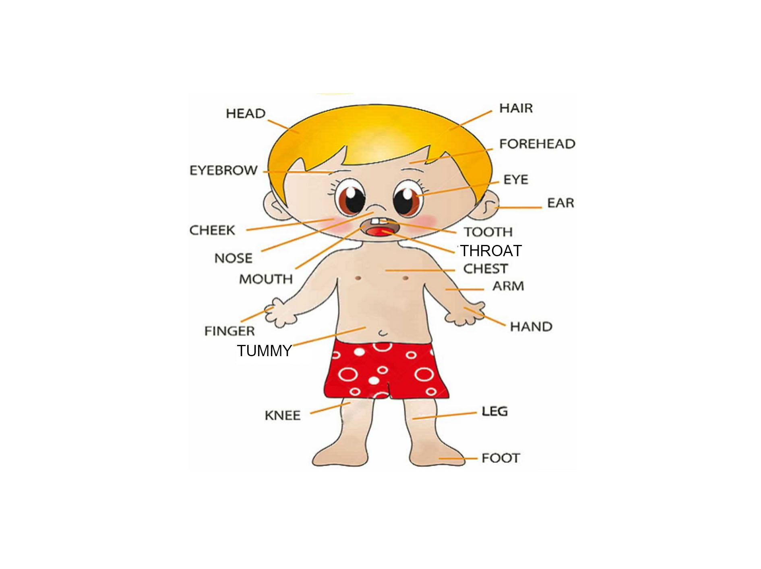
2. Who called a doctor?
3. Who arrived at Siriwat’s house?
4. What did doctor give Siriwat?

Exercise B - Read the questions. Listen carefully, and write your answer.
- Why did Siriwat get more ill?
- Why did the doctor check Siriwat’s temperature at first?
Discussion - Talk to your partner about the questions below.
- We have been ill like Siriwat. At that time, what do my parents do for me?
- What are some good foods that keep us from getting ill?
<Answer>
Exercise A - Literal Question
- Where was Siriwat ill? Look for the ill part of the body and circle it.
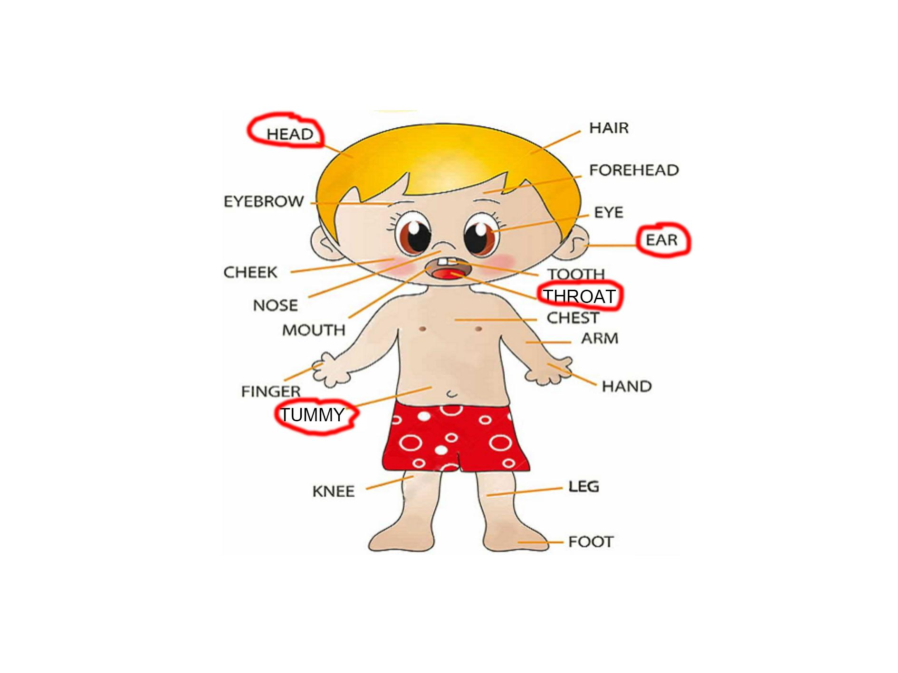
2. Who called a doctor? (Dad)
3. Who arrived at Siriwat’s house? (doctor)
4. What did doctor give Siriwat? (medicine)

Exercise B - Interpretive Question
1. Why did Siriwat get more ill?
2. Why did the doctor check Siriwat’s temperature at first?

Discussion - Applied Question
1. We have been ill like Siriwat. At that time, what do my parents do for me?
2. What are some good foods that keep us from getting ill?
Instructor’s Comments and Assessment

Pros
Cons
Change
Overall Comments
Grade
Above Standard 85%-100% | Standard 70%-84% | Below Standard 69%-0%
Instructor | Student Signature | Date
Taute, David

