Background Information Sheet
Name | Class | Date | Lesson Type | Plan type | Length
Florence | TESOL | 27.April.2019 | Listening | PPP | 35 min

Lesson
Topic | Work-life balance
Main Aim | Students practice their listening comprehension.
Secondary Aim | Students practice their speaking fluency.

Materials and References
Audio file (https://learnenglish.britishcouncil.org/intermediate-b1-listening/work-life-balance)
speakers and computer; worksheets; board and markers.

Student Profile
Level | Intermediate
Age | 20’s -40’s | Number of Students | 5
Detail | All has different jobs and they would develop their speaking skills in normal communication.

Anticipated Difficulties and their Solutions:
Technical failure. - Prepare a backup audio file on my smartphone.

My Personal Aim
What I hope most to demonstrate in this lesson is the ability to write a detailed and accurate lesson plan.

Stage Name: Lead-in
Purpose of this stage: To relax both the teacher and students. To focus attention on the lesson. To lead in to the topic, activating background knowledge.
Materials: -
Time | Interaction | Procedure
30 sec | T  Greet. Instructions. | (Line on board to divided three columns.)  Hi, nice to see you again class.  how are you?  (short answering time with everyone)  now we are going to talk about your daily schedule during weekdays.  For example, I usually have coffee in the morning. And I usually go to work at seven in the morning.  Talk to your partner.
2 min | T-S/S-S  Brainstorm | (2min)
30 sec | T-S  Feedback if appropriate. | OK, Ryatt. Please tell me how your day is going?  And Lily?  One more person?  (2-3 students answer the question)

Stage Name: Presentation
Purpose of this stage: To pre-teach keywords if necessary, and to help students be better able to understand a difficult part of the audio.
Materials: board, markers
Time | Interaction | Procedure
2 min  30 sec | T-S | Alright. Thanks.  (drawing Scales on the board)  What is important on this?  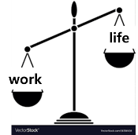  (drawing Scales on the board)  What is important on this?  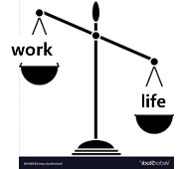  (drawing Scales on the board)  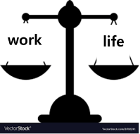  Now which one is important? (Students answering) Both are important.  Now work and life balanced.  work life balance  (point the picture again)  is work important?  is life important?  And now? Work-life balance  (Choral drills three times)  (Individual drills from front to clock wise)  Work-life balance  (write on board )  And follow after me.  "this is good thing for work-life balance.”  (Choral drills three times)  (individual drills from front to clock wise)
10 sec | T | Alright.  What are some ways to work with others with distance?  Please talk to your partner.
1 min  30 sec | S-S | (1min talking)
50 sec | T-S | Tell me what you think.  (answering: smartphone, email and so on.)  we can move around and still work with other.  The work is able to move somewhere.  Do you know any word can say for this, something can be able to move.  “Mobility”

Stage Name: Practice - Literal Comprehension Listening
Purpose of this stage: is to get students to practice their literal listening skill.
Materials: audio material, worksheets, board, markers
Time | Interaction | Procedure
30 sec | T | I will give you hand out, please do not turn the page when you get it.  We are going to listen to the conversation with the presenter and Chris.  Please listen carefully and find the correct answers for each question.  (distribute hand-outs)  Start now.  1. is the book they mentioned popluar?  1) yes 2) no 3) can not know  2. what is the title of the book written by Chris?  The work-life balance  3. what is the meaning of overtime?  1) working less than your normal work  2) working as your normal working hours  3) working more than your normal work  4) no working  4. which one is NOT related 'mobility'of current working environment?  1) email  2) mobile phone  3) working nine to five  4) laptop
3min | S | (Listening the audio files)  Did you find all answers? Check with your partner.
1 min | S-S | (Students check the answers)
2 min | T-S | What’s the answer for question number one? (listen to a chosen student the answer)  What’s the answer for question number two? (listen to a chosen student the answer)  What’s the answer for question number three? (listen to a chosen student the answer)  What’s the answer for question number four? (listen to a chosen student the answer)  Good job.  I think you have all correct answers.

Stage Name: Practice - Interpretive Comprehension Listening
Purpose of this stage: is to get students to practice their interpretive listening skill.
Materials: audio material, worksheets, board, markers
Time | Interaction | Procedure
30 sec | T | Alright. We are going to listen again.  Turn the page, then read your questions.  Find answers from the conversation.  Start now.  1. In the past, how could spend time with their family in the evening and holidays?  - Because they can clearly separate their working lives and their private lives.  2. Why does the presenter feel much of work-life balance from Current work environment?  - people can access their work in any time and everywhere.  Talk with your partner about what you found out.  (If they need to listen one more time, listen again)
3 min | S | (Listening the audio files)
1min | S-S | Please check the answer together.  (Students check the answers)
2 min | T-S | What is the answer of question number 1 of the second section?  Read the question one person. And another person tells the answer.  1. In the past, how could spend time with their family in the evening and holidays?  - Because they can clearly separate their working lives and their private lives.  What is the answer of question number 2 of the second section?  2. Why does the presenter feel much of work-life balance from Current work environment?  - people can access their work in any time and everywhere.____________

Stage Name: Production - Applied Comprehension Speaking
Purpose of this stage: is for students to practice their speaking fluency on a topic related to the lesson.
Materials: printed statement, board, markers
Time | Interaction | Procedure
1 min | T | here is the statement for you. Please, yumi read the satament.  "Mobility helps work-life balance"  do you agree or disagree?  +the second question : Discuss ways to make your life have more mobility.  talk to your partner about your idea.
9 min | S-S | (Students discussion)
2 min | T-S | Who would agree?  (listening to students who agree with the statement.)  Is there anyone disagree?  (listening to students who agree with the statement.)

Stage Name: Wrap-up
Purpose of this stage: is to end the lesson on a positive note so that students feel they have achieved progress.
Materials: -
Time | Interaction | Procedure
2 min | T | Well done.  Alright. Working environment has been changing somehow. And there are always pros and cons.  Hope you find your own “work-life balance”.  Next lesson, we are going to talk about non-work area.  The Chris mentioned it before in the conversation we heard today.  What is it?  (Listening to students : hobbies, holidays)  Yes, it s about your life out of work. Hope see you all again in next lesson.  Have a good week!  See you.

[Transcription]

Work–life balance

Presenter: Good morning, everyone. On today's show, we've got Chris Svensson with us, the author of No more nine to five, the new best-selling book about work–life balance in the current working world. Good morning, Chris. Thanks for coming.

Chris: Thanks for having me, Anna.

Presenter: So, Chris, tell us about your book and how the concept of a work–life balance has been changing?

Chris: Well, in the more traditional workplaces, people's working lives and their private lives are, or were, clearly divided. People often work from nine in the morning until five or six in the evening. People sometimes stay late in the office and work in the evenings. This is called working overtime.

Presenter: OK, and what else?

Chris: Well, in these environments it isn't common for people to work at the weekend or while they're on holiday. They can clearly separate their working lives and their private lives. And the evenings, weekends and holidays are free to focus on non-work areas of life, such as hobbies, interests, sports, spending time with the family and friends, and so on. It's important and healthy not to spend all your time just working, right?

Presenter: Right! So what has changed? How are things different now?

Chris: Well, for a start, most people can now access their work emails from their mobile phones. So they are more likely to quickly reply to an important mail in the evening or at the weekend. The same goes for laptops. It's easier to access your work in the evenings from home or even from your hotel when you're on holiday.

Presenter: That doesn't sound like much of a work–life balance. It sounds like all work.

Chris: Exactly, but this new mobility brings a lot of advantages with it. More people are now able to work flexibly, so if they need to leave the office early one afternoon to be with their family, they can catch up on work that evening from home or somewhere else.
Presenter: That sounds good. So, what you're saying is that although traditional divisions between work and life are fading, many employees now have more freedom to do their work from different locations and at different times.

Chris: Yes, that's it.

https://learnenglish.britishcouncil.org/intermediate-b1-listening/work-life-balance
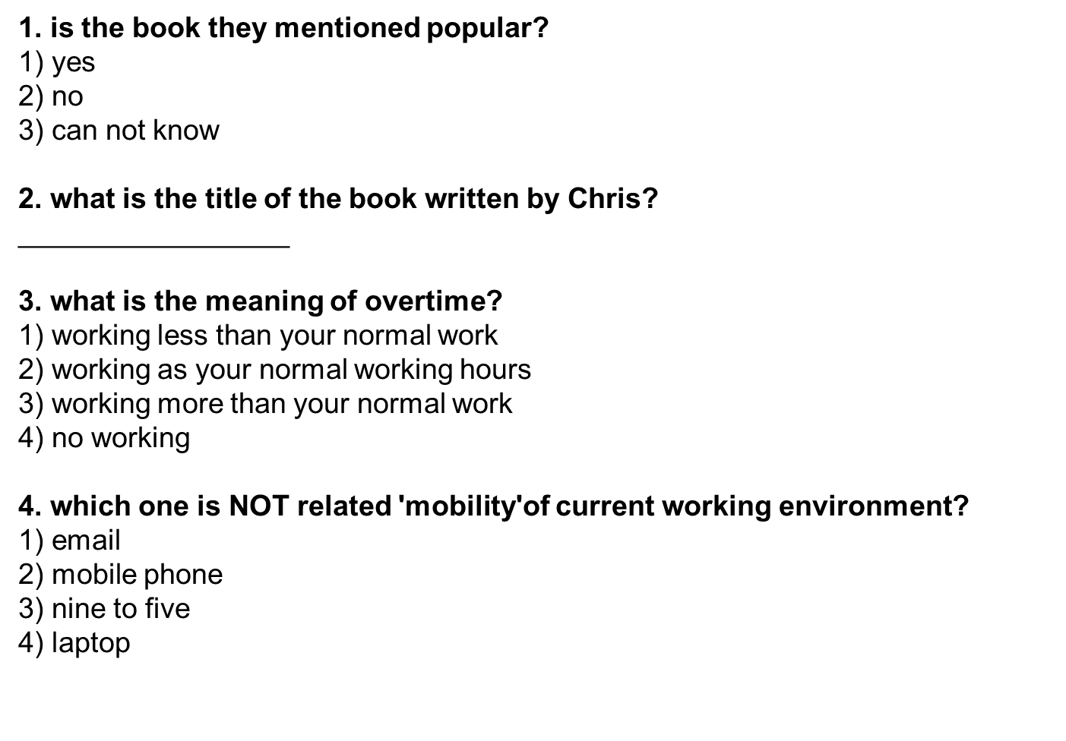
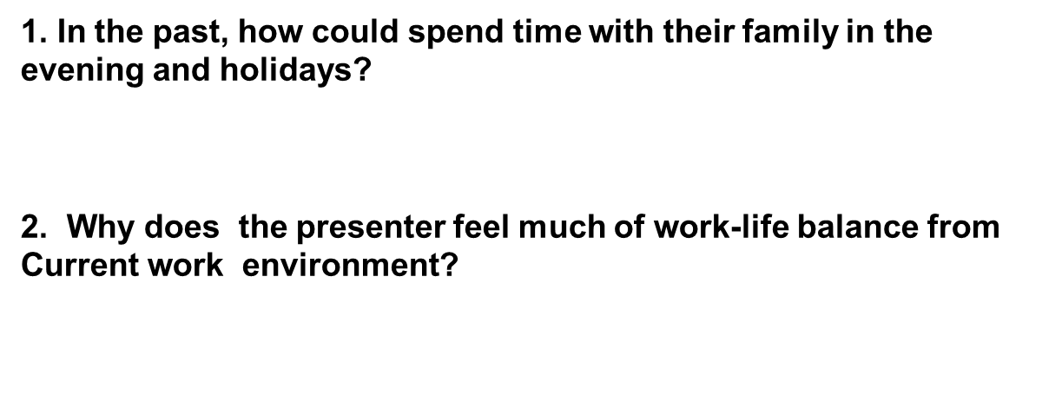

Mobility helps
work-life balance.

[Extra activitiy]

Draw your work -non work time
in a daily routine. in weekdays,
demonstrate your life on the table.

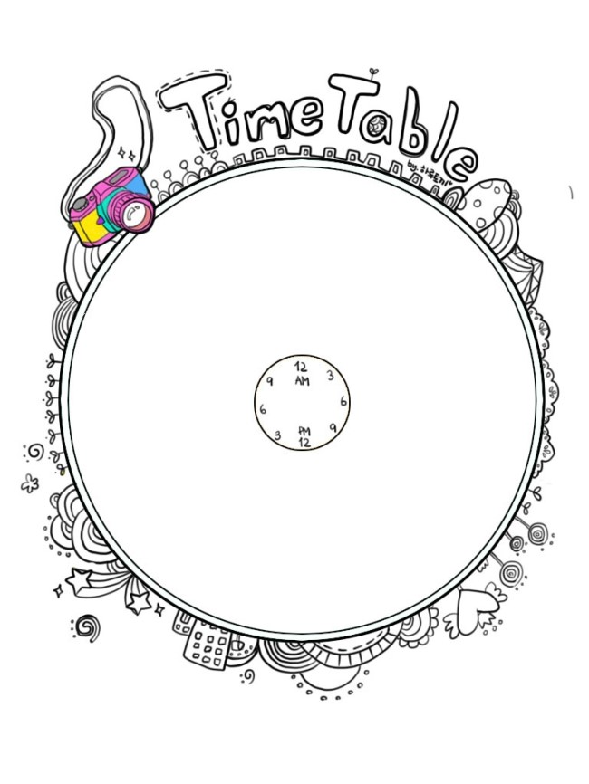
[Extra Activitiy] Draw your work -non work time.
in a daily routine. in weekdays, demonstrate your life on the table.

Instructor’s Comments and Assessment
Pros
Cons
Change
Overall Comments
Grade
Above Standard 85%-100% | Standard 70%-84% | Below Standard 69%-0%
Instructor | Student Signature | Date
Taute, David

