Background Information Sheet
Name | Class | Date | Lesson Type | Length
You-mi | 193rd TESOL | 04.MAY.19 | Speaking | 35min

Lesson
Topic | Online shopping (role playing)
Main Aim | SS will practice their speaking fluency.
Secondary Aim | SS will improve their ability to handle the certain situation in their target language.
Materials and References
https://www.onlinelanguageacademy.com/en/blog/conversation-class-online-shopping.htm
https://www.youtube.com/watch?v=xgq8iV-_PjA
PPT file, pictures, white board, marker, matching exercise materials

Student Profile
Level | Advanced
Age | Adults | Number of Students | 4
Detail | 3 Female students and 1 male student are in the class.  All of them are native Korean speakers very passionate for the class.
Assumptions about students’ knowledge as required for this lesson:
It is assumed that students already have experienced the convenience of online shopping.
Because online shopping has quickly become one of the most popular ways to buy things in our society. Also they have an experience for role play and simple discussion.
This would be an interesting topic to share about.

Anticipated Difficulties and their Solutions:
Technical failure-> Prepare a picture instead of PPT file
They are not familiar with some expressions that is being used for online shopping
->do matching exercise for the students to get familiar with it before we prepare the role play

My Personal Aim
What I hope most to demonstrate in this lesson is the ability to give an opportunity for my student to speak more. I will try to do my best to reduce TTT, and increase STT.
Also I want to make a good rapport with my students.
Stage Name: Pre Task (5min)
Purpose of this stage: Create interest in the topic. Brainstorm ideas which will be useful for the next stage. Students may be given a communicative task e.g. discuss, arrange/sort, create a list, etc.
The aim is to relax students, activate their background information, and gather useful ideas for the lesson.
Materials: PPT file or Picture, white board, Marker , matching game material
Time | Interaction |  | Procedure
1min  1min  1min  2min | T-S  S  T-S  T-S  T-S |  | Greeting and elicit  Hello class!  How are you doing guys?  SS: Fine  (Show and give them a picture)  What would you do in this situation?  Has something like this happened to you?  Talk to your partner about the picture  (divide them in pairs)  SS: Talk  Let’s share about it.  (Pointing each student then ask)  Do you have any experience?  SS: Answer  Interesting!  I think you guys can guess about today’s topic, now.  Do you guys have any good idea of today’s topic?  SS: Yes, online shopping  Write down the topic “online shopping” on the board  Give them a communicative task  Let’s start matching exercise.  (divide them into A & B team)  Hold a worksheet then explain quickly  Guys, please talk to your partner then find out the meaning  When you are ready, come up to the front (Hand out)  Everyone just come up to the front then put the answer on the board
Stage Name: Task Preparation (12min)
Purpose of this stage: This is a student centered stage, to give students time to prepare and practice a speaking task which they will perform in Task Realization. Clear detailed instructions or a demonstration must be provided so students know what is expected. Prepared materials may be provided to assist their preparation. Monitor and offer brief tips if necessary.
Materials: 2 copies of customer service manual
Time |  | Interaction |  | Procedure
2min  10min |  | T-S  S  T |  | Instructions  Today, we’ll do a role play that you make a call to the customer service to complain then you need to resolve your problem.  First, decide what the item is and what the problem is.  Second, prepare what to say to the customer service  Then, contact customer service to resolve your problem.  I will give you guys 10 min to prepare and at least more than 3 min for role play.  *Rule: Customer should ask politely  Customer service make their customer feel valued but refuse their refund  (provide them customer service manual)  It can help you to prepare for role play  ICQ check  - What are we going to do first?  SS: Decide what the item & problem is  - How long do we need to prepare for role play?  SS: 10 min  - How long do we need to do our role play?  SS: At least more than 3 min  SS start their preparation  Monitor  Give them time notification  Guys we only have 1 min left please finish it quickly.
Stage Name: Task Realization (10min)
Purpose of this stage: This is a very student centered stage to allow for maximum speaking fluency practice. Monitor discretely and take note of incorrect language. Students perform their task without interruptions from the teacher.
Materials: no materials needed
Time |  | Interaction |  | Procedure
10min |  | T-S  T |  | Alright times up  Who’s going to show first?  SS: Answer  (If there’s no volunteer, ask them to start first)  SS: Yes, Role playing start (at least 3 min for each)  Thank you guys

stage Name: Post Task (8min)
Purpose of this stage: To end the lesson with a final student centered task such as voting, summarizing, discussing, deciding etc. The teacher may offer delayed error correction to the previous stage, as well as mention positives and points to improve for next time such as useful strategies.
Materials: PPT file for extra questions
Time | Interaction | Procedure
8min | T-S  S  T-S | Feedback and discussing more about the topic  We’ve been talked about online shopping today  Let’s talk about more all together  (Show them with PPT file or write them on the board for more questions)  - Do you shop online? Why or why not?  - What are the advantages of shopping online?  - What would you never buy online?  - What things do you prefer buying from shop?  - Do you prefer to use cash or debit/credit card?  SS: Talk together and share their ideas  Finish the lesson by telling them  Alright guys, it was so interesting to watch your role play and discuss more about online shopping  How was that guys?  All of you guys did a really good job and hope you guys learned something new from this class. thank you.
Pros
Instructor’s Comments and Assessment
Cons
Change
Overall Comments
Grade
Above Standard 85%-100% |  |  | Standard 70%-84% | Below Standard 69%-0%
Instructor |  |  | Student Signature | Date
Taute, David

Picture for the students
Let’s talk about this picture
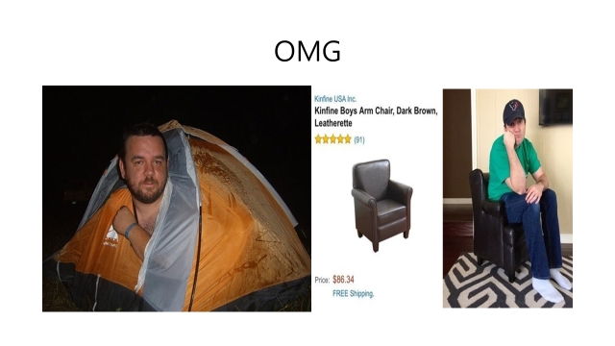

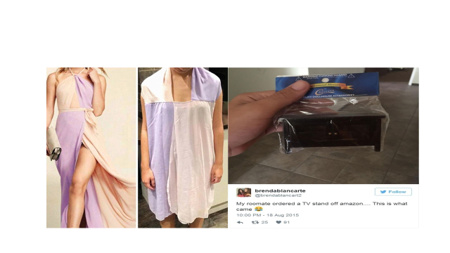
Matching exercise worksheet
match the word to the picture

- to be ripped off
- something is missing
- incorrect item
- improper packaging
- damaged item

Answer sheet
1.to be ripped off
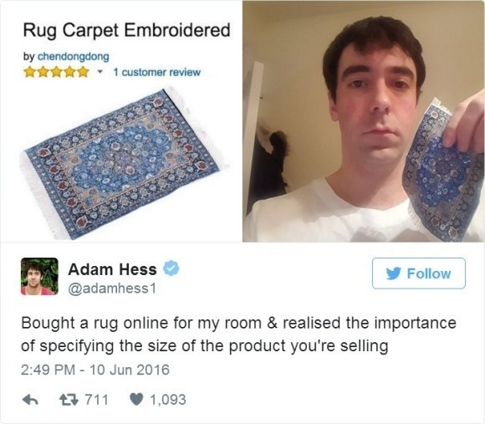
2.Something is missing
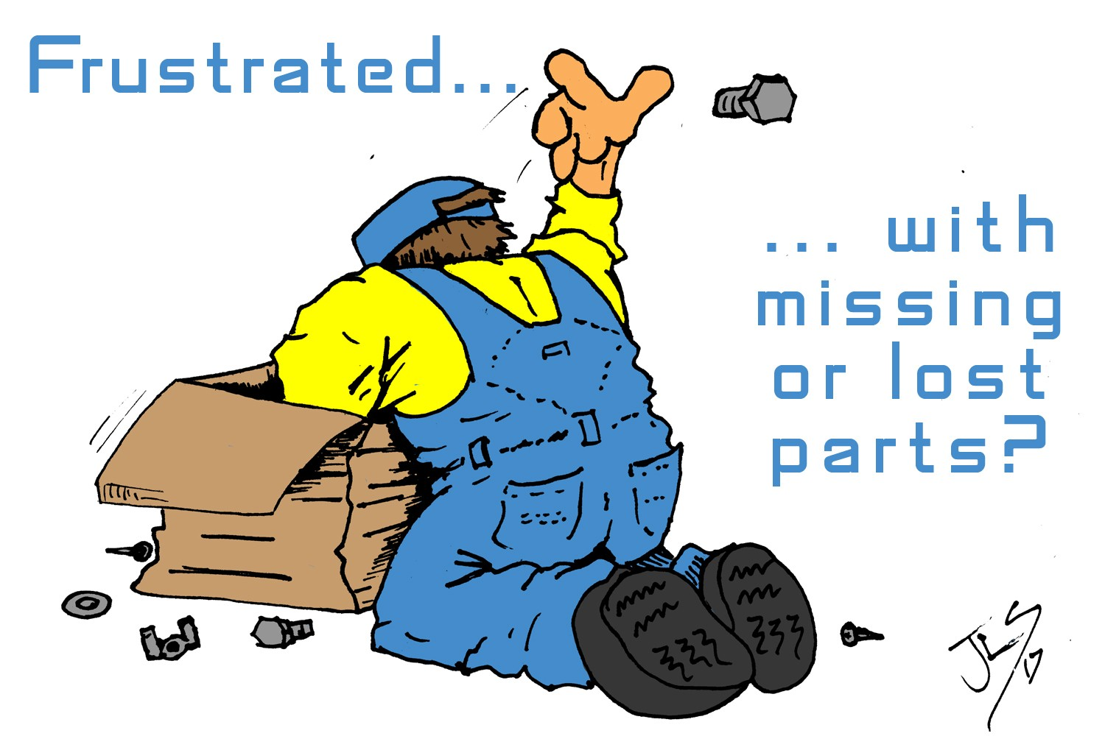
3.Incorrect item

- Improper packaging
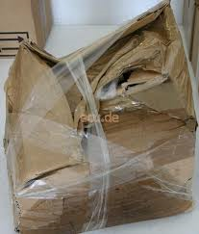

5.Damaged item

CUSTOMER SERVICE MANUAL (for students)

- Hello/Good morning
- Thank you for calling/coming to ______, this is ______
May I help you / how can I help you?
- I’m afraid I didn’t hear what you said, could you speak a little louder please?
- I’m very sorry to hear that you are having a problem sir/madam
- When would you be available for us to deliver/fix
- Can I just check that your address is______?
- Ok, can I just confirm that ______
- Thank you for calling ______, I hope we have provided a satisfactory solution to your problem

Extra questions for discussion

- Do you shop online? Why or why not?
- What are the advantages of shopping online?
- What would you never buy online?
- What things do you prefer buying from shop?
- Do you prefer to use cash or debit/credit card?
- Have you had a bad experience/been disappointed with something you bought online?
- Did you ask a refund?

