Background Information Sheet
Name | Class | Date | Lesson Type | Length
Lily | 193th TESOL | 2019/05/04 | Speaking | 35min

Lesson
Topic | Food Idioms
Main Aim | Ss practice their speaking fluency
Secondary Aim | Ss practice idiomatic expressions
Materials and References
Pre task- PPT (Pictures), Worksheet#1 (Front-Matching idioms and definitions)
Task preparation – PPT (Pictures), Worksheet#1 (Back-Dialogue Sample/ Rubric)
Task realization – Role play
Post task- Worksheet#1 (Back-Dialogue Sample / Rubric)

Student Profile
Level | Advanced
Age | Adult | Number of Students | 4
Detail | There are 3 females and 1 male.  Everyone is native Korean. They are food lovers and enjoy having conversation to share their ideas when they are talking about food.
Assumptions about students’ knowledge as required for this lesson:
It is assumed that students know about the materials because they can usually find in real life
Students can create their own sentences and have short dialogue/conversation by using English.

Anticipated Difficulties and their Solutions:
Technical failure – Print backup photos and paste them on the white board in case that computer monitor doesn’t work
Use of L1 – Remind students of the rule speaking English only. Write the reminder on the white board

My Personal Aim
What I hope most to demonstrate in this lesson is the ability to maximize STT and minimize TTT.
Additionally, I want to practice giving clear instruction and speaking slowly.
I would like to avoid speaking filler words such as ‘um’, ‘uh’ and ‘so’
Stage Name: Pre Task
Purpose of this stage: Create interest in the topic. Brainstorm ideas which will be useful for the next stage. Students may be given a communicative task e.g. discuss, arrange/sort, create a list, etc.
The aim is to relax students, activate their background information, and gather useful ideas for the lesson.
Materials: Computer, Monitor, PPT (Picture), Worksheet#1(Front)
Time  (6min) | Interaction | Procedure
1min  30sec  30sec  2min  1min  1min | T-S  T  S  S-S | [Greeting]  Hello everyone! How are you today? (Ss: good,fine…)  [Eliciting]  I have a picture of a cat pulling out a man’s tongue.  - What situation or message can you get from this picture?  (Ss: A situation someone can’t talk/stop talk)  - Alright. But could you understand the meaning when you just read the two separate words ‘cat’ and ‘tongue’ without a picture?  (Ss: No.)  - Then, what do we call when two separate words combine and have new meaning?  (Ss: Idiom)  - So, if we are not native, do you think is it easy to understand the meaning of their idioms at once? (Ss: No)  That’s why, now we become idiom hunters to find out the meaning of idioms!  [Instruction]  I’ll give you a piece of paper. It’s double sided but you can see the front page only. Match two columns. A is food idioms and B is their meanings. This is an individual work. I’ll give you 2 minutes.  [Hand out worksheet to students]  [Ss work the task]  Time is up. Now, check your answer with your partner. You can change your answers if you need  I’ll give you 1 minute.  [Pair checking]  (T is monitoring if they have the same answers or who has the different answers)  [Check the accuracy]  (Time is up) Okay. Now, let’s check your answer with your class.  Read the full sentences of your answer to the class  For just an example, it’s like, Apple of one’s eye means being pregnant!  Let’s start from ______.  (Ss read until the last item)  Very good!

Stage Name: Task Preparation
Purpose of this stage: This is a student centered stage, to give students time to prepare and practice a speaking task which they will perform in Task Realization. Clear detailed instructions or a demonstration must be provided so students know what is expected. Prepared materials may be provided to assist their preparation. Monitor and offer brief tips if necessary.
Materials: Computer, Monitor, PPT(Pictures), Worksheet#1(Backside)
Time  (14min) | Interaction | Procedure
30sec  30sec  10min  3min | T  T-S  S-S  T  S-S | [Instruction]  Class, I have pictures showing some situation. By pair, choose one picture and create a dialogue to describe the picture by using the idioms.  Use at least 2 idioms in your dialogue. Please turn over the paper and see the back side. You can see some guide lines to make your dialogue.  I’ll give you 10 minutes.  [ICQ]  Class, (Raising right hand to get the attention)  What do you need to do by pair? (Ss: create a dialogue)  How many idioms? (2)  How many minutes do you have? (Ss: 8minutes)  Okay. Let’s start.  [Ss work the task]  T is monitoring around the learners and check if they have difficulty.  (If they ask or take so much time in thinking, T can give a hint/idea for them to start creating their dialogue)  Time is up. Now you will role play your dialogue. You will show your role play to the class later.  I’ll give you 3 minutes.  [Ss practice their role play]  [T is far away from the students and monitors their practice]

Stage Name: Task Realization
Purpose of this stage: This is a very student centered stage to allow for maximum speaking fluency practice. Monitor discretely and take note of incorrect language. Students perform their task without interruptions from the teacher.
Materials: Worksheet (Rubric part)
Time  (11min) | Interaction | Procedure
30sec  10min  30sec | T  S-S | Now, you will role play  Then, we will choose which team is the best.  Let’s start our role playing.  Come to this front desk and show your role play within 5 minutes.  Please remember  You have to watch when the other is role playing. While watching, grade the role playing on the rubric in your worksheet.  Let’s start with this team! (Pointing the 1st team)  [Ss role play their dialogue by pair. Each pair has five minutes.]

Stage Name: Post Task
Purpose of this stage: To end the lesson with a final student centered task such as voting, summarizing, discussing, deciding etc. The teacher may offer delayed error correction to the previous stage, as well as mention positives and points to improve for next time such as useful strategies.
Materials: Prize / Medals
Time  (4min) | Interaction | Procedure
30sec  2min  30sec  30sec  30sec | T  S-S  T  T  T-S | [Awarding]  Wow great! Thank you for the presentations.  Each of you will nominate one person and say the reason to the class.  You can use the rubric to support your reason.  If you want, you can nominate yourself.  After our discussion, we will decide the best actor!  We will start from (a student’s name) !.  [Ss discuss]  So, the best actor today is (a student’s name) !  Congratulation! Let’s give a round of applause for ____ !  [Feedback]  Feedback is given to Each team.  A teacher gives praise and mentions interesting / noticeable points from each team.  [Closing/Reflection]  This is all about today.  T asks 2 learners to have brief review of today’s lesson.  _______, what was the most interesting idiom you learned from this class today?  Okay. I hope those idioms you learn today would be helpful in your daily life.  Thank you for your participation today.  See you next class!

[PPT- Eliciting Picture]

[Worksheet#1] – Front

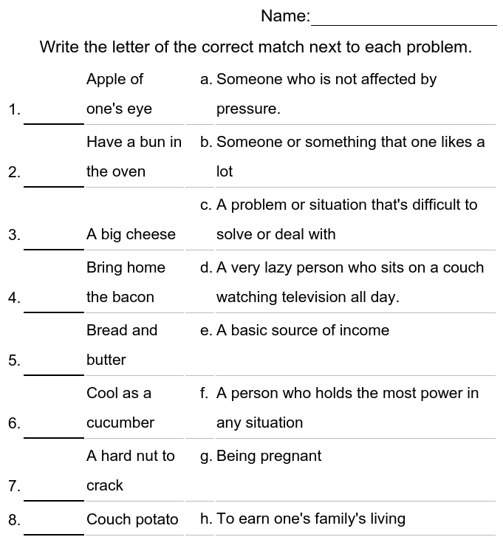

[Worksheet#1] – Back
Sample:
- Oh,,i’m not sure if I can survive from this interview today!
- Yes.. the interview question was a hard nut to crack! I couldn’t answer most of the questions.
- Pheww..By the way, Have you seen a guy sitting on the chair with us and waiting his turn while we’re waiting the interview on the aisle?
- Yes! The one who was cool as a cucumber unlike us! He looked so relaxed.
(…continue your dialogue)

[Rubric]
Scale: 5 Excellent / 4 Good / 3 Needs some improvement/ 2 Needs much improvement/1 Not appropriate
Scoring Criteria / Name
Role-plays dialogue with feeling and expression
Speech is clear with appropriate volume and intonation
Use at least 2 idioms in the dialogue
Apply the idioms in appropriate context
Total Score
Additional Comment:

[Worksheet#1]-Answer key
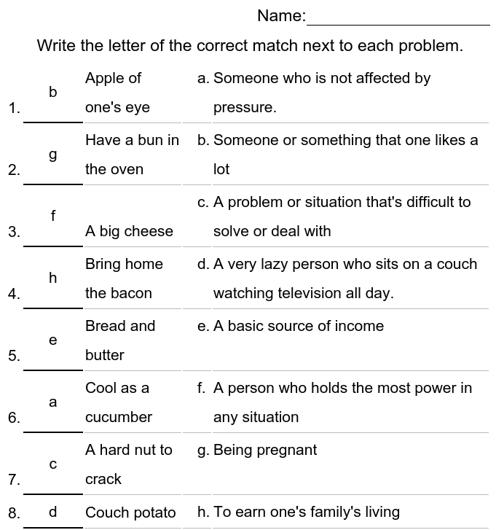

[PPT-Situation pictures]
[possible idioms to be used]
-Apple of one’s eye
-Have a bun in the oven
-A big cheese
[possible idioms to be used]
-Cool as a cucumber
-A hard nut to crack
-Bring home the bacon
-Bread and butter
-A big cheese

[possible idioms to be used]
-Couch potato
-Bring home the bacon
-A hard nut to crack
Instructor’s Comments and Assessment
Pros
Cons
Change
Overall Comments
Grade
Above Standard 85%-100% | Standard 70%-84% | Below Standard 69%-0%
Instructor | Student Signature | Date
Taute, David

