Name | Class | Date | Lesson Type | Plan type | Length
Shirley | 193th WK | 05.10.2019 | Grammar | PPP | 35 min

Lesson
Topic | Grammar Micro teaching: the present perfect simple  Topic: " The experiences of working "  Model Sentence: "Ester has worked at London zoo for seven years"
Main Aim | students will practice the present perfect simple tense using "for" and "since "
Secondary Aim | Students will be communicative with this grammar. they can speak ,write about their working experiences

Materials and References
Materials teacher gave me for the GMT. white board, colored marks.PPT pictures ,fill in the blank work sheet (form focused), work sheet (meaning focused) work sheet (for )

Student Profile
Level | Lower intermediate
Age | adult | Number of Students | 4
Detail | Ss are able to handle successfully a limited number of uncomplicated communicative tasks, predictable topics related to basic personal information.  Their utterances are often filled with hesitancy and inaccuracies that require repetition or rephrasing
Assumptions about students’ knowledge as required for this lesson:
students already know the present perfect simple (have/has+p.p) but don`t know how to properly use" for" and "since "

Anticipated Classroom Management Difficulties and their Solutions:
what if Ss can`t understand teacher technical terms
- Instead of using the teacher technical terms I will create a clear and understandable situation and let them think about it.

My Personal Aim
What I hope most to demonstrate in this lesson is the ability to present the target language using a situational presentation.

Stage Name: Lead-in
Purpose of this stage: To relax both the teacher and students. To focus attention on the lesson. Create a situation for students to experience or think about, and then to elicit the target language.
Materials: a picture , White board, markers
Timings | Interactions | Procedure
T-S | 2min | Show a picture of a professional zoo keeper.  Look at these pictures. . Same person is in the picture A and picture B.  -What are the differences?  - let`s think about it altogether (S: past and present, same person and same job)  -How long has she worked here? How long has it been?  (S: she`s working in 2012 and she`s still working.)

Stage Name: Presentation (9min )
Purpose of this stage: Make the students think about the situation. To clarify the meaning, form, and pronunciation features of the target language.
Materials: List all materials that will be needed in this stage.
Timings | Interactions | Procedure
10 sec  3min  2min 50 sec  3min | T  T-S | Board the model sentence  "Ester has worked at London zoo for seven years"  "Ester has worked at London zoo since 2012"  CCQ – ask questions,  - Is she still working at London zoo? ( yes )  - When did she start working at London zoo? (the answer should start with the past sentence) (7 years ago  - How long has she worked at London zoo? for 7 years  - let`s imagine she worked somewhere else 7 months ago and then she came back to work here now. can we say she`s worked at London zoo for seven years”? (No. Why? because of it`s broken duration time. )  Show the Meaning of the model sentence and use time lines.  - Ester started working 7years ago and she`s working now  - (Does the line have any gab? (no. unbroken. continuous) is this talking about  The past? No  Form – clarify the affirmative form, or other special features. May be of use.  what`s the difference between for and since when you make the present perfect simple tense?  (for + duration / since +moment or past tense)  - Identifying sentence / clause structure  - What tense is this sentence? the present perfect simple tense  - Highlight the grammar structure e.g. Subject + the present perfect simple (have/has+P.P) + time reference (since, for)  -what tense is this word "worked" past  - draw Substitution tables to change some words and explain the tense  -Do we have another word besides "for? can I use" since" here? No  (if you have more time, make negative, Question form )  Drill – drill the spoken form, focusing on contractions, stress and intonation.  - Everybody stand up~! everybody listen ( teacher only speaks the model sentence)  - Say and gesture “Listen and repeat: [model sentence.]” (ss repeat it)  -Ester has worked at The shopping mall since last week”. (ss repeat it)  -"Ester has worked at The shopping mall for seven years”. (ss repeat it)  - say happily /sadly /angrily ( T Says and gesture and ss repeat it)  - (T points out the sentence, Make special pronunciation features visible on the board, using color.)  - T: which words are stressed? S: London, seven years  - T: what about this word? S: unstressed or weak stressed  - T: Is there intonation? Are there contraction?  (repeating the sentence over and over altogether)

Stage Name: Controlled Practice(form)
Purpose of this stage: students practice working with the form (scrambled sentences, split sentences, select the correct form of the verb, correct incorrect sentences, and change one form into another form). Accuracy must be checked.
Materials: white board, colored marks. fill in the blank work sheet (form focused),
Timings | Interactions | Procedure
5min (whole) | T  S  S – S  T - S | Give Instructions. while Handing out the work sheet (form focused)  Now we`re going to do exercise 1. everyone get work sheet and please do it individually  ICQ.  Do we work altogether or individually? individually  ok let`s start~!  Students do a worksheet.(writing the answers)  Pair check.  ss compare their answers with their partner .  Feedback to check accuracy. Board correct answers visually.  Let`s go over the answers together  -which one is right? what`s the answer for No 1?  -If it`s positive form what`s the negative and question form? (ss say and T write it out )  -is this sentence about past or present or future? (from about past to present . we’re not sure about the future )  Do we have another word besides _____? ( no. we can`t)

Stage Name: Less Controlled Practice (meaning )
Purpose of this stage: students practice working with the meaning (match a timelines to sentences; choose the sentence that matches a picture, gap-fill a paragraph). Accuracy must be checked.
Materials: white board, colored marks. work sheet (meaning focused)
Timings | Interactions | Procedure
6min (whole) | T  S  S – S  T - S | Give Instructions. while Handing out the work sheet (meaning focused)  Now we`re going to do exercise 1. everyone get work sheet and please do it individually  ICQ.  Do we work altogether or individually? individually  ok let`s start~!  Students do a worksheet.(writing the answers)  Pair check.  ss compare their answers with their partner .  Feedback to check accuracy. Board correct answers visually.  (T gives some Question about the sentence and since e and use time line.)  Let`s go over the answers together.  Which one is right? what`s the answer for No 1?

Stage Name: Production – Freer Practice
Purpose of this stage: is to get students to practice the grammar communicatively.
Materials: white board, colored marks. work sheet (speaking focused)
Timings | Interactions | Procedure
30 sec  8min30 sec  3min | T  S-S  T | Instructions. (Visual.)  I want you to group work (while Handing out the work sheet (speaking focused)  ( they make a group of 4 and start to write down the answer first . and then go around the class and ask the questions )  ICQ.  What we are going to do? Now? group work  Before that what should we do? write the answers  ok let`s start~!  Ss have group discussion time ( T monitors from a distance  Give feedback  Can you share your experience? ( and so on)  While I listening. I note down some errors things you`re saying concerning the grammar  let`s check about it.  ex)you should use ~  (write the errors on the board)

Stage Name: Wrap-up
Purpose of this stage: is to end the lesson on a positive note so that students feel they have achieved progress.
Materials: white board, colored marks.
Timings | Interactions | Procedure
1 min  30 sec  30 sec | T – S  T  T | Offer delayed corrections to the previous stage.  - “Look at the board. Here are some sentences I heard. Tell me how to correct them.”  - is it right? Who can fix this sentence?  Set homework.  Inform students about the topic for the next lesson. and then finish  next class we will talk about ~  Ok. Time’s up~! it`s really time to go home Bye

Pros
Cons
Change
Overall Comments
Grade
Above Standard 85%-100% | Standard 70%-84% | Below Standard 69%-0%
Instructor | Student Signature | Date
Taute, David

L ead in <picture 1>

Name: Esther in 2012

L ead in <picture 2>
Name: Esther in 2019
Work sheet (form focused)

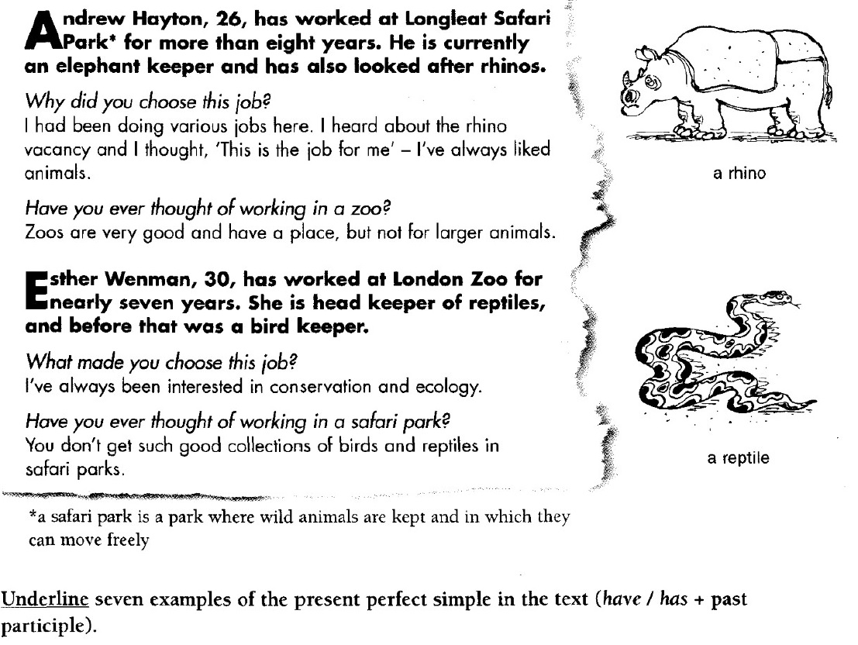

Find examples of the present perfect simple (question form) and make a negative form
Ex) Have you ever thought of working in a safari park?
- I haven`t thought of working in a safari park

Answer key (form focused)
Answer:
Has worked at Longleat /has looked /I`ve liked/ have you ever thought of working in a zoo/
Has worked at Londonzoo / I`ve been interested/ have you ever thought of working in a safari
Find examples of the present perfect simple (question form) and make a negative form
Ex) Have you ever thought of working in a safari park?
- I haven`t thought of working in a safari park
Answer: Have you ever thought of working in a zoo?
Q form :(I haven`t thought of working in a zoo)

Work sheet (meaning focused)

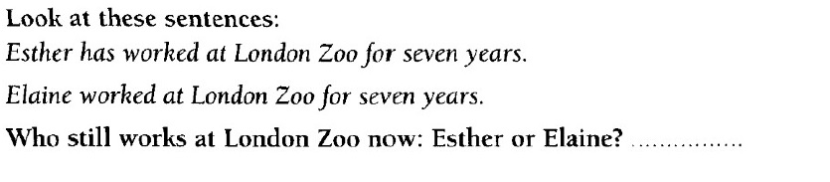
Choose the correct time line
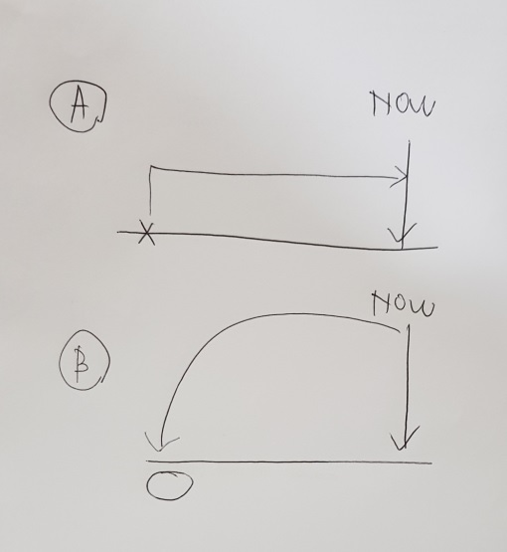

I have read this book several times since the day my mom gave that book to me.
Choose the correct time line

Answer (meaning focused)

Answer :
- A
- B

work sheet (speaking focused)

Go around the class and ask people the Questions. Find someone who answers Yes(비스듬하게) to each question. Write their name next to the question. The person who gets a name for all the questions first is the winner.

1) have you been self employed? (how long? since when?)

2)have you worked at a trading company ? (how long? since when?)

3)have you worked with foreign coworkers? ? (how long? since when?)

4) have you been engaged in commerce ? (how long? since when?)

5) have you been employed as a flight attendant ? (how long? since when?)

6)have you got a safe job like civil service? (how long? since when?)

7)have you worked in a cosmetic store as a salesclerk? (how long? since when?)

8)have you been an office worker? (how long? since when?)

9) have you had your own business ? (how long? since when?)

