Background Information Sheet
Name | Class | Date | Lesson Type | Plan type | Length
You-mi | TESOL 193th | 18 May 2019 | Reading | PPP | 35 min

Lesson
Topic | Visiting the Museum ( National Folk Museum of Korea )
Main Aim | SS practice their reading comprehension.
Secondary Aim | SS practice their speaking fluency.

Materials and References
Leaflet from the National Folk Museum of Korea, PPT file, Picture, White board, Colored marker, Work sheet

Student Profile
Level | Upper Intermediate
Age | Adults (20s-30s) | Number of Students | 4
Detail | There are 3 females and 1 male student.  They are mostly outgoing, enjoy learning in their target language at the class.  All students love to travel.
Assumptions about students’ knowledge as required for this lesson:
It is assumed that the students have experienced to visit the Museum.
It can be an interesting point for the class.

Anticipated Difficulties and their solutions:
Technical failure -> Prepare a picture to cover PPT file
Not familiar with some word from the Museum leaflet -> Pre-teach some key word before reading

My Personal Aim
What I hope most to demonstrate in this lesson is the ability to reduce Teacher Talking time,
and try to give very clear instructions for the students by using appropriate materials.

Stage Name: Lead-in (2min)
Purpose of this stage: To relax both the teacher and students. To focus attention on the lesson. To lead in to the topic, activating background knowledge.
Materials: PPT file, Picture
timing | Interactions | Procedure
30 sec  1 min  30 sec | T  T-S  S-S  T-S | [Greeting]  Hello, class!  How are you doing?  SS: Answer.  [Instruction]  I have a picture to show you guys. (Show PPT file or Picture)  what is it?  SS: Museum.  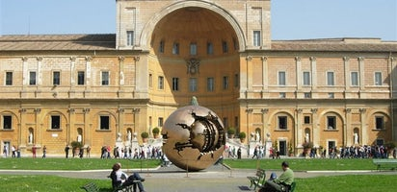  Have you guys ever visited Museum?  Talk to your partner where you visited and how it was.  You guys are partner for today (Divide them into 2 groups)  [Pair work]  Students talk to their partner.  Guys! Can we share what we just talked?  (Nominate one student from each group)  Good! Thank you.

Stage Name: Presentation (7min)
Purpose of this stage: To pre-teach keywords if necessary, and consider guiding questions. These steps provide extra help for students to comprehend the text.
Materials: White board, colored marker, PPT file, Picture
Timings | Interactions | Procedure
3min  2 min  20sec  1min  40sec | T-S  T-S  T-S  S-S  T-S | [Pre-teach keywords]-Folklore  [Elicit] –elicit/mime  Look at this picture (Show PPT file with pointing it)  What is this? (pointing each picture then ask)  SS: story (myths, folktales), wedding ceremony, parade, traditional dance or costume.  Thank you, can you guys think of any word that we can cover all these pictures?  SS: No  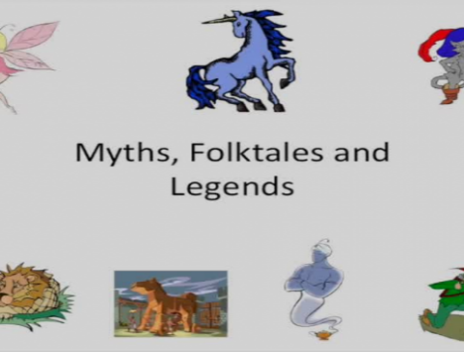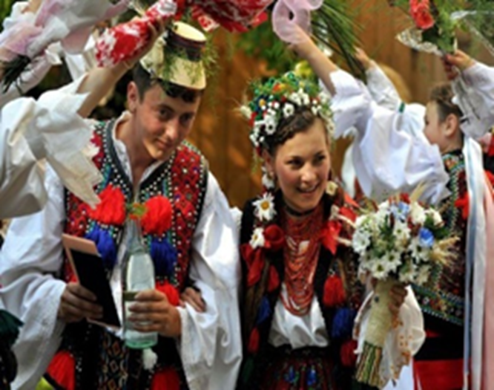  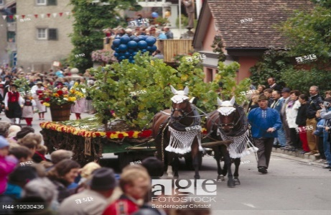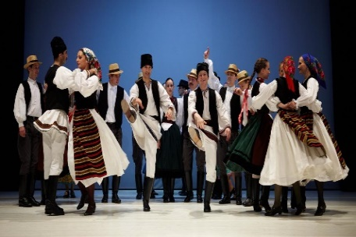  It’s called “folklore” (showing the students about meaning with PPT file)  [CCQ] –check students properly understand the meaning  - Is it traditional things? -> Yes  - Can we only see this in our country? -> No  - Is it passed by word of mouth? ->Yes  Folklore is the traditional beliefs, customs of a certain community or nation.  People told one another over the years  [Drill] -choral and individual drilling for correct pronunciation  T: Please, just listen first “Folk-lore” (repeat 3 times)  This time listen and repeat after me  “Folk-lore”  SS: “Folklore”  Repeat all together 3 times (give them hand gesture to repeat it)  Repeat individually with gesture (teacher correct pronunciation errors)  [Board]-highlight special areas of pronunciation  Board the word “folklore”  T: What part of speech is this?  SS: Noun  T: How many syllables are? (nominate one student for answer)  SS: two (folk/lore)  T: Where is the stress?  SS: first part  Thank you guys  [Pre-teach keyword ds]-Preserve  [Elicit] -Show the picture or PPT file  Look at this picture again.  This is Mozart house  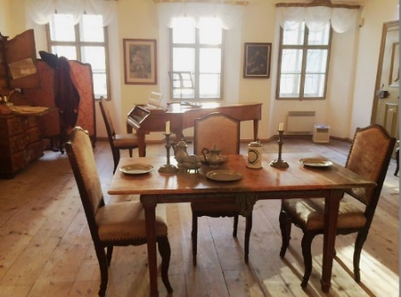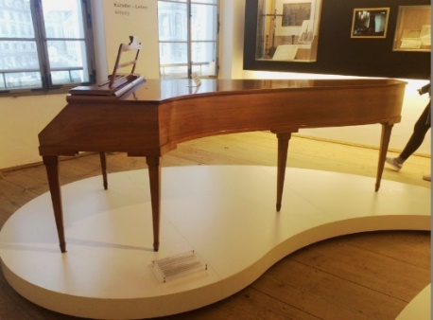  What word do we use if someplace or something is maintained like before?  SS: we don’t know  The word is pre-serve. (show the meaning)  [CCQ]  - Is he(Mozart) still living here? -> No  - Is this house damaged or changed? -> No  - Is there someone to keep it as it is? ->Yes  If you preserve something, you maintain it well in its original.  [Drill]  T: Guys just listen first “Pre-serve”  This time listen and repeat after me  “Pre-serve”  SS: “Pre-serve”  Repeat all together 3 times (give them hand gesture to repeat it)  Repeat individually with gesture (teacher correct pronunciation errors)  [Board]  Board the word “Preserve”  T: What part of speech is this?  SS: Verbs  T: How many syllables are? (nominate one student for answer)  SS: two (Pre/serve)  T: Where is the stress?  SS: first part  [Guiding Question]-connected with reading material  Where would you take people if you want to show Korean traditional things to them? Talk to your partner about it  I can give you guys 1 min. (show PPT file or picture)  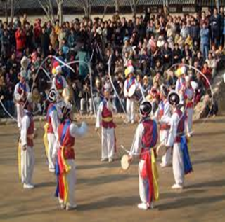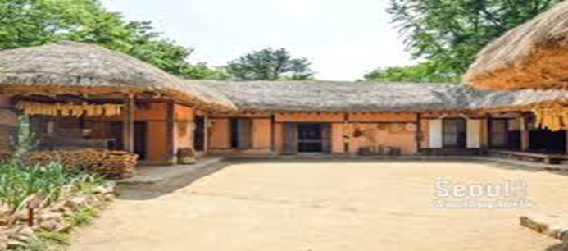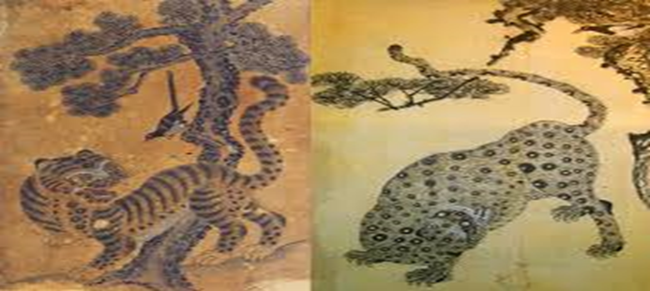  [Pair talk]-Students discuss the question in groups  [Nominate a few students] -to share their ideas  Let’s share about it  [Feedback]  Interesting! We can take people to the folk village or folk museum.  Today’s reading is related to folk museum.

Stage Name: Practice – Literal Comprehension (9min)
Purpose of this stage: is to get students to practice reading for literal detail.
Materials: Worksheet A, Museum leaflet
Timings | Interactions | Procedure
1min  7 min  30 sec  30 sec | T  T-S  S  T  T-S | [Instructions]  Now, we’ll have a reading exercise with museum leaflet which is coming from National Folk Museum of Korea. (Holding and pointing the leaflet)  Check this leaflet first, it has front and back.  I also have a worksheet A here. (holding it)  Please just tick or circle to each question. (gesture)  This is an individual work.  I will give you guys 7 min to finish it. Hand out  [ICQ]  1. Can we finish this worksheet without reading this leaflet? -> No  2. Is it pair work? -> No it’s an individual work  [Individual work]  Give time notification for the students  [Pair check]  Let’s compare with your partner  [Monitor]  [Feedback to check accuracy]  Let’s check the answers together  (Nominate each student for each question)
Stage Name: Practice – Interpretive Comprehension (7min)
Purpose of this stage: is to get students to get students to practice interpreting a text correctly This will require more detailed, careful reading, and thinking time to arrive at the correct answer.
Materials: Work sheet B , Museum leaflet
Timings | Interactions | Procedure
30 sec  5 min  30 sec  1 min | T  S  S-S  T  T-S | [Instructions]  Now, I have work sheet B.  This time, I want you guys to think more with it.  Please, Check this leaflet again then answer these two questions.  It is also an individual work.  I will give you guys 5 min to finish it. Hand out  [ICQ]  How long do we have? -> 5min  Can I do it with my partner? -> No  [Student do their worksheet]  Give time notification  [Pair check]  Alright guys, compare with your partner  [Monitor]  [feedback to check accuracy]  Let’s check the answers together  (Ask another student if nominated student don’t have any idea or we can do it together)

Stage Name: Production - Applied Comprehension (9min)
Purpose of this stage: is for students to practice their speaking fluency on a topic related to the lesson.
Materials: PPT file, Picture
Timings | Interactions | Procedure
1 min  6 min  2 min | T  S-S  T  T-S | [Instructions]  Guys, Look at the screen.  I have two questions, read this first, then talk more with your partner.  (PPT File shows a question and also two type of pictures)  I will give you guys 6 min then we will share with a class  If you don’t have enough time, you can just pick one question from here (pointing the screen). It’s ok with it.  [ICQ]  - Is this reading time or speaking time?  SS: Speaking time  [Applied question]  - If you have two options in your major event like your wedding or baby’s 1st birthday, which type would you choose between traditional and modern way and why?  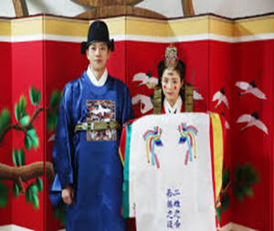 VS 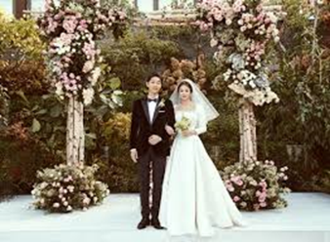  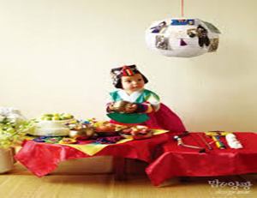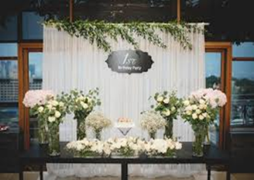  - If you would make your own museum, what you would display and why?  [Pair talk]  [Monitor]  (Give them time notification)  [Feedback]  Let’s share about your idea with a class.  Ask what they’ve talked  (if I have a time to talk, ask all students) Good interesting!
Stage Name: Wrap-up (1min)
Purpose of this stage: to end the lesson on a positive note so that students feel they have achieved progress.
Materials: No materials needed
Timings | Interactions |  | Procedure
1 min | T |  | [Lesson feedback]  Guys, how was your class today?  Was it fun? Maybe this week, you guys can take your friends or family to this museum. (if teacher found an error, let them know about it)  Set homework.  I have home work this weekends.  When you go outside in this weekends, please just pick up at least one reading stuff from anywhere. It can be a newspaper or time table or leaflets.  [Inform students about next lesson]  Next week, we’ll have a time to talk about that reading stuff.  Then write something with that. Thank guys.

Work sheet A

Read your reading material, then answer these questions.
Are the sentences true or false?

- National Folk Museum of Korea is a political place.
True False

- We can see various folklore collections around the world in the two special exhibition galleries.
True False

- Museum becomes independent directly under the Ministry of Culture in 1946.
True False

- In the exhibition 1, we can see what the Korean people ate and wore, and where they lived.
True False

- Museum has a gallery for Donated Artifacts.
True False

- The Open-air Exhibition only presents a traditional village of Korea.
True False

- Last admission is 30 min before closing time.
True False

Answer sheet A
Read your reading material, then answer these questions.
Are the sentences true or false?

- National Folk Museum of Korea is a political place -> cultural place
True False

- We can see various folklore collections around the world in the two special exhibition galleries.
True False

- Museum becomes independent directly under the Ministry of Culture in 1946. -> in 1992
True False

- In the exhibition 1, we can see what the Korean people ate and wore, and where they lived.
True False

- Museum has a gallery for Donated Artifacts.
True False

- The Open-air Exhibition only presents a traditional village of Korea. -> as well as the modern and contemporary streets of Korea
True False

- Last admission is 30 min before closing time. -> 1 hour before
True False

Work sheet B

Answer the questions based on your reading material

- Why does the Museum present the Korean’s life to the people?

- What kind of activities can children and their parents have?

Answer sheet B

Answer the questions based on your reading material

- Why does the Museum show the Korean’s traditional life to the people?
If they don’t preserve these traditional things, it will quickly disappear.
This is why they try to keep it and show it to the people living now

- What kind of activities can children and their parents have?
Attend folk game competition like …
yut-nori (a stick-tossing board game) and neolttwigi (traditional Korean see-sawing).
Join the education program like ...
Culture sharing program (make some special ornament from other countries)
Watch the play for folktales…

Applied question
Talk to your partner about…

- If you have two options in your major event, which type you would choose between traditional and modern and why? (wedding ceremony, baby’s 1year birthday…)

- If you would make your own museum, what you would display and why?
talk to your partner

Instructor’s Comments and Assessment

Pros
Cons
Change
Overall Comments
Grade
Above Standard 85%-100% | Standard 70%-84% | Below Standard 69%-0%
Instructor | Student Signature | Date
Taute, David

