**Background Information Sheet**

|  |  |  |  |  |  |
| --- | --- | --- | --- | --- | --- |
| **Name** | **Class** | **Date** | **Lesson Type** | **Plan type** | **Length** |
| Kim / 김지양 | TESOL | 17/05/2019 | Listening | PPP | 35 min |

|  |  |
| --- | --- |
| **Lesson** | |
| **Topic** | Pete’s a Pizza |
| **Main Aim** | Students will practice their listening comprehension. |
| **Secondary Aim** | Students will practice their speaking fluency |

|  |
| --- |
| **Materials and References** |
| **-**Audio File:<https://www.youtube.com/watch?v=Yj4rKkMO5TE>  **-**William Steig, Pete’s a Pizza by HarperCollins |

|  |  |  |  |
| --- | --- | --- | --- |
| **Student Profile** | | | |
| **Level** | Intermediate | | |
| **Age** | 10 | **Number of Students** | 3 |
| **Detail** | They are all girls. They are close friends. They usually help their mother cook, and it grows their interest in cooking. One of the girls likes talking and is auditory learner. The other two girls are visual learners and like to draw and see pictures. | | |

|  |
| --- |
| **Anticipated Difficulties and their Solutions:** |
| **Technical failure** – Audio might not work. Or there can be wireless connection problem so that I cannot access to the link.  **Solution-** I can use my cell phone to listen.  I can bring an audio CD that is attached to a book or read from the transcript |

|  |
| --- |
| **My Personal Aim** |
| What I hope most to demonstrate is the ability to write down detailed and complete lesson plan |

|  |  |  |
| --- | --- | --- |
| **Stage Name:** Lead-in **(2min 30sec)**  **Purpose of this stage:**  Relaxing students and the teacher. To focus students’ attention on the lesson. To increase students talk.  To introduce the topic or ideas related to the topic | | |
| **Materials:** pictures of food | | |
| **Time** | **Interaction** | **Procedure** |
| 10sec  2min  20sec | T  T-S | **[Before the class starts, prepare to show pictures of food]**  **[Greeting]**  Hello, everyone! How’s it going?  **[Warm-up]**  Look at these pictures (pointing at these pictures)  What can you see?  (Students answer: a pizza, a hamburger, and a spaghetti)  What’s your favorite food?  (Nominating students, and every student gets a chance to answer)  Can you guess what we will talk about today?  (Students answer: food!)  Yes, you guys are right. |

|  |  |  |
| --- | --- | --- |
| **Stage Name:** Presentation**(6 min)**  **Purpose of this stage:** To give students extra support to comprehend the text | | |
| **Materials: a white clay that can be considered as a dough, pictures related to keywords, a ribbon twirl, a worksheet** | | |
| **Time** | **Interaction** | **Procedure** |
| 2min  30sec  20sec  40sec  10sec    2min    20sec | T-S    T  S  T  S-S  T-S | **[Pre-teach keywords]**  **1-knead**  **Elicit-**  What is this white thing in the picture? (Pointing at the picture)  (Students: Clay? Dough? )  It can be a cookie or bread after it is baked.  What is it?  (Students: Dough!)  (Bring a white clay out and start kneading)  What am I doing with the dough?  (Students: squeezing? Pressing? Making a pretty circle shape?)  (When I don’t get the word, ‘knead’ from students)  You’re so close! It is called ‘knead’.  I was kneading the dough.  **CCQ**   1. Do you knead to make bread? (Students: Yes!) 2. Can you knead a rock? (Students: No!) 3. Tell me what else you can make after kneading a dough   (Students: cookies, a pizza)  **Drill**  Listen and repeat after me  “Knead”  (Gesture to make students say the word)  (Students: “Knead” –chorally)  (Make students say the word chorally 2 times)  Student A, Can you say ‘knead’?  (Make sure every student says the word individually)  **Board**  (Write ‘knead’ on the board)  How many syllables in ‘knead’? (One)  What part of speech is it? (verb)  **2-twirl**  **Elicit-**  (Show students a picture of a stick with a ribbon)  What is this?  (Students: a stick with a ribbon)  (Start ribbon twirling and twirl)  What am I doing?  (Students: spinning? Turning around? Twirl?)  Yes, twirl!  **CCQ**   1. Am I twirling? (Miming-twirling) (Students: Yes!) 2. Am I twirling? (Just standing still) (Students: No!) 3. Which is twirling? (Showing pictures) (Students point at one of pictures)   **Drill**  Listen and repeat after me  “Twirl”  (Gesture to make students say the word)  (Students: “Twirl” –chorally)  (Make students say the word chorally 2 times)  Student A, Can you say ‘Twirl”?  (Make sure every student says the word individually)  **Board**  (Write ‘Twirl’ on the board)  How many syllables in ‘knead’? (One)  What part of speech is it? (Verb)  **[Guiding Question]**  **Instruction**  Let’s think of what toppings you want to put on your pizza.  You’ll work on your own pizza shortly.  I.C.Q-What food will you work on? (A pizza)  What do you choose for your pizza? (Choose toppings)  (Hand out the worksheet)  (Work on the worksheet)  Now tell your friends what toppings you choose to put and why.  When your friends talk about their pizza, you can draw their pizzas on the worksheet.  I.C.Q-What do you do when your friends talk about their pizza?  (Draw their pizzas on the worksheet!)  **Group Work**  **Feedback** |

|  |  |  |
| --- | --- | --- |
| **Stage Name:** Practice - Literal Comprehension Listening **(7 min)**  **Purpose of this stage:** Students will practice their literal listening comprehension | | |
| **Materials: Audio file and the worksheet (Exercise A and Exercise B)** | | |
| **Time** | **Interaction** | **Procedure** |
| 30 sec  3 min  30sec  2min  1 min | T        S    S-S  T-S | **[Instruction + Set the purpose for listening]**  (Showing worksheet.)  Here is our worksheet. While you’re listening, you can find answers for questions.  You will work on the worksheet individually.  I.C.Q- Will you work with your partner? (No)  Can you work on the worksheet while listening? (Yes)    (Hand out worksheets.)  Are you ready? Let’s get started!  Play the audio- “Pete’s a Pizza” (2min 30sec)  <https://www.youtube.com/watch?v=Yj4rKkMO5TE>  **[Students listen for the 1st time]**  **(30sec) Pause-**Give students time to finish multiple choice questions  Are you ready to listen the rest?  (Students: Yes)  **Play**  (After listening)  **Group Work**  Share your answers with your friends for 2 min. Try to help each other.  (Monitoring students to see how they did on the worksheet)  **Feedback to check answers are correct**  What is the answer for the first question? (Students: 3)  What is the answer for next question? (Students: 4)  Next part is putting pictures in right order.  Which picture comes first? (Students: 3)  What is happening in the picture? (Students: Kneading)  Next is…? (Students: 2)  And then….? (Students: 1)  Next one? (Students: 6)  Next? (Students: 4)  What is the last one? (Students: 5) |

|  |  |  |
| --- | --- | --- |
| **Stage Name:** Practice - Interpretive Comprehension Listening **(6 min 30 sec)**  **Purpose of this stage:** Students will practice inferring and interpreting | | |
| **Materials: Audio file and the worksheet** | | |
| **Time** | **Interaction** | **Procedure** |
| 30 sec  4min  2min  1 min | T  S  S-S    T-S | **[Instructions]**  Go onto the next page, and there is Exercise B. There are two Questions. This time, you need to think a little harder.  I will let you listen the whole story one more time.  **[I.C.Q]**  How many questions are you going to answer? (Students : two)  Are you going to listen one more time or just answer questions?  (Students: Listen one more time)    Play the audio- “Pete’s a Pizza” (2min 30sec)  <https://www.youtube.com/watch?v=Yj4rKkMO5TE>  [**Students listen for 2nd time**]  This time, show students video (Same audio but with pictures from the book).  There is no pausing this time.  Students work on the worksheet individually after listening.  **Group Work**  Share your answers with your friends for 2 minutes. Tell them what you thought and why you thought that way.  (Monitoring how students are doing. Trying to encourage students to talk more)  **Feedback** (Get to hear from every student. Nominate a student who likes talking first) |

|  |  |  |
| --- | --- | --- |
| **Stage Name:** Production - Applied Comprehension Speaking**(9 min)**  **Purpose of this stage:** Students will practice their speaking fluency | | |
| **Materials: The worksheet for Exercise C** | | |
| **Time** | **Interaction** | **Procedure** |
| 30 sec  1 min  30sec  5 min  2 min | T      S    S-S  T-S | **[Instructions]**  Let’s think what food you would make Pete into if you were Pete’s father. Write down what food you choose and make your recipe.  What would you need when you cook?  (Students: ingredients and recipe)  Right. First, work individually.  I.C.Q- Will you work with your friends on the first page?  (Students: No)  Here is the worksheet.  (Hand out the worksheet)    **(Students work on the worksheet individually)**    Are you ready to share your recipe with your friends?  Turn to the second page of worksheets.  Talk to your friends for 5 minutes and write down your friends’ recipe.  You can learn how to make other food!  **Group Work**  (Students fill out the worksheet by asking friends and talking)  (Monitoring students and encouraging them to talk)  **Feedback**  (Ask students what food they choose to make and how they can make it) |

|  |  |  |
| --- | --- | --- |
| **Stage Name:** Wrap-up**(2 min)**  **Purpose of this stage:** End the lesson on a positive note. General lesson feedback | | |
| **Materials:** | | |
| **Time** | **Interaction** | **Procedure** |
| 2 min | T | **[Ask students if they have a question to ask]**  What part of the lesson did you like?  Do you have any question about today’s lesson?  **[Lesson feedback]**  I liked how you guys tried so hard.  I’m glad that you guys do your best to do all the exercises!  **[Review Keywords]**  Do you remember the words we learned today?  What do you do with the dough? (Students: Kneading)  **[Assign homework]** |

**[Pictures that I will show during Lead-in]**

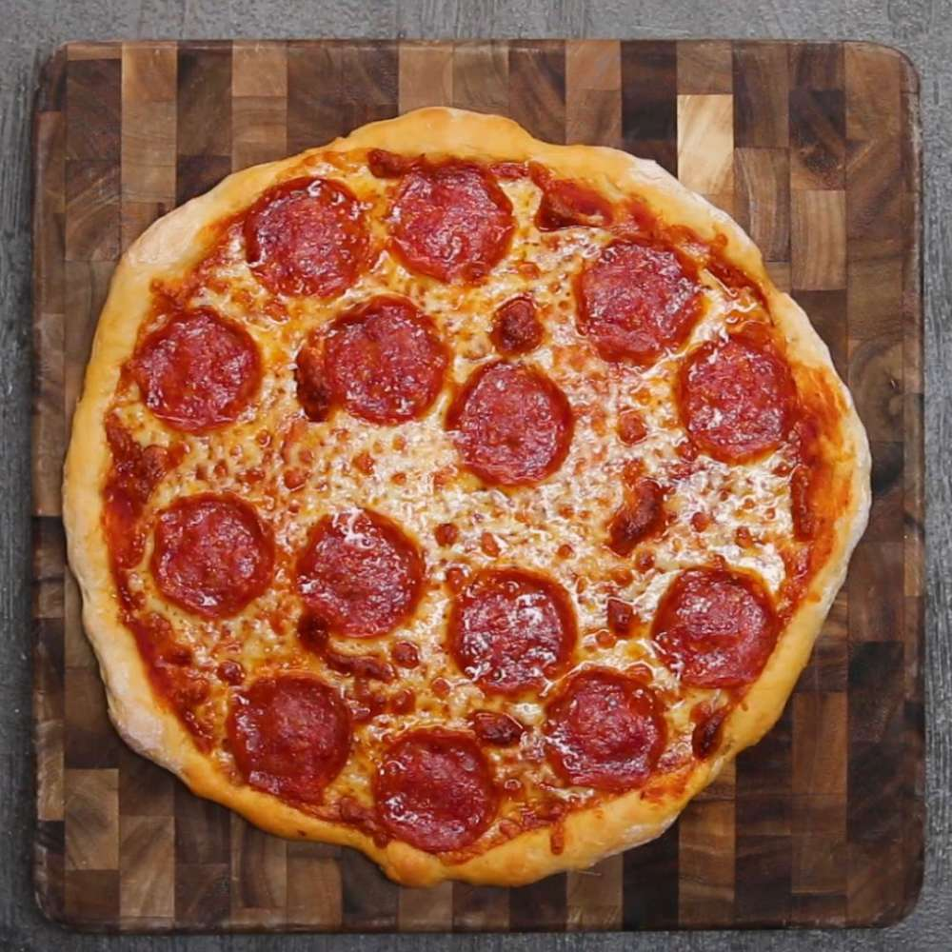

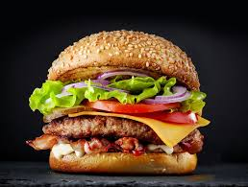

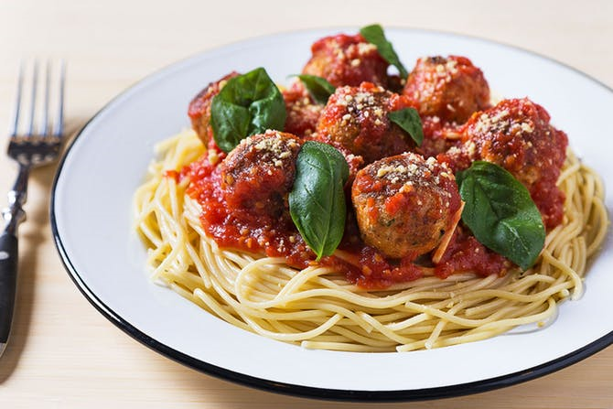

**[Keywords –C.C.C]**

* + - 1. **Knead**

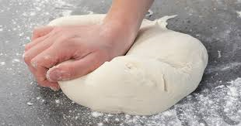

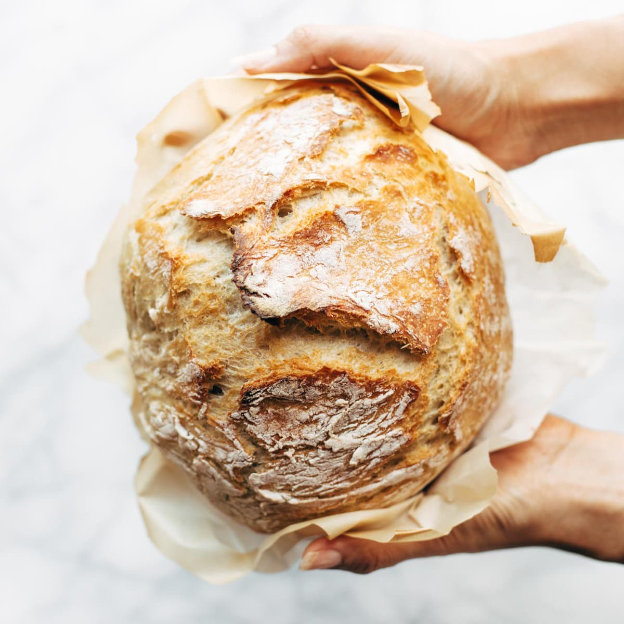

**2. Twirl**



(Pictures for C.C.Q- discriminative question)

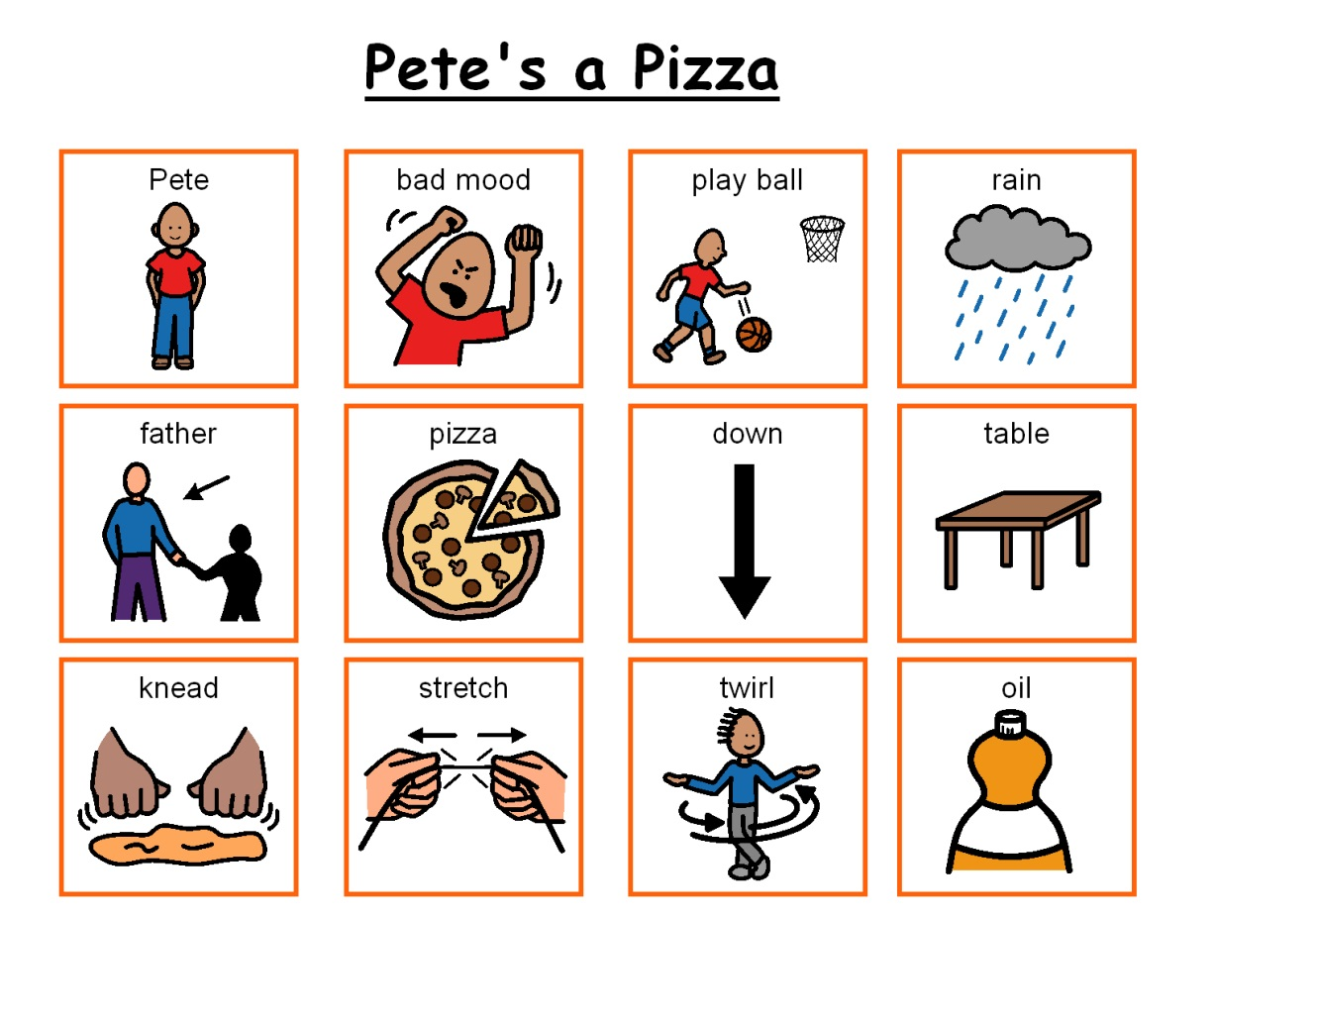

<Picture A>



<Picture B>

**[Guide Questions]**



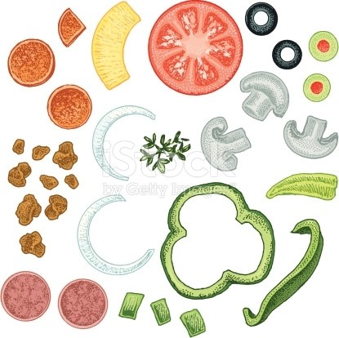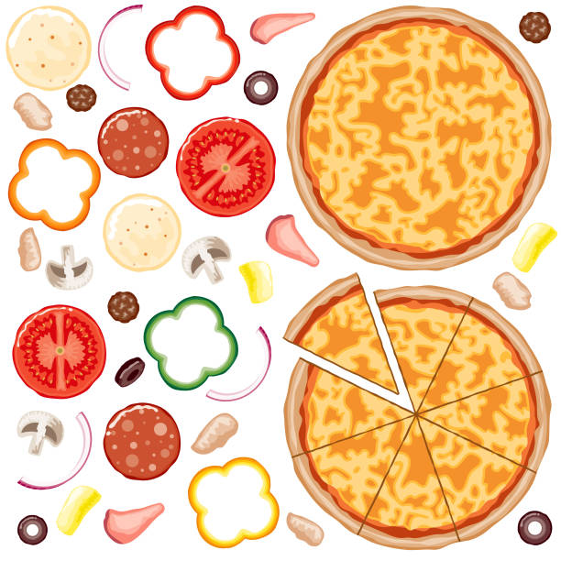

**[EXAMPLE: Tomato / Olive / Mushroom / Onion / Bacon / Pineapple / Parsley /**

**Pepperoni / Mozzarella / Cheddar / Gorgonzola / Basil / Paprika / Nuts ]**

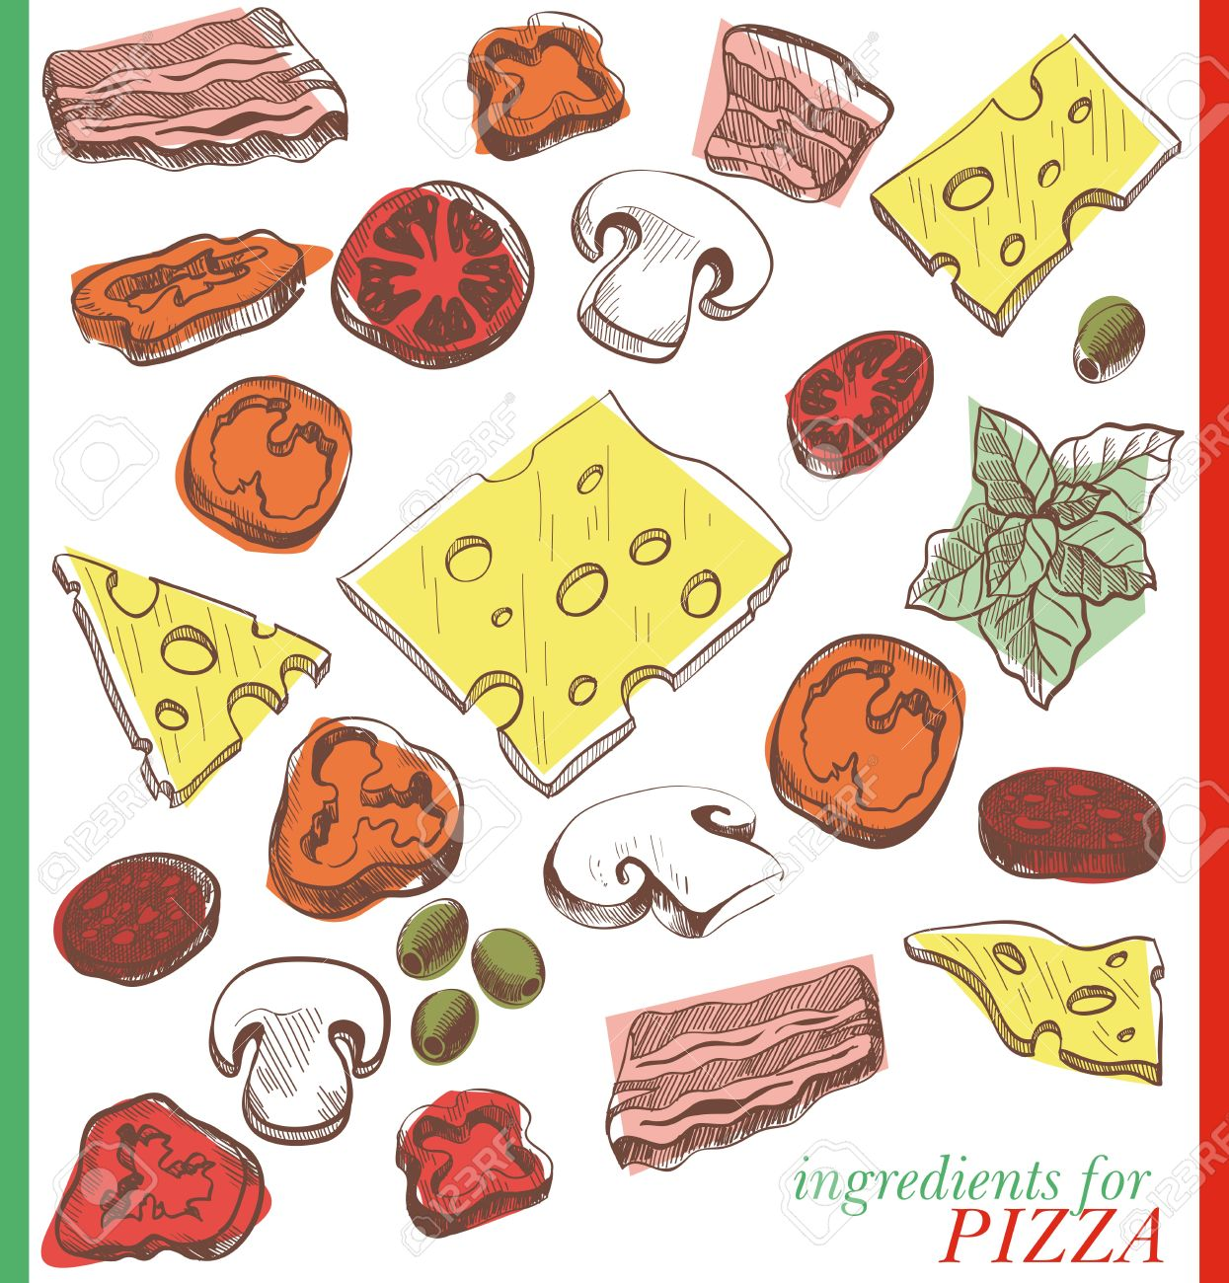

**[Listening Transcript]**

<https://www.youtube.com/watch?v=Yj4rKkMO5TE>

Pete's in a bad mood. Just when he's supposed to play ball with the the guys, it decides to rain.

Pete's father can't help noticing how miserable his son is.

He thinks it might cheer Pete up to be made into a pizza.

So he sets him down on the kitchen table.

And starts kneading the dough

And stretching it this way and that

Now the dough gets whirled and twirled up in the air

Next, some oil is generously applied (it's really water.)

Then comes some flour (it's really talcum powder)

And then some tomatoes (They're really checkers)

Pete can't help giggling when his mother says

She doesn't like tomatoes on her pizza.

"All right," says his father, "No Tomatoes, just some cheese" (the cheese is pieces of paper).

"How about some pepperoni, Petey?"

Pete can't answer because he's only some dough and stuff

But when that dough gets ticked, it laughs like crazy

"Pizzas are not supposed to laugh"

"Pizza makers are not supposed to tickle their pizzas!"

"Well," says his father,

"It's time for this pizza to be put in the oven"

"Ah! Now Out pizza is nice and hot!"

Pete's father brings the pizza to the table

"It's time to slice our pizza" He says

But the pizza runs away and the pizza maker chases him

The pizza gets captured and hugged

Now the sun has come out

And so the pizza decided to go look for his friends

**Instructor’s Comments and Assessment**

|  |  |  |
| --- | --- | --- |
| **Pros** | | |
|  | | |
| **Cons** | | |
|  | | |
| **Change** | | |
|  | | |
| **Overall Comments** | | |
|  | | |
| **Grade** | | |
| **Above Standard 85%-100%** | **Standard 70%-84%** | **Below Standard 69%-0%** |
| **Instructor** | **Student Signature** | **Date** |
| **Taute, David** |  |  |