Exercise B
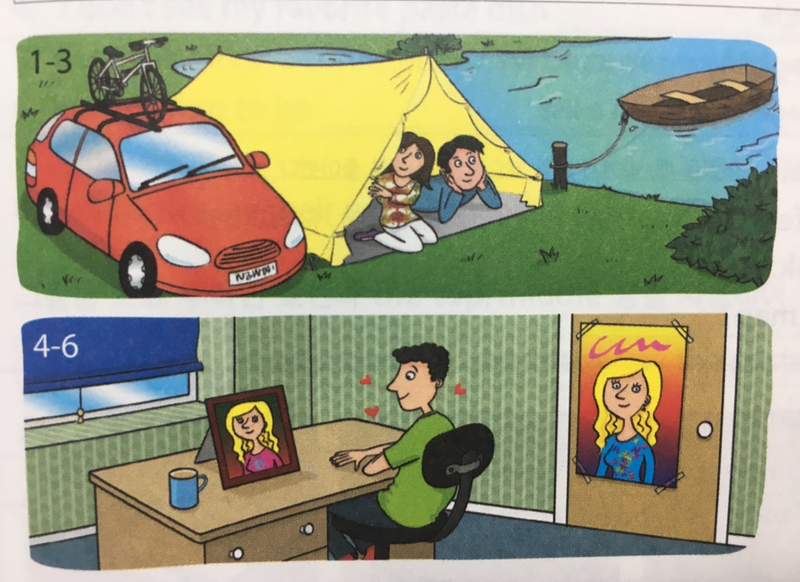
Complete the sentences. Use in, at, or on.
Example: 1. There is a boat on the lake.

2. Two people are _____________________________________________________________.

3. There is a bicycle __________________________________________________________________.

4. There is a poster _____________________________________________________________________.

Make your own sentence about the pictures! Use in, at, or on.

1. _________________________________________________________________________________________

2. ________________________________________________________________________________________

Exercise A
At | *Specific point or place  -an exact address  -events | -at home  -at school  -at the airport  -at a party  -at the traffic light  -at the bus stop
In | *Enclosed space  -Towns or cities | -in a garden  -in a country  -in a room  -in a box  -in a town/ city  -in a pool  -in a building
On | *For a surface | -on the floor  -on the wall  -on the ceiling  -on the table  -on the second floor  -on Main Street  -on the bench
*Complete the sentences with in, at, or on.
Example: Peter lives _in Turkey
1. I’ll meet you _____ the airport.
2. She has a house _____ Japan
3. I might just watch TV ____ home.
4. All cars must stop ______ the traffic light when the light is red.
5. Is the cafeteria ______ the 2nd floor?
6. This car key was _____ the table. Is it yours?
7. The people are ______ a party.
8. There were some people swimming ______ the pool.

