Background Information Sheet
Name | Class | Date | Lesson Type | Plan type | Length
Chris Park | TESOL | 8-10-2019 | Grammar | PPP | 30 min

Lesson
Topic | A is taller than B. A is the tallest.
Main Aim | Students will learn the 2nd conditional.
Secondary Aim | Students will practice their speaking fluency.

Materials and References
Board, Marker, Worksheet

Student Profile
Level |  | Lower Intermediate
Age |  | adults |  | Number of Students | 3
Detail |  | Each Student is going to be taught how to use the correct comparatives and superatives.  Each Student is going to
Assumptions about students’ knowledge as required for this lesson:
- Students know the vocabulary used in this lesson
- Students have learned about the subject and ‘be’ verb relationship
- Students know how to make the negative form using ‘not’
What language difficulties to expect when presenting, and how to deal with it:
- Meaning: “If I had a million dollars; I’d buy a new car.” Students may think it is talking about a real situation in the past because of the word ‘had’. Make a clear visual context and C.C.Q.

- Form: Students may confuse how to use the if-clause e.g. ‘If I buy a new car I had a million dollars.’ Identify the two separate clauses being the if-clause and the result/consequence clause. Highlight the variable sentence structure.
E.g. I’d buy a new car if I had a million dollars.

- Pronunciation: Students may not know where to put natural sentence stress. Drill several times chorally, then individually. Ask, “Which words sound stressed?” Board the stress markers in red.

Anticipated Classroom Management Difficulties and their Solutions:
The quantity of new language points to be learned about the 2nd conditional is too much for students to handle in a short 30 minute lesson. This could lead to anxiety, rushing, and a lot of teacher talk. For this lesson I will manage this by selectively presenting only a few new concepts about the 2nd conditional. The remaining new language points can be presented in the next lesson.
My Personal Aim
What I hope most to demonstrate in this lesson is the ability to
- present the target language using a situational presentation
- to be an involver type teacher
Stage Name: Lead-in
Purpose of this stage: To relax both the teacher and students. To focus attention on the lesson. Create a situation for students to experience or think about, and then to elicit the target language.
Materials: List all materials that will be needed in this stage.
Timings | Interactions |  | Procedure
1min | T-S |  | Draw two persons. One person (A) is tall and the other person (B) is short.  Let the students elicit a new sentence. (A is taller than B.) (B is shorter than A.)  Draw three persons and write “A”,”B”, and “C” below each person. (A is the tallest.)  Make a sentence only about “A”. (A is the tallest.)  Write three sentences about both “B” and “C”.  (B is shorter than A.) (B is taller than C.) (C is the shortest.)
Stage Name: Presentation
Purpose of this stage: Make the students think about the situation. To clarify the meaning, form, and pronunciation features of the target language.
Materials: List all materials that will be needed in this stage.
Timings | Interactions |  | Procedure
30sec  2min  3min  1min | T  T-S  T-S  T-S |  | Board the model sentence (if students are unable to tell you, just board it).  CCQ – ask questions..  1 Are we comparing A and B? (Yes.)  2. Are A and B different? (Yes.)  3. Is C the tallest? (No.)  Form – clarify the affirmative, negative, question form, or other special features. Substitution tables may be of use.  Adjective Comparative Superlative  tall taller tallest  short shorter shortest  big bigger The biggest  Drill – drill the spoken form, focusing on contractions, stress and intonation.  - Say and gesture “Listen and repeat: [model sentence.]”  - Make special pronunciation features visible on the board, using colour.  - Nominate each person to say the model sentence three times.
Stage Name: Controlled Practice
Purpose of this stage: students practice working with the form (scrambled sentences, split sentences, select the correct form of the verb, correct incorrect sentences, and change one form into another form). Accuracy must be checked.
Materials: List all materials that will be needed in this stage.
Timings | Interactions |  | Procedure
1min  2min  2min  2min | T  S  S – S  T - S |  | Instructions. Tell the students to do Exercise A.  ICQ.  Positive: A is taller than B. A is the tallest.  Negative: A is not tallest than B.  Question: Is A taller than B?  Hand out the worksheets. And students do a worksheet.  Pair check.  Feedback to check accuracy. Board correct answers visually.
Stage Name: Less Controlled Practice
Purpose of this stage: students practice working with the meaning (match a timelines to sentences, choose the sentence that matches a picture, gap-fill a paragraph). Accuracy must be checked.
Materials: List all materials that will be needed in this stage.
Timings | Interactions |  | Procedure
30sec  2min  2min | T  S-S  T-S |  | Instructions.  Turn over your worksheet. Exercise B tells you to make 2 true sentences about the two people.  Pair Work  Feedback
Stage Name: Production – Freer Practice
Purpose of this stage: is to get students to practice the grammar communicatively.
Materials: List all materials that will be needed in this stage.
Timings | Interactions |  | Procedure
30 sec  5 min  1min | T  S-S  T-S |  | Instructions. (Visual.)  Students are required to talk to each other, comparing themselves to the others.  Each student is required to use both comparatives and superatives.
Stage Name: Wrap-up
Purpose of this stage: is to end the lesson on a positive note so that students feel they have achieved progress.
Materials: List all materials that will be needed in this stage.
Timings | Interactions |  | Procedure
1 min  1 min | T – S  T |  | Offer delayed corrections to the previous stage.  - “Look at the board. Do you know how to correct them?”  - A is more taller than B. A is the much tallest person.  Now, you can use both comparatives and superlatives. Even though you cannot use them perfectly,

Instructor’s Comments and Assessment
Pros
Cons
Change
Overall Comments
Grade
Above Standard 85%-100% | Standard 70%-84% | Below Standard 69%-0%
Instructor | Student Signature | Date
Taute, David
Worksheet: ~er than, the ~est

Example 1
Positive: A is taller than B.
Negative: A is not taller than B.
Question: Is A taller than B?

1) Positive: Chris is shorter than Michael.
Negative:
Question:

2) Positive:
Negative: Dan is not fatter than Dave.
Question:

Example 2
Positive: A is the tallest.
Negative: A is not the tallest.
Question: Is A the tallest?

3) Positive: David is the tallest.
Negative:
Question:

4) Positive:
Negative:
Question: Is Daniel the shortest?
Answersheet: ~er than, the ~est

Example 1
Positive: A is taller than B.
Negative: A is not taller than B.
Question: Is A taller than B?

1) Positive: Chris is shorter than Michael.
Negative: Michael is not shorter than Chris.
Question: Is Chris shorter than Michael?

2) Positive: Dave is fatter than Dan.
Negative: Dan is not fatter than Dave.
Question: Is Dan fatter than Dave?

Example 2
Positive: A is the tallest.
Negative: A is not the tallest.
Question: Is A the tallest?

3) Positive: David is the tallest.
Negative: David is not the tallest.
Question: Is David the tallest?

4) Positive: Daniel is the shortest.
Negative: Daniel is not the shortest.
Question: Is Daniel the shortest?
Worksheet: ~er than, the ~est
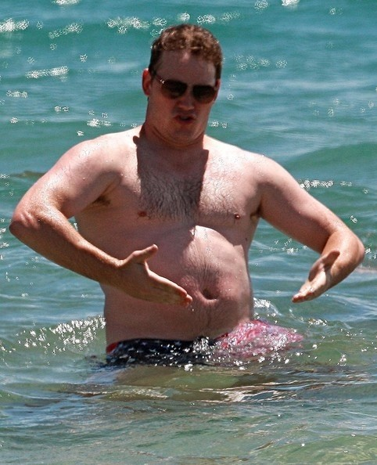
Chris Pratt Tom Hiddleston

1)
2)
3)
4)

Answersheet: ~er than, the ~est
Chris Pratt Tom Hiddleston

1) Chris Pratt is fatter than Tom Hiddleston.
2) Chris is the fattest.
3) Tom Hiddleston is slimmer than Chris Pratt
4) Tom Hiddleston is the slimmest.

