Shin yeon kyung
196th WD

My experience of L2 Acquisition- a Success or Failure?

The definition of second language acquisition means the process of learning other languages in addition to the native language. ln my essay i would like to write about my experience how i got my second language. was the method used did they made a success results or was is failure? I can say in my experience it was failure.
During old day in my class many teachers was not approach to building a Rapport with students.it was like teacher talk to much(T.T.T)to the students and students listen too much situation. They were like much likely a explainer. type of teacher lots of lecturing not much developed teaching method. They used traditional type of teaching style.
however, it cause less effective interaction between students and the teacher. They gave us too much homework to do which depend too much on writing ,vocabulary, checking grammar and learning by study it force to get higher mark all times. was not much fun memory i recall.
if i were them as i have learned from TESOL(teaching English to speakers of other language) lesson i will find out what are individual learner differences to build better relationship with the students and also to make the lesson effective to all most of the class.
Firstly, knowing individual learners find out why do they need to learn second language their age,ability,interest,skills,jobs and more noted to provide suitable level and get more ideas to improve teaching method. If my teacher taught me the way i wanted to be learn like more fun and interesting topics? and learning by doing it naturally how will that be affect to my daily life? I guess i became the person who is more communicate with others freely and more creative maybe?unfortunatlly our time was still followed traditional type.
As we want to learn more about individual learner differences we can refer to Malcolm Knowles- Characteristics of Adult.
in his research we can easily find out how important to understand individual learner differences.
• Autonomous & Self-directed.
Adults learners are Self-directed not like a young age student they can encourage themselves to participate in the lesson
• A foundation of life experiences & knowledge.
Learners need to connect learning to their knowledge and experience base like family relationships, professional life, and previous academic experience or more.
• Goal-oriented
When they are in a course, learners usually know what goal they want to attain.
As a teacher we have to provide relevant lesson with tools for them to reach their goal successfully. And of course with some respect because their living experience are valuable it is sometime as teacher might learn from them.
what about for children lesson? Do they know how to self direct?do they have many life experience? Do they do their goal to attain the second language class very clearly? Answers are no.as you have learned we have to understand learner differences and let all different type of groups to reach their goal while they acquisitionL2.
Secondly, it would be successfully accepted if classroom dynamics seated up a
positive classroom atmosphere where students feel comfortable learning and communicating with class.
My day in the classroom the table arrangement was one line narrow next to each other seated.
Let me compare some of traditional type of class room and modern classroom.
• traditional type-they were too many students in the class vs 1 teacher in the results,studnets was not have many chance to talk to teachers they could not have many question not much group work more or less individual study.
• Modern type. Class arrangement done horse shoes type less students in the class in the results teacher can pay more attention to every students and the arrangement make easier for students to communicate each other
Here are in fact chart shows learner retention rates

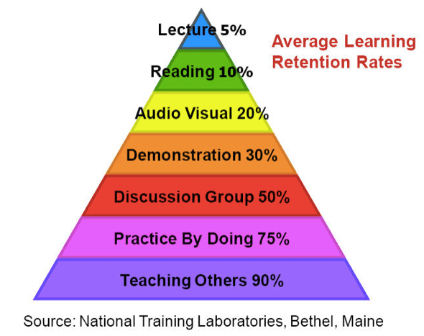
that most students only remember about only 10% of what they read from textbooks, but 90% of what they learn through teaching others. This charts shows and suggests that some methods of study are more effective than others.
In a conclusion what we have learned our second language during old days was not very effective. When i become a teacher i will highlight few points i learned i want to make use if it to have more fun and enjoyable learning and teaching help students to acquisition second language fluently.

734words

