Background Information Sheet
Name | Class | Date | Lesson Type | Plan type | Length
Jina / Shin WD 198 | TESOL | 24/09/2019 | Listening | PPP | 35 min
Lesson
Topic | “boy band”
Main Aim | Student will practice their listening comprehension.
Secondary Aim | Student will practice their speaking fluency.
Materials and References
Audio file.( https://learnenglishteens.britishcouncil.org/skills/listening/upper-intermediate-b2-listening/boy-bands) Work sheets. Audio transcript. Picture. speakers. computer monitor. White board and color board markers.
Student Profile
Level | Upper-intermediate
Age | Teenager | Number of Students | 10
Detail | Everyone is Korean.  There is age between 16~19  There is 5 female students and 5 male students  They have a good rapport
Anticipated Classroom Management Difficulties and their Solutions
Technical Failure – prepare a back-up audio file on my smart phone
Absence, lateness – send worksheet and audio file to student
My Personal Aim
Complete and detail lesson plan.

Stage Name: Lead-in(4min)
Purpose of this stage: To relax both the student and teacher
To lead-in to the topic

Materials: A picture of “one direction band” , computer monitor.
Time | Interaction | Procedure
30 sec  2 min  1min  30 sec | T  T-S  S-S  T-S | <greet instructions>  Hello everyone! ( S.S: Good! )  Great, good to see all of you today  Today we will start from taking a look at a picture and telling me what it reminds you of.  (monitor show “one direction band” picture)  What do you guys think about band?  (S.S : I love their music, I think they are cool. // Well I don’t like them.)  Do you have any favorite band music? If you don’t have any why not?  Discuss with your partner.  Time is up! Can you share your discussion with your class?  (nominate 3 students to share their opinion)

Stage Name: Presentation(6min)
Purpose of this stage: To help students better able to understand difficult words.

Materials: Board and colored markets.
Time | Interaction | Procedure
3 min  10 sec  2 min  50 sec | T-S  T  S-S  T-S | Pre-teach Key words  “unthreatening”  Elicit – elicit/mime  Show the picture on the board image1, image2  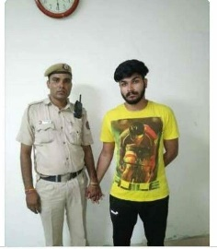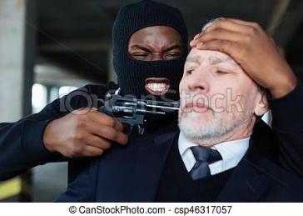  - Class look at the picture what are they doing now? Who are they?  <SS: scary, bally someone, robbery…>  - The one who wearing a mask what is he doing to the old man?  <SS: he seems like threatening the old man!>  CCQ – check students properly understand the meaning?  - If someone threatening you will you feel scary?  <SS: yes!>  - If you see someone threatening others will you call police man for help?  <SS : yes!>  - What’s the opposite meaning threatening?  <SS: unthreatening>  Drill  - Please listen and repeat after me “unthreatening”  - Very good now listen and repeat 3times  (“unthreatening, unthreatening, unthreatening”)  - Select one or two student check accuracy  Board  - Write the “unthreatening” on the board with black marker.  - Ask student  how many syllables? (3 syllables)  what part of speech? (adjective)  where is the stress? (first)  guiding question  what is your first thought when you hear the good boy band is?  - Discuss with your partner  Time is up! Can you share your opinion?

Stage Name: Practice - Literal Comprehension Listening (8min)
Purpose of this stage: To get students to practice their listening skill

Materials: An audio file, worksheet, a picture of “ one direction” on the screen.
Time | Interaction | Procedure
1min  3 min  2 min  2 min | T  S  S-S  T-S | Now we are going to listen to two people talk about boy band  Listen carefully and answer the questions on worksheets.  (hand out worksheets to students)  Play the audio  Students listen for the 1st time, and writhe answers on the worksheet. There are 4 literal questions.  - What are the two ability for traditional boy band?  - Why does boys band have different appeal?  - “Well, we have to talk about them because they’re the biggest thing at the moment” here who are they talking about? Who are the biggest thing at the moment?  - What age group does one direction appeal to exactly?  (pair check)  Now when you done writing, please compare your answer with your partner  Alright, class let’s check the answer together  Now, one student to read the questions and answer.  (nominate 3students share their opinion.

Stage Name: Practice - Interpretive Comprehension Listening(7min)
Purpose of this stage: To students listen thoughtfully to interpret meaning

Materials: an audio file, worksheet
Time | Interaction | Procedure
30 sec  3 min  2 min  2 min | T  S  S-S  T-S | Now you will listen again to the audio one more time. While you are listening to the audio.  Please turn over the worksheet answer the one question and true or false questions.  Student listen for the 2nd time  - To attract bigger fan group does appearance are important for boy’s band?  <True false question.>  a) are the boy’s band is always popular?  - One direction first become famous on youtube?  c) to attract bigger fan group it is important to appear unthreatening?  They will answer the 3 true or false questions and one question in the worksheet.  Walk around the class to check if they are finish their answer.  Check the time  *give extra time if needed.  Time is up.  Discuss your answer with your partner  Nominate 4 students to share their answer.

Stage Name: Production - Applied Comprehension Speaking(7min)
Purpose of this stage: Students practice speaking offer necessary support

Materials: no material needed
Time | Interaction | Procedure
1 min  5 min  1 min | T  S-S  T-S | Okay guys I have a question for you.  If you are stylist how would you like to style one direction band’s each member?  List different type for 5 of them.  Discuss with your partner  Select two group to share their idea to the class

Stage Name: Wrap-up(2min)
Purpose of this stage: To end lesson on ? feeling

Materials:
Time | Interaction | Procedure
2 min | T | Well done guys you all did very good job today. Thank you all for great participation.  This one my homework for you today.  Please do reviewing today’s lesson at home. That’s all for today.  Please arrange the table and clean up your area before you go thank you all for today class.

Instructor’s Comments and Assessment
Pros
Cons
Change
Overall Comments
Grade
Above Standard 85%-100% | Standard 70%-84% | Below Standard 69%-0%
Instructor | Student Signature | Date
Taute, David

<PICTURE>
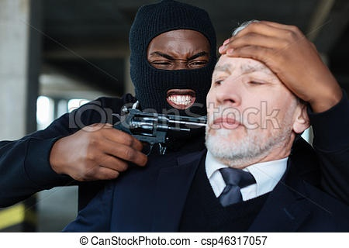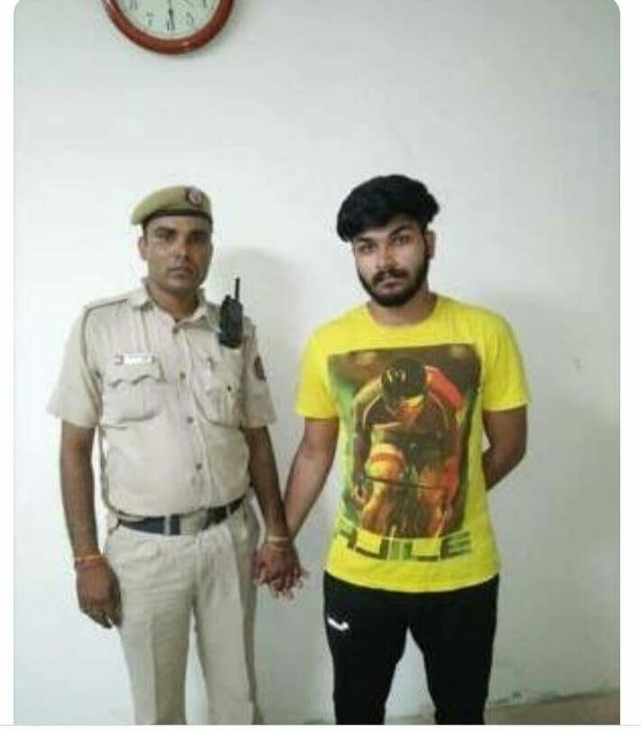
Work sheet 1
Literal question

Listen and write the answer next to the question.
- What are the two ability for traditional boy band?
Answer musical ability ability to dance
- Why does boys band have different appeal?
Answer – appeal to different girls, so you can have a bigger fan base.
- “Well, we have to talk about them because they’re the biggest thing at the moment” here who are they talking about? Who are the biggest thing at the moment?
Answer – one direction
- What age group does one direction appeal to exactly?
Answer – teenage girls

Work sheet 2
Interpretive question

Listen carefully, think and white your answer
- To attract bigger fan group does appearance are important for boy’s band?
Answer – yes, it is important. If the group have different look like cut, rebel, joker shy, mysterious
they can attract different type of people it will help for them to have bigger fan group.

<True false question.>
a) are the boy’s band is always popular?
Answer - false
- One direction first become famous on youtube?
Answer – false
c) to attract bigger fan group it is important to appear unthreatening?
Answer – true

Applied question
If you are stylist how would you like to style one direction band’s each member?
List different type for 5 of them.

☞Script
Boy bands
Presenter: The internet is full of articles about what makes a good boy band. But many bands appear and disappear without a trace. Alana, it can’t be as easy as following a formula, can it?
Alana: No, I don’t think so. The traditional formula is that you have four or five good-looking young guys with some musical ability and the ability to dance – the choreographed dancing was very important to boy bands in the past. They tended to wear the same, or very similar clothes when they performed, so you had to decide on a ‘look’ for the group. The most important element, however, was said to be that the band members had different and very distinct personalities.
Presenter: Right, the cute one, the rebel, the joker, the shy one, mysterious one ...
Alana: Yeah, although sometimes they all just seem to like the cute one! The idea is that different boys appeal to different girls, so you can have a bigger fan base. There’s someone in the band for everyone.
Presenter: So, do you think this all still holds true? Or have things changed in the 21st century?
Alana: Yeah, I guess things have changed for several reasons – partly just because we needed a change – but mainly because of changes in the media and with new technology. Take One Direction …
Presenter: Ah, I’ve been counting the seconds before you mentioned One Direction!
Alana: Well, we have to talk about them because they’re the biggest thing at the moment, although who knows how long they will last.
Presenter: Oh, ages and ages ...
Alana: We’ll see. Anyway, One Direction, as you know, came to fame through the X Factor, a reality show, and that was a great way to start. You had loads of people watching them every week and wanting them to win. They felt as if they had a personal stake in their story as they voted for them every week.
Presenter: What age group does One Direction appeal to exactly?
Alana: That’s another clever thing, they seem very unthreatening, so they appeal to very young girls, they are cute so teenage girls really like them, but they also have a laddish, slightly naughty side to appeal to the mums! The teenage girls and the mums are the ones who will spend money. The lyrics to the songs are calculated to appeal to girls who feel a bit insecure about themselves, like most teenage girls."You don't know you're beautiful, that's what makes you beautiful", that kind of thing. Lots of girls want to feel wanted, but not scared, and that’s traditionally what boy bands do. They present this image of a clean-cut, reliable boyfriend. Actually, One Direction’s clothes also help here: chinos and clean casual shirts and canvas shoes. You’ll have noticed that they don’t wear the same clothes. Their stylists have been instructed to keep them looking individual, but despite that they all have this attractive but unthreatening look. No tattoos, or piercings, or black leather, or make-up or anything.

