Background Information Sheet
Name | Class | Date | Lesson Type | Plan type | Length
Luna | TESOL | 05/10/2019 | Listening | PPP | 35 min
Lesson
Topic | Getting advice
Main Aim | Literal listening comprehension
Secondary Aim | Students practice their speaking fluency
Materials and References
○ Transcript and listening file: https://learnenglish.britishcouncil.org/b2-upper-intermediate-listening/getting-advice
● Dictionaries
○ Images from google

Student Profile
Level | Upper intermediate
Age | Adults | Number of Students | 2
Detail | ▷ They are female.  ▶ They have job experience.  ▷ They graduated university.  ▶ They are good adviser, and good listener.
Anticipated Classroom Management Difficulties and their Solutions
▷ Audio website does not work -> play backup audio file from the cell phone.
▶ Late/absent student -> (Late student) If she come almost beginning or middle of the class, she could listen 1 time and start working with the activity. (Absent student) Send a link the website, and activity sheet and she chould do it as an assignment; then, check the answer next class.
▷ Unknown Vocabuluary -> It could be covered by procedure, and teach the keyword.

My Personal Aim
To give them clear instruction, and students have fun with doing this activity at the same time expand their listening skill.

Stage Name: Lead-in
Purpose of this stage: Asking a question to student that related with topic, it allows to have more SS(student center). Students share their idea freely. Thus, students would be interested, and easy to understand the listening topic.

Materials:
Time | Interaction | Procedure
10 sec  30sec  1min 30sec  30 sec | T  T-S  S-S  T-S | <Greet>  “Hello everyone!”  “How was your weekdays?” - (Student answer)  “I had a long hard weekdays”  “When I'm stressed, I like to talk about it with my friends because she makes me feel relief”  “How about you guys?”  <Instructions>  Q: “what do you do when you get stressed? and how do you handle it?”  “Talk about it with your partner”  <Brainstorm/talk to a partner>  - moniotring their discussion  <Feedback if appropriate.>  “Okay. Can anyone share their story?”  -> If, no one volunteer pick one student to share it.

Stage Name: Presentation
Purpose of this stage:
Giving help/support student before listening topic.

Materials: picture, board, color pen
Time | Interaction | Procedure
2 min  10 sec  1 min  50 sec | T-S  T  S-S  T-S | Pre-teach keywords: panic attack- 1)an episode of acute of disabling anxiety associated with such physical symptoms as hyperventilation and sweating.  2) is the abrupt onset of intense fear or discomfort that reacheas a peak within mintues and includes at least four of the following symptoms: Palpitations, pounding heart, or accelerated heart rate. Sweating. Trembling or Shaking.  Elicit – elicit/mime  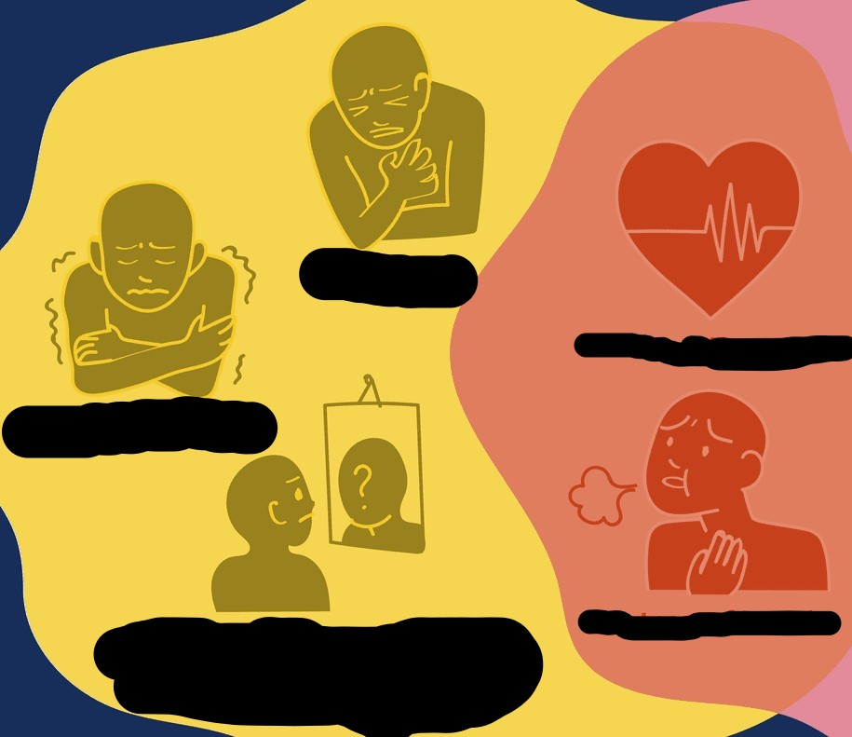  “What this symptoms called?” - (Panic attack)  CCQ – check students properly understand the meaning  “Is this symptoms happen when you feel calm or intense fear?” - (”intense fear”)  “Is this symtoms comes with anxiety and physcial symptoms such as sweating?” - (”Yes”)  Drill – choral and individual drilling for correct pronunciation  “Repat 'Panic attack'” - show the finger of 3, so student repeat 3 times.  Count down as they speak “panic attack”  Pointed each student to check their pronunciation. (1 time each).  Board – highlight special areas of pronunciation  Write 'Panic attack' on the board. (Use black color)  “How many syllables?” (S:”4”, T: “Good”) -> Divide it as 'Pa l nic at l tack. (Use green color)  “Where's the stress?” (S: “1st”) -> Put dot on panic. (Use Red color)  “What part of speech?” (S: “noun”)  Guiding Question  “When you feel under pressure, who is your best adviser? and why she/he is the best adviser than other people?”  “Talk about it with your partner”  Students discuss the question with a partner.  -Monitoring them.  Feedback. Nominate a few students to share their ideas, if necessary.  “Okay, can you share your story?”

Stage Name: Practice - Literal Comprehension Listening
Purpose of this stage:
Students practice literal listening comprehension skill.

Materials: audio file, worksheet
Time | Interaction | Procedure
20 sec  2 min  1 min  1 min | T  S  S-S  T-S | Instructions. Set the purpose for listening. Hand out worksheets.  “You're going to listen the audio, and fill out the answers on the front page(Work sheet A) while you listening” “Plus, it is individual work!”  Double check by asking Q: “Which worksheet are you going to fill out?” - “Worksheet A”  -Hand out worksheets  Students listen for the 1st time, and write answers on the worksheet.  monitoring their answer.  (Front page: Worksheet A)  1. Do they have seen each other every day?  2. How long did it take for Ben to leave house?  3. What is the symptom of Ben experience?  4. Does Clara still having hard time?  Pair check.  “Go ahead to check the answers with your partner”  monitoring their discussion  Feedback to check accuracy.  “Okay. Let's check the answer together!”  1. No, Clara said “I haven't seen you in a class for a while.”  2. 2 hours  3. Panic attack  4. No.

Stage Name: Practice - Interpretive Comprehension Listening
Purpose of this stage:
Students practice listening to details.

Materials: Worksheet, audio file, computer
Time | Interaction | Procedure
30 sec  3 min  1 min  2min | T  S  S-S  T-S | Instructions. Set the purpose for listening. Hand out worksheets.  “Turn to the back page(Worksheet B), and answer these question while you're listening”  Students listen for the 2nd time.  (Back page: Worksheet B)  1. Ben said, “you're so together!” what does it mean? and how Clara look that way?  2. Does panic attack is common? and why people, who suffered by panic attack, do not talk about their symptom?  Pair check. Monitor. If students need, then replay the audio a 3rd time.  Check if everyone write down the answer. If they aren't repeat 1 more.  If they have their own answer, then say “Let's start to check your answers with your partner”  Feedback to check accuracy.  1. It means, she looks meantally/emotionally stable, organized, and confident. Clara look that way because she overcome the pain attack.  2. Yes. Ben describes his symptom with using 'stupid'(It sounds even more stupid when I say it out loud), Clara said(So – and this may sound strange). It shows the symptom controlled their life, so that they loss their control of their life. Therefore, even lots of people have pain attack, they don't want to open to talk about thier symptoms to others easily.

Stage Name: Production - Applied Comprehension Speaking
Purpose of this stage:
Students practice their speaking fluently.

Materials:
Time | Interaction | Procedure
1 min  5 min  1 min | T  S-S  T-S | Instructions. Give students a question to discuss in pairs or groups.  Q: “Have you ever feel you lost control of your life? Life is not allways flow what you wanted/desired.”  “If you can go back to the past and change one thing, when and what event do you want to change?”  Students discuss.  “Discuss with your partner”  monitoring their discussion.  Feedback. Students share their ideas with the class.  “Can you share your story? when would like to go back?”

Stage Name: Wrap-up
Purpose of this stage:
To end class positively

Materials: transcript
Time | Interaction | Procedure
2 min | T | Lesson feedback. Tell the class what they did well, and what needs to improve.  “You guys were great!”  “What vocabuluary did we learn today?”  “Good!”  Offer delayed corrections to the previous stage.  Set homework.  “Don't forget to review what we have learned today”  Thus, I'll give you transcript and you could read throughly, and make 1~2 good question for listening exercise.  Inform students about the topic for the next lesson.  “We'll going to review the questions all together in next class”  “Great jobs today, see you guys in next week!”

Instructor’s Comments and Assessment
Pros
Cons
Change
Overall Comments
Grade
Above Standard 85%-100% | Standard 70%-84% | Below Standard 69%-0%
Instructor | Student Signature | Date
Taute, David

