Background Information Sheet
Name | Class | Date | Lesson Type | Plan type | Length
Jina | 198WD | 2019.10.16 | Grammar | PPP | 45 min

Lesson
Topic | I’m faster than you
Main Aim | Students will learn the comparative. -re/more/less
Secondary Aim | Students will practice their speaking fluency.

Materials and References
Whiteboard, colored markers, PPT, Daily routine fill in the blank worksheet (including pictures), Daily routine question worksheet.

Student Profile
Level | Lower Intermediate
Age | 10 years old | Number of Students | 10
Detail | Most of the students are native Koreans. Some students are strong in speaking than grammar, others are good at grammar than English speaking. Everyone is motivated to learn English.
Assumptions about students’ knowledge as required for this lesson:
- Students know the vocabulary adjectives in this lesson
- Students learn about comparatives using "adj.+er (+than)" and "more+adj. (+than)".
- Students know how to make the comparatives sentence.
What language difficulties to expect when presenting, and how to deal with it:
Meaning: “I am faster than you; I’m fast between two people. Make a clear visual context and C.C.Q.

Form: Students learned that There are two ways to make or to "form" a comparative adjective

Pronunciation: Students may not know where to put natural sentence stress. Drill several times chorally, then individually. Ask, “Which words sound stressed?” Board the stress markers in red.
Anticipated Classroom Management Difficulties and their Solutions:
The quantity of new language points to be learned about the comparative is too much for students to handle in a short 45 minute lesson. This could lead to anxiety, rushing, and a lot of teacher talk. For this lesson I will manage this by selectively presenting only a few new concepts about the comparative. The remaining new language points can be presented in the next lesson.
My Personal Aim
What I hope most to demonstrate in this lesson is the ability to
- present the target language using a situational presentation
- to be an involver type teacher

Stage Name: Lead-in(5min)
Purpose of this stage: To relax both the teacher and students. To focus attention on the lesson. Create a situation for students to experience or think about, and then to elicit the target language.
Materials: Board and colored markers, eraser and ppt.
Timings | Interactions | Procedure
5min | T-S | Draw, mime, show a picture etc. to create a clear and understandable situation related to your target language. Try elicit the model sentence (a sentence that contains the target language) by referring to the situation.  Greetings  “Hello Everyone  Do you know this movie?(S: Lion King)  Yes, they are characters in the movie “Lion King’  Ask student character’s name.  They are friends but they are arguing each other now. Let’s check the situation.  video (1min)  T: what’s happening?  S: they said I am the best.  T: why Simon said I’m the best?  S: because he faster and smarter than others.

Stage Name: Presentation(10mim)
Purpose of this stage: Make the students think about the situation. To clarify the meaning, form, and pronunciation features of the target language.
Materials: Board and colored markers, eraser.
Timings | Interactions | Procedure

1min  2min  5min  2min | T-S  T-S  T-S  T-S | Board the model sentence (if students are unable to tell you, just board it).  I’m faster than you.  CCQ – ask questions, and use time lines or scales where appropriate.  - Simon is a fast?(yes)  - Simon is a fast animal in the world?(no)  - btween, who is the fast?(Simon)  Form – clarify the affirmative, negative, question form, or other special features. Substitution tables may be of use.  Draw the structure of the sentences.  S+V+comparavive adjective +O  I am faster than you.  This comparative form has a grammar rule.  (if the adjective has only one syllable we make its comparative form by adding the suffix ER…(explain 1-4 rules)  Rule. adjective comparative  1. add-er Tall Taller than  2. drop-y, add-er Lazy Lazier than  3. 2 or + syllables add more beautiful More beautiful than  Drill – drill the spoken form, focusing on contractions, stress and intonation.  - Say and gesture “Listen and repeat: 3X [model sentence.]”  1. I am faster than you.  2. I am lazier than you.  3. I am (more/less) beautiful than you.  - Drill will energy and enthusiasm, using natural intonation and stress.  - Make special pronunciation features visible on the board, using colour.

Stage Name: Controlled Practice(7mim)
Purpose of this stage: students practice working with the form (scrambled sentences, split sentences, select the correct form of the verb, correct incorrect sentences, and change one form into another form). Accuracy must be checked.
Materials: worksheet, board and maker, eraser.
Timings | Interactions | Procedure
1min  3min  2min  1min | T  S  S – S  T - S | Instructions.  ICQ.  Hand out. Exercise A says to fill the gaps in the form.  Students do a worksheet.  Rule.  1. add-er  2. drop-y, add-er  3. 2 or + syllables add more  Pair check.  Feedback to check accuracy. Board correct answers visually.
Stage Name: Less Controlled Practice(11min)
Purpose of this stage: students practice working with the meaning (match a timelines to sentences, choose the sentence that matches a picture, gap-fill a paragraph). Accuracy must be checked.
Materials: worksheet, board and maker.
Timings | Interactions | Procedure
1min  5min  2min  3min | T  S  S-S  T-S | instructions  Turn over your worksheet. Exercise B says make 4 true sentences about the animal.  ICQs  “Should you mark on your worksheet step1? (Yes.)  “Will you try to make as many sentences as possible? (Yes.)  Students do the worksheet.  Pair check  Feedback to check accuracy.
Stage Name: Production – Freer Practice(10min)
Purpose of this stage: is to get students to practice the grammar communicatively.
Materials: none
Timings | Interactions | Procedure
1min  8min  1min | T  S-S  T-S | Instructions. (their belongings)  Students tke their belongings.  Ask student 1-2 “what is your belongings benefit?”  After that tell the students discuss Comparing with your partners belongings.  feedback
Stage Name: Wrap-up(2min)
Purpose of this stage: is to end the lesson on a positive note so that students feel they have achieved progress.
Materials: none.
Timings | Interactions | Procedure
2min | T | Offer delayed corrections to the previous stage.  - “Look at the board. Here are some sentences I heard. Tell me how to correct them.”  Set homework.  compare what is the difference between your family members.  Inform students about the topic for the next lesson.
Instructor’s Comments and Assessment
Pros
Cons
Change
Overall Comments
Grade
Above Standard 85%-100% | Standard 70%-84% | Below Standard 69%-0%
Instructor | Student Signature | Date
Taute, David

Worksheet A: The Comparative

1. Check your grammar: gap fill writing – comparatives Write the words to fill the gaps. Use comparatives.

1. It’s _______________________ (far) than I thought – I think we’re lost.

2. I hope your team’s _______________________ (lucky) today than last week.

3. They’re _______________________ (happy) in their new school than in their old one.

4. Your spaghetti sauce is _______________________ (tasty) than my mom’s.

5. Mike is _______________________sociable than Jack.(2 types answer)

Worksheet B
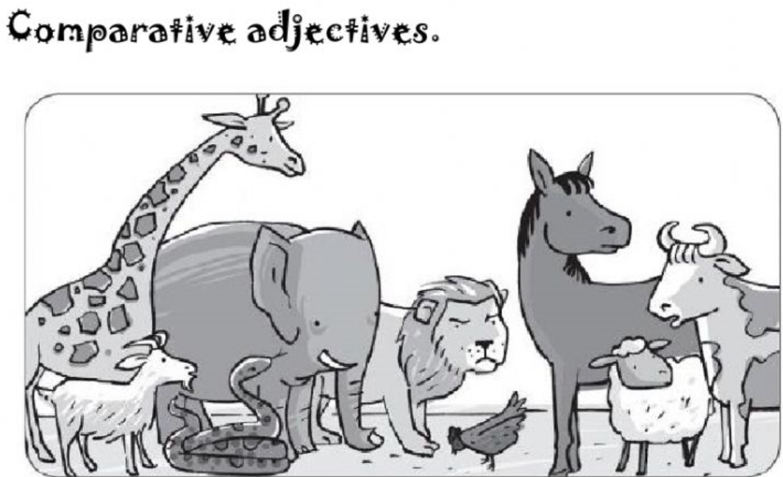
Make sentence using the words.
1. tall

2. dangerous

3. creepy

4. slow

