Background Information Sheet
Name | Class | Date | Lesson Type | Plan type | Length
MJ | 198WD | 16/10/2019 | Grammar | PPP | 45 min

Lesson
Topic | I am studying English
Main Aim | Students will learn the Present Progressive Tense (happening now)
Secondary Aim | Students will practice their speaking fluency through practice of the structure and function of the Present Progressive Tense

Materials and References
Board and colored markers, worksheets

Student Profile
Level |  | Lower Intermediate
Age |  | 8-12 years old |  | Number of Students | 10
Detail |  | Students are all native Korean.  Everyone is motivated to learn English
Assumptions about students’ knowledge as required for this lesson:
-Students are familiar with the Present Simple and Past Simple tenses
-Students have learnt and used the Present Continuous / Progressive tense for actions happening right now / at the time of speaking.
What language difficulties to expect when presenting, and how to deal with it:
- Meaning: Students may confuse the use of the present simple and present continuous. / Possible solution- Make it clear when Lead in and CCQ
- Form: students may confuse the sentence structure of positive, negative statement and questions sentences. / Possible solution- Include this in the controlled practice stage to consolidate the learning
- Pronunciation: Students may have difficulty pronouncing the ‘ing’ sound or the contracted forms of the auxiliary verb ‘be’ (‘I’m’, ‘he’s’, etc.)./ Possible Solution: show articulation of the –ing and model sound. Get SS to repeat the sound in isolation first, then through words ending in -ing. Model pronunciation of the contractions
Anticipated Classroom Management Difficulties and their Solutions:
There isn’t really time in this lesson to teach the spelling rules for forming the present continuous tense, but it would reinforce students’ learning to think of and write sentences using the tense.
Solution: assure students it’s OK to concentrate on good sentences and not worry about spelling for now. Note that they will get the spelling rules soon.
My Personal Aim
What I hope most to demonstrate in this lesson is the ability to
- present the target language using a situational presentation
- to be an involver type teacher
Stage Name: Lead-in
Purpose of this stage: To relax both the teacher and students. To focus attention on the lesson. Create a situation for students to experience or think about, and then to elicit the target language.
Materials: board, markers, picture to describe
Timings | Interactions |  | Procedure
3min  2min | T-S  S-S |  | Hello everyone. Look at me and stand up (say and write on the board ‘You are standing’)  Repeat with several other known commands to various individuals, asking students in each case ‘what action do you see?’ and writing it on the board. (He is reading, she is writing, they are talking, we are singing)  Ok. Look at my action and make a sentence. (mime and elicit the sentence from students that ‘I am studying English’  I am studying English  You are standing  He is reading  She is writing  They are talking  We are ’ singing  Distribute picture to students and work with partner to describe the actions that are happening in the picture. (picture No.1)  Alright. Today topic is ‘Present Progressive / Continuous
Stage Name: Presentation
Purpose of this stage: Make the students think about the situation. To clarify the meaning, form, and pronunciation features of the target language.
Materials: board, makers
Timings | Interactions |  | Procedure
2min  3min  5min | T-S  T-S  T-S |  | CCQ – ask questions, and use time lines or scales where appropriate.  Draw a timeline and ask student  Is it talking about past? (No)  Is it happening right now? (Yes)  where should I put ‘I am doing’ arrow? (Now)  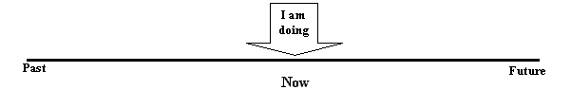  Form – clarify the affirmative, negative, question form, or other special features. Substitution tables may be of use.  I am studying English (S+be verb +V-ing)  I am not studying English (S+be verb (NOT)+V-ing)  Am I studying English? Yes I am / No I am not (Be verb+S+V-ing)  I am not studying  You are  He / She / It Is  They / We are  Explain contractions:  I am->I’m, You are->you’re, He’s, She’s, it’s, They’re, We’re  I am not-> I’m not, you are not-> you’re not, you aren’t  Drill – drill the spoken form, focusing on contractions, stress and intonation.  - Listen and repeat / Conduct the drill chorally 3 times  - What are you doing? I am Verb+ing / Conduct the Student-Student drill. Ask each other and answer  - Team drill. Divide Team A & Team B.  Teach speak the word ‘he drives a car’  Team A make it positive after that Team B negative, again team A question form,  Team A: He’s driving a car  Team B: He’s not driving a car  Team A: Is he driving a car?  Try this way with few different sentences
Stage Name: Controlled Practice
Purpose of this stage: students practice working with the form (scrambled sentences, split sentences, select the correct form of the verb, correct incorrect sentences, and change one form into another form). Accuracy must be checked.
Materials: worksheet
Timings | Interactions |  | Procedure
1min  3min  2min  1min | T  S  S – S  T - S |  | Hand out worksheet  Look at your worksheet Exercise A. What is the model sentence? I am working.  Positive statements are written. So just fill the rest of blank according to order. Negative, questions, positive and negative answer. Be careful with each subject and use contraction to write. / Read the example answers together  Students do a worksheet.  Pair check.  Feedback to check accuracy. Board correct answers visually.
Stage Name: Less Controlled Practice
Purpose of this stage: students practice working with the meaning (match a timelines to sentences, choose the sentence that matches a picture, gap-fill a paragraph). Accuracy must be checked.
Materials:
Timings | Interactions |  | Procedure
1min  3min  2min  1min |  |  | Instructions  Turn over your worksheet. Exercise B There are 3 type of exercises.  Read the question ABC together and show them how to answer for example.  Student do the worksheet  Pair check  Feedback to check accuracy
Stage Name: Production – Freer Practice
Purpose of this stage: is to get students to practice the grammar communicatively.
Materials: A4 size storyboard resources
Timings | Interactions |  | Procedure
30 sec  10 min  3min 30sec | T  S-S  S-S |  | Instructions.  Hand out storyboard  This we call storyboard, talk to your partner and create your own story. Remember to use the present progressive tense.  Students discuss and free practice fluency  Each team present their story in front of class
Stage Name: Wrap-up
Purpose of this stage: is to end the lesson on a positive note so that students feel they have achieved progress.
Materials:
Timings | Interactions |  | Procedure
1 min  30 sec  30 sec | T – S  T  T |  | Offer delayed corrections to the previous stage.  - “Look at the board. Here are some sentences I heard. Tell me how to correct them.”  Tell the class what they did well and what need to improve  Set homework.  Inform students about the topic for the next lesson.  Ok. In next lesson, we are going to study about Present Progressive Tense to talk about future. Enjoy your weekend and see you next week
Instructor’s Comments and Assessment
Pros
Cons
Change
Overall Comments
Grade
Above Standard 85%-100% | Standard 70%-84% | Below Standard 69%-0%
Instructor | Student Signature | Date
Taute, David

Picture No.1 (Lead in)
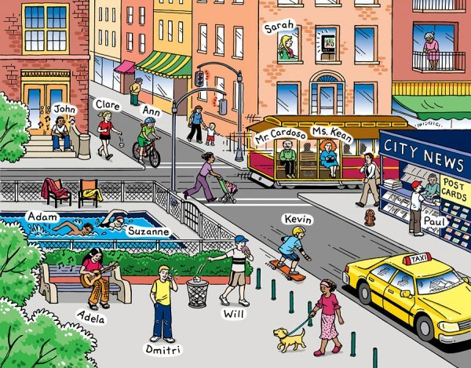

Exercise A
Statements  + | Statements  - | Questions | Short answer  + | Short answer  -
I'm working. | I'm not working. | Am I working? | Yes, I am. | No, I'm not.
He's working.
She's working.
It's working.
You're working.
We're working.
They're working.

Exercise B
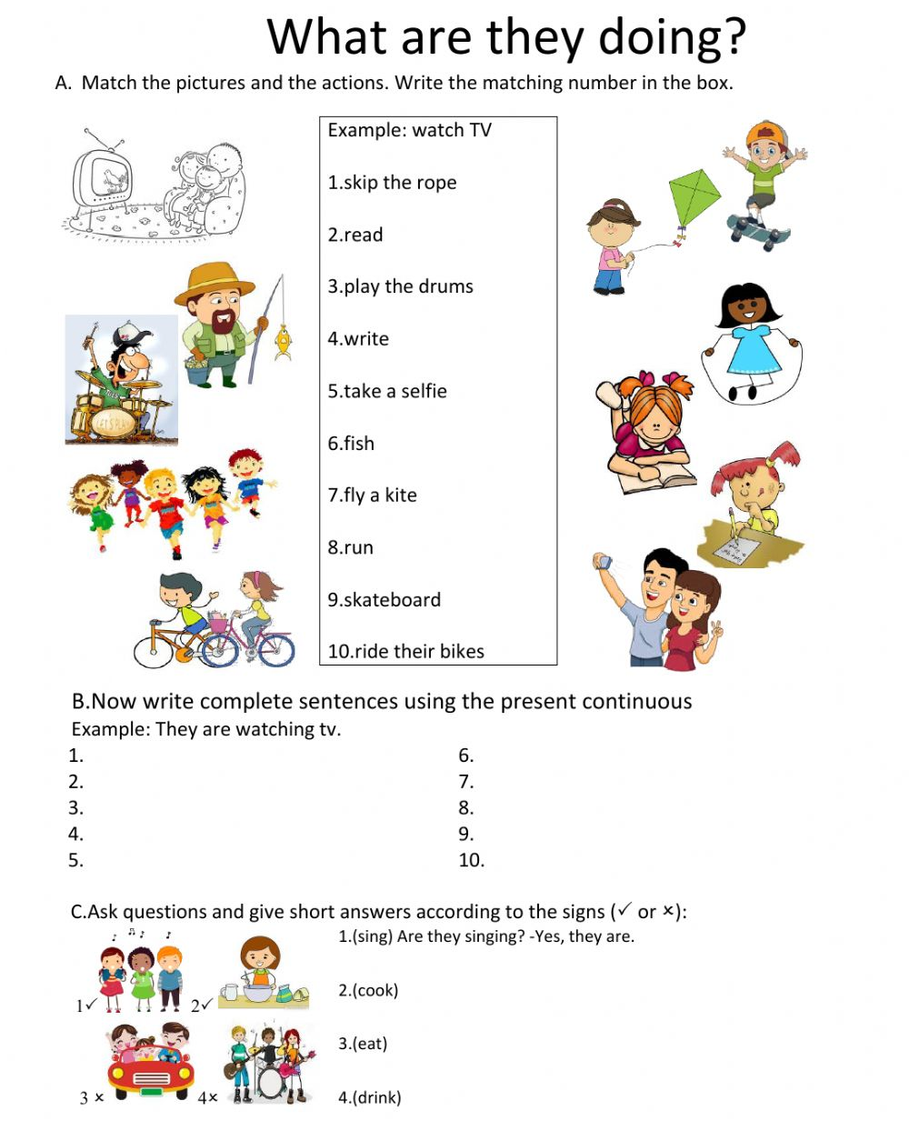

Production stage – storyboard
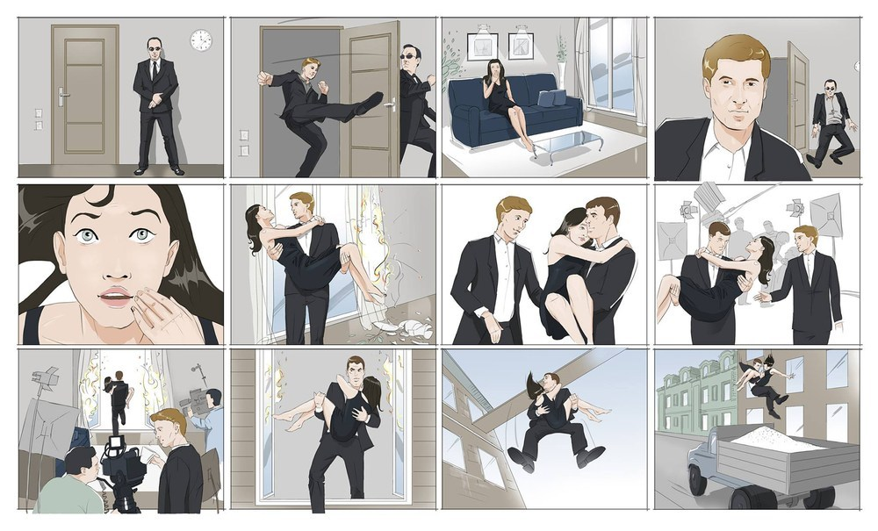
Answers
Exercise A

Statements  + | Statements  - | Questions | Short answer  + | Short answer  -
I'm working. | I'm not working. | Am I working? | Yes, I am. | No, I'm not.
He's working. | He isn't working. | Is he working? | Yes, he is. | No, he isn't.
She's working. | She isn't working. | Is she working? | Yes, she is. | No, she isn't.
It's working. | It isn't working. | Is it working? | Yes, it is. | No, it isn't.
You're working. | You aren't working. | Are you working? | Yes, you are. | No, you aren't.
We're working. | We aren't working. | Are we working? | Yes, we are. | No, we aren't.
They're working. | They aren't working. | Are they working? | Yes, they are. | No, they aren't

Answer / Exercise B

Filler
Illustrations
Students guess sentences from drawings. All the sentences are present continuous affirmative sentences beginning with 'He/She is...' or 'They are...' The class is divided into two teams (A and B). One student from Team A comes up to the board. The student is given a present continuous sentence card. The student then draws the sentence on the board. The student is not allowed to speak or write anything. Team A then has one minute to try to guess the sentence. Teams must guess the exact words on the card to win. If Team A hasn't guessed correctly after one minute, Team B can try to answer. The first student to say the sentence on the card wins a point for their team. Then, a student from Team B comes to the board and so on. The game continues with teams taking it in turns to draw sentences until all the cards have been used. The team with the most points at the end of the game wins.

(Present continuous card)
They are sunbathing on the beach
He is singing in the shower
They are speaking Japanese
She is doing yoga
She is listening to dance music
They are playing badminton
He is cooking a steak
She is eating noodles

