Background Information Sheet
Name | Class | Date | Lesson Type | Plan type | Length
Soo(한수영) | 198WD | 16/Oct/2019 | Grammar | PPP | 45 min

Lesson
Topic | If it’s sunny at noon, I will play tennis.
Main Aim | Students will learn the first conditional.
Secondary Aim | Students will practice their speaking fluency.

Materials and References
Board, markers, eraser, worksheets.

Student Profile
Level |  | Lower Intermediate
Age |  | Children |  | Number of Students | 10
Detail |  | Students are all Korean.  Students’ age: between 8-12years old
Assumptions about students’ knowledge as required for this lesson:
- Students know the vocabulary used in this lesson
- Students have learned about the present simple and the future simple
- Students know how to make the negative form using ‘not’
- Students know how to make the question form
What language difficulties to expect when presenting, and how to deal with it:
- Meaning: “If it’s sunny at noon, I will play tennis.” Students may think it is talking about a 100% possible situation. Make a clear visual context from the lead-in and C.C.Q.

- Form: Students may confuse how to use the if-clause e.g. ‘If I will play tennis at noon, it will be sunny.’ Identify the two separate clauses being the if-clause (condition) and the result clause. Highlight the variable sentence structure.
E.g. I will play tennis if it’s sunny at noon.

- Pronunciation: Students may not know where to put natural sentence stress. Drill several times chorally, then individually. Ask, “Which words sound stressed?” Board the stress markers in red.

Anticipated Classroom Management Difficulties and their Solutions:
The quantity of new language points to be learned about the first conditional is too much for the low intermediate level students to handle in a short 45minute lesson. This could lead to anxiety, rushing, and a lot of teacher talk. For this lesson I will manage this by selectively presenting only the results that are possible in the future of the first conditional.
My Personal Aim
What I hope most to demonstrate in this lesson is the ability to
- present the target language using a situational presentation
- to be an involver type teacher
Stage Name: Lead-in
Purpose of this stage: To relax both the teacher and students. To focus attention on the lesson. Create a situation for students to experience or think about, and then to elicit the target language.
Materials: A board, a black marker, eraser
Timings | Interactions |  | Procedure
5 min | T-S  S-T |  | “Hello, everyone! I’m going to draw some pictures. While I’m drawing, I want you to describe what is going on! Just say it.”  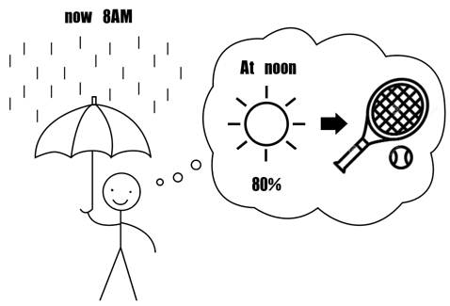  (Draw on the left side of the board.)  Draw a man holding an umbrella in the rain at 8AM. And the man thinks about the weather forecast for noon. Write down the possibility of the weather and the right side of the weather pictogram, draw the tennis racket and ball.  Some students might say the exact model sentence, or other students may say similar to this. Try students elicit the model sentence.
Stage Name: Presentation
Purpose of this stage: Make the students think about the situation. To clarify the meaning, form, and pronunciation features of the model sentence.
Materials: A board, a black marker, a blue marker, a red marker, eraser
Timings | Interactions |  | Procedure
10 min | T  T-S  T-S  T-S |  | Board the model sentence (if students are unable to tell you, just board it).  CCQ – ask questions, and use time line. 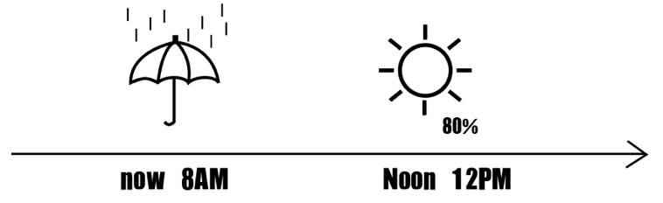  - Is this (Model sentence) talking about the future? -Yes  - Can this (Play tennis) happen now? -No  - Is this (Sunny at noon) 100% possibility? Or high chance to happen?  -High chance to happen  Form – clarify the affirmative, negative, question form.  - Where is the main verb? – is (present V)  - Which part tells you, this is talking about the future? - will play (will+base V)  - Explain the structure. We use present simple because this can happen in high possibilities. This is result and we use future tense because this is result of the future.  - Switch the order of ‘If’ clause and the ‘result’ clause. Highlight the comma mark.  - Make the negative form. Highlight the contraction- will not=won’t / I will=I’ll  - Make the question form. Switch the order like before.  Drill&Board – drill the spoken form, focusing on contractions, stress and intonation.  - “Listen and repeat: [model sentence]” X 3times. Count with fingers.  - Drill will energy and enthusiasm, using natural intonation and stress.  - Drill the question form chorally 3times. Count with fingers.  - Name a student and ask question. After the student answers, the student asks same question to another student. X 2times.  - Which part is stressed? Highlight with a red marker.  - How about the intonation at the end? Up or down?  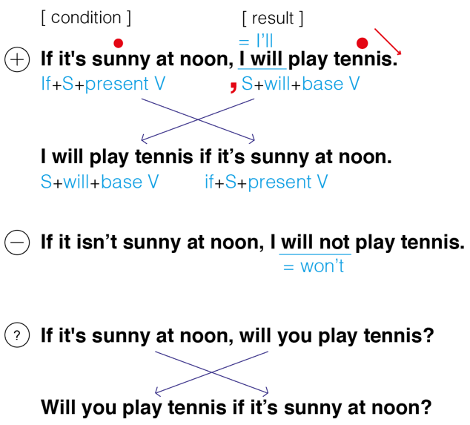  (Write right side of the board)
Stage Name: Controlled Practice
Purpose of this stage: students practice working with the form (select the correct form of the verb). Accuracy must be checked.
Materials: Worksheet exercise A, board, markers, eraser
Timings | Interactions |  | Procedure
1 min  3 min  1 min  2 min | T  S  S – S  T - S |  | Instructions. Hold up the worksheet, point to exercise A.  Exercise A says to choose the correct answer.  . If I study hard, I ____________ this year’s exam.  - pass  - won’t pass  - will pass  - passes  Hand out the worksheet.  Students do a worksheet exercise A.  Pair check.  Feedback to check accuracy. Board correct answers.
Stage Name: Less Controlled Practice
Purpose of this stage: students practice working with the meaning (match a timelines to sentences, choose the sentence that matches a picture, gap-fill a paragraph). Accuracy must be checked.
Materials: Worksheet B
Timings | Interactions |  | Procedure
1 min  5 min  2 min  3 min | T  S  S-S  T-S |  | Instructions: Turn over your worksheet.  Exercise B says Complete the sentences with different ideas by using [ will / won’t ~ ]  Students do a worksheet exercise B.  Pair check.  Feedback to check accuracy.
Stage Name: Production – Freer Practice
Purpose of this stage: is to get students to practice the grammar communicatively.
Materials: None
Timings | Interactions |  | Procedure
1 min  8 min  1 min | T  S-S  T-S |  | Instructions : Ask your partner what will they do if they pass / fail this class.  For example, if you fail this class, what will you do? And the answer can be I’ll take another class, or I won’t try again.  Students do a productive task which requires natural communication.  Feedback
Stage Name: Wrap-up
Purpose of this stage: is to end the lesson on a positive note so that students feel they have achieved progress.
Materials: None.
Timings | Interactions |  | Procedure
1 min  10 sec  5 sec | T – S  T  T |  | If there were some errors during the previous stages, offer delayed corrections.  Look at the board. Here are some sentences I heard. Tell me how to correct them.  Set homework.  I’ll give you homework. Go home and ask your family the same questions in exercise B. Write at least 5 answers each.  Everyone did great job today! Keep going and don’t forget the homework. See you tomorrow!
Instructor’s Comments and Assessment
Pros
Cons
Change
Overall Comments
Grade
Above Standard 85%-100% | Standard 70%-84% | Below Standard 69%-0%
Instructor | Student Signature | Date
Taute, David

Worksheet : If… , I will / won’t ~
Exercise A
Choose the correct answer.

1. If I study hard, I ___________ this year’s exam.
- pass
- won’t pass
- will pass
- passes

2. If the weather is fine, we ____________ on a picnic.
- go
- went
- won’t go
- will go

3. If I _____________ to Paris, I will visit the Eiffel Tower.
- will go
- go
- went
- won’t go

4. If they don’t invite me, I _____________.
- go
- will go
- won’t go
- don’t go

5. If it ____________ , she won’t go out.
- will rain
- rain
- rains
- rained

Worksheet : If… , I will / won’t ~

Exercise B
Complete the sentences with different ideas by using [ will / won’t ~ ]

If it’s sunny on this weekend, I will go to the park with my dog.

If it’s sunny on this weekend, __________________________________________.

If it’s sunny on this weekend, __________________________________________.

If it’s sunny on this weekend, __________________________________________.

If it rains on this weekend, I won’t go to the concert.

If it rains on this weekend, _____________________________________________.

If it rains on this weekend, _____________________________________________.

If it rains on this weekend, _____________________________________________.
Answer sheet Exercise A

- c
- d
- b
- c
- c

Answer sheet Exercise B

I’ll play football.
I’ll go shopping with my family.
I’ll go to the park.
I won’t go out.
I won’t play tennis.
I’ll play computer game.
Etc.

Filler
<Kim’s game>
Prepare 25 to 30 flashcards (random words with various difficulty) on the floor or on the board. Show them to the students for 2 minutes, then flip them. The students must make a list of all things they can remember as a pair.
The winner is the team who gets most words.

