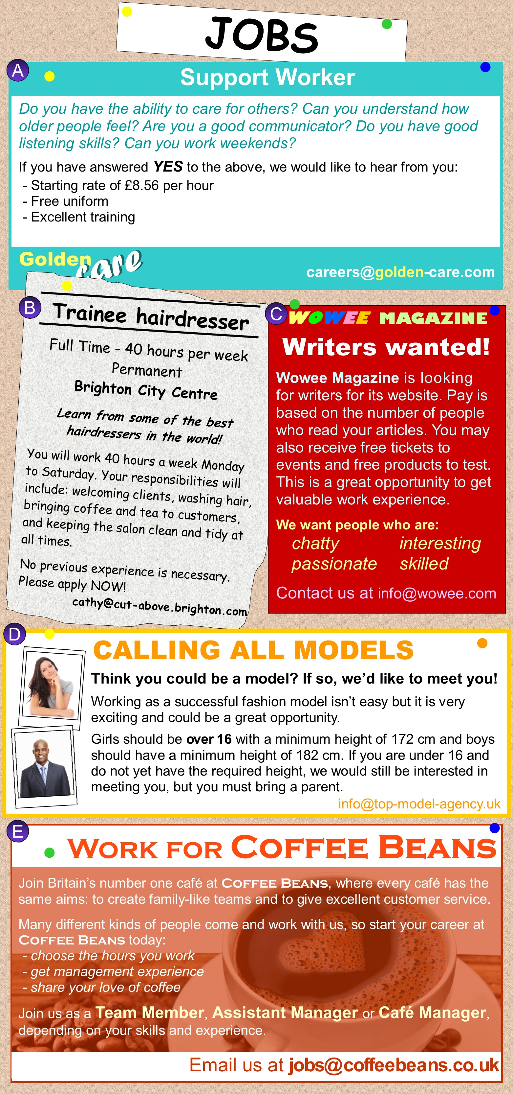
Worksheet
Exercise A - Which job would be best for each person?
A) Support Worker B) Trainee hairdresser C) WOWEE Magazine Writer
D) Model E) Coffee Beans Café Worker
- Nina is studying English and has her own blog. She is a very sociable person, and is interested in music and fashion. Answer:

- Dave has just finished school and is looking for a full-time job. He is sociable, likes working with his hands and cares about his appearance. Answer:

- Dewei enjoys helping people. He wants to make a difference to other people's lives.
He is looking for opportunities to learn new things that will help him in his career.
Answer:

- Sarah is a student and she is looking for flexible, part-time work. She doesn't want to work in a restaurant or shop. She is tall, beautiful and has her own unique look.
Answer:

- Sam is friendly and sociable. He has experience working in a restaurant and wants a job with more responsibility. He is studying part-time so he needs flexible working hours.
Answer:

Exercise B - ‘What information is included on a job posting?’
1.
2.
3.
4.
5.

Answers

Exercise A - Which job would be best for each person?
A) Support Worker B) Trainee hairdresser C) WOWEE Magazine Writer
D) Model E) Coffee Beans Café Worker
- Nina is studying English and has her own blog. She is a very sociable person, and is interested in music and fashion. Answer: C WOWEE Magazine Writer

- Dave has just finished school and is looking for a full-time job. He is sociable, likes working with his hands and cares about his appearance. Answer: B Trainee hairdresser

- Dewei enjoys helping people. He wants to make a difference to other people's lives.
He is looking for opportunities to learn new things that will help him in his career.
Answer: A Support worker

- Sarah is a student and she is looking for flexible, part-time work. She doesn't want to work in a restaurant or shop. She is tall, beautiful and has her own unique look.
Answer: D Model

- Sam is friendly and sociable. He has experience working in a restaurant and wants a job with more responsibility. He is studying part-time so he needs flexible working hours.
Answer: E Coffee Beans café worker

Exercise B - ‘What information is included on a job posting?’
Job title, Job location, main responsibility, contact, qualification, benefit, working hour, job description, company story etc

