Worksheet: Will /be going to
Exercise A) Choose the correct option to complete the sentences.

- A: Tea or coffee? B: ______coffee, please.
- I’ll have
- I’m going to have
- I’ve told my bank to close my account.
______an account with a more ethical bank.
- I’ll open
- I’m going to open
- I’ve decided that ____to my boss about the situation.
- I’ll speak
- I’m going to speak
- I want to do more with my free time. I know! I think ______taking Mandarin lessons.
- I’ll start
- I’m starting
- What ____this weekend?
- will you do
- are you doing
- Waitress: And what would you like to drink?
Customer: _____ an orange juice, please.
- I’ll have
- I’m going to have

Exercise B) Write the verb in the future tense. Use both won’t and be not going to.
- not have They __________________ a party tomorrow.
They __________________ a party tomorrow.
- not leave She _________________ early tomorrow.
She _________________ early tomorrow.
- not walk I ____________________ to school next week.
I ____________________ to school next week.

Exercise C) Complete the question and answer.

- _______ you be in China next summer? Yes, ____________
- _______ it going to be hot tomorrow? No, ____________
- _______ they going to sell cookies tomorrow? Yes, _____________
- _______ she make breakfast tomorrow morning? Yes, ____________
- _______ Sam going to play soccer this weekend? No, ____________
- _______ the boys dance on the stage tomorrow? No, _____________

Worksheet: Will /be going to
Exercise D
She has now planned his trip to Hawaii. She is telling his friend about her plan.
Write the dialog sentences. (example: I’m going to travel to Hawaii.)

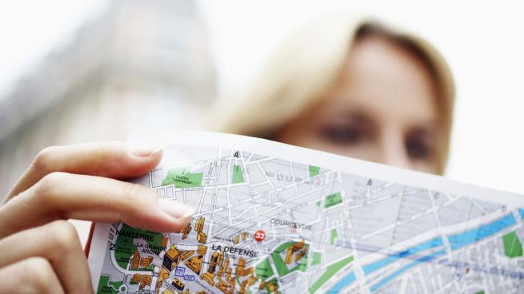

A:

B:

A:

B:

A:

B:

