Background Information Sheet
Name | Class | Date | Lesson Type | Plan type | Length
Sinae Kim | 201WD | 12/04/2019 | Grammar | PPP | 35 min

Lesson
Topic | She looks after a baby.
Main Aim | Students will learn about phrasal verb ‘look after’
Secondary Aim | Students will practice their speaking fluency.

Materials and References
Board and colored makers, worksheets, pictures.

Student Profile
Level |  | Low Intermediate
Age |  | teens |  | Number of Students | 7
Detail |  | Students are all native Korean. A few students have lived abroad and have the local accent. Everyone is motivated to learn English.
Assumptions about students’ knowledge as required for this lesson:
- Students know the vocabulary used in this lesson.
- Students have learned about phrasal verb ‘look after’.
- Students know how to make the present simple tense, interrogative sentence, and negative form.
What language difficulties to expect when presenting, and how to deal with it:
- Meaning: “She looks after a baby; This phrasal verb is used when a person makes sure that someone or something is safe and well. You look after someone or something by doing what is needed to keep them well or in good condition. You can look after another person or yourself. Make a clear visual context and C.C.Q.

- Form: Student may confuse how to use the phrasal verb. They might put the object in between phrasal verb. E.g. I looked my sister after. Identify the phrasal verb and object. We put the phrasal verb before the object. Highlight the phrasal verb (look after), indicate the subject (she) and object.
Ex) she looked after her dog. (O) // she looked her dog after. (X)

Anticipated Classroom Management Difficulties and their Solutions:
The quantity of new language points to be learned about phrasal verb is too much for students to handle in a short 35 minute lesson. This could lead to anxiety, rushing, and a lot of teacher talk. For this lesson, I will manage this by selectively presenting only a few new concepts about the phrasal verb. The remaining new language points can be presented in the next lesson.
My Personal Aim
What I hope most to demonstrate in this lesson is the ability to
- present the target language using a situational presentation
- to be an involver type teacher
Stage Name: Lead-in
Purpose of this stage: To relax both the teacher and students. To focus attention on the lesson. Create a situation for students to experience or think about, and then to elicit the target language.
Materials: pictures.
Timings | Interactions |  | Procedure
3min | T-S |  | Hello, everyone. How are you?  Today I am going to show you some pictures.  (Put 3 pictures on the board)  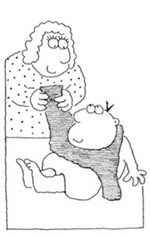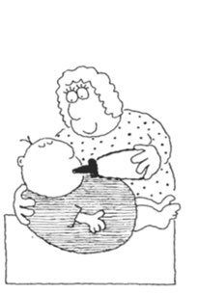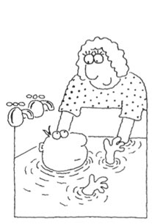  Describe and tell what is happening in each picture.  (Ss are answer)  Make sentence.  When Ss will answer.
Stage Name: Presentation
Purpose of this stage: Make the students think about the situation. To clarify the meaning, form, and pronunciation features of the target language.
Materials: List all materials that will be needed in this stage.
Timings | Interactions |  | Procedure
15sec  1min  4min  3min | T  T-S  T-S |  | Board the model sentence (if students are unable to tell me, just board it). : She looks after a baby.  CCQ – ask questions, and use timelines or scales where appropriate.  - Is she just look at the baby? (No)  - Does she make sure the baby is safe? (Yes)  - Does the baby need help? (Yes)  Form  In this sentence what part is she? (subject)  Then where is a verb? (look after)  What about a baby? (object)  All right!  How about if I put the word ‘a baby’ between look and after?  Write on the board: She looks a baby after.  Does it make sense? (No)  We can’t separate look after.  There are some other phrasal verbs have same rule.  Ex.) take after, grow up  How do we make this into a negative sentence?  (She doesn’t look after a baby.) Board She doesn’t look after a baby.  How do we make this a question? (Does she look after a baby?)  Board Does she look after a baby?  How can we answer this question? (Yes, she does)  Board Yes, She does or No, She doesn’t  Subject - verb Object  + She looks after a baby  - She doesn’t looks after a baby  ? Does she look after a baby  Drill  Listen. She looks after a baby.  What words are stressed? (looks, baby) Mark the stress with a red marker.  Listen and repeat 3 times. /She looks after a baby/ Conducts the drill chorally 3 times with gestures. Nominate for individual drilling.  Listen and repeat 3 times. /She doesn’t looks after a baby/ Conduct the drill chorally 3 times with gestures. Nominate for individual drilling.  Listen and repeat 3 times. /Does she look after a baby? / Conduct the drill chorally 3 times with gestures. Nominate for individual drilling.
Stage Name: Controlled Practice
Purpose of this stage: students practice working with the form (scrambled sentences, split sentences, select the correct form of the verb, correct incorrect sentences, and change one form into another form). Accuracy must be checked.
Materials: Worksheet.
Timings | Interactions |  | Procedure
30sec  3min  1min  2min | T  S  S – S  T - S |  | Instructions. Hold up the worksheet,  We are going to do exercise A and B. Exercise A says circle the correct sentence and exercise B says change the sentence in the new form.  Positive: I looked after his bike while he’s away.  Negative: I didn’t look after his bike while he’s away.  Question: Did you look after his bike while he’s away?  Don’t turn over the pages yet.  ICQ.  Are we going to do exercise A only? (No, A and B)  In exercise A, are we going to write a correct sentence? (No, just circle)  Great, go ahead.  Hand out the worksheets.  Students do worksheet exercises A and B.  Pair check.  Feedback to check accuracy. Board correct answers visually.
Stage Name: Less Controlled Practice
Purpose of this stage: students practice working with the meaning (match timelines to sentences, choose the sentence that matches a picture, gap-fill a paragraph). Accuracy must be checked.
Materials: Worksheet.
Timings | Interactions |  | Procedure
30sec  3min  1min  2min | T  S  S-S  T-S |  | Instruction. Hold up the worksheet, show exercise C.  Exercise C says look at the pictures and write a sentence using look after.  Hand out the worksheet.  Students do the worksheet.  Pair check.  Feedback to check accuracy.
Stage Name: Production – Freer Practice
Purpose of this stage: is to get students to practice the grammar communicatively.
Materials: None.
Timings | Interactions |  | Procedure
30 sec  8 min  1min | T  S-S  T-S |  | Instructions.  Talk to your group about your past.  For example, can you talk about your experience in looking after someone or something for somebody?  Students discuss their past using the target language naturally.  Feedback.
Stage Name: Wrap-up
Purpose of this stage: is to end the lesson on a positive note so that students feel they have achieved progress.
Materials: None.
Timings | Interactions |  | Procedure
1 min  15 sec | T – S  T |  | Offer delayed corrections to the previous stage.  - “Look at the board. Here are some sentences I heard. Tell me how to correct them.”  Inform students about the topic for the next lesson.

Instructor’s Comments and Assessment
Pros
Cons
Change
Overall Comments
Grade
Above Standard 85%-100% | Standard 70%-84% | Below Standard 69%-0%
Instructor | Student Signature | Date
Taute, David

Worksheet: look after
Exercise A
Circle the correct sentence.

  - I looked after my sister.
  - I looked my sister after.

  - He looked after his car.
  - He looked his car after.

  - Can you look the dog after while I’m away?
  - Can you look after the dog while I’m away?

Exercise B
Change the sentence to the new form. Write your answers neatly.

Example:
Positive: I looked after his bike while he’s away.
Negative: I didn’t look after his bike while he’s away.
Question: Did you look after his bike while he’s away?

- Positive: _________________________________________________________.

Negative: ________________________________________________________.

Question: Did he look after the baby?

- Positive: __________________________________________________________.

Negative: He isn’t looking after his dog.

Question: _________________________________________________________?

- Positive: Nurse looks after patients in hospital.

Negative: _________________________________________________________.

Question: _________________________________________________________?

Exercise D
Look at the pictures. Write a sentence using look after.
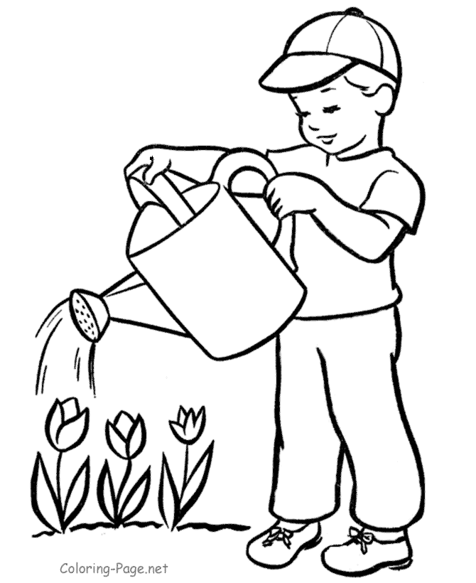 | 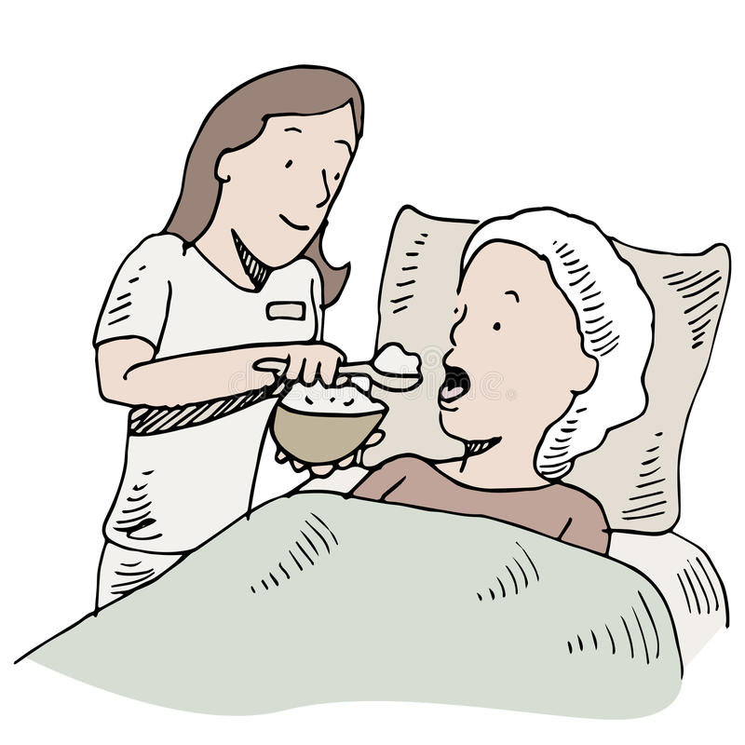
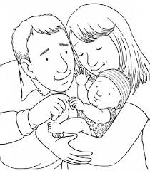 | 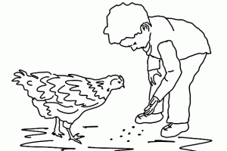

Answer sheet
Exercise A
Circle the correct sentence.
- I looked after my sister.
I looked my sister after.

- He looked after his car.
He looked his car after.

- Can you look the dog after while I’m away?
Can you look after the dog while I’m away?
Exercise B
Change the sentence to the new form. Write your answers neatly.
- Positive: He looked after the baby while you’re cooking.
Negative: He didn’t look after the baby while you’re cooking.
Question: Did he look after the baby while you’re cooking?

- Positive: He is looking after his dog.
Negative: He isn’t looking after his dog.
Question: Is he looking after his dog?

- Positive: Nurse looks after patients in hospital.
Negative: Nurse doesn’t look after patients in hospital.
Question: Does nurse look after patients in hospital?

Exercise C
Look at the pictures. Write a sentence using look after.
- He looks after plants. Or He is looking after plants.
- Nurse looks after a patient. Or Nurse is looking after a patient.
- They look after their baby. Or They are looking after their baby.
- He looks after his hen. Or He is looking after his hen.

