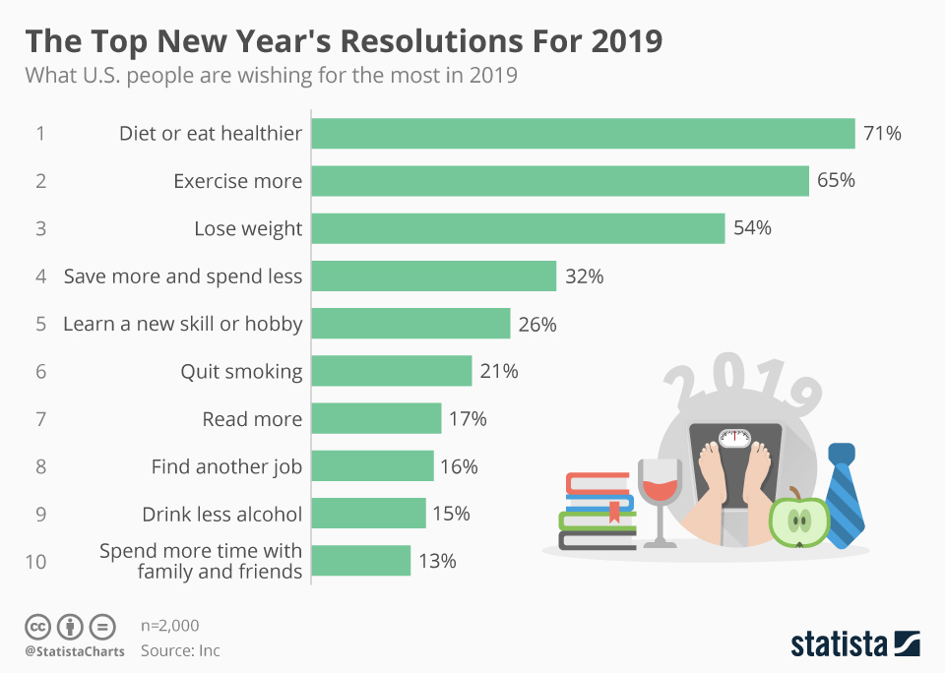

What are your New Year’s resolutions for 2020 ?
1.
2.
3.
4.
5.

