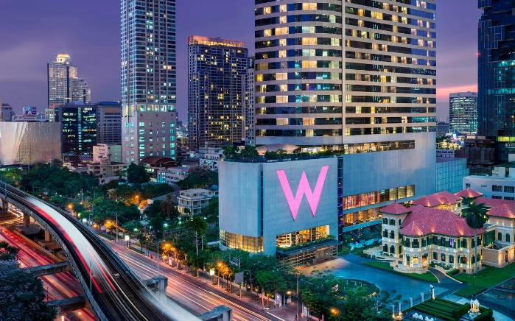
5 Star Luxury Hotel in Bangkok Near BTS
Welcome to a luxury urban playground in Bangkok, Thailand, seamlessly blending premier accommodations with style and comfort. Located on North Sathorn road, W Bangkok is a stylish icon of Asian chic set amidst the hotels of the city. Unwind in one of 403 spacious, smoke-free guest rooms and suites boasting inspiring designs and custom furnishing, a one-of-a-kind luxury accommodation in the heart of the city. Relax and recharge with nearly every comfort and amenity you’ve ever dreamed of. Enjoy Whatever/Whenever® 24/7 at our 5-star hotel.
Play, relax, indulge and revel amid jet-setters, fashionistas, exotic designs, mystical elements and up-and-coming artists in an innovative space where fashion meets culture. Our hotel’s idyllic location in Silom invites guests to traverse the city’s lively streets and dive right into the middle of the action in Bangkok.
Whatever, Whenever
Whatever You Need, Whenever You Need It
A personal shopper to navigate every corner of this out-of-this world fashion mega? An indulgent banquent while cruising the Chao Phraya River? A helicopter ride over traditional temple sprites and skyscraper tips? At W Bangkok, our whatever/whenever service transforms the ordinary into an extraordinary.
More Information:
Email > whotels.bangkok@whotels.com
Tel > +66 (0) 2344 4000
WIRED Business Center
Get Connected With Your Business
Connect in our WIRED® Business Center. Situated on the hotel’s ground floor, it offers two PC workstations and one MAC workstation along with a laser printer, photocopier, scanner, fax machine, audiovisual equipment, and High Speed Internet Access. If you forget your laptop, help yourself to one of ours via Wired2Go and of course we’re here if there’s anything else you need.
P.A.W. - Pets Are Welcome
You’re invited—and your pet is too. Experience W Bangkok with your four-legged friend by your side.

