Background Information Sheet
Name | Class | Date | Lesson Type | Plan type | Length
MIJUNG SUNG(Mimi) | TESOL | 11/12/2019 | Reading | PPP | 30 min

Lesson
Topic | Biography of Pablo Picasso
Main Aim | Students will practice their reading comprehension.
Secondary Aim | Students will practice their speaking fluency.

Materials and References
Excerpt from the book “The life and works of Picasso(Nathaniel Harris)”, board and board pen (different colours), worksheets, PC and monitor (for PPT)

Student Profile
Level | Advanced
Age | Adults | Number of Students | 7
Detail | This is a general English class with 7 native Koreans. They are all adults and have Advanced level of English. They are quite accustomed to pair work, but still needs to be relaxed to open up to communicate freely. The students tend to favor the visual mode and the auditory and kinesthetic learning needs developing.

Anticipated Difficulties and their Solutions:
- Nervousness at the start of the lesson Check that all needed materials are ready (e.g. worksheets printed, lesson plan printed, board is clean, different coloured pens are ready etc.). Try to be calm and follow the planned teacher talk.
- Every student might have different reading speed Prepare an appropriate level and length of the text. Also check the level of the questions so that everyone can finish in time. Monitor the students carefully, to make sure that no one is bored for being much ahead of the others and also that no one is suffering from being much behind.
- Vocabulary The students may not know all the words in the text. Teach the students keywords by asking them appropriate CCQs in the presentation stage, so that they can be prepared before reading the actual text.
- The PC or monitor may not work prepare a printed version of PPT. (bigger size the better!)

My Personal Aim
What I hope most to demonstrate in this lesson is the ability to
- give good instructions
- be an involver type of teacher in teaching reading comprehension
- monitor students effectively

Stage Name: Lead-in
Purpose of this stage: To relax both the teacher and students. To focus attention on the lesson. To lead in to the topic, activating background knowledge – this will help to contextualize the text.
Materials: List all materials that will be needed in this stage.
Timing | Interaction | Procedure
30 sec  1 min  1 min | T  S-S  T-S | Greet. Instructions.  “Good morning everyone! Did you all have a nice weekend?  It’s already almost the end of the year and I was wondering, did you all have a successful year?  Talk to your partner about what you achieved this year.”  Gesture for students to begin talking to their partners.  Students begin talking to their partners. Monitor for any use of keywords.  Feedback. Briefly go around the groups and ask the students to share what they talked about.  “Did your partner have a successful year?” etc.

Stage Name: Presentation
Purpose of this stage: To pre-teach keywords if necessary, and answer a guiding questions (such as a predicting task, or a specific question). These steps provide extra help for students to comprehend the text.
Materials: List all materials that will be needed in this stage.
Timing | Interaction | Procedure
10 sec  1 min  1 min  1 min  30 sec  1 min  30 sec | T  T-S  T-S  T-S  T  S-S  T-S | Prepare PPT slide on the PC & turn on the monitor.  Pre-teach keywords: a false start, henceforth, geometric  Elicit- Point to the Monitor.  “Here’s Mimi! She was looking for a job and got accepted at the company A.  So she tries it out and finds out, that she’s not ready for this job, so she quits.  She goes to company B and didn’t know what to do there! So quits.  Same thing happens at the company C! She’s not ready nor able to do anything there.  So she quits again. After several times, she finds a perfect job for her and becomes very successful.  After 20 years, she’s become a successful CEO and gives a speech about her success.”  “After a number of problems at the beginning, I finally found a job that I liked!”  “How can you rephrase ‘problems at the beginning’ with 2 words?” (false start)  Listen to the answers. If students don’t seem to know the word, tell them the word.  CCQs – “Does it mean that she was not ready for it?” (Yes.)  “Does it mean that she was able to do it?” (No.)  “Does it mean that her attempt was not successful?” (Yes.)  “Does it also mean that she was not successful at all?” (No. Only her attempt.)  Drill – Listen and repeat 3 times together. (Gesture)  Nominate 2 or 3 individually.  If needed, correct students’ pronunciation.  Board – Write ‘a false start’ on the board (with a black pen).  “How many syllables?” (each word 1 syllable) Mark with a blue pen.  “Where is the stress?“ (‘start’) Mark with a red pen.  “What type of word is this?” (noun)  Elicit- Point to the monitor. (next slide of PPT)  “By the way, Mimi is a CEO of a fashion company.  Using this chance, she decides to introduce a new line of bags at the speech.”  “From now on, this line of bags will be called ‘mimi’!”  “How can we say ‘from now on’ in one word?” (henceforth)  Listen to the answers. If students don’t seem to know the word, tell them the word.  CCQ – “Does it mean it happened before now?” (No.)  “Does it mean it will start in the future?” (No. It will start from this time!)  “Is it just an instant thing?” (No. It lasts until someone else changes it.)  Drill – Listen and repeat 3 times together. (Gesture)  Nominate 2 or 3 individually.  If needed, correct students’ pronunciation.  Board – Write ‘henceforth’ on the board (with a black pen).  “How many syllables?” (2) Mark with a blue pen.  “Where is the stress?“ (2) Mark with a red pen.  “What type of word is this?” (adverb)  Elicit- Point to the monitor. (next slide of PPT)  “A reporter asks a question: ‘What are the special features of the bag “mimi”?’  So she shows the bag clearer and answers ‘Including the shape of the bag, I only used squares, triangles and circles.’  How can we describe this feature in one word?” (geometric)  Listen to the answers. If students don’t seem to know the word, tell them the word.  CCQ – “Is it made up of shapes such as squares, triangles, circles?” (Yes.)  “Is it used to describe a pattern or arrangement?” (Yes.)  “Is wavy line geometric?” (No.)  (show next slide) “Can we say that this picture is ‘geometric’?” (No.)  Drill – Listen and repeat 3 times together. (Gesture)  Nominate 2 or 3 individually.  If needed, correct students’ pronunciation.  Board – Write ‘geometric’ on the board (with a black pen).  “How many syllables?” (2) Mark with a blue pen.  “Where is the stress?“ (2) Mark with a red pen.  “What type of word is this?” (adverb)  Guiding Question  “100 years later, a book about her success is written.  What do we call this kind of book?” (Biography.)  “Yes. It’s called a biography.  Discuss with your partner, what kind of information you can expect from a biography.”  Gesture for students to begin talking to their partners.  Students discuss the question with a partner.  Short Feedback.  “Okay. So what kind of information can you expect?”

Stage Name: Practice – Literal Comprehension
Purpose of this stage: is to get students to practice reading for literal detail. They will also practice fast reading (skimming and scanning)
Materials: List all materials that will be needed in this stage.
Timing | Interaction | Procedure
30 sec  2 min  1 min  1 min | T-S  S  S-S  T-S | Instructions. Set the purpose for reading. Hand out worksheets.  “Now I’m going to give you a short biography and a worksheet.  Work individually and answer the questions in exercise A only; don’t turn over the worksheet yet.  Try to scan through to answer the questions as quickly as possible.”  Ask I.C.Qs:  “What type of writing is this?” (A biography.)  “Do we work with the partner?” (No, individually.)  “Do we turn over the worksheet?” (No.)  “Good. Now begin!”  Hand out the worksheet.  Students read the whole text for the 1st time, and write answers on the worksheet.  Students do the worksheet individually. Monitor the students to see who has the right answers and who has wrong answers. Also check who is finished.  If everyone seems to be finished at a similar time, tell everyone to compare their answers with their partners. If some pairs have finished earlier, tell them quietly to compare their answers with their partners. If everyone seems to be nearly finished when 2 mins are almost over, tell everyone to just compare their answers with their partners.  “Right! Check your answers with your partners”  Pair check. Monitor the students to see which group has right answers or wrong answers.  Feedback to check accuracy.  After monitoring the students, if everyone seems to have same answer, ask for choral feedback.  If only some groups have the right answers, ask the groups individually.  “What did you get for number 1?” etc.

Stage Name: Practice – Interpretive Comprehension
Purpose of this stage: is to get students to get students to practice interpreting a text correctly This will require more detailed, careful reading, and thinking time to arrive at the correct answer.
Materials: List all materials that will be needed in this stage.
Timing | Interaction | Procedure
30 sec  3 min  1 min  2 min | T  S  S-S  T-S | Instructions. Set the purpose for reading.  “Now, turn over your worksheets. This time, please answer the questions in exercise 2.  These questions require more thoughts. Read carefully and write down the answers individually.  Don’t read exercise 3 yet.”  Ask I.C.Qs:  “Do you write down the answers to exercise 2?” (Yes)  “Do you work with your partner?” (No)  “Do we do exercise 3 now?” (No)  Gesture for students to begin.  Students read for the 2nd time. Students write their answers down.  Students do the worksheet individually. Monitor the students to see who has the right answers and who has wrong answers. Also check who is finished.  If everyone seems to be finished at a similar time, tell everyone to compare their answers with their partners. If some pairs have finished earlier, tell them quietly to compare their answers with their partners. If everyone seems to be nearly finished when 3 mins are almost over, tell everyone to just compare their answers with their partners.  “Right! Check your answers with your partners”  Pair check. Monitor.  Feedback to check accuracy. Nominate groups for the answers.  “What did you write for number one?” etc.

Stage Name: Production - Applied Comprehension
Purpose of this stage: is for students to practice their speaking fluency on a topic related to the lesson.
Materials: List all materials that will be needed in this stage.
Timing | Interaction | Procedure
30 sec  6 min  2 min  30 sec | T  S-S  T-S | Instructions. Give students a question to discuss in pairs or groups.  “Now, read the questions in exercise 3.  Talk freely and remember to listen and ask questions to your partner.”  Ask I.C.Q.  “Do you need to write down your answers?” (No.)  Gesture for students to begin talking to their partners.  Students discuss. Monitor the students.  Feedback. Students share their ideas with the class.  Go around the groups and ask for short feedback.  “What did you guys talk about?”  Monitor carefully for delayed corrections in the wrap-up stage!!

Stage Name: Wrap-up
Purpose of this stage: is to end the lesson on a positive note so that students feel they have achieved progress.
Materials: List all materials that will be needed in this stage.
Timing | Interaction | Procedure
2 min | T | Offer delayed corrections to the previous stage.  “Thank you all for sharing your thoughts. They were all great ideas.  (Mention any errors that were made in the previous stage.  If none, move on to the next step.)”  Lesson feedback. Tell the class what they did well, and what needs to improve.  “Does everyone remember the 3 words we learned today?”  (a false start, henceforth, geometric)  “Does ‘a false start’ mean that the attempt was not successful?” (Yes)  “What is the one word synonym for ‘from now on’?” (henceforth)  “Then what are geometric shapes?” (Triangle, rectangle, square.)  “Good. Just watch out where you put the stress when in pronouncing these words.”  Set homework. Inform students about the topic for the next lesson.  “For homework, I want you to write a short biography of your own: an autobiography!  It doesn’t have to be long. Try to include basic information, such as when and where you were born and include 3 major events in your life.  Next lesson, we will compare the difference between biography and autobiography.  Please bring your homework to the class. Well done guys!! ”

Instructor’s Comments and Assessment
Pros
Cons
Change
Overall Comments
Grade
Above Standard 85%-100% | Standard 70%-84% | Below Standard 69%-0%
Instructor | Student Signature | Date
Taute, David

Text: PABLO PICASSO 1881-1973

Pablo Picasso, the most famous and also the most versatile artist of the 20th century, was born at Málaga in the south of Spain on 25 October 1881. His father was a drawing master, so Picasso’s obvious talent received early recognition, and at fifteen he already had a studio of his own.
After a false start as an art student in Madrid and a bohemian period in Barcelona, Picasso made his first visit to Paris in October 1900. The city was still the artistic capital of Europe, and it became Picasso’s permanent home from April 1904, when he moved into the building nicknamed the Bateau-Lavoir (Laundry Boat) in Montmartre, henceforth the new centre of avant-garde art and literature.
During these years Picasso’s work was relatively – though only relatively – conventional, moving through a mournful Blue Period (1901-05) to the mellower Rose Period (1905-1907.). The change of mood may have been prompted in part by his liaison with Fernande Olivier, his first great love. In Picasso’s life, women and art were inextricably mixed, the appearance of a new woman often signaling a change of artistic direction.
Although his work was becoming commercially successful, Picasso resolutely abandoned his ‘Rose’ manner. In 1907, inspired by Iberian and African sculpture, he painted Les Demoiselles d’Avignon, one of the great liberating works of modern art. Revelling in a new pictorial freedom, Picasso went on to become co-founder (with the French painter Georges Braque) of Cubism, in which the visible world was deconstructed into its geometrical components. This was arguably the decisive moment at which a fundamental tenet of freedom also extended to materials, so that traditional media such as painting and sculpture could be supplemented or replaced by cut-paper designs, objects glued on to a canvas, or ‘assemblages’ of made or ‘found’ items.

Worksheet: PABLO PICASSO (1881-1973)

Exercise A
- When and where was Pablo Picasso born?
- Where was the artistic capital of Europe in 1900?
- Name the building, which became the permanent home for Picasso since 1904?
- Is Picasso the only founder of Cubism?
- Which three periods are mentioned in the text? Fill in the table below:
Period | Years | Painting
 | 1901-1905 | 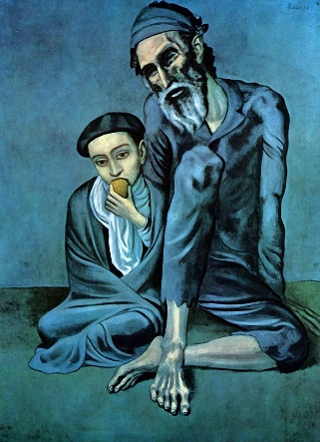
Rose Period |  | 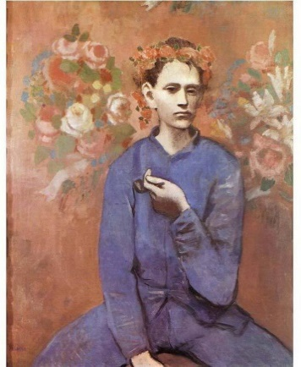
 | 1907+ | 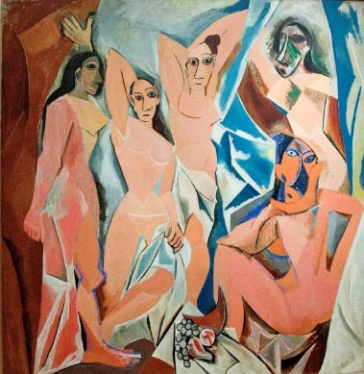
Exercise B
- Do you think Picasso was influential in France?

- Do you think that money was important to Picasso?

- Read the text again carefully and also infer to question 5 in exercise A.
To which period do you think the following drawing belong? Why?
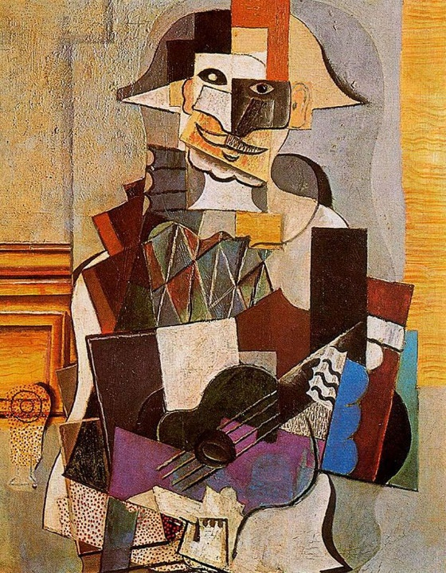

Exercise C
- Who do you respect the most? Have you read that person’s biography?
Explain what you learned and liked about the person’s biography.
- Do you like art or have a favourite artist? Why? (or why not?)
- What do you think ‘success’ is?
Answer Sheet - PABLO PICASSO (1881-1973)

Exercise A
- When and where was Pablo Picasso born? Málaga in the south of Spain on 25 Oct. 1881
- Where was the artistic capital of Europe in 1900? Paris.
- Name the building, which became the permanent home for Picasso since 1904?
Bateau-Lavoir (Laundry boat)
- Is Picasso the only founder of Cubism?
No. Co-founder with French painter Georges Braque
- Which three periods are mentioned in the text? Fill in the table below:
Period | Years | Painting
Blue Period | 1901-1905
Rose Period | 1905-1907
Cubism | 1907+

Exercise B
- Do you think Picasso was influential in France?
Yes. Although Paris was already the artistic capital of Europe, after Picasso moved to a house in Montmarte, that place became the new centre of avant-garde and literature. This shows, that Picasso had a big influence in Paris.
- Do you think that money was important to Picasso?
No. He left Spain when he had his own studio and moved to a house in Paris. It would’ve cost him more as he had to travel to Paris and pay for his own rent. Moreover, he abandoned the “Rose” manner when he could earn money from it and chose to continue with the art, where he can express his ideas. This shows that money was not really important to Picasso.
- Read the text again carefully and also infer to question 5 in exercise A.
To which period do you think the following drawing belong? Why?
I think this drawing belongs to the Cubism period. It has geometrical features and the style looks similar to the last painting in number 5 of exercise A.
Exercise C
- Who do you respect the most? Have you read that person’s biography?
Explain what you learned and liked about the person’s biography.
- Do you like art or have a favourite artist? Why? (or why not?)
- What do you think ‘success’ is?

