Background Information Sheet
Name | Class | Date | Lesson Type | Plan type | Length
Jiyeon Kim (Joy) | 202WK | 13/12/2019 | Grammar | PPP | 35 min

Lesson
Topic | What are you doing?
Main Aim | Students will learn Present Progressive.
Secondary Aim | Students will practice their speaking fluency.

Materials and References
Worksheet1, Worksheet2, PPT 1,2&3

Student Profile
Level |  | Lower Intermediate
Age |  | 9 years old |  | Number of Students | 1
Detail |  | The student is a Korean and has experiences of learning English in an institute. She enjoys learning things new and is interested in sports and arts.
Assumptions about students’ knowledge as required for this lesson:
- The student knows the vocabulary used in this lesson
- The student has learned about the subject and ‘be’ verb relationship
- The student knows how to make the negative form using ‘not’
What language difficulties to expect when presenting, and how to deal with it:
- Meaning: The student may be confused between things happening now and around now because the form is the same ‘be’ + verb-ing. Make a clear timeline and C.C.Q.

- Pronunciation: Students may not know where to put natural sentence stress. Drill several times individually. Ask, “Which word has stress?” Board the stress markers in red.

Anticipated Classroom Management Difficulties and their Solutions:
As the student is a child, give her simple and easy examples to help her understand.

My Personal Aim
What I hope most to demonstrate in this lesson is the ability to
- present the target language using a situational presentation
- to be an involver type teacher

Stage Name: Lead-in
Purpose of this stage: To relax both the teacher and students. To focus attention on the lesson. Create a situation for students to experience or think about, and then to elicit the target language.
Materials: PPT1, 2, 3
Timings | Interactions |  | Procedure
5min | T-S |  | Stick the PPT1 on the board. Look at this picture. What is she doing now? (She is sleeping now)  Stick the PPT2 and 3 on the board. Then look at these pictures. What is she doing before now and after now? (She is reading a book.) It means the action is not happening right now but is happening in the past and in the future, around now; close to now, not far away from now. How do we speak about this one? (She is reading a book these days.)
Stage Name: Presentation
Purpose of this stage: Make the students think about the situation. To clarify the meaning, form, and pronunciation features of the target language.
Materials:
Timings | Interactions |  | Procedure
30sec  1min  1min  1min  30sec  2min  1min | T  T  T-S  T-S  T-S  T-S  T-S |  | Board the model sentence.  - “She’s sleeping now”  - “She’s reading a book these days.”  Draw a timeline and explain which one shows which sentence.  CCQ 1): Point to the sentence 1).  1. Is this action happening right now? (Yes)  2. Is it talking about past? (No)  3. Is it talking about future? (No)  CCQ 2): Point to the sentence 2)  1. Is this action happening right now? (No)  2. Did she read a book last night? (Yes)  3. Will she read it tomorrow? (Not sure but probably yes)  Summary: We use the present progressive to talk about an action that is happening now and around now.  Form: Where is the subject? Where is the verb? And where is the object? What about this? It shows when.  Drill: Listen and repeat: “She’s sleeping now.” “She’s reading a book these days.”  Which word has stress? (sleeping & reading)
Stage Name: Controlled Practice
Purpose of this stage: students practice working with the form (scrambled sentences, split sentences, select the correct form of the verb, correct incorrect sentences, and change one form into another form). Accuracy must be checked.
Materials: Worksheet1
Timings | Interactions |  | Procedure
30sec  5min  30sec | T  S  T–S |  | Now it’s time to do a worksheet. Do the exercise number 4. You have 5 minutes.  ICQ.: How many minutes do you have to do the worksheet? (5 mins.) Now begin.  Hand out.  The student does a worksheet.  Feedback to check accuracy. Board correct answers visually.
Stage Name: Less Controlled Practice
Purpose of this stage: students practice working with the meaning (match timelines to sentences, choose the sentence that matches a picture, gap-fill a paragraph). Accuracy must be checked.
Materials: Worksheet2
Timings | Interactions |  | Procedure
30sec  6min  1min 30sec | T  S  T-S |  | Now you will do the next worksheet, exercise number 6. You better make some notes. You have 6 minutes. Now begin. Hand out.  The student does a worksheet.  Feedback to check accuracy. Board correct answers visually.
Stage Name: Production – Freer Practice
Purpose of this stage: is to get students to practice the grammar communicatively.
Materials:
Timings | Interactions |  | Procedure
10sec  2min 30sec  20sec  3min | T  T-S  T  T-S |  | Inhye, tell me what you are doing now. Let’s talk about what is happening now in this classroom.  The student talks about what is happening now.  Then, what are you doing these days? Tell me about your life these days.  The student talks about what she is doing these days.
Stage Name: Wrap-up
Purpose of this stage: is to end the lesson on a positive note so that students feel they have achieved progress.
Materials: List all materials that will be needed in this stage.
Timings | Interactions |  | Procedure
2min | T-S |  | Write the errors on the board.  Look at the board. Here are some sentences I heard. Tell me how to correct them.  -End-

PPT1
PPT2
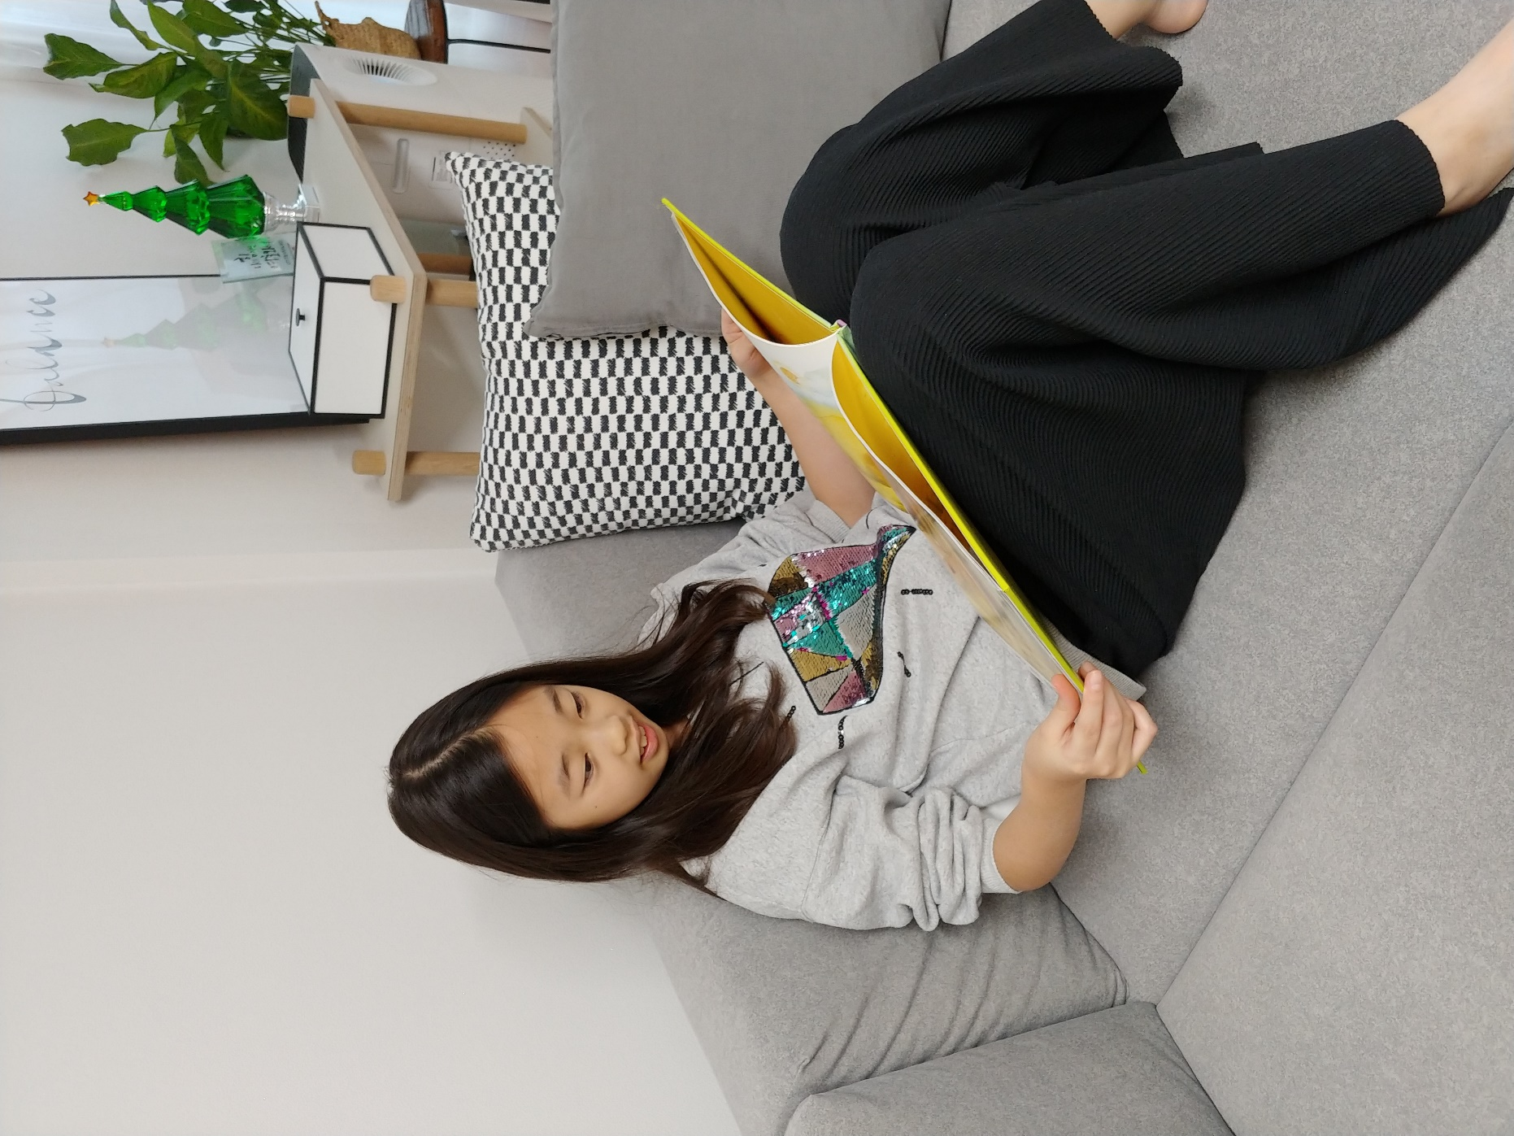
PPT3
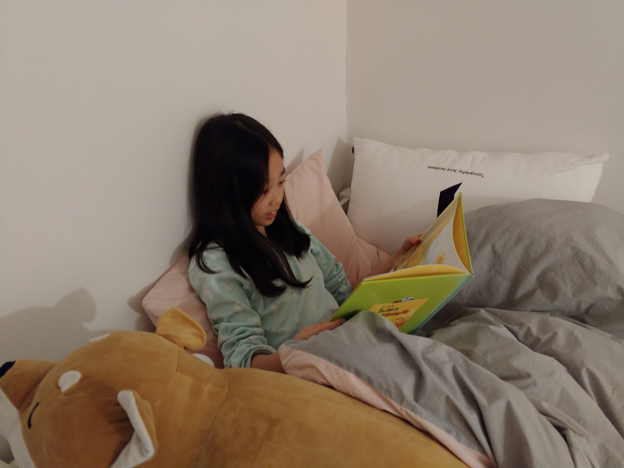
Worksheet1
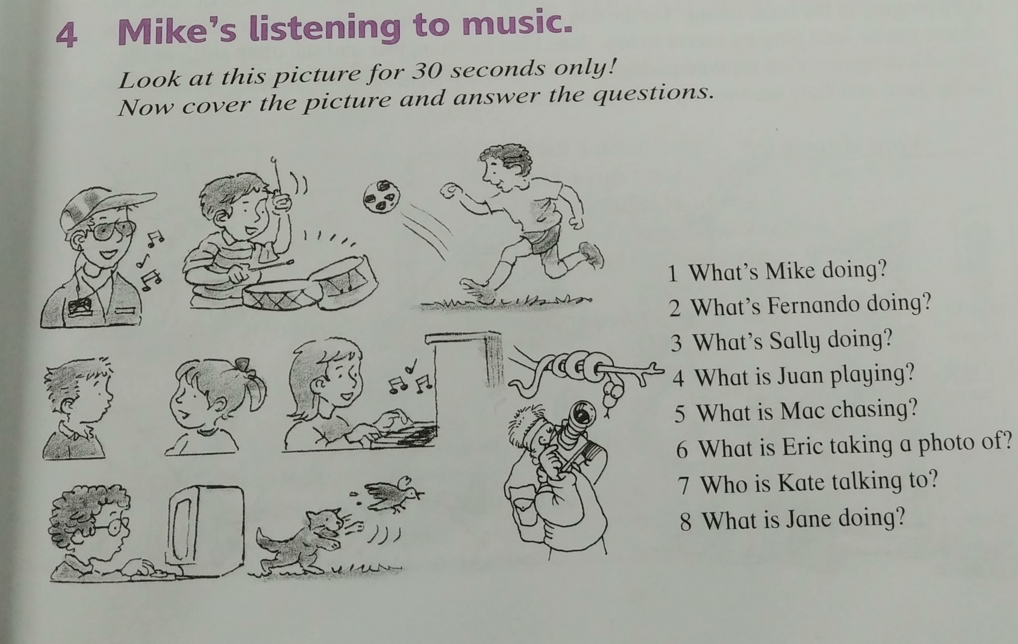
Worksheet2
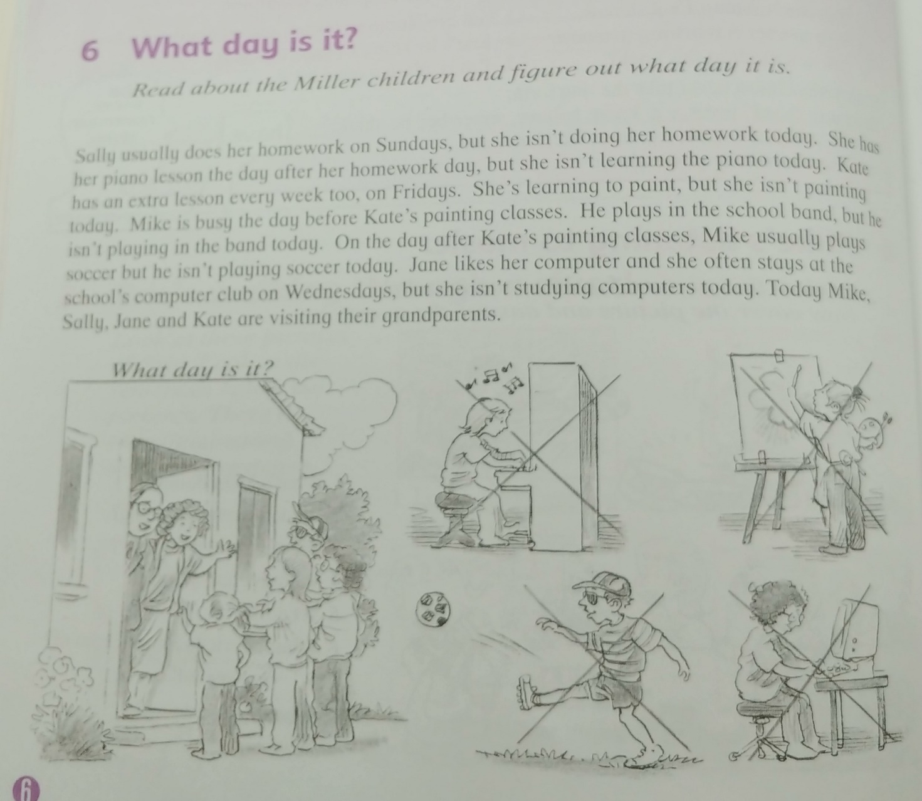
Instructor’s Comments and Assessment
Pros
Cons
Change
Overall Comments
Grade
Above Standard 85%-100% | Standard 70%-84% | Below Standard 69%-0%
Instructor | Student Signature | Date
Taute, David

