|  |  |  |  |
| --- | --- | --- | --- |
| **xXx Language or Activity Based  Storytelling  Puppet Play Presentation** | | | |
| **Topic: planning Christmas party!** | | | |
| Instructor:  **Summer** | **Students Competency Level and Student ages**  **Elementary, 7-9 years old** | **Number of Students:**  **10** | **Lesson Length:**  **60 min** |
| Materials:**(List the Names of all materials used in the lesson. Materials must be shown at the end of this document)**   * Movie Clip What Is It? (Christmas Vocabulary) * Computer * Video Screen * Filling The Blanks Worksheet * Vocabulary Word Search Worksheet * Pictures – What Makes A Good Party   _ Party Place  _ Types Of Party/ Activity  _Types Of Invitation   * Christmas Planner Worksheet * Pencils * Invitation Papers * Colored Pencils | | | |
| Lesson Objectives(What do you want the students to know (**new skill** or **knowledge** that you want them to gain)?AndWhat do you want them to be able to do?  Ss are happy to learn about vocabulary related to Christmas and improve their ability to imagine and create their plan by doing an activity and making their own plan for Christmas! | | | |
| Aims:**(What students will be able to achieve by participating in the activities of the lesson. (Ss gain or get by doing…)**  Ss will be interested in knowing Christmas and the vocabulary related to Christmas by listening the song and doing worksheet.  Ss will improve listening and speaking skills by responding to teacher and discussing with group.  Ss will gain writing skills by writing the sentence during doing worksheet and making their invitation.  Ss will have some creativity and imagination by planning and drawing their Christmas invitation.  Ss will improve interaction and communication skills by having discussion as a group. | | | |
| Language Skills:**(Lists what activities language skills students will be using by participating in the activities of the lesson.)**   * Reading: **(Where did reading occur in the lesson?)**   Whiteboard, Worksheet   * Listening:**(Where did listening occur in the lesson?)**   Teacher talk, Discussion , Listening the song.   * Speaking: **(Where did speaking occur in the lesson?)**   Answering teacher, Discussion, Presentation their plan for Christmas   * Writing: **(Where did writing occur in the lesson?)**   Worksheet, activity sentences | | | |
| Assumptions:**(What students must already be able to do and what concepts must already be mastered before the lesson in order to achieve the aims of the lesson.)**  Ss will enjoy and also have fun  Ss like knowing what Christmas is.  Ss can make a sentence and make guess. | | | |
| Anticipated Errors and Solutions:**(What things might go wrong in the lesson and what the solution will be. An SOS activity should also be included)**  The computer doesn’t work, teacher will song by self and help learn the melody.  The activity takes too long, the other activity may be shortened.  Teacher can give students more information when they have difficulty understanding activity.  Teacher can give students little examples when they may not many ideas.  Teacher can give students some hints when they have a difficulty of worksheet.  Teacher can give lots of encouragement when students might be shy. | | | |
| References:  YouTube (What is it) | | | |

|  |  |  |  |
| --- | --- | --- | --- |
| **Lead-In or Pre-Task Part (Warm-Up Part to activate and create interest in the lesson.)** | | | |
| Materials: **(List the Names of all materials used in the Lead-In or Pre-Task Part of the lesson. Materials must be shown at the end of this document)**   * Movie Clip What is it? (Christmas vocabulary) * Computer * Video Screen * Filling The Blanks Worksheet * Vocabulary Word Search Worksheet | | | |
| 1min  2min  3min  5min | Whole  Whole  Whole  Whole | Ss greet the teacher.  Ss listen to T and become interested.  Ss listen the song and sing together.  Ss answer the questions. | T greets.  T introduces about Christmas and tells what are we going to do.  T shows what is it song with movie clip and sing a song.  T asks give vocabulary work sheets related to Christmas and let students do it. |

|  |  |  |  |
| --- | --- | --- | --- |
| **Pre-Activity or Task Familiarization Part (Presentation Partfor Presenting the language structure to be covered in the lesson. Prepares students for the communication activity.)** | | | |
| Materials: **(List the Names of all materials used in the Pre-Activity or Task Familiarization Part of the lesson. Materials must be shown at the end of this document)**   * Pictures – What Makes A Good Party   _ Party Place  _ Types Of party/ Activities  _Types Of Invitation | | | |
| **Time:** | **Classroom Set Up:** | **Student Activity and Goals:** | **Teacher Procedure & Instructions:** |
| 3min  3min  3min  3min | Whole  Whole  Whole  whole | Ss listen what T says and Ss respond their opinions.  Ss listen what T says and Ss respond their opinions.  Ss listen what T says and Ss respond their opinions.  Ss listen what T says and Ss respond their opinions. | Tasks Ss what makes a good party and shows the example.  T asks Ss where will have the party and shows the example.  T asks Ss what types of party and activities do they want and shows the example.  T asks Ss how will invite the guest and shows the example. |

|  |  |  |  |
| --- | --- | --- | --- |
| **Main Activity or Task Realization Part(Practice to Production Part Teacher leads practice of the language presented and move to communication based more student centered activity)** | | | |
| Materials: **(List the Names of all materials used in the Main Activity or Task Realization Part of the lesson. Materials must be shown at the end of this document)**   * Christmas Planner Worksheet * Pencils | | | |
| **Time:** | **Classroom Set Up:** | **Student Activity and Goals:** | **Teacher Procedure &Instructions:** |
| 2min  2min  1min  10min  5min  2min | Whole  Whole  Group  Group  Whole  whole | Ss listen what T says.  Ss listen and know how to do activity.  Ss move into pairs and receive worksheets.  Ss discuss each other and write the plans on the worksheet  Ss give a presentation about their Christmas plan.  Ss applaud each other. | T introduces what is going to do about activity and how to do activity.  T shows T’s Christmas plan which are already prepared before.  Divide Ss into pairs and give worksheets to group  T monitors the activity and gives encouragement to each group.  T lets students to give a presentation about their Christmas plan and gives good feedbacks.  T gives lots of encouragement and gives Ss positive feedback. |

|  |  |  |  |
| --- | --- | --- | --- |
| **Post Activity or Post Task Part (Wrap-Up Part to Close the Lesson on a high note to and consolidate language learned in a communication based activity new situation.)** | | | |
| Materials: **(List the Names of all materials used in the Post Activity or Post Task Part of the lesson. Materials must be shown at the end of this document)**   * Invitation Papers * Colored Pencils | | | |
| **Time:** | **Classroom Set Up:** | **Student Activity and Goals:** | **Teacher Procedure &Instructions:** |
| 2min  7min  5min  1min | Whole  Whole  Whole  Whole | Ss listen and get interested in.  Ss draw and write their invitation they want.  Ss show their invitation and introduce in detail.  Ss applaud | T introduces teacher’s invitation first and explain in detail.  T lets students to draw and write their invitation and monitors it.  T lets students to show their invitation.  T expresses congratulations and thanks for great effort for Ss. |

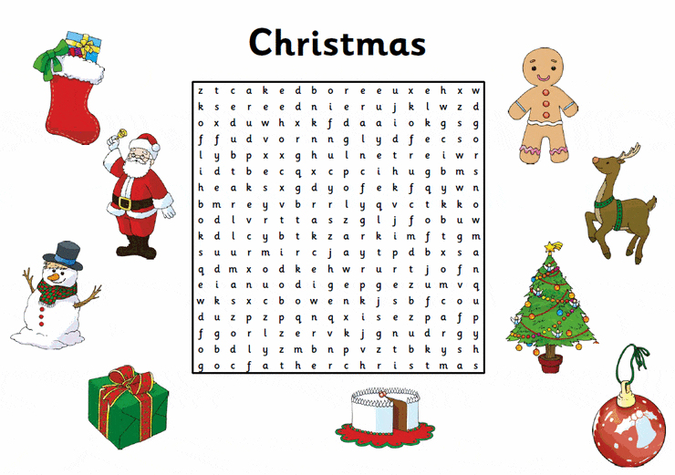





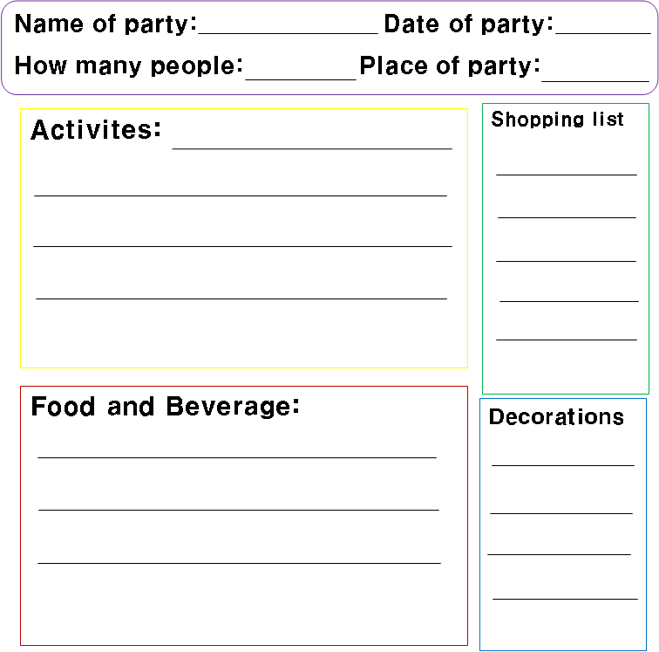**We’re Party Planner!**

