Language or Activity Based Xx Storytelling Puppet Play Presentation
Topic or Title: Little Red Riding Hood
Instructor:  Summer | Students Competency Level and Student ages  Elementary, 7-9 years old | Number of Students:  10 | Lesson Length:  60min
Materials:(List the Names of all materials used in the lesson. Materials must be shown at the end of this document)
- Errand Picture
- Little Red Riding Hood Book
- Finger Puppets –
- Mom
_ Grandma
_ Red
_ Big Bad Wolf
_ Hunter
- Paper
- Pencils
- Two Ending Situation Pictures
- Wanted Poster
- Colored Pencils
- Teacher’s Poster

Lesson Objectives(What do you want the students to know (new skill or knowledge that you want them to gain)? And wWhat do you want them to be able to do?
Ss are happy to understand story in English by listening to teacher’s storytelling and Ss enjoy making the ending story themselves with their plentiful imagination.

Aims:(What students will be able to achieve by participating in the activities of the lesson. (Ss gain or get by doing…)
Ss will be interested in the story of Little Red Riding Hood by listening to the story of Little Red Riding Hood in English.
Ss will improve listening and speaking skills by listening to the teacher’s storytelling responding to the teacher and participating in the role play.
Ss will gain writing skills by writing the sentence during roleplay and making the poster.
Ss will have some creativity and imagination by making the ending themselves.
Ss will improve interaction and communication skills by having discussion as a group.
Language Skills:(Lists what activities language skills students will be using by participating in the activities of the lesson.)
- Reading: (Where did reading occur in the lesson?)
Worksheet
- Listening:(Where did listening occur in the lesson?)
Teacher talk, Teacher’s storytelling , During role play
- Speaking: (Where did speaking occur in the lesson?)
Answering teacher, Discussion, During role play
- Writing: (Where did writing occur in the lesson?)
Drawing poster, activity for make some sentences

Assumptions:(What students must already be able to do and what concepts must already be mastered before the lesson in order to achieve the aims of the lesson.)
Ss will enjoy and also have fun during the role play.
Ss will be interested in listening to the teacher’s story with pictures.
Ss can make a sentence and know some general vocabulary.
Ss will enjoy making the ending with their imagination.
Anticipated Errors and Solutions:(What things might go wrong in the lesson and what the solution will be. An SOS activity should also be included)
The activity takes too long, the other activity may be shortened.
Teacher can give students more information when they have difficulty understanding activity.
Teacher can give students little examples when they may not many ideas.
Teacher can give lots of encouragement when students might be shy.
References:

Lead-Inor Pre-Task Part (Warm-Up Part to activate and create interest in the lesson.)
Materials: (List the Names of all materials used in the Lead-In or Pre-Task Part of the lesson. Materials must be shown at the end of this document)
- Errand Picture
Time: | Classroom Set Up: | Student Activity and Goals: | Teacher Procedure &Instructions:
1min  3min  3min | Whole  Whole  Whole | Ss greet the teacher.  Ss listen to T and become interested.  Ss answer their experiences. | T greets.  T shows Errand Picture and tells about the T’s experience running an errand before.  T asks Ss if they have experiences running an errand for their parents.

Pre-Activity or Task Familiarization Part (Presentation Part for Presenting the language structure to be covered in the lesson. Prepares students for the communication activity.)
Materials: (List the Names of all materials used in the Pre-Activity or Task Familiarization Part of the lesson. Materials must be shown at the end of this document)
- Little Red Riding Hood Book
- Finger Puppets:
–Mom
_ Grandma
_ Red
_ Big Bad Wolf
_ Hunter
Time: | Classroom Set Up: | Student Activity and Goals: | Teacher Procedure &Instructions:
1min  10min  3min  2min | Whole  Whole  Whole  whole | Ss listen what T says.  Ss look at the pictures and finger puppets and listen to T.  Ss answers T what they think.  Ss listen what T says and know what’s going on next. | T introduces a book ‘Little Red Riding Hood.  T tells the story with pictures and introduces story using finger puppets and introduces without ending.  T asks Ss some questions while telling a story.  T tells Ss that this story will end two types and let students imagine the ending through two situations

Main Activity or Task Realization Part(Practice to Production Part where Teacher leads practice of the language presented and move to communication based more student centered activity)
Materials: (List the Names of all materials used in the Main Activity or Task Realization Part of the lesson. Materials must be shown at the end of this document)
- Paper
- Pencils
- Two Ending Situation Pictures
- Finger Puppets:
–Mom
_ Grandma
_ Red
_ Big Bad Wolf
_ Hunter
Time: | Classroom Set Up: | Student Activity and Goals: | Teacher Procedure &Instructions:
2min  2min  1min  8min  7min  2min | Whole  Whole  Group  Group  Whole  whole | Ss listen what T says.  Ss think and imagine the ending.  Ss move into group and receive the paper and finger puppets.  Ss discuss each other and each group writes the script.  Ss play in role about two endings.  Ss applaud each other. | T shows two ending situations with pictures.  T lets students think about two situations and imagine the ending.  Divide Ss into group and give the paper and finger puppets.  T monitors the activity and gives encouragement and help to each group.  T lets students to play in role about two endings and gives good feedbacks.  T gives lots of encouragement and gives Ss positive feedback.

Post Activity or Post Task Part (Wrap-Up Part to Close the Lesson on a high note to and consolidate language learned in a communication based activity new situation.)
Materials: (List the Names of all materials used in the Post Activity or Post Task Part of the lesson. Materials must be shown at the end of this document)
- Wanted Poster
- Pencils
- Colored pencils
- Teacher’s Poster
Time: | Classroom Set Up: | Student Activity and Goals: | Teacher Procedure &Instructions:
2min  7min  5min  1min | Whole  Whole  Whole  Whole | Ss listen and get interested in.  Ss draw and write their posters.  Ss show their posters and introduce in detail.  Ss applaud | T introduces that why we make a poser and show teacher’s poster and explain in detail.  T lets students to draw and write their posters and monitors it.  T lets students to show their poster  T expresses congratulations and thanks for great effort for Ss.
Errand Picture

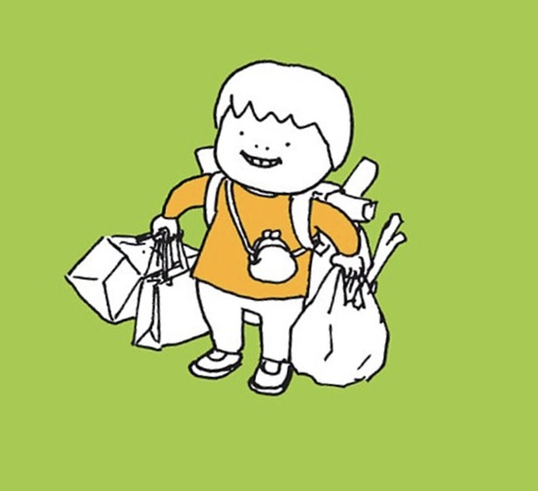

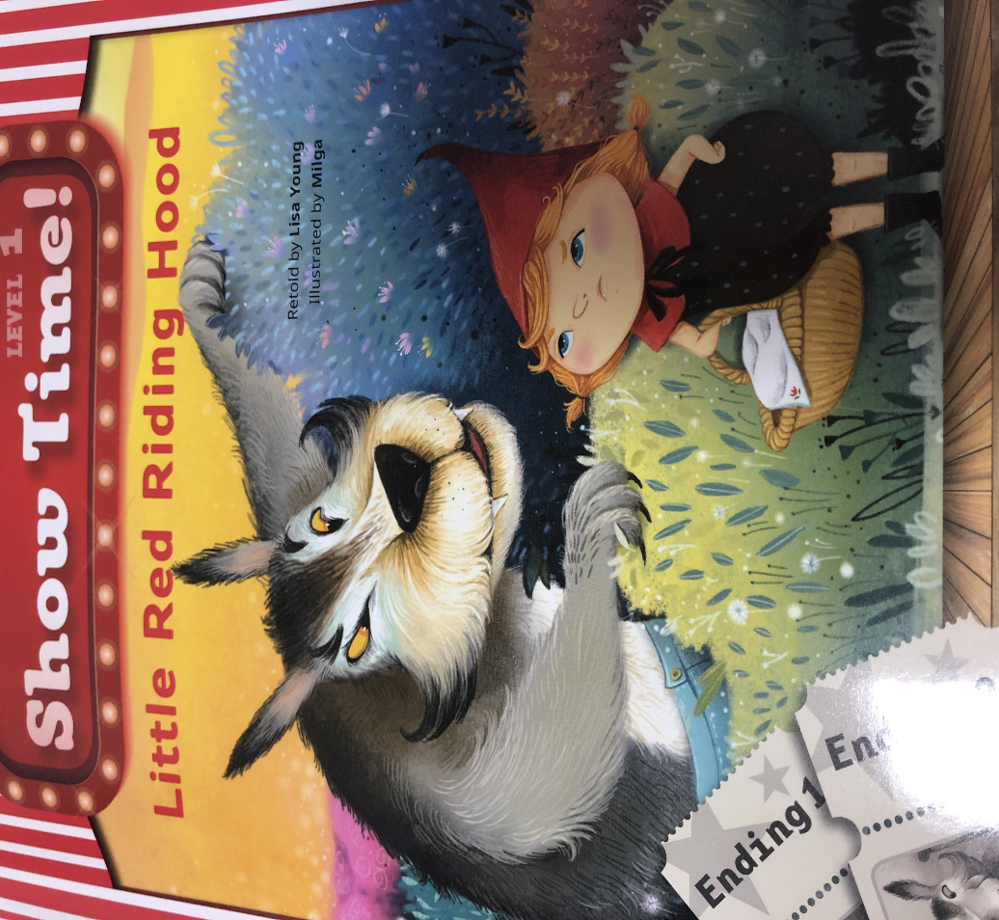
Little Red Riding Hood Book

Finger Puppets

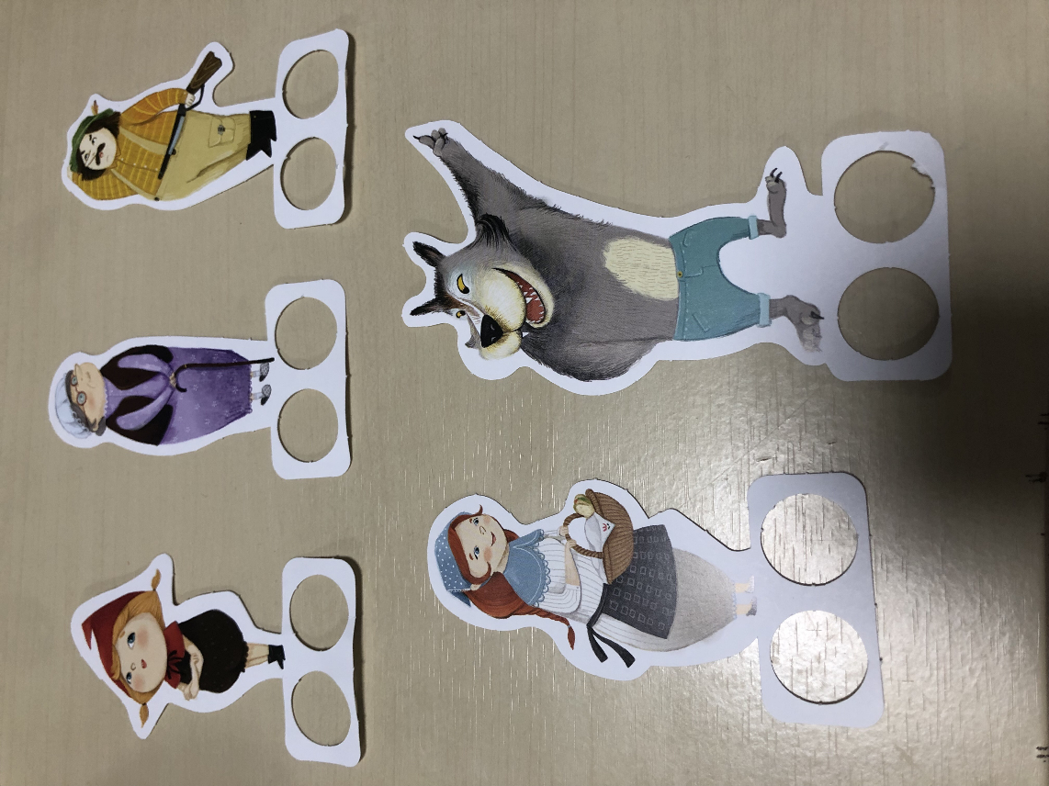

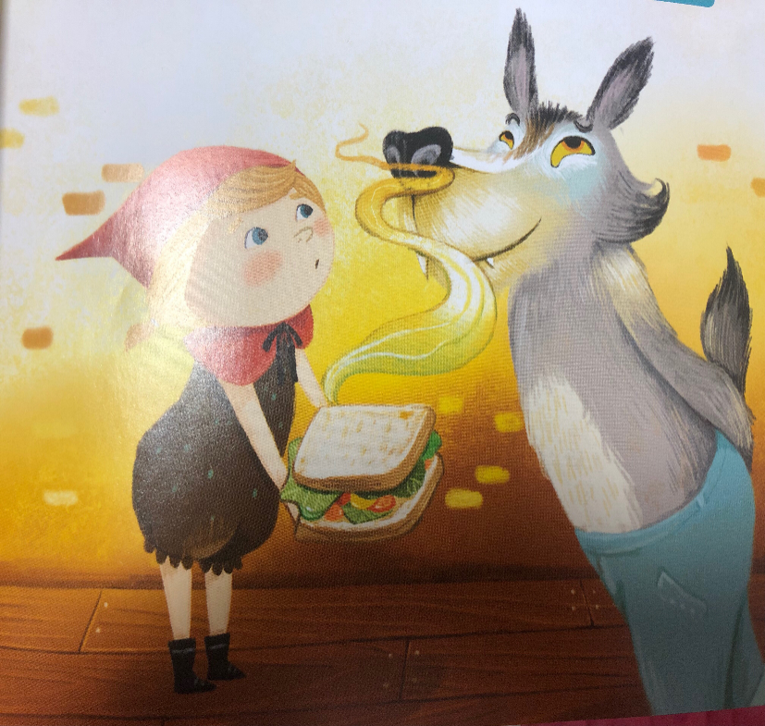
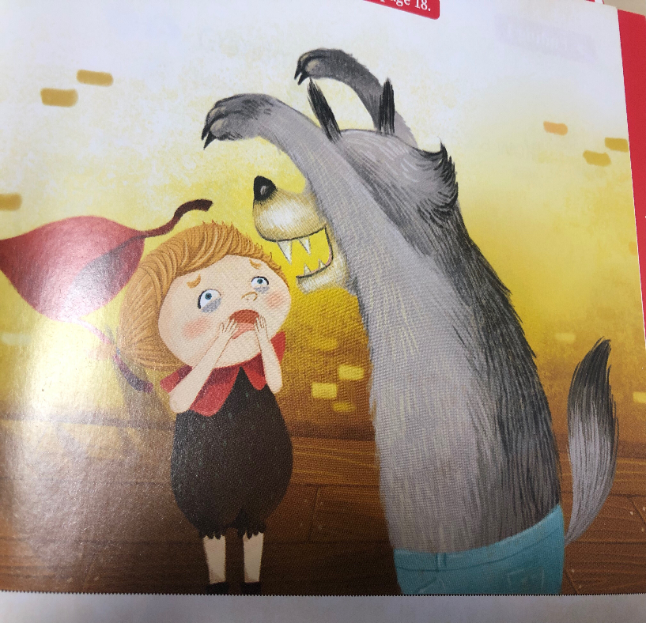
Ending Situation 1 Ending Situation 2
Poster Paper

