Language or Activity Based Storytelling Puppet Play Presentation
Topic, Story Title, or Puppet Play Name: How Do I Get There?

Instructor:  Matt | Students Competency Level and Student ages  Elementary, 7-9 | Number of Students:  6 students | Lesson Length:  62 minutes
Materials:(List the Names of all materials used in the lesson. Materials must be shown at the end of this document)
- Computer
- Video Screen
- Picture of a Town
- White Board and Markers
- Shopping Mall Pictures
Shopping Mall Picture 1
Shopping Mall Picture 2
- Places to find Lists:
List of Places 1
List of Places 2
- Teacher’s Town Picture
- Paper and Color Pencils
Lesson Objectives(What do you want the students to know (new skill or knowledge that you want them to gain)?andWhat do you want them to be able to do?
Students will be able to describe the location of a place and guide others by giving directions to get there..
Aims:(What students will be able to achieve by participating in the activities of the lesson. (Ss gain or get by doing…)
- Ss will improve their ability to give directions by using a map.
- Ss will improve listening and speaking skills by participating in a communication activity
Language Skills:(Lists what activities language skills students will be using by participating in the activities of the lesson.)
- Reading: (Where did reading occur in the lesson?)
Map of mall and town picture
- Listening:(Where did listening occur in the lesson?)
Teacher talk, group discussion, listening to directions
- Speaking: (Where did speaking occur in the lesson?)
Responding to teacher and group discussion
- Writing: (Where did writing occur in the lesson?)
No emphasis on writing

Assumptions:(What students must already be able to do and what concepts must already be mastered before the lesson in order to achieve the aims of the lesson.)
- Picture of a Town
- White Board and Markers
- Shopping Mall Pictures
Shopping Mall Picture 1
Shopping Mall Picture 2
- Places to find Lists:
List of Places 1
List of Places 2

Anticipated Errors and Solutions:(What things might go wrong in the lesson and what the solution will be. An SOS activity should also be included)
- If Ss have difficulty in giving directions T will assist.

References:
- None

Lead-In or Pre-Task Part (Warm-Up Part to activate and create interest in the lesson.)
Materials: (List the Names of all materials used in the Lead-Inor Pre-Task Partof the lesson. Materials must be shown at the end of this document)
- No materials
Time: | Classroom Set Up: | Student Activity and Goals: | Teacher Procedure &Instructions:
1 min  3 min  5 min  3 min | Whole  Whole  Whole  Whole | Greeting from teacher  Ss listen to the T’s talk.  Ss tell about their places.  After listening to T’s talk, Ss tries to explain their places’ location. | Greeting  T tells Ss about the places where he like to go in his free time (Café, Park or Library… etc.) and the reason why he goes there.  T asks Ss about their preferred places to go.  T asks Ss if they can describe the location of the places Ss mentioned. Before listening to Ss’ answers T first tells Ss about the location of the T’s places.

Pre-Activity or Task Familiarization Part (Presentation Part for Presenting the language structure to be covered in the lesson. Prepares students for the communication activity.)
Materials: (List the Names of all materials used in the Pre-Activity or Task Familiarization Part of the lesson. Materials must be shown at the end of this document)
- Picture of a Town
- White Board and Markers
Time: | Classroom Set Up: | Student Activity and Goals: | Teacher Procedure &Instructions:
1min  3 min  5 min  2 min | Whole  Whole  Whole  Whole | Ss listens to T’s introduction  Ss listens to T’s talking and guess the place T’s mentioning  Ss listens to T’s talking and try to draw lines to get to the place and write the place number on the picture.  Ss participate in T’s listing up on the white board. | T shows a picture of a town and describes 4 places to go and the directions to get there. T asks Ss to listen and guess the location of the places.  T told to the Ss for the places one by one. At first case, T repeats the sentences slowly and draw the lines following the directions and write the number on the 1st place.  From 2ndto 4th, Ss listen to the T’s directions and try to draw the lines to move on the picture and write the number 2 to 4. While Ss trying to guess the locations, T repeats the sentences to finding places and draw the moving lines together with Ss  After that, T remind the words or expressions appeared in the activity and list up them on the white board. The words which will be used in main activity also can be added.

Main Activity or Task Realization Part (Practice to Production Part Teacher lead practice of the language presented and move to communication based more student centered activity)
Materials: (List the Names of all materials used in the Main Activity or Task Realization Part of the lesson. Materials must be shown at the end of this document)
- Shopping Mall Pictures
Shopping Mall Picture 1
Shopping Mall Picture 2
- Places to find Lists:
List of Places 1
List of Places 2

Time: | Classroom Set Up: | Student Activity and Goals: | Teacher Procedure &Instructions:
2 min  3 min  2 min  10 min  3 min  1 min | Pairs  Pairs  Pairs  Pairs  Pairs  Pairs | Ss sit in pairs. Get T’s hand outs and listen to T’s instructions.  Examining the map and places list, Ss think about how to tell the partner the way to get there.  Ss listens to T’s demonstration.  Following T’s guide, Ss ask and answer each other one by one for the locations they are looking for. | T setup the class into pairs and introduce the activity. T hand out the shopping mall maps and finding places’ list to the Ss. Make each person in the pair get different maps and place lists so that they ask and answer each other without knowing partner’s map. (Let Ss be careful not to show their maps or lists with partners.)  T gives Ss some time to check the known places in S’s maps and think about how to explain to get there from the place “You are here”  T shows demonstration for one place.  T guides Ss to ask and answer each other about the location of the places they are looking for. The S who are answering should not use finger or any motion so that S who are asking can’t guess the place from the motion but only can get idea from listening to partners saying.  While Ss in the pairs ask for the location in turn. Ss should discuss enough to check if one describe the location correctly and the other one understood clearly. (While Ss’ doing pair work, T monitors it and involve or help)  After Ss work, T select 2~3 places among the Ss work and provide best answers for their locations.  T ask for Ss any questions and appreciates to Ss.

Post Activity or Post Task Part (Wrap-Up Part to Close the Lesson on a high note to and consolidate language learned in a communication based activity new situation.)
Materials: (List the Names of all materials used in the Post Activity or Post Task Part of the lesson. Materials must be shown at the end of this document)
- Teacher’s Town Picture
- Paper and Color Pencils
Time: | Classroom Set Up: | Student Activity and Goals: | Teacher Procedure &Instructions:
4min  5min  8min  1min | W  Ss  Ss  Ss | Ss listen to teacher  Ss receives paper and color pencils and draws a picture of their town  Ss individually comes to front and presents and describes their town picture  Ss say goodbye | T shows his town picture and describe the buildings inside  T hands out paper and tells students to draw a picture of their town  T asks Students to share their picture of their town and present to class  T thanks students for their active participation and closes lesson

- Picture of a Town

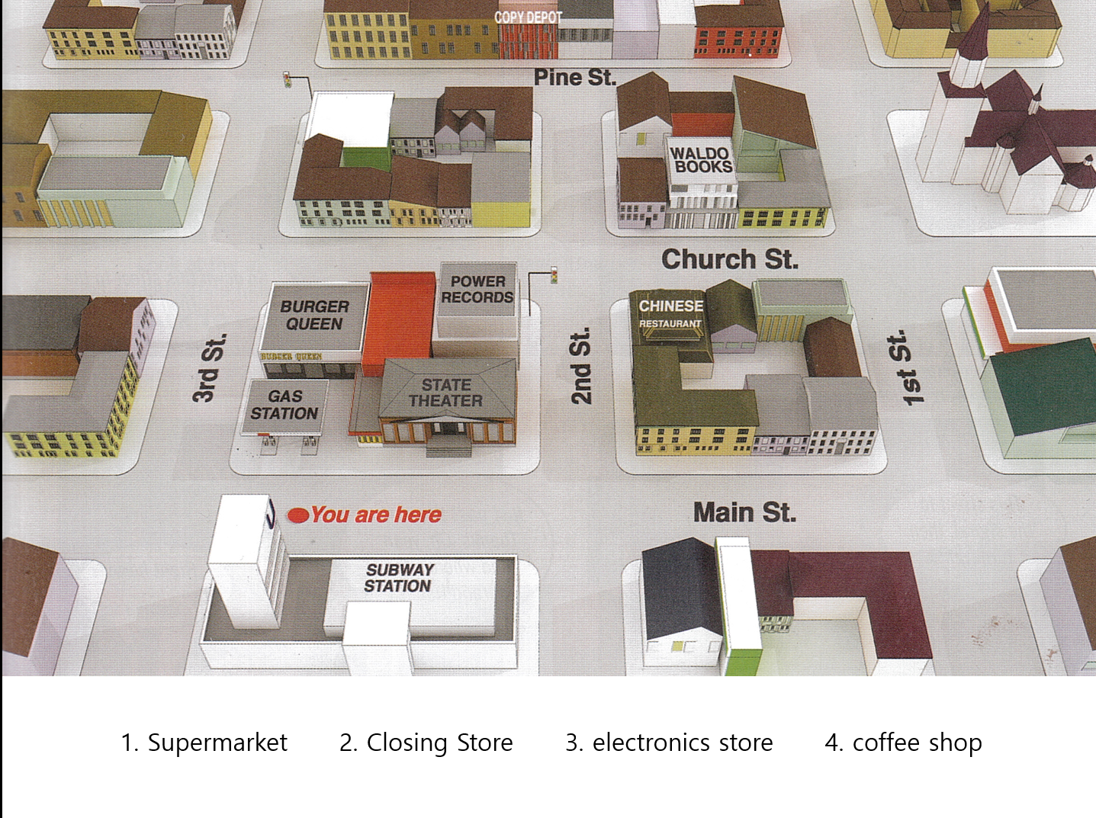

- Shopping Works Sheet 1 (Shopping Mall and List of Places)
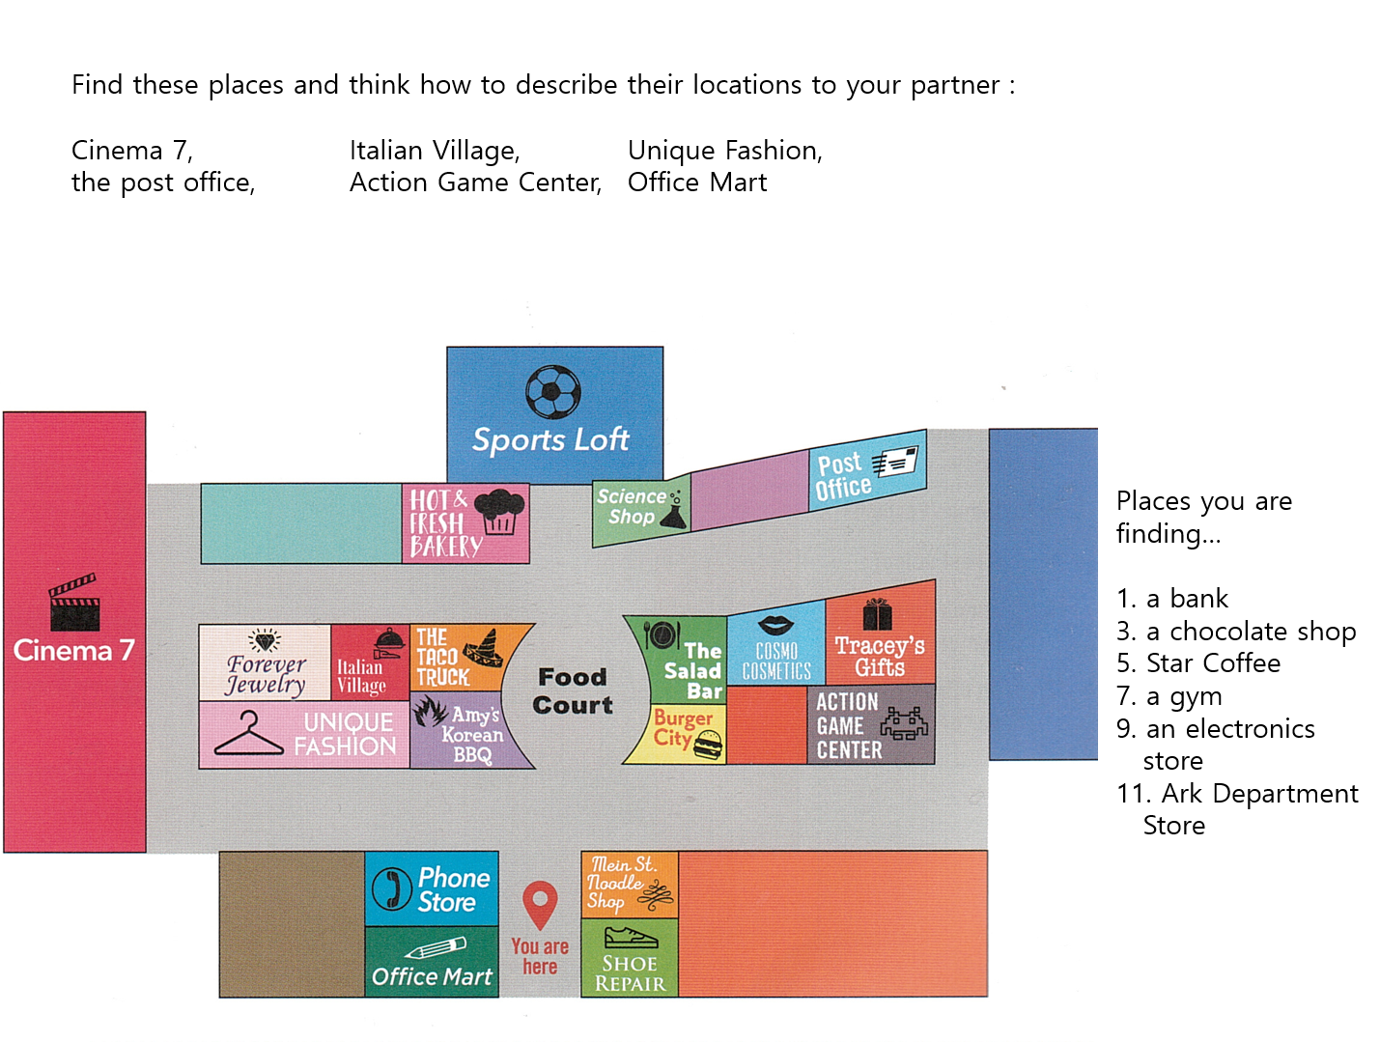

- Shopping Works Sheet 2 (Shopping Mall and List of Places)
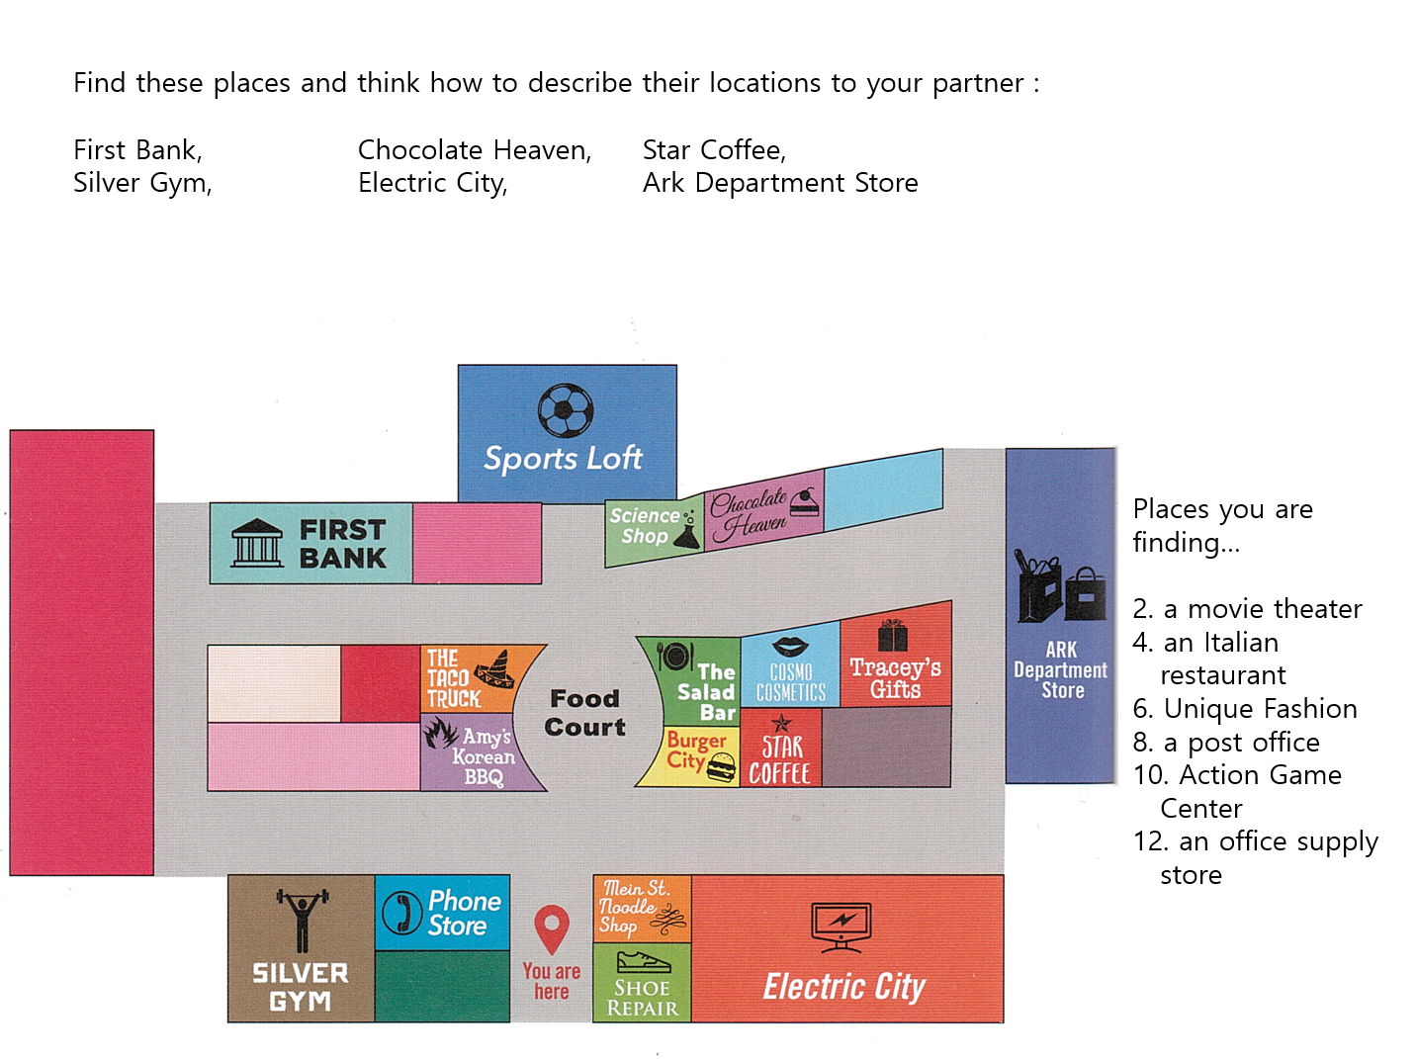

- Teacher’s Town Picture

