Language or Activity Based Storytelling Puppet Play Presentation
Topic, Story Title, or Puppet Play Name: The Elves And The Shoemaker

Instructor:  Matt | Students Competency Level and Student ages  Elementary, 7-9 | Number of Students:  6 students | Lesson Length:  47 minutes
Materials:(List the Names of all materials used in the lesson. Materials must be shown at the end of this document)
- “The Elves And The Shoemaker” Book (or Book File)
- Computer and Screen
- Papers for Making Shoes With
- Sample Paper Shoe
- Color Pencils
- Scotch Tape (or Stapler)
- Word Cards
- Whiteboard and Markers
Lesson Objectives(What do you want the students to know (new skill or knowledge that you want them to gain)?andWhat do you want them to be able to do?
Students will comprehend the story and participate and enjoy the activities.
Aims:(What students will be able to achieve by participating in the activities of the lesson. (Ss gain or get by doing…)
- Ss will improve understanding book stories and communicate with the stories.
- Ss will improve listening, speaking and reading skills by participating in a communication activity
Language Skills:(Lists what activities language skills students will be using by participating in the activities of the lesson.)
- Reading: (Where did reading occur in the lesson?)
“Word Card” post activity
- Listening:(Where did listening occur in the lesson?)
Teacher talk, storytelling, listening to directions
- Speaking: (Where did speaking occur in the lesson?)
Responding to teacher and doing activities
- Writing: (Where did writing occur in the lesson?)
In the Post Activity ("Word Card")

Assumptions:(What students must already be able to do and what concepts must already be mastered before the lesson in order to achieve the aims of the lesson.)
- Ss will be interested in listening to the story
- Ss know some stories about elves, fairies
- Ss can deal with papers and can make paper shoes when guide given
Anticipated Errors and Solutions:(What things might go wrong in the lesson and what the solution will be. An SOS activity should also be included)
- If Ss have difficulty in making paper shoes T will assist.

References:
- None

Lead-In or Pre-Task Part (Warm-Up Part to activate and create interest in the lesson.)
Materials: (List the Names of all materials used in the Lead-Inor Pre-Task Partof the lesson. Materials must be shown at the end of this document)
- No materials
Time: | Classroom Set Up: | Student Activity and Goals: | Teacher Procedure &Instructions:
1 min  4 min  4 min  1 min | Whole  Whole  Whole  Whole | Greeting from teacher  Ss listen to T and answer or reply to the T’s questions.  Ss listen to T and respond to T with the stories they know.  Ss listen | Greeting  T asks Ss if they heard about Elves or Fairies or Goblins and ask several things about them. (What’s the similar things and differences between them? Do you believe that there exist such ones in the world?)  And ask Ss if they know any story they comes in. T mentions first about that kind of stories (Cinderella, Peter Pan …)  T tell Ss that we will see a story in which elves appears.

Pre-Activity or Task Familiarization Part (Presentation Part for Presenting the language structure to be covered in the lesson. Prepares students for the communication activity.)
Materials: (List the Names of all materials used in the Pre-Activity or Task Familiarization Part of the lesson. Materials must be shown at the end of this document)
- “The Elves And The Shoemaker” Book (or Book File)
- Computer and Screen
Time: | Classroom Set Up: | Student Activity and Goals: | Teacher Procedure &Instructions:
6 min  3 min  3 min | Whole  Whole  Whole | Ss listen carefully.  Ss respond to T.  Ss answer ot respond to T’s talk. | T tells the story with the book  T asks some questions while telling the story with book.  T asks some questions after telling the story with the book

Main Activity or Task Realization Part (Practice to Production Part Teacher lead practice of the language presented and move to communication based more student centered activity)
Materials: (List the Names of all materials used in the Main Activity or Task Realization Part of the lesson. Materials must be shown at the end of this document)
- Papers for Making Shoes With
- Sample Paper Shoe
- Color Pencils
- Scotch Tapes (or Stapler)

Time: | Classroom Set Up: | Student Activity and Goals: | Teacher Procedure &Instructions:
5 min  5 min  5 min | Whole  S  S | Ss learn making paper shoes from T  Ss make their paper shoe.  Ss present about their paper shoes. | T explain Ss the way to make shoes with paper and show them demonstration with sample. And guide Ss to make their paper shoes and prepare the presentation for it (What are the good points and weakness of it)  T asks Ss to make their shoes and help Ss while they are making.  After Ss work, T asks Ss to make presentations in turn. While Ss present, T respond and ask questions.  T appreciates Ss for their excellent work.

Post Activity or Post Task Part (Wrap-Up Part to Close the Lesson on a high note to and consolidate language learned in a communication based activity new situation.)
Materials: (List the Names of all materials used in the Post Activity or Post Task Part of the lesson. Materials must be shown at the end of this document)
- Word Cards
- Whiteboard and Markers
Time: | Classroom Set Up: | Student Activity and Goals: | Teacher Procedure &Instructions:
5 min  5 min | Whole  Pair | Ss remind the words and helps T to write correct words and perform the actions for the word.  Listen to T’s guide and do activity | T helps Ss to remind some words which appeared in the story and write the words on the white board. While writing the words interlocking with Ss, ask Ss to perform act the actions for that words.  Introduce Word Card game. And let Ss do the activity. After the activity, T thanks students for their active participation and closes lesson

- Picture about Elf, Fairy and Goblin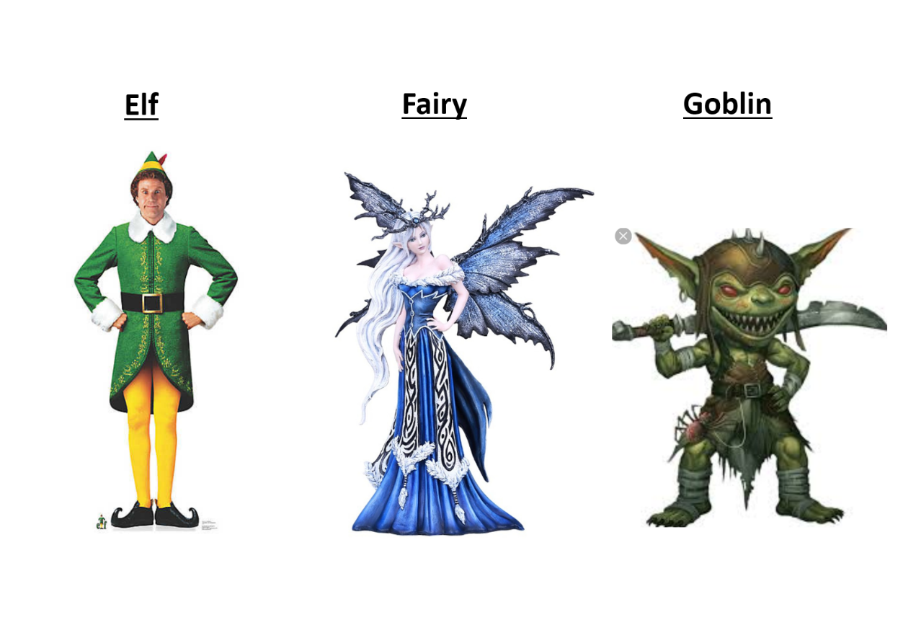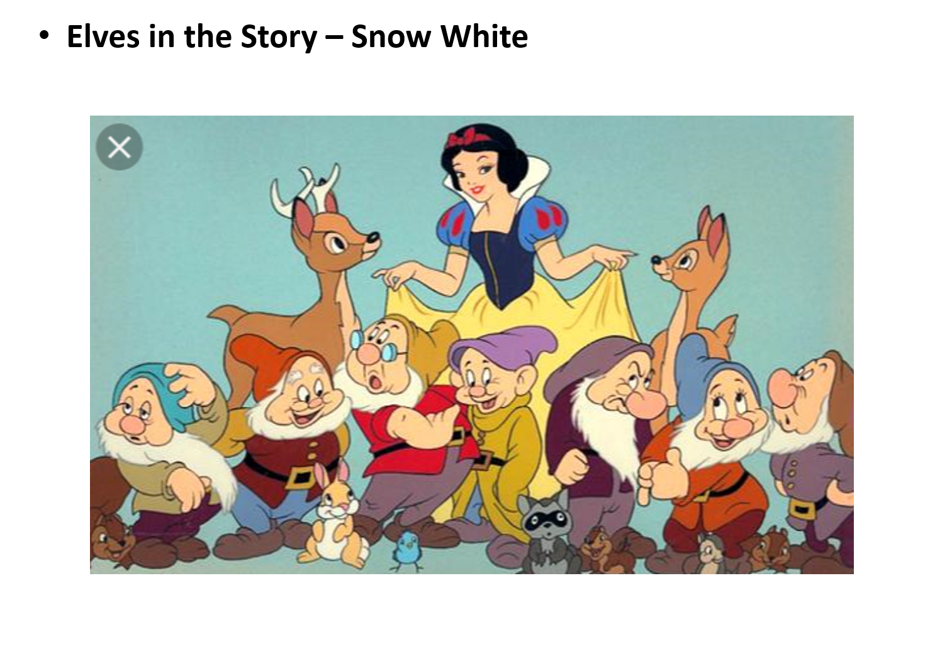
- 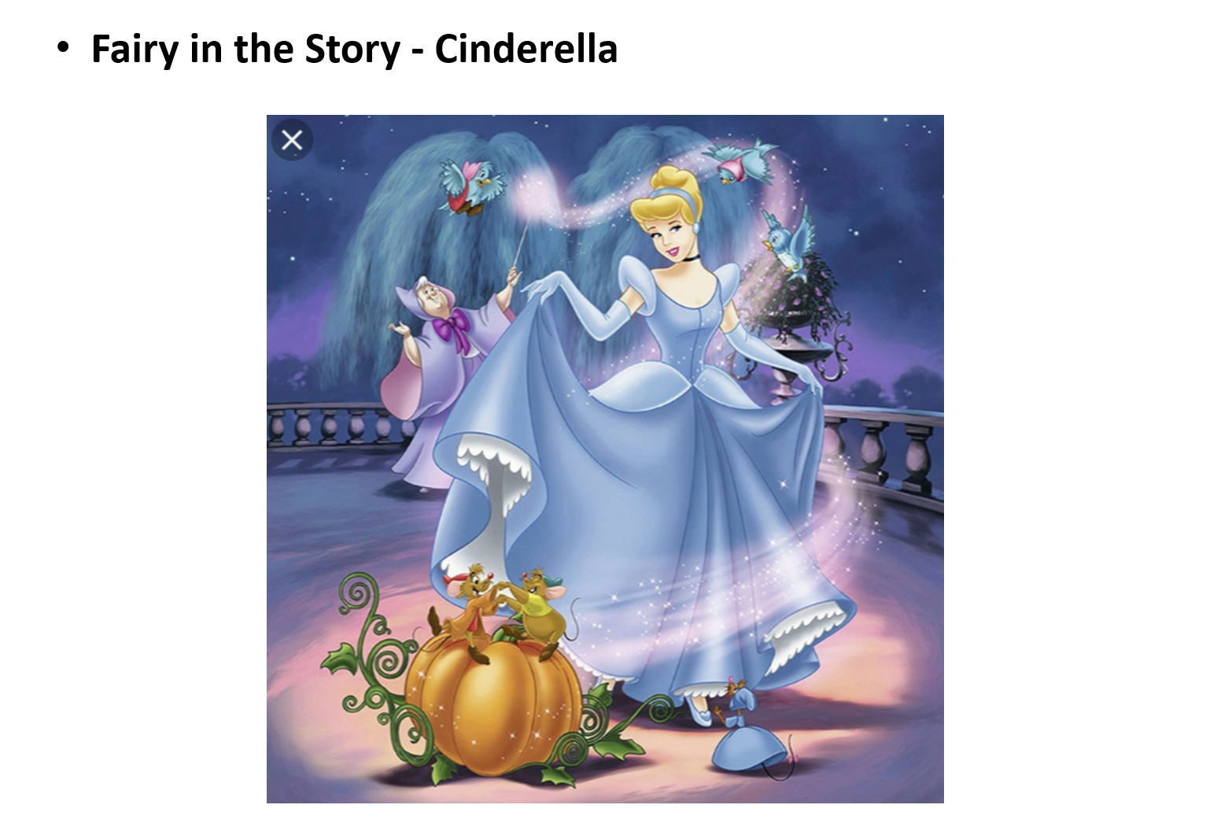
- 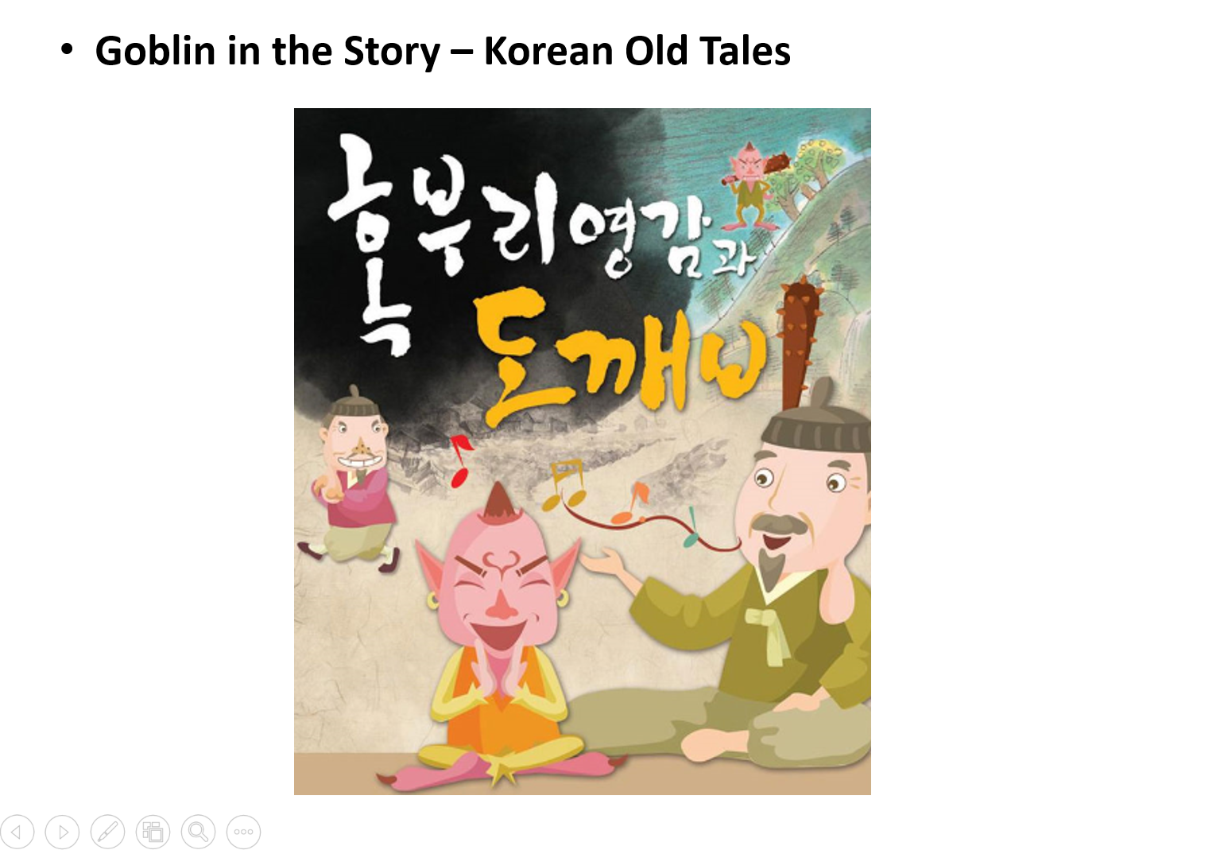

- Story Book (“The Elves And The Shoemaker”)

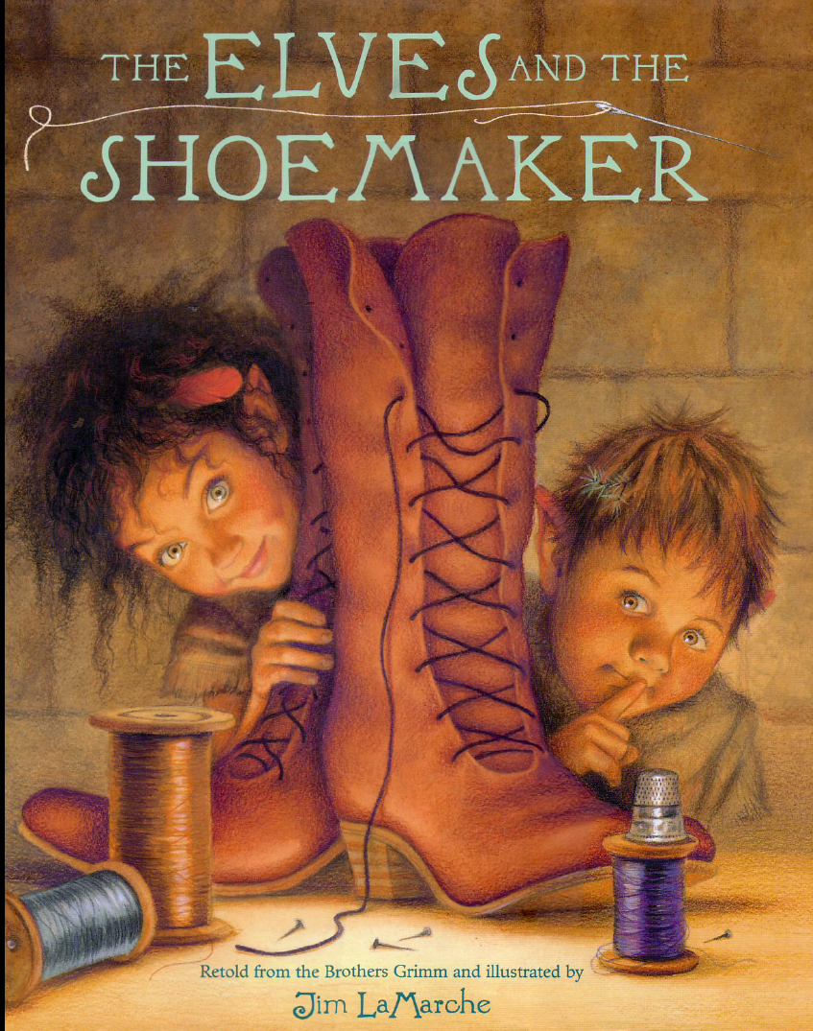

- Word Cards

