Background Information Sheet
Name | Class | Date | Lesson Type | Plan type | Length
Jiyeon Kim (Joy) | TESOL | 20/12/2019 | Reading | PPP | 30 min

Lesson
Topic | Seven Stars
Main Aim | The student practices her reading comprehension.
Secondary Aim | The student practices her speaking fluency.

Materials and References
PPT, Worksheet, board pens, fake lotteries, spider toy, paper cups

Student Profile
Level | Lower Intermediate
Age | 10 years old | Number of Students | 1
Detail | This is a general English class and the student is a Korean who is learning English in an institute and school. She enjoys reading and reads many books. She is accustomed to pair work, but still needs to be relaxed before she will open up to communicate freely.

Anticipated Difficulties and their Solutions:
Interpretive questions could be a bit difficult for the 10-year old student to answer. - > create easy questions.
Nervousness at the start of the lesson -> check the material are well prepared; to start the lesson; sit down and follow the planned teacher talk.

My Personal Aim
What I hope most to demonstrate in this lesson is the ability to

- to write out a complete, detailed lesson plan
- to be an involver type teacher

Stage Name: Lead-in
Purpose of this stage: To relax both the teacher and students. To focus attention on the lesson. To lead in to the topic, activating background knowledge – this will help to contextualize the text.
Materials:
Timing | Interaction | Procedure
30 sec  1 min  30 sec | T  T-S | Instructions. Hi Inhye, have you helped others? For example, visiting old people to talk to them or help them, or walking dogs at an animal shelter, or giving your clothes to a charity that helps sick children or poor people and so on. Let me hear your experiences.  The student talks to the teacher.

Stage Name: Presentation
Purpose of this stage: To pre-teach keywords if necessary, and answer a guiding questions (such as a predicting task, or a specific question). These steps provide extra help for students to comprehend the text.
Materials: Board pens
Timing | Interaction | Procedure
1 min  30 sec  2 min  1 min  30 sec | T-S  T-S  T-S | Pre-teach keywords: long, exclaim  Elicit – You are on diet because you gained 7kgs recently. You ate just one apple for the last 2 days. You are starving now. Do you want to eat something? (Yes) What do you want to eat now? Do you want it so much? (Yes) You can say I long for it.  CCQ – Do you want it very much? (Yes)  Do you feel a strong desire for it? (Yes)  Drill – Listen and repeat 3 times. (Gesture - Chorally and individually.)  Board – Write long on the board.  What type of word? (Verb) You already know what the word long means as an adjective.  But as a verb, long has totally different meaning.  Elicit – Inhye, I bought 2 lotteries. I will give you one. (Give one to the student.) Let’s scratch.  I won 2 thousand won... Did you win? Wow, you won 200 million won! What a lucky girl!  Did you and I say loudly because we were surprised? (Yes) It can be said we exclaimed.  Inhye, here is your juice. (Give a cup of juice to the student. There is a spider toy in the cup.)  Oh my goodness! I hate spiders! Did you shout because of fear? (Yes)  It can be also said you exclaimed.  CCQ – Do you say loudly or shout? (Yes)  Do you say something suddenly? (Yes)  Do you say something loudly or shout because of surprise, fear, pleasure, etc.? (Yes)  Drill – Listen and repeat 3 times. (Gesture - Chorally and individually.)  Board – Write exclaim on the board.  How many syllables? (2) Mark with a blue pen.  Where is a stress? (2nd) Mark with a red pen.  What type of word? (Verb)  Guiding Question  Before we read a story, let’s talk about this.  If it doesn’t rain for several months, what would happen?  And if there is a lack of water because it doesn’t rain for a long time, what would you do?

Stage Name: Practice – Literal Comprehension
Purpose of this stage: is to get students to practice reading for literal detail. They will also practice fast reading (skimming and scanning)
Materials: PPT1, Worksheet
Timing | Interaction | Procedure
1 min  2 min  30 sec  30 sec | T  S  T-S | Instructions. Now it’s time to read a story about Seven Stars. (Show the PPT 1.)  This time, you will read page 3, 4, 5 and 6 quickly and answer these questions in exercise 1. (Show the worksheet.) When you catch the answer, write it down next to the question.  Don’t do exercise 2 yet.  I.C.Q. – Do you need to read the whole story now? (No)  Do you need to write your answers? (Yes.)  Do we need to read the questions for exercise 2 now? (No.)  Do you have a pen or a pencil ready? (Yes.)  Read each question aloud for the student. Hand out the PPT 1 and worksheet 1.  The student reads page 3 to 6 for the 1st time, and write answers on the worksheet.  Feedback to check accuracy.

Stage Name: Practice – Interpretive Comprehension
Purpose of this stage: is to get students to get students to practice interpreting a text correctly This will require more detailed, careful reading, and thinking time to arrive at the correct answer.
Materials: PPT1&2, Worksheet, Answer sheet
Timing | Interaction | Procedure
30 sec  8 min  30 sec | T  T-S  T-S | Instructions. Read again. This time, answer exercise 2.  These questions are more difficult but if you read and think carefully, you can find the answers.  Write your answers below the questions. I will give you 8 minutes.  I.C.Q. – Do you need to read the whole story now? (Yes)  Do you need to rush to answer these questions? (No)  The student reads the whole text for the 2nd time and write her answers down.  Monitor.  Feedback to check accuracy. Hand out the PPT 2 and answer sheet.

Stage Name: Production - Applied Comprehension
Purpose of this stage: is for students to practice their speaking fluency on a topic related to the lesson.
Materials: Worksheet 1
Timing | Interaction | Procedure
1 min  7 min | T  T-S | Instructions. Now it’s time to talk freely. Turn over the worksheet. Let’s talk about any of these questions. Inhye, please read the questions.  You have 7 minutes to talk.  I.C.Q. – Do you need to write anything? (No.)  The student discusses with the teacher.

Stage Name: Wrap-up
Purpose of this stage: is to end the lesson on a positive note so that students feel they have achieved progress.
Materials:
Timing | Interaction | Procedure
1 min  50 sec  10 sec | T-S  T | Lesson feedback.  Which part of the lesson did you enjoy?  Tell the student what she did well, and what needs to improve.  Tomorrow we will do a reading lesson about Helping Others.  Dismissed.

PPT 1 <Seven Stars>
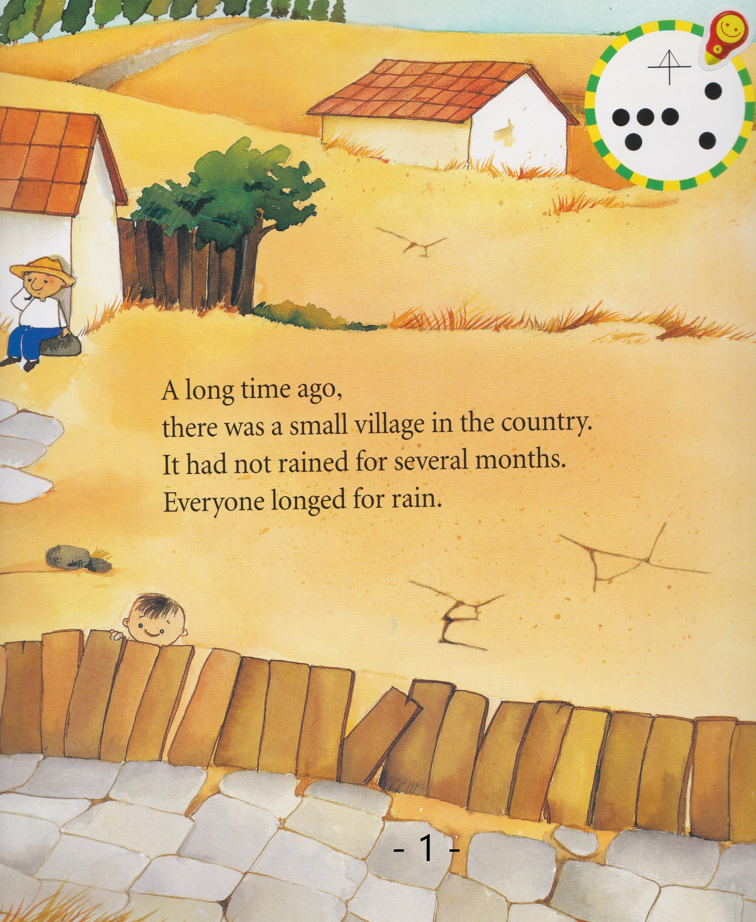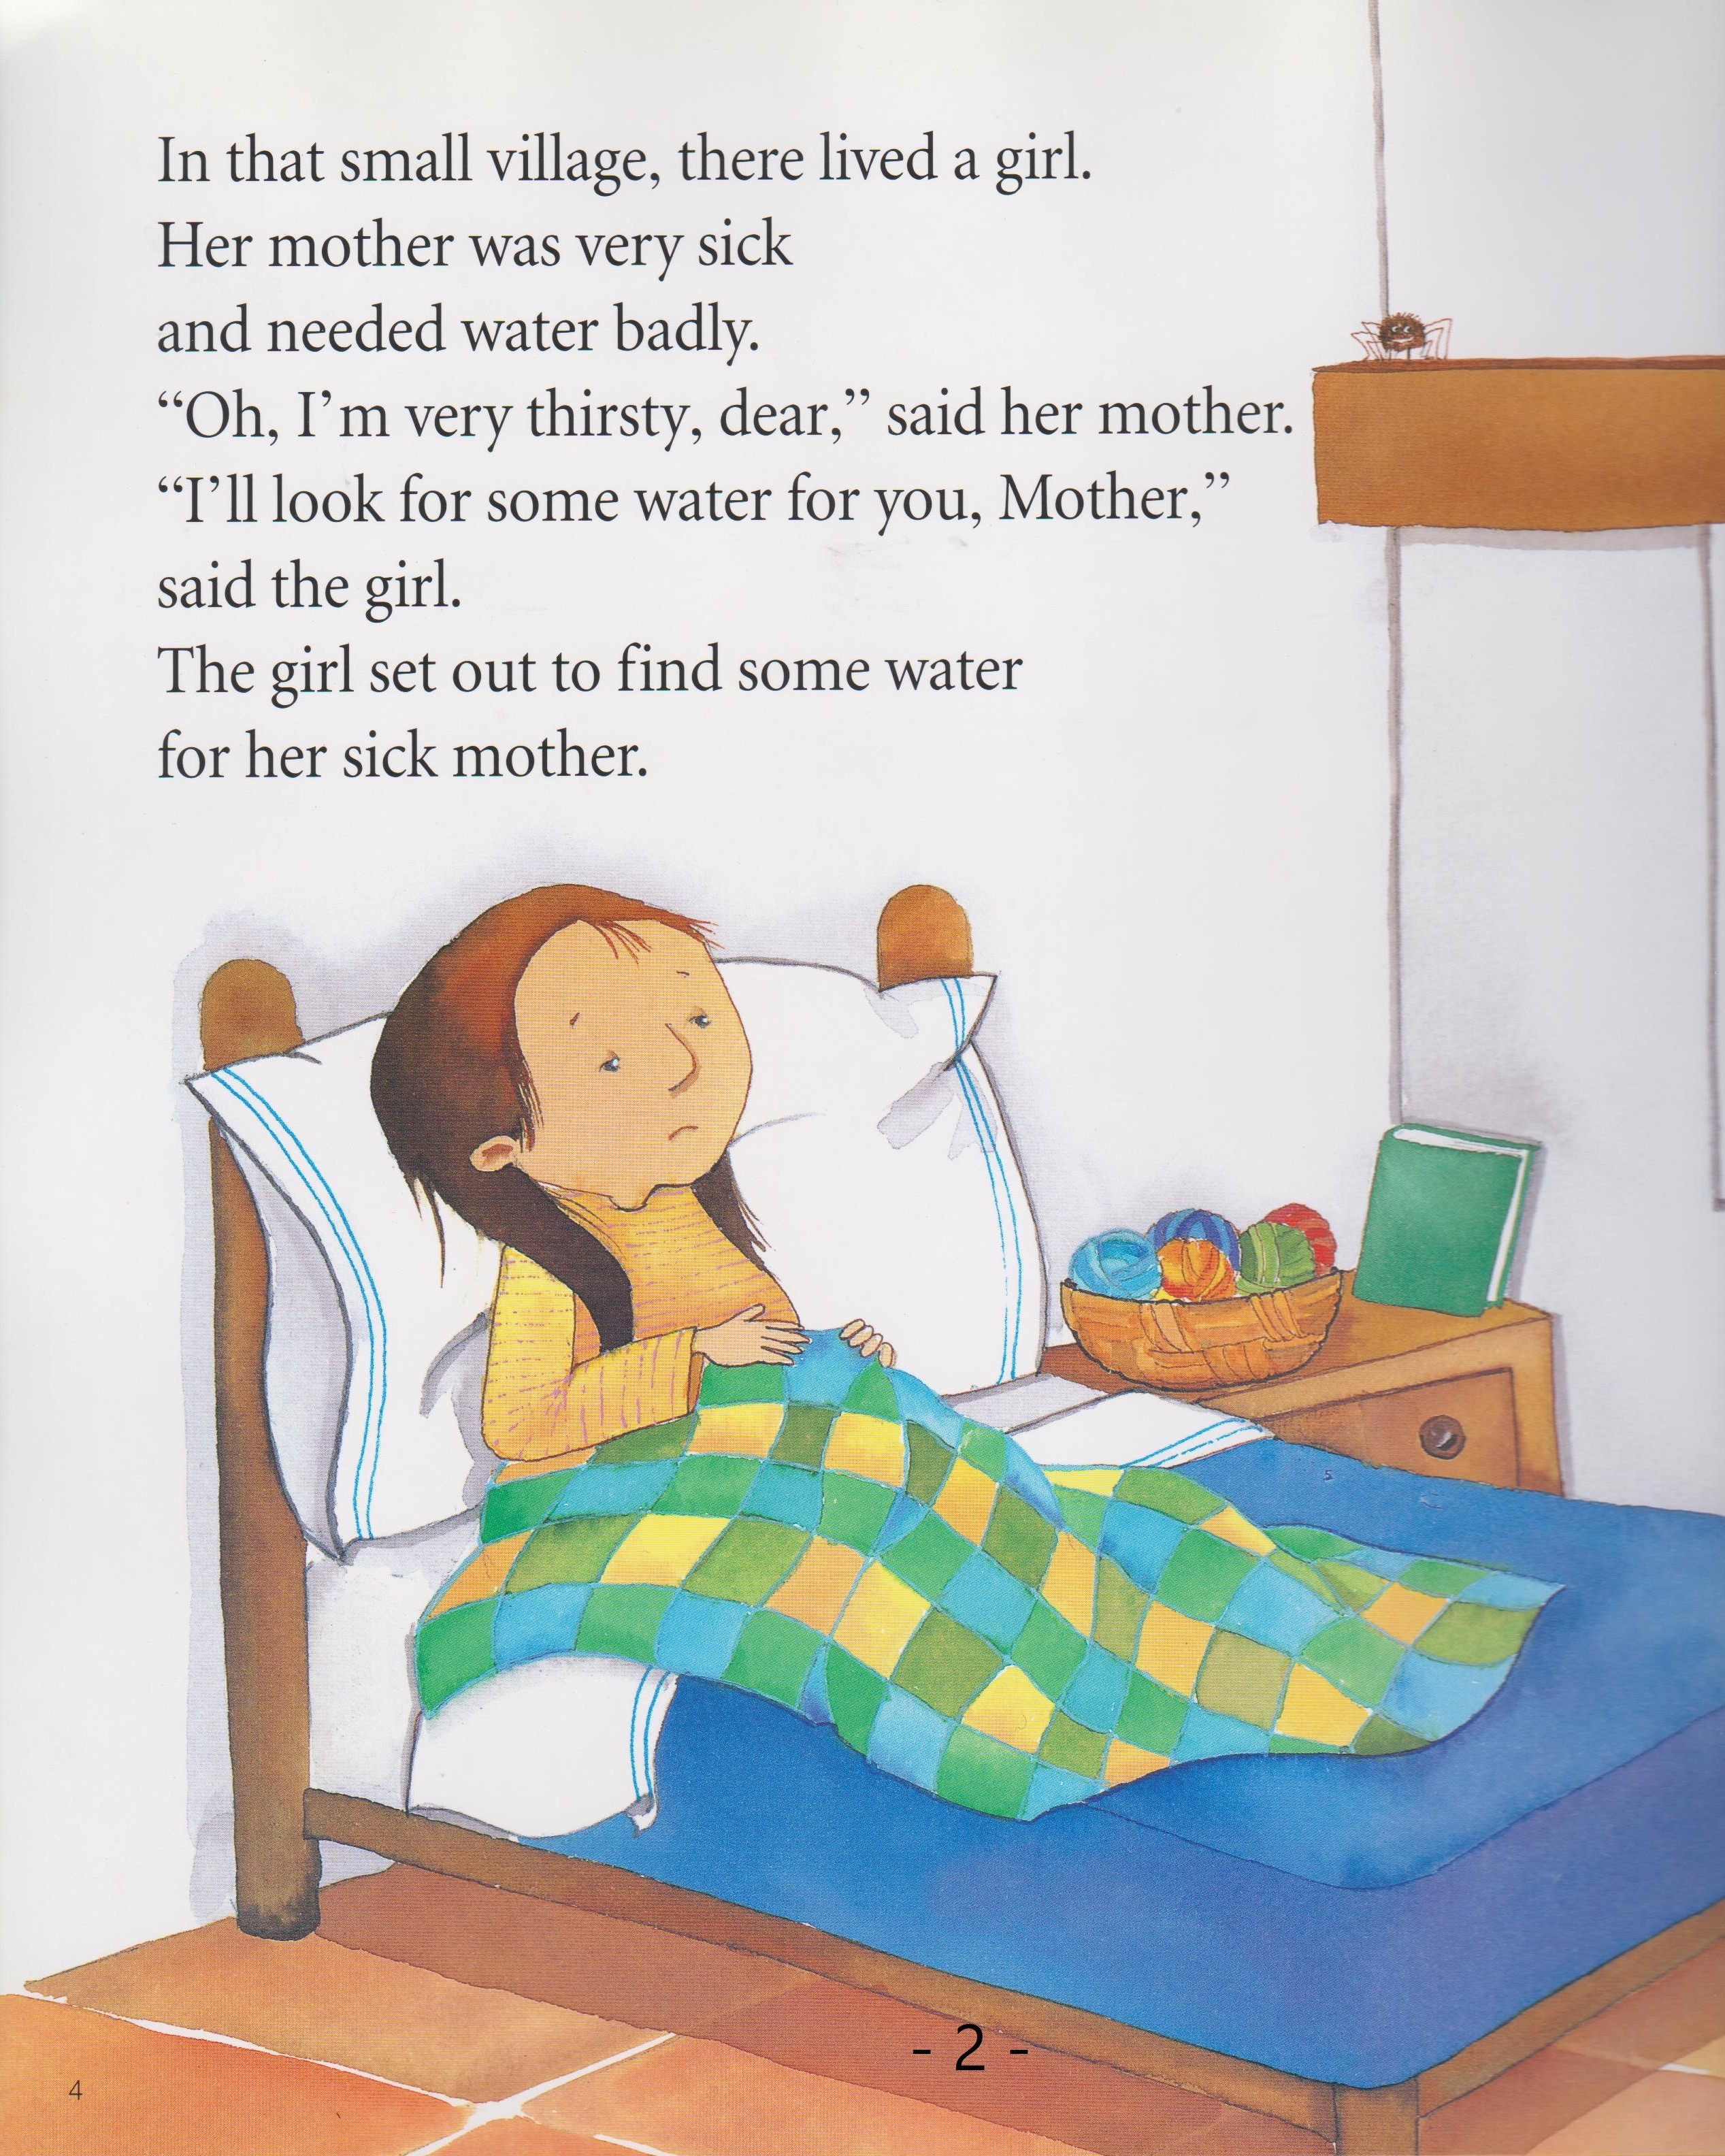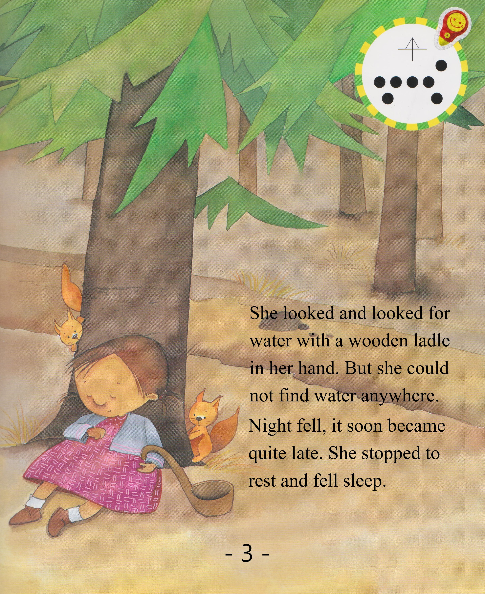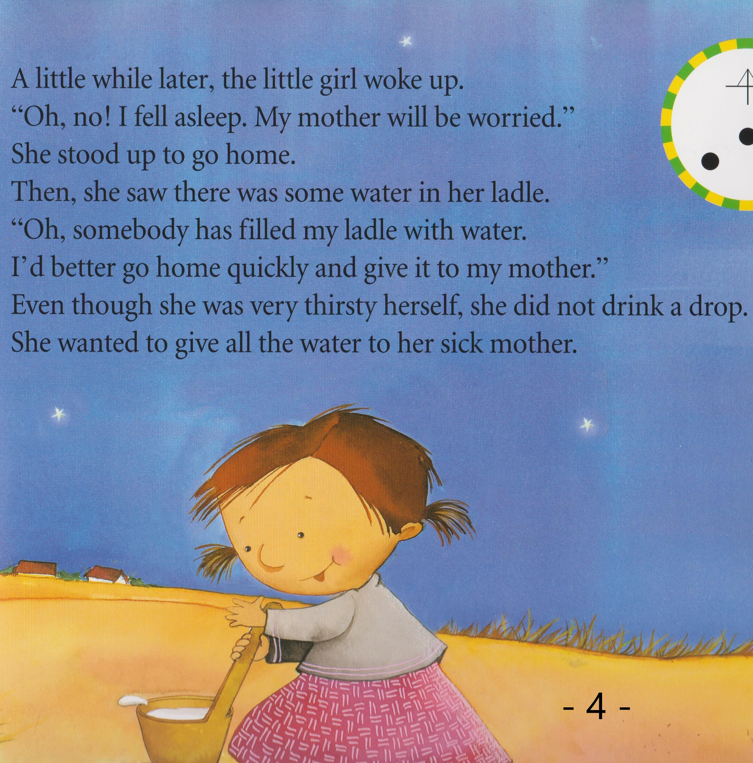
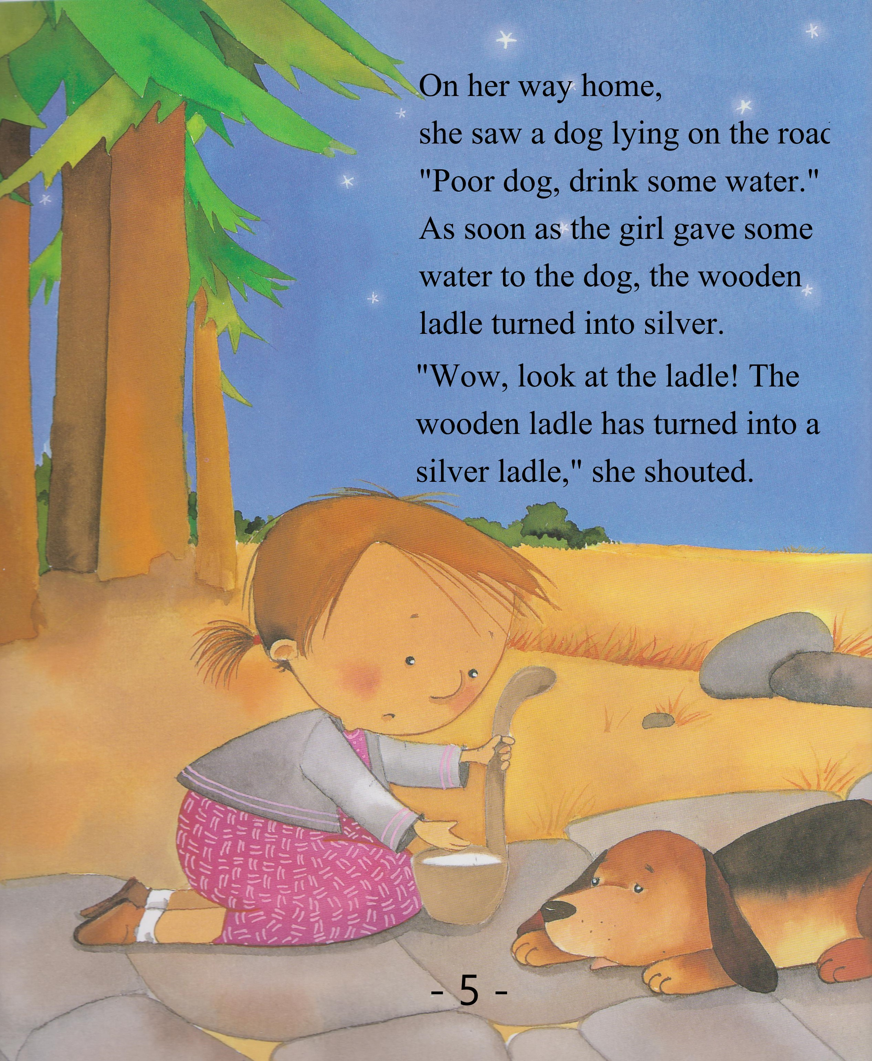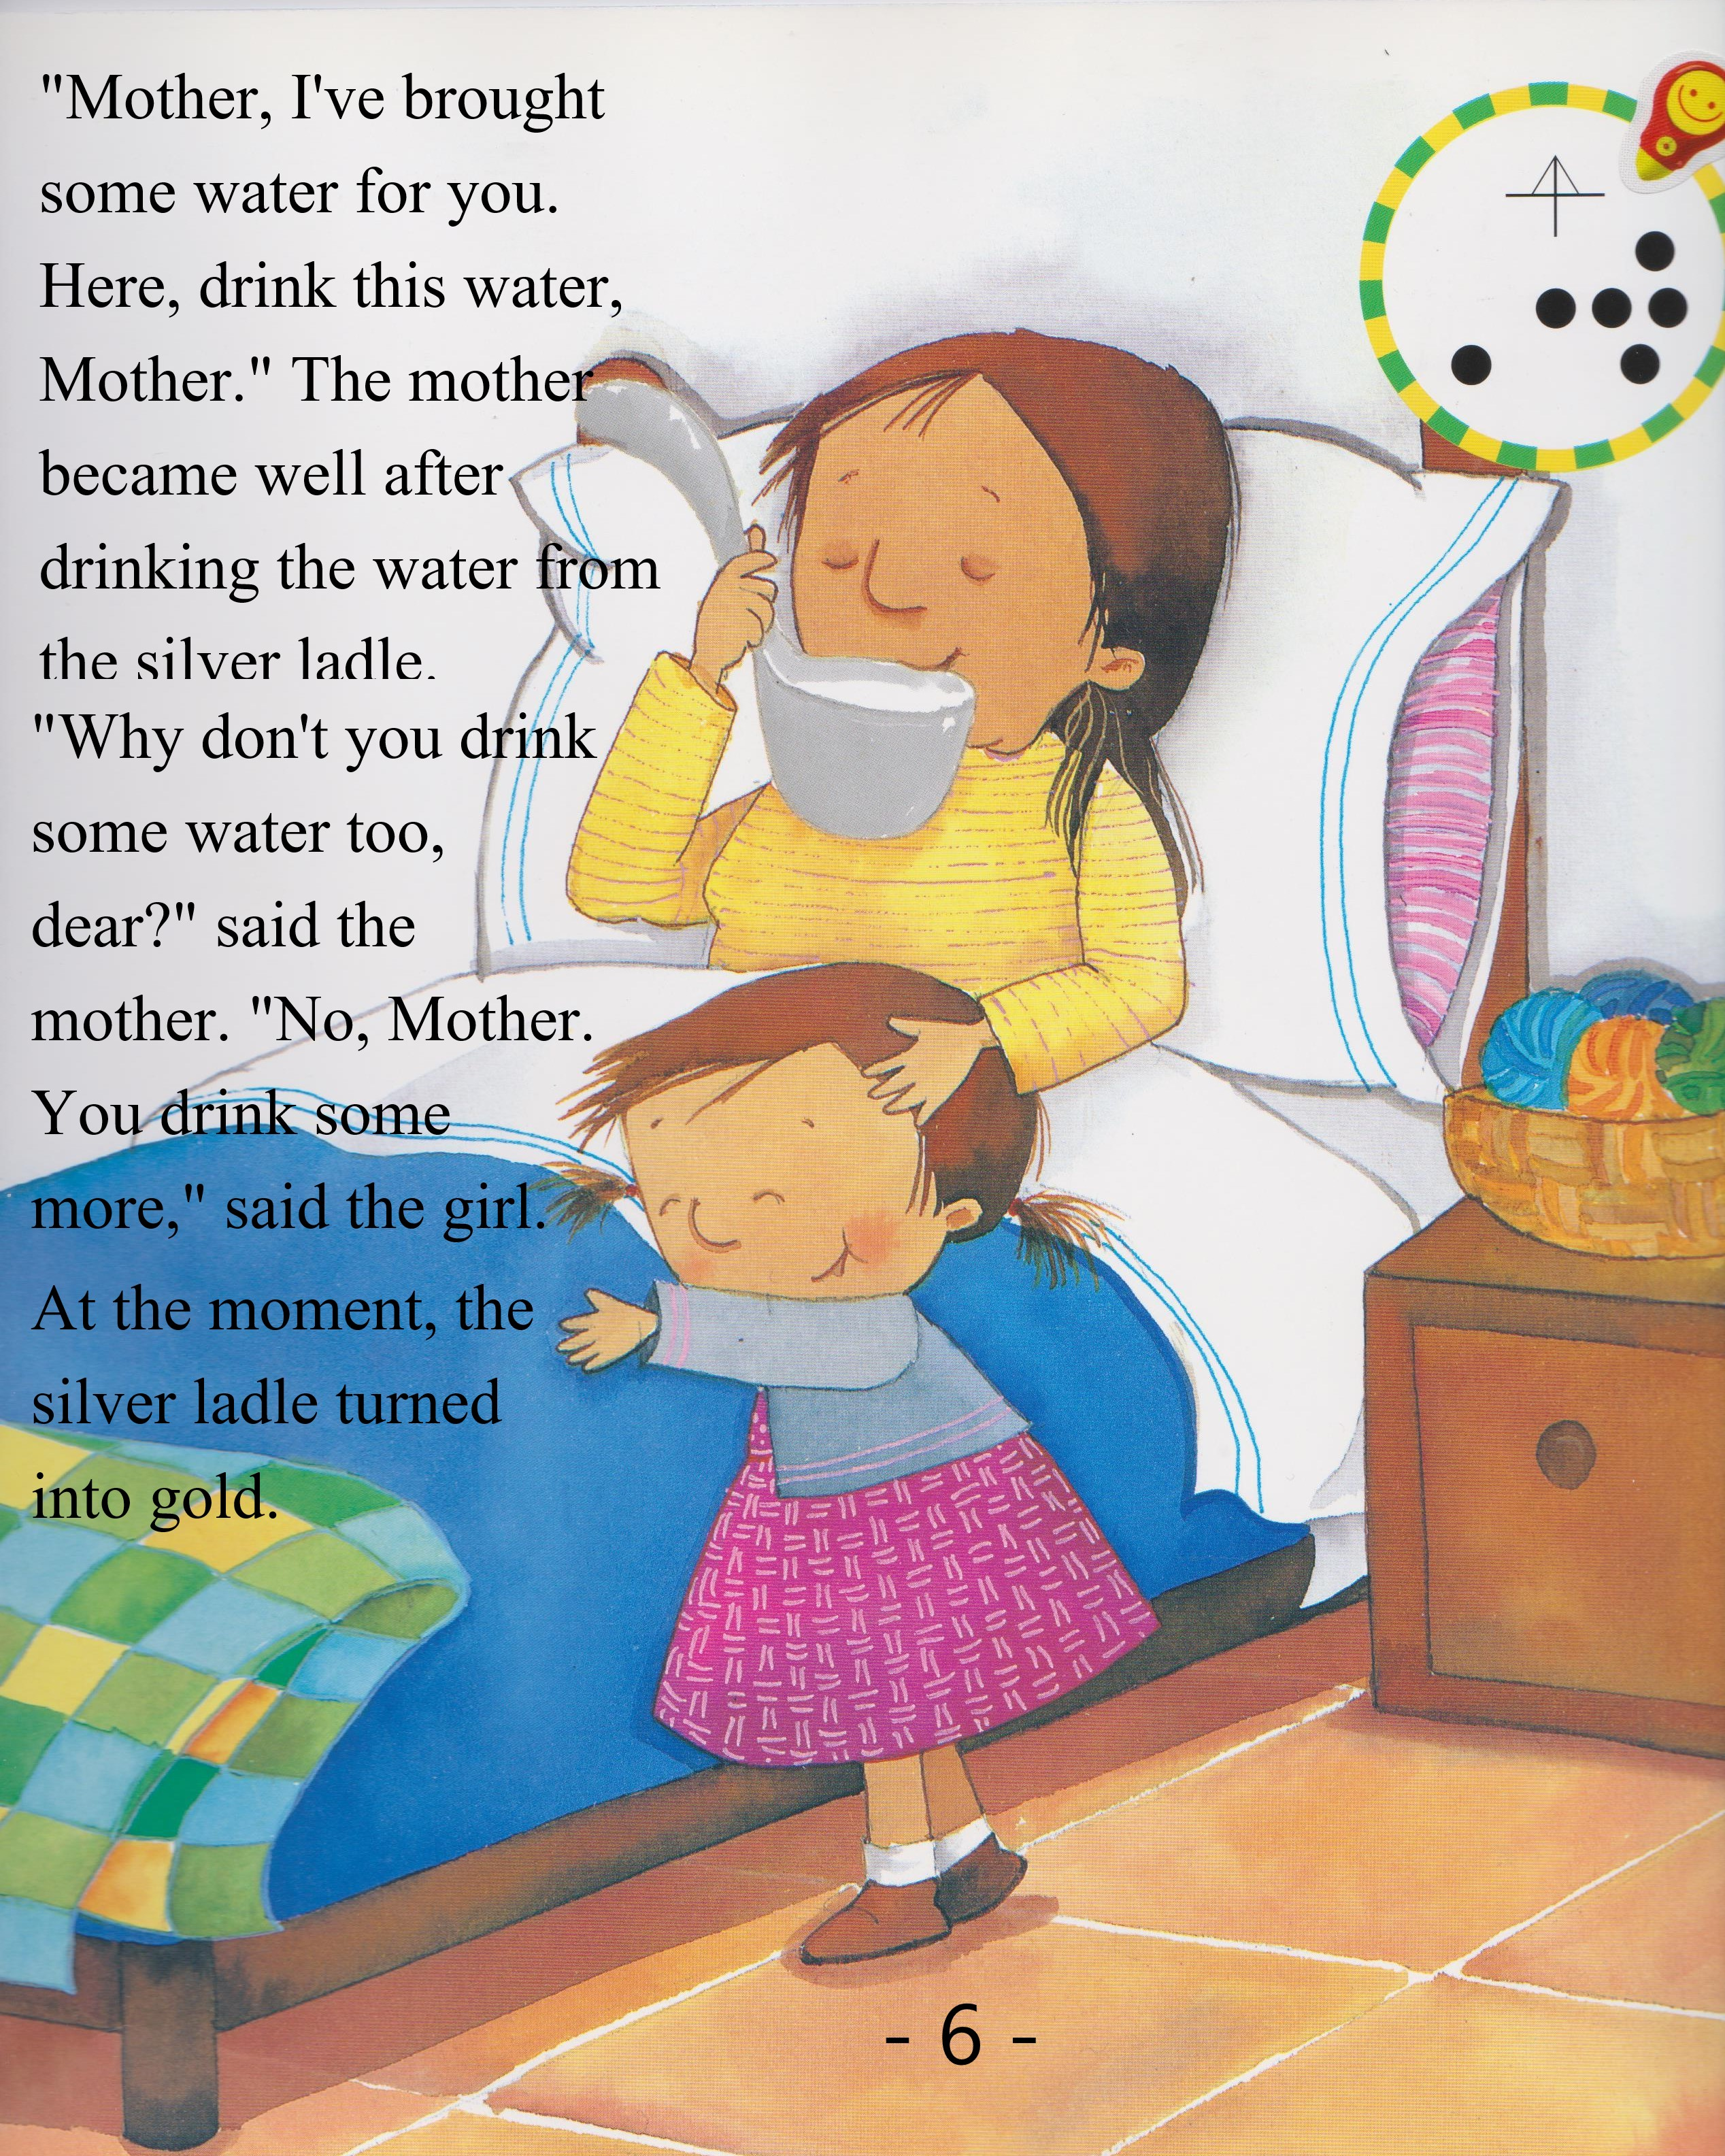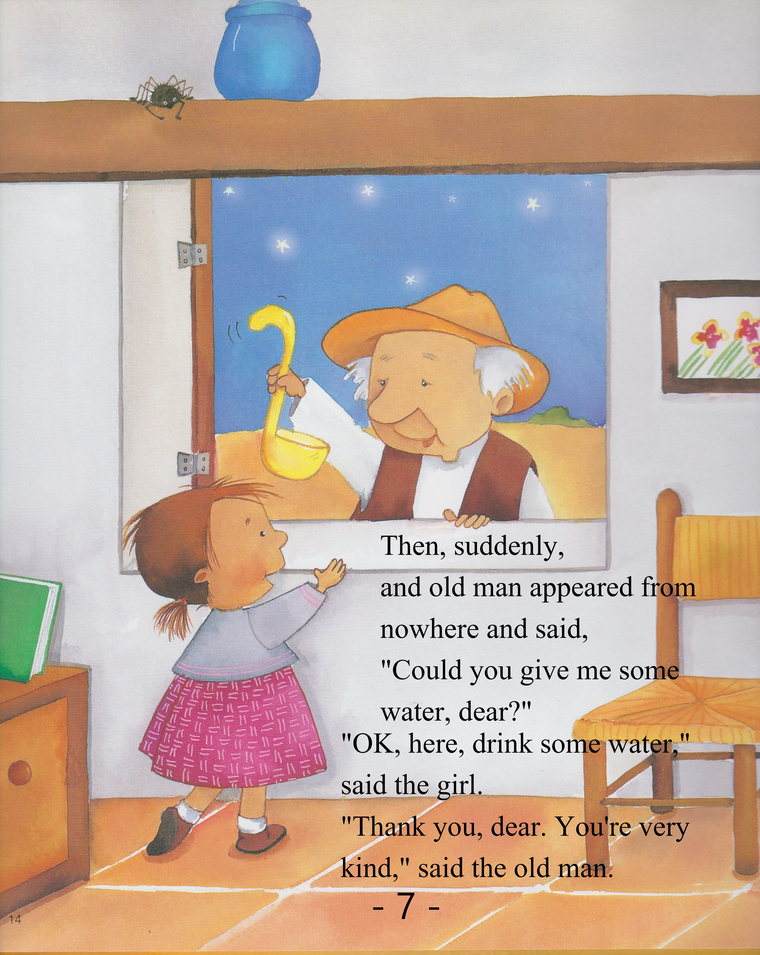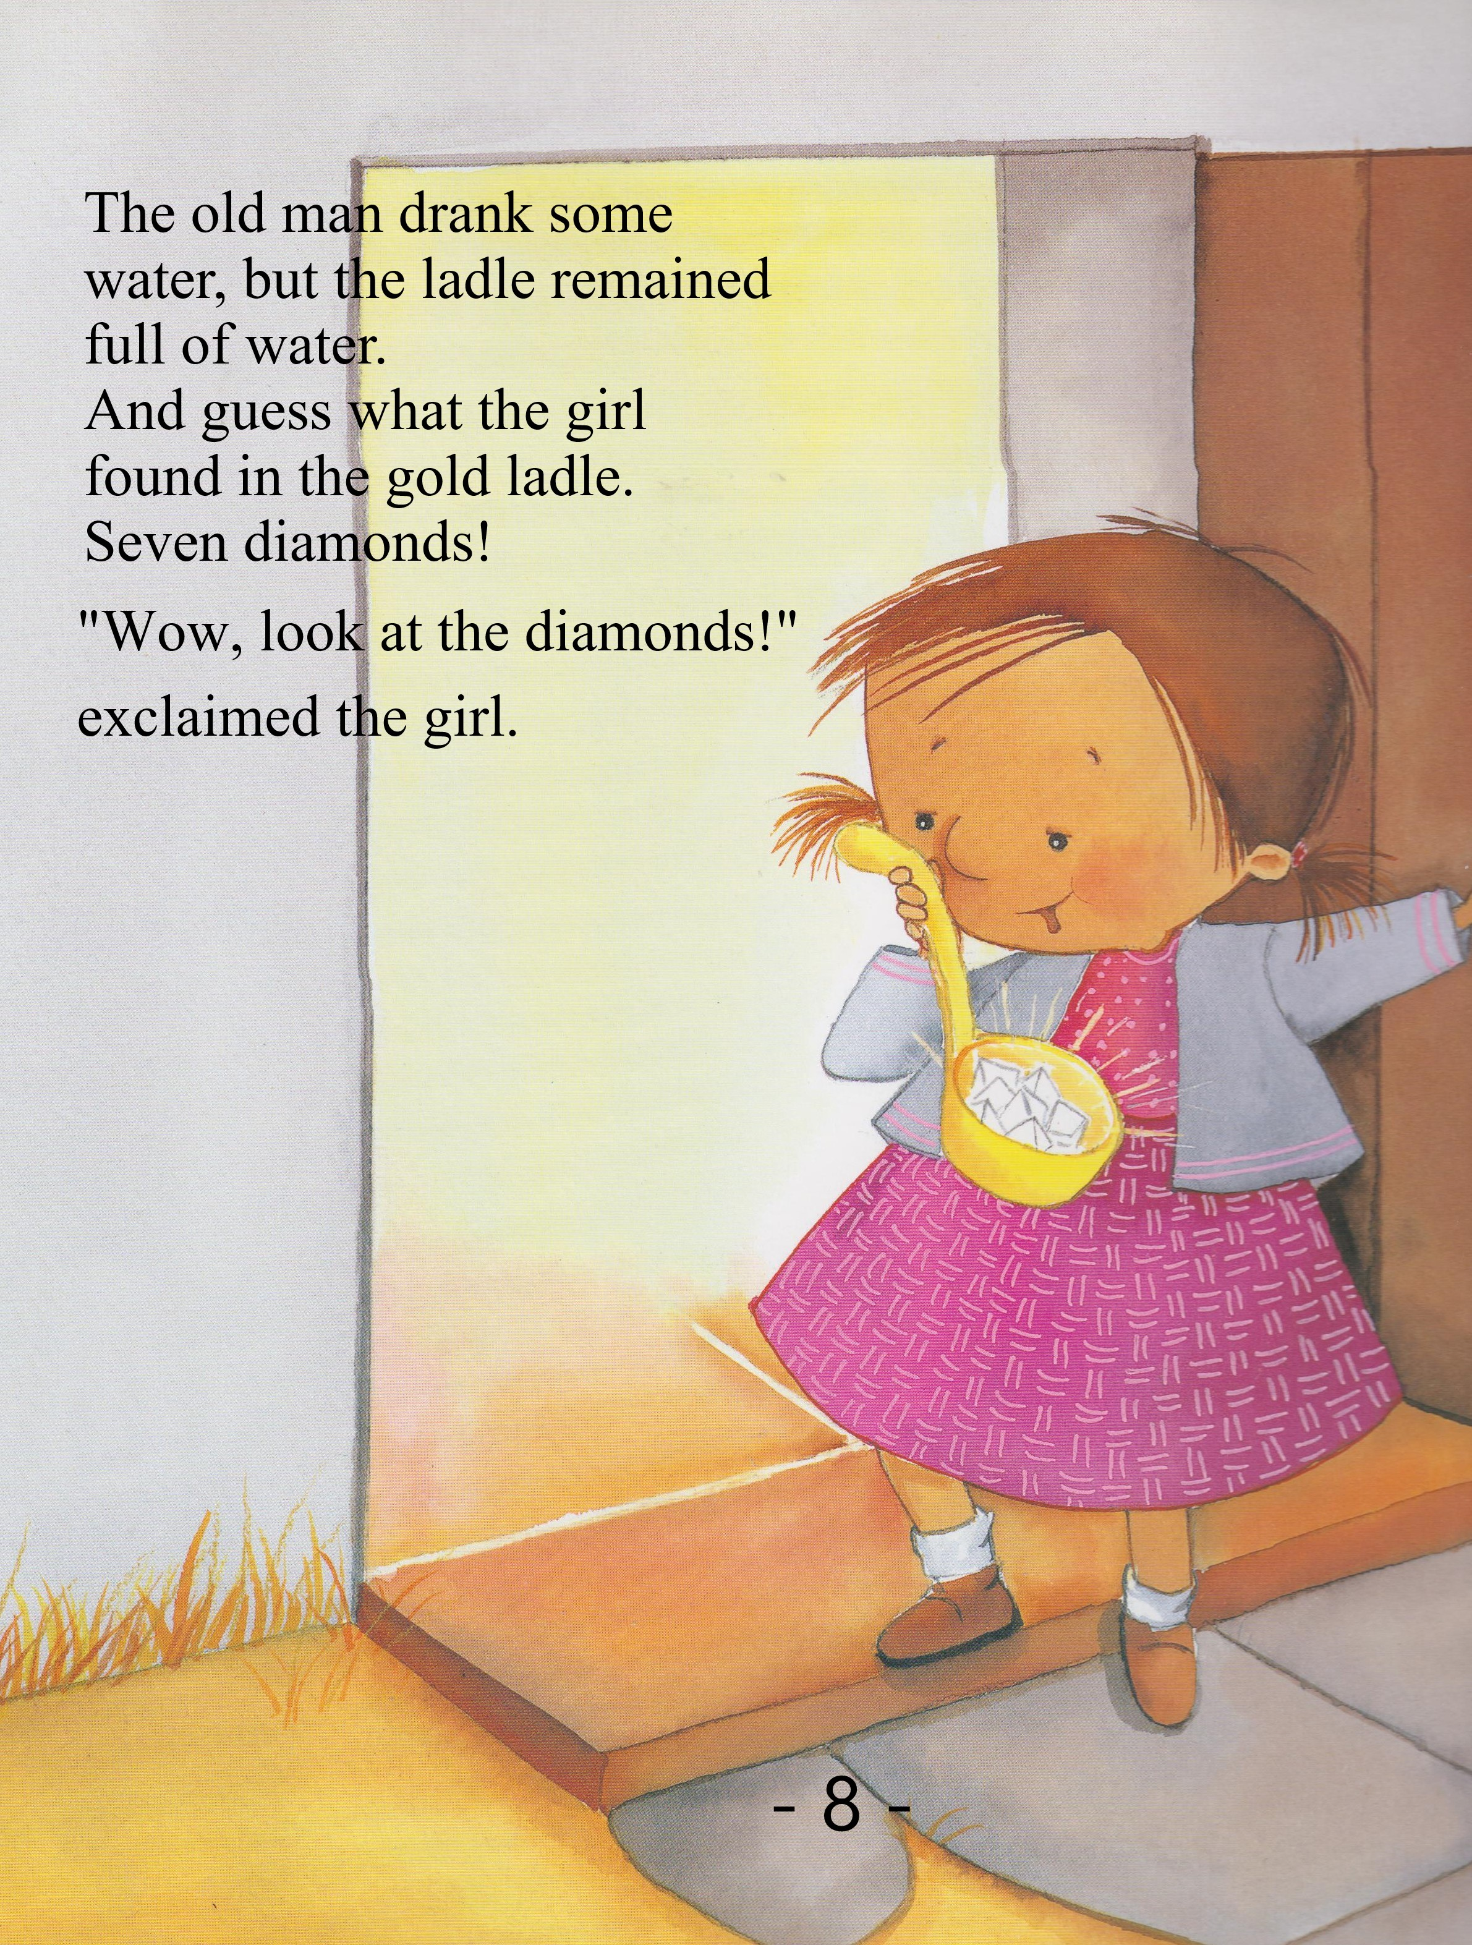

Worksheet – Seven Stars

Exercise One: Listen and write the answer next to the question.
a) What was the girl holding in her hand?
b) What happened to the ladle after the girl woke up?
c) Who did the girl give water first?
d) What color did the ladle turn into after her mother drank the water?
e) Did the girl drink the water?

Exercise Two: Listen carefully, think, and write your answer.
- Why did the ladle’s color keep changing?

- What happens next to the seven diamonds?

Exercise Three: Talk to your partners freely about any of the questions below. No writing!
- Do you have anything you have longed? What is it and what did you do to have it?

- Do you agree with the saying that “Heaven helps those who help themselves”? Why?

Answer sheet – Seven Stars

Exercise One: Listen and write the answer next to the question.
a) What was the girl holding in her hand? Wooden ladle
b) What happened to the ladle after the girl woke up? The ladle was filled with water.
c) Who did the girl give water first? A dog
d) What color did the ladle turn into after her mother drank the water? Gold
e) Did the girl drink the water? No.

Exercise Two: Listen carefully, think, and write your answer.
- Why did the ladle’s color keep changing?
The girl did her best to do whatever she can to in that bad situation and helped whoever she can do. God showed mercy to the good the girl did, by changing the color of the ladle, and it was a process to show how the problem the village faced was solved.

- What happens next to the seven diamonds?
They rise high into the sky and become seven stars. The girl prays to the stars for rain and it finally rains a few days later.
PPT 2
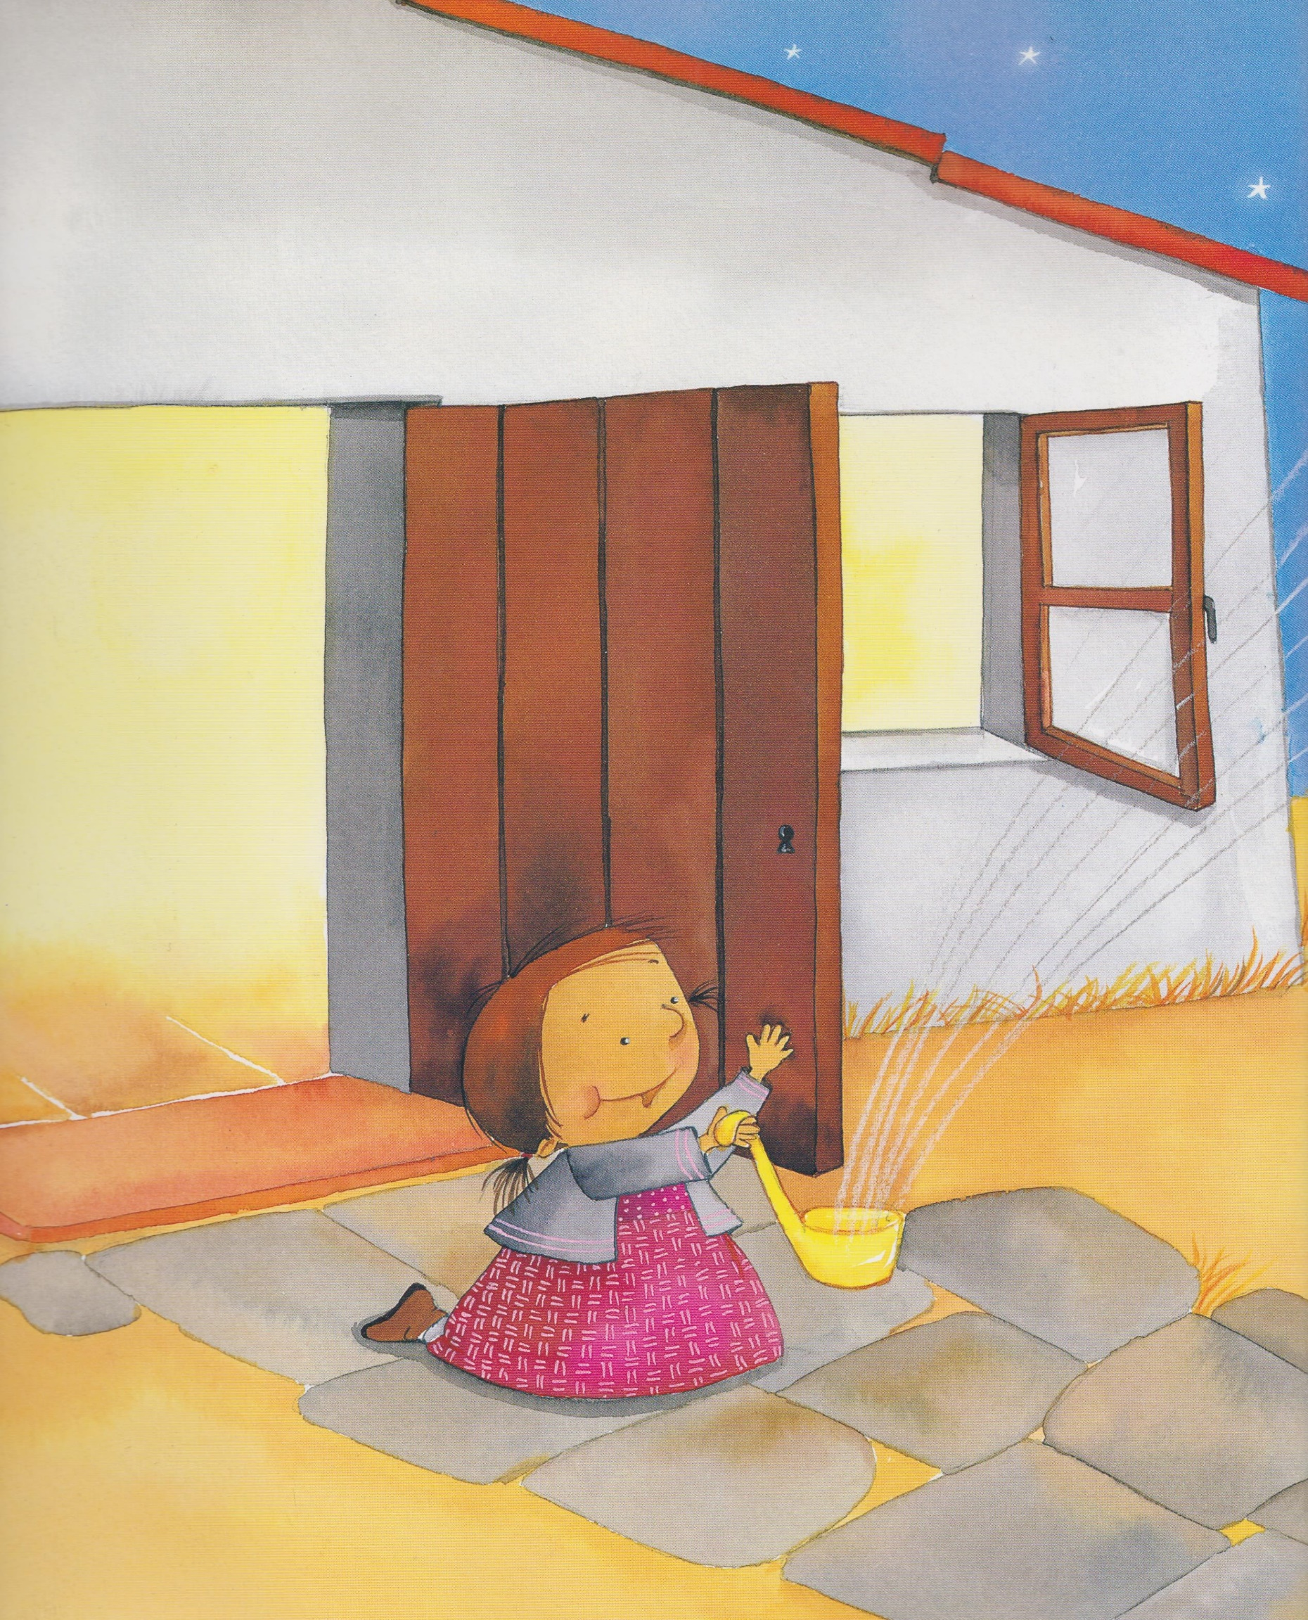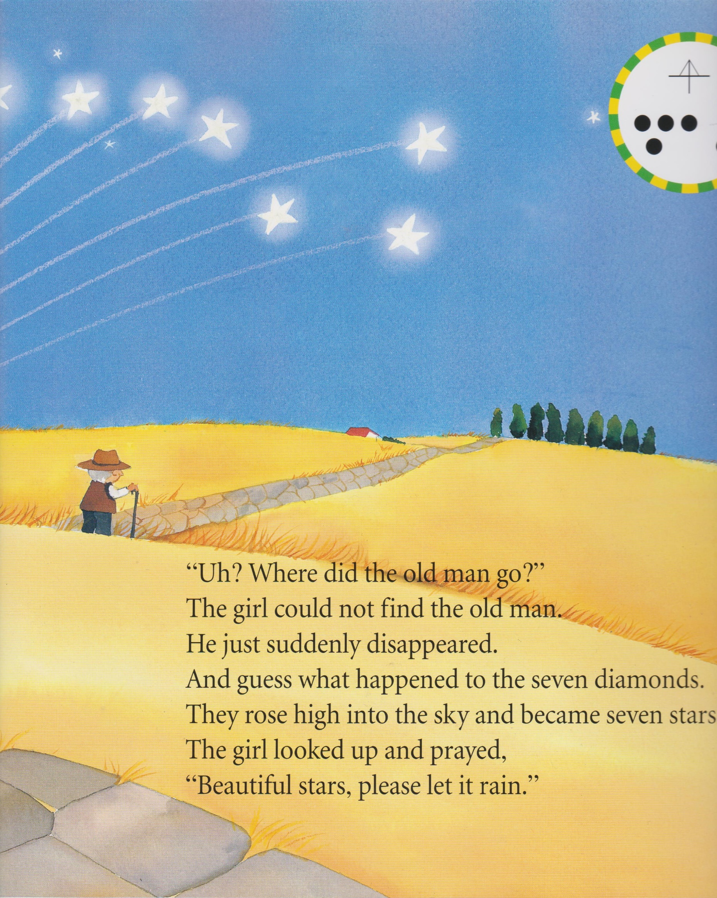
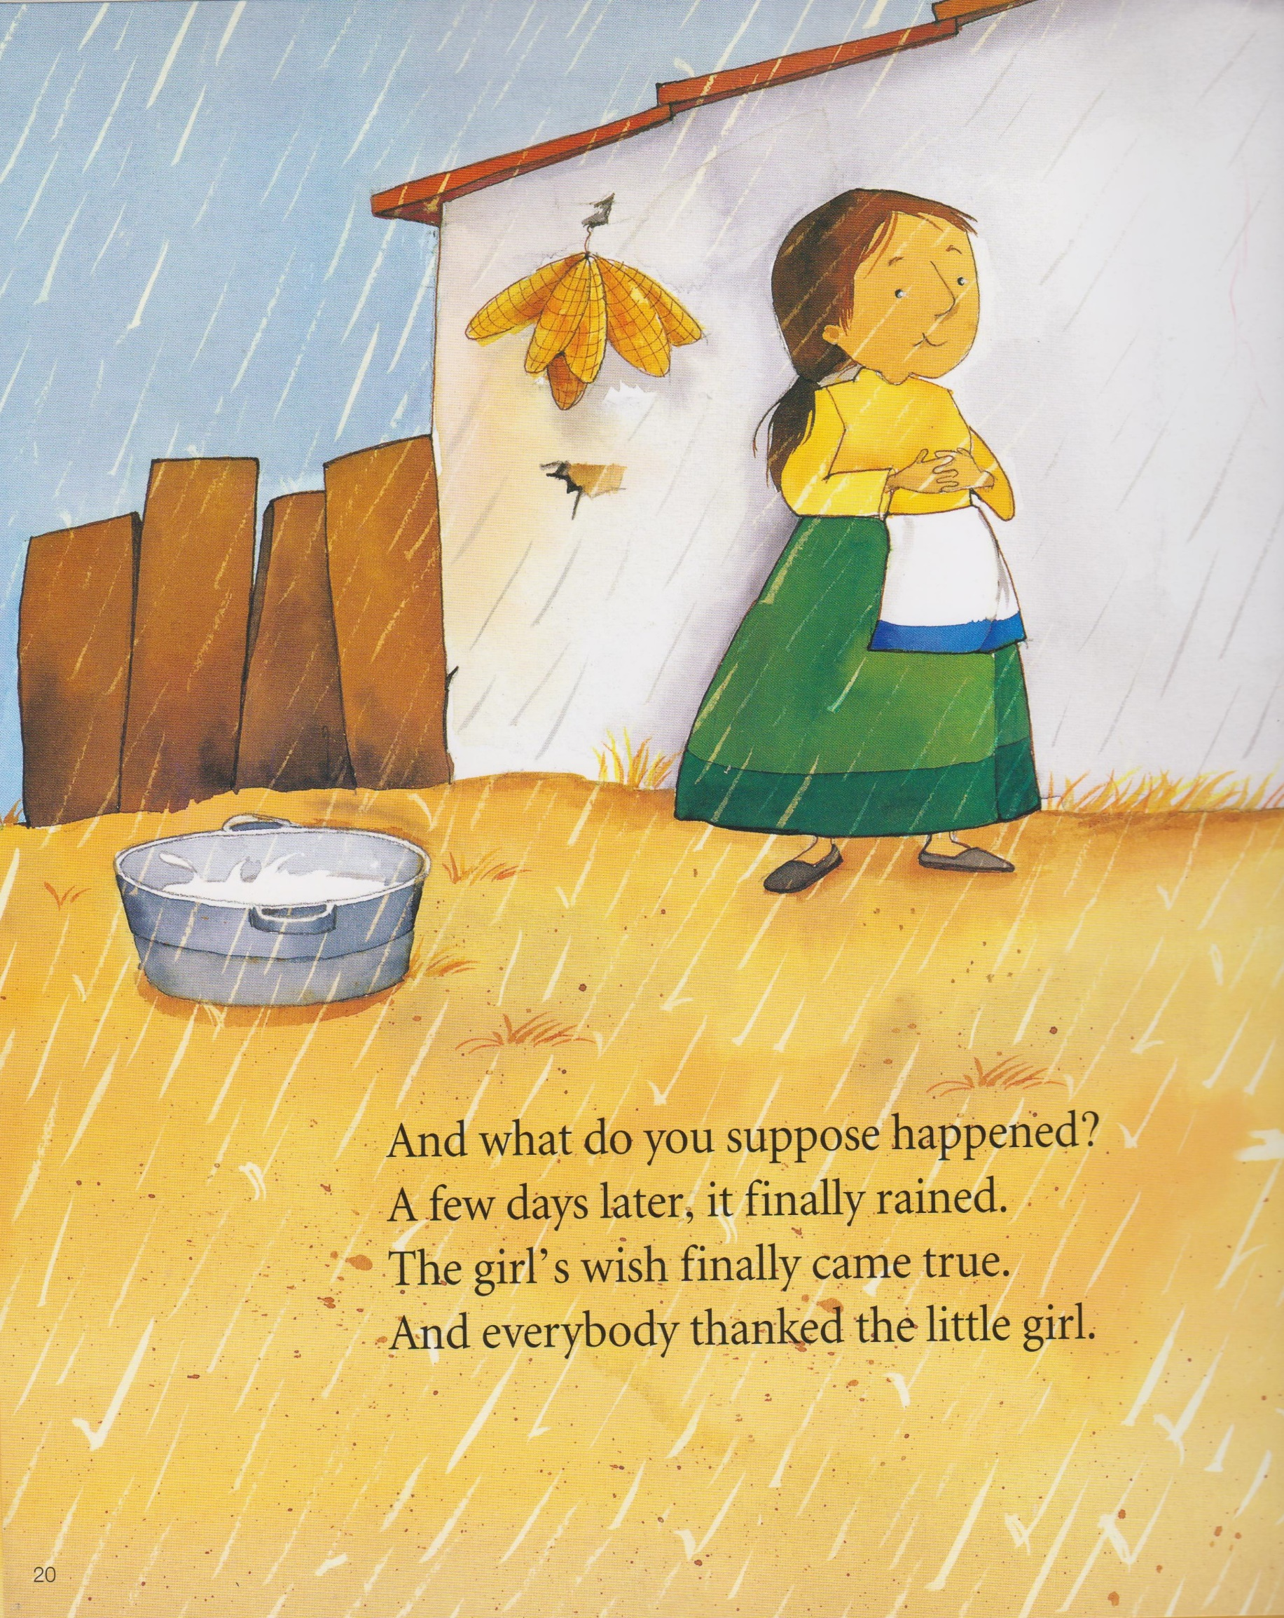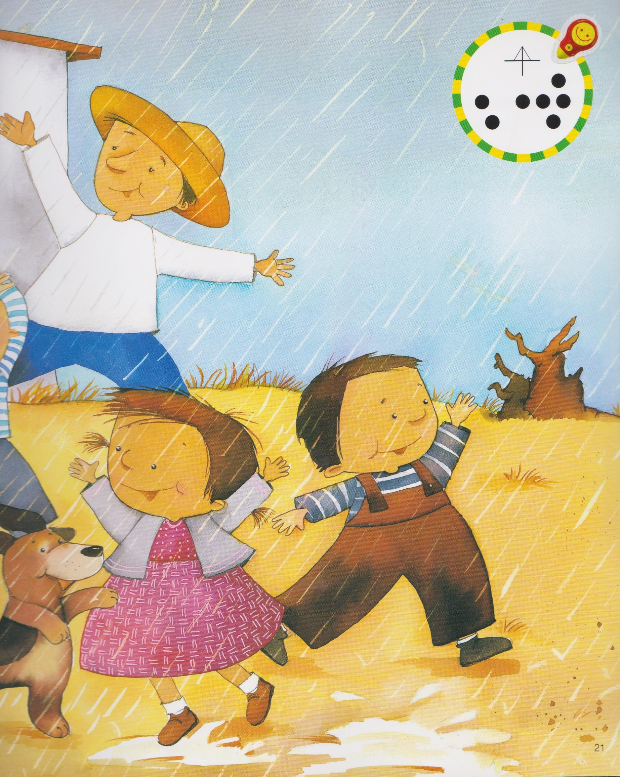

Instructor’s Comments and Assessment

Pros
Cons
Change
Overall Comments
Grade
Above Standard 85%-100% | Standard 70%-84% | Below Standard 69%-0%
Instructor | Student Signature | Date
Taute, David

