Background Information Sheet
Name | Class | Date | Lesson Type | Length
Soomi | 201WD | 27/11/2019 | TBL | 20min

/Lesson
Topic | Planning activity: Planning Europe trip with 15000$
Main Aim | Students will practice their speaking fluency.
Secondary Aim | Students will learn to speak persuasively.
Materials and References
map

Student Profile
Level | Upper intermediate
Age | Adult | Number of Students | 7
Detail | This is a general English class and students are highly motivated learners. The students are all Koreans, and enjoy science fiction. They are accustomed to pair work, but still need to be relaxed before they will open up to communicate freely. They engage actively in kinaesthetic learning and tend to favor the visual learner mode, but, auditory learning still needs developing.
Assumptions about students’ knowledge as required for this lesson:
Students know how to plan a trip and they need to communicate with partners and need persuade skills.

Anticipated Difficulties and their Solutions:
Some students are likely to plan just staying in one place tell them they need to go at least 2 places
Time: the planning may not all be planned before time runs out announce time is finished to end the planning
Desk arrangement: moving desks, spilling drinks clear desks of everything before the lesson
Technical failure use my laptop as a backup

My Personal Aim
What I hope most to demonstrate in this lesson is the ability to give good instructions.

Stage Name: Pre Task
Purpose of this stage: Create interest in the topic. Brainstorm ideas which will be useful for the next stage. Students must be given a communicative task e.g. discuss, arrange/sort, create a list, etc.
The aim is to relax students, activate their background information, and gather useful ideas for the lesson.
Materials: List all materials that will be needed in this stage.
Time | Interaction | Procedure
30 sec  1 min  30sec  1min | T-S  S-S  T-S  S-S | Show them picture of money in ppt  Hello guys, if you get 15000dollar from someone or from lottery and you got missioned to spend all the 15000dollar, what will you do?  Talk with your partners.  Students talking with partner about how they will spend all the 15000dollar.  Give them pictures and let them talk with their partners what is related to with these pictures.  Students are talking with their partner what these pictures related to.

Stage Name: Task Preparation
Purpose of this stage: This is a student centered stage, to give students time to prepare and practice a speaking task which they will perform in Task Realization. Clear detailed instructions or a demonstration must be provided so students know what is expected. Prepared materials may be provided to assist their preparation. Monitor and offer brief tips if necessary.
Materials: .
Time | Interaction | Procedure
1min  1min  5min | T  T  S-S | Instructions  Okay. Some of you might found out or some of you didn’t. these pictures are related to Europe. These pictures are all famous in Europe.  today, we will travel to Europe with that 15000dollar. So, we will make a Europe tour plan with your partner.  (Showing rules in ppt)  But we have a rule. First, we need to go somewhere at least 2 places per day, also decide where to sleep and we need to eat something whatever you want at least 1 time per day.  And you guys need to spend all the 15000dollar while traveling you cannot save for the future so if your money left, you can spend on shopping or just donate to somewhere.  and we will write down in paper. I recommend writing with pencils, because you might change your plan later.  Divide students into 2/2/3 group.  I will give you 5minutes to do. You do not have to plan seriously. you can just plan simple and easy.  Give students piece of map and paper to write down.  Okay lets begin with your partners!  Planning with their partner.

Stage Name: Task Realization
Purpose of this stage: This is a very student centered stage to allow for maximum speaking fluency practice. Monitor discretely and take note of incorrect language. Students perform their task without interruptions from the teacher. Classroom management may be an important consideration here.
Materials: List all materials that will be needed in this stage.
Time | Interaction | Procedure
30sec  5 min | T-S  S-S | Okay now, we will change the desk arrangement. And we will meet other groups in Europe so we will plan the trip with other groups. Because each group have different places of Europe, you don’t have to meet everyday you can just meet with other team for just one day. I will give you 5minutes.  Talking with different group. 3/4 people

Stage Name: Post Task
Purpose of this stage: To end the lesson with a final student centered task such as voting, summarizing, discussing, deciding etc. The teacher may offer delayed error correction to the previous stage, as well as mention positives and points to improve for next time such as useful strategies.
Materials: List all materials that will be needed in this stage.
Time | Interaction | Procedure
30 sec  3~4min  30 sec | T  S-S  T | Times up! Now, you guys will tell your Europe trip to classmates in past.  Nominate one student.  So how was your trip to Europe? Where did you go?  Talking about their trip to classmates.  Wow I think you guys had an exciting trip! Okay this class is over for today.
Instructor’s Comments and Assessment
Pros
Cons
Change
Overall Comments
Grade
Above Standard 85%-100% | Standard 70%-84% | Below Standard 69%-0%
Instructor | Student Signature | Date
Taute, David

Ppt1

(PPT2)
Rules
You need to go somewhere at least 2 places per day and also, we need to eat something whatever you want at least 1 time per day so it means you need to decide the menu what to eat each day.
And you guys need to spend all the 15000dollar while traveling so you cannot save for the future.
If the land is not connected, you need to use airplane to go.
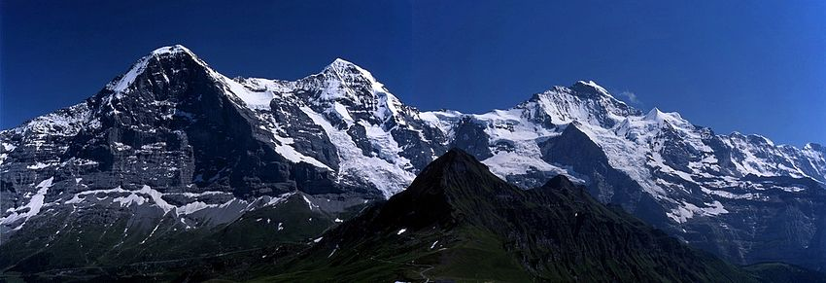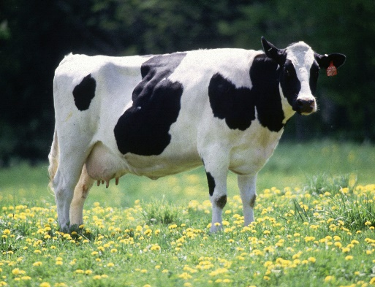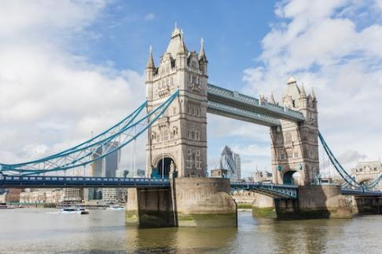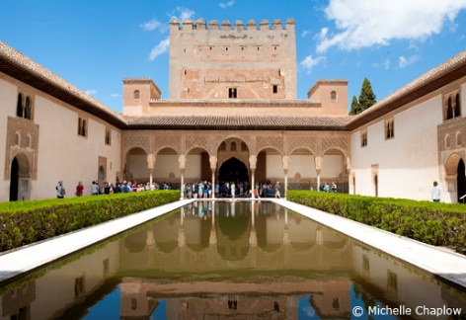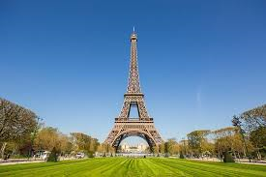

Every tourist places each 50$
Any food each 50$
<place to sleep>
Luxury hotel per one day 150$
Guest house per one day 30$
<transportation>
Airplane 100$
Car rent per day 100$
Train 50$

