Background Information Sheet

Name | Class | Date | Lesson Type | Plan type | Length
Daisy Ma | TESOL | 29/01/2020 | Listening | PPP | 35 min
Lesson
Topic | Creating a study group
Main Aim | Students will practice Listening & Speaking fluency.
Secondary Aim | Students will specking what they want to say freely with a simple words and a simple sentence.
Materials and References
Worksheet, Audio, PPT, White Board and pens
https://learnenglish.britishcouncil.org/skills/listening/upper-intermediate-b2/creating-a-study-group

Student Profile
Level | Upper Intermediate
Age | Adult | Number of Students | 7
Detail | Use simple sentence & easy vocabulary  All Gender  All Korean
Anticipated Classroom Management Difficulties and their Solutions
If audio doesn’t work – Turn on the mobile phone or reading the script
Make sure to the students feel comfortable before start to class.
Try to help the students to be focus on the class during the class.

My Personal Aim
Let students know how to catch up the content of conversation and make them practice listening skill without being boring.

Stage Name: Lead-in
Purpose of this stage:
To relax both the students and the teacher; to increase student talk through the sharing of ideas or experiences; to introduce the topic, or something topic-related.
Materials: PPT
Time | Interaction | Procedure
30 sec  2 min  1  min | T  S-S  T-S | Hi everyone, look at this picture.  Talk to your partner about them. For example, what they are doing now, what does their relationship look like and what is the age group. You have 2minute.  Students talk to their partners. Monitor for any use of key words.  Feedback. Gesture to a few groups and ask – “Tell me about your ideas.”

Stage Name: Presentation
Purpose of this stage: To offer any needed help which students may need in order to comprehend the text more easily. This includes teaching from 1 to 4 key words using the C.C.C. technique, and asking a guiding question which will allow students the opportunity to think of and share ideas they are likely to encounter when listening. This encourages the use of their schema when comprehending a text.
Materials: PPT
Time | Interaction | Procedure
2 min  2 min  10 sec  2 min  1  min | T-S  T-S  T  S-S  T-S | Pre-teach keywords – Study group, Library  Elicit- Point to PPT 1. See, what they’re doing? (They are studying in a group)  CCQ- They are more than two people in a group? (Yes)  They want to study at the same place and time? (Yes)  They are regularly meet to discuss shared field of study (Yes)  Drill – Listen and repeat 3times all together (gesture)  Board – Write “study group” on the board.  How many syllables? (3) Mark with a blue pen.  Where is a stress? (1st) Mark with a red pen.  What type of word? (Noun)  Elicit- Point to PPT 1. Look at the picture. Where they are studying at?  (They are in a library)  CCQ- Students can use many type of information in a library? (Yes)  Can students make much noise in a library? (No)  Drill – choral and individual drilling for correct pronunciation  Board – Write “library” on the board.  How many syllables? (3) Mark with a blue pen.  Where is a stress? (1st) Mark with a red pen.  What type of word? (Noun).  Guiding Question  Talk to your partners. Is studying in a group better than alone?  Students discuss the question with a partner.  Feedback. Nominate a few students to share their ideas, if necessary.

Stage Name: Practice - Literal Comprehension Listening
Purpose of this stage: For students to listen for the first time in order to get the facts. This may include the overall idea or topic of the text; to notice who the speakers are; where they are; and perhaps why they are speaking. The responses are short, objective, and are only surface understanding. This is an accuracy focused stage.

Materials: Worksheet
Time | Interaction | Procedure
40 sec  5  min  1 min  1 min | T  S  S-S  T-S | Instructions. Set the purpose for listening before handing out worksheets.  Now it’s time to listen to a story about “Creating a study group”.  As you listen, you must answer these questions in exercise 1 only.  When you catch the answer, write it down next to the question.  Don’t do exercise 2.  I.C.Q. – Do you need to write your answers? (Yes.)  Do we need to read the questions for exercise 2? (No.)  Do you have a pen or a pencil ready? (Yes.)  Read each question aloud for the students Hand out the work sheet.  Students listen for the 1st time, and write answers on the worksheet.  Pair check. Compare your answers with your partner. Monitor.  Feedback to check accuracy. Ask students for answer, checking if others have the same or different answers. Does anyone else have a different answer? Who agrees with this answer? Why do students go to library?

Stage Name: Practice - Interpretive Comprehension Listening
Purpose of this stage: Students listen a second time, more carefully, to infer or interpret meaning of the literal facts. This is still an accuracy focused stage – answers need to be checked for accuracy. Students are required to think about why in order to support their answers. They may need to focus on things like the overall situation, tone of voice, multiple pieces of information, or a single statement to explain the unspoken, intended meaning

Materials:
Time | Interaction | Procedure
1 min  5 min  1 min  1 min | T  S  S-S  T-S | Listen again. This time, answer exercise 2.  These questions are more difficult, but if you listen carefully and think about what you know, you can find the answers.  Write your answers next to the questions.  I will give you time afterwards to think and write.  I.C.Q. – Do you need to rush to answer these questions?  (No, we will have time afterwards to write.)  Read the questions aloud for the students.  Students listen for the 2nd time, and write their answers.  Pair check. Monitor. If students need, then replay the audio 3rd time.  Feedback to check accuracy.

Stage Name: Production - Applied Comprehension Speaking
Purpose of this stage: For students to practice their speaking fluency. Therefore, this stage should be no less than 5 minutes to allow students to practice. Give them a few questions to help them communicate without intervention from the teacher. This is a fluency focused stage.
Materials: PPT
Time | Interaction | Procedure
1 min  5 min  2 min | T  S-S  T-S | Make 3 groups of 7 students+Teacher (back up)  Now, turn over your worksheets.  Talk to your partners about any of these questions.  You should talk freely, and remember to listen and ask questions to your partners.  You have 4 minutes.  I.C.Q. – Do you need to write anything? (No.)  Students discuss. Monitor from a distance.  Feedback. Students share their ideas with the whole class.

Stage Name: Wrap-up
Purpose of this stage: To end the lesson on a positive note. This will give students a sense of accomplishment, encourage students to continue progressing, and realize how to improve in future. A teacher may also get valuable feedback from students regarding the activities used in the lesson.
Materials: board
Time | Interaction | Procedure
2 min | T | Lesson feedback. Tell the class what they did well, and what needs to improve.  Thank you for your attention during class.  Did you enjoy today’s topic about the “Creating a study group”?  What part of lesson did you enjoy the most?  Set homework.  Please review the new words you learned today. And also you can try to self-test by yourself after class and find out a similar vocabulary of the keyword you learned and make 5 sentences with this new words.  Inform students about the topic for the next lesson.  Next on Monday, we’ll do a listening lesson about “Dead Poets Society”.

Instructor’s Comments and Assessment
Pros
Cons
Change
Overall Comments
Grade
Above Standard 85%-100% | Standard 70%-84% | Below Standard 69%-0%
Instructor | Student Signature | Date
Taute, David

Worksheet-1

Exercise One: Listen and write the answer next to the question.
- Who wants to make a study group for the first time?
- Where is the meeting place?
- How many people are join the study group?
- What day is going to study every week?
- How many hours study in a week?

Exercise Two: Listen carefully, think, and write your answer.
- Why can’t Chris join the study group?

- Why students can’t meet the library for their study? Is it bad meeting place for the students?

Exercise Three: Talk to your partner freely about any of the questions below.
No Writing!

- Do you prefer studying home or studying at a library?

- Do you prefer to join a study group or study alone?

- What is the most efficient way to study?

Listening script: “Creating a study group”

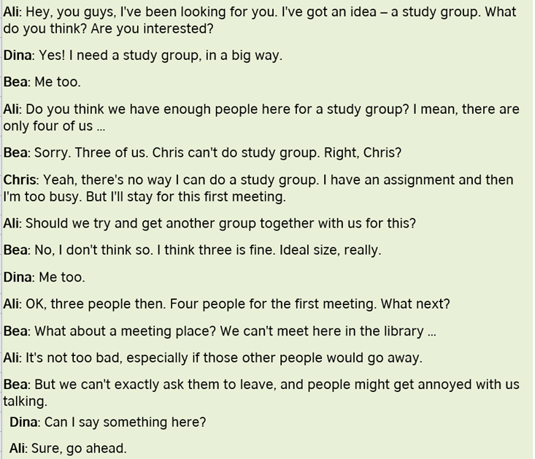
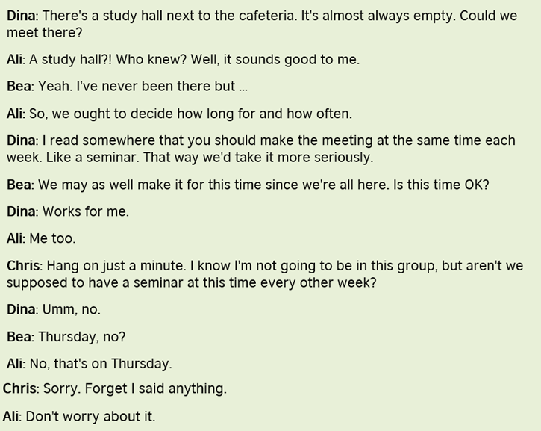
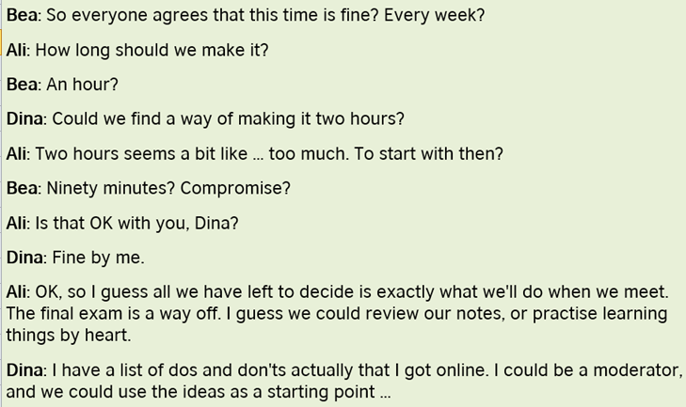

Answer Sheet-“Creating a study group”

Exercise One: Listen and write the answer next to the question.
- Who wants to make a study group for the first time? Ali
- Where is the meeting place? A Study hall
- How many people are join the study group? Regularly 3people
- What day is going to study every week? Thursday
- How many hours study in a week? One and half hr

Exercise Two: Listen carefully, think, and write your answer.
- Why can’t Chris join the study group?
- Chris has an assignment and then he is too busy. But he’ll stay for the first meeting only.

- Why students can’t meet the library for their study? Is it bad meeting place for the students?

- Not too bad if those other people would go away, but students can’t exactly ask them to leave of each meeting

Exercise Three: Talk to your partner freely about any of the questions below.
No Writing!

- Do you prefer studying home or studying at a library?

- Do you prefer to join a study group or study alone?

- What is the most efficient way to study?

