Background Information Sheet
Name | Class | Date | Lesson Type | Plan type | Length
Young(Young Min Kwon) | 203WD | 12 Feb 2020 | Grammar | PPP | 25 min

Lesson
Topic | The bus leaves tonight.
Main Aim | Students will learn ‘present simple tense’ for scheduled events/timetable events.
Secondary Aim | Students will practice present simple tense as well as speaking fluency.

Materials and References
Board and colored markers, worksheets, pictures

Student Profile
Level |  | Low Intermediate
Age |  | Adults |  | Number of Students | 7
Detail |  | They are low intermediate level of Korean students. Everyone in the class is very enthusiastic and engages actively in kinesthetic learning. The students are also quite accustomed to pair and group work.
Assumptions about students’ knowledge as required for this lesson:
- Students know the vocabulary used in this lesson.
- Students have learned about the subject and verb agreement.
- Students know how to make the negative form and question.
- Students have learned about the past simple tense and ‘will future’ and ‘be going to’ future.
- Students have experience in travelling abroad and have seen various timetables before.

What language difficulties to expect when presenting, and how to deal with it:
- Meaning: Present simple is used to scheduled events. Students possibly confuse about when should use present simple and how to use it. Make a clear visual context and C.C.Q.
- Form: Students may confuse how to use present simple for scheduled events/timetable events.
- Pronunciation: Students may not know where to put natural sentence stress. Drill several times chorally, then individually. Ask, “Which words have stress?” and indicate the stress with red marker.

Anticipated Classroom Management Difficulties and their Solutions:
The quantity of new language points to be learned about present simple is too much for students to handle in a short 25 minute lesson. This could lead to anxiety, rushing, and a lot of teacher talk. For this lesson I will manage this by selectively presenting only a few new concepts about present simple for scheduled events. The remaining new language points can be presented in the next lesson.
My Personal Aim
What I hope most to demonstrate in this lesson is the ability to
- present the target language using a situational presentation
- to be an involver type teacher

Stage Name: Lead-in
Purpose of this stage: To relax both the teacher and students. To focus attention on the lesson. Create a situation for students to experience or think about, and then to elicit the target language.
Materials: Board and colored markers, eraser, picture
Timings | Interactions |  | Procedure
2 min | T-S |  | Organize seating arrangements, one group of 3 sitting together and the other 2 groups of 2 sitting together, so they can have one or two partners. All can easily see the board.  Hello, everyone. Attention please.  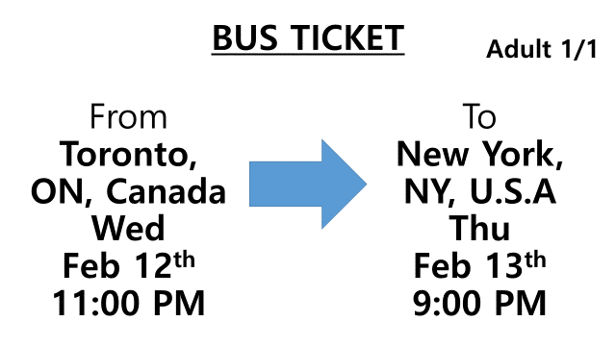  (Showing the bus ticket picture to students very slowly. It is A4 size print).  Let’s imagine I live in Toronto and I have this bus ticket. Tell me about it.  ( SS will freely say)
Stage Name: Presentation
Purpose of this stage: Make the students think about the situation. To clarify the meaning, form, and pronunciation features of the target language.
Materials: Board and colored markers, eraser.
Timings | Interactions |  | Procedure
10 sec  2 min  2 min | T  T-S  T-S |  | Board the model sentence: The bus leaves tonight.  Meaning  CCQ  - Are we talking about the past or the future? (The future.)  - Are we talking about the near future? (Yes.)  - Is it scheduled? (Yes.)  - Can we control about it? (No.)  (Draw a timelines on the board)  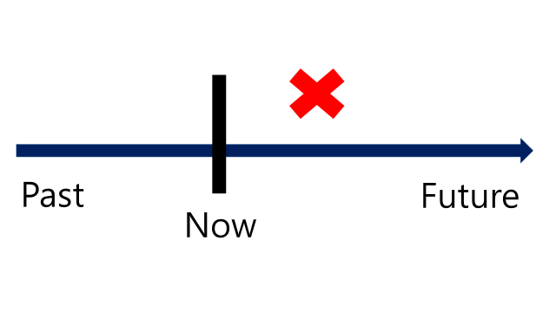  Form  Look at this sentence again. “The bus leaves tonight” What is subject? What is verb? Ok then, what tense? “leaves” is present simple verb. Of course, it has ‘s’ behind ‘leave’ because the bus is the subject. We are talking about scheduled events or timetable events. So no past or future tense is needed.  Pronunciation & Drill  Listen carefully. Where is stressed?  (Mark stresses on the board with red marker)  Repeat 3 times. Conduct the drill chorally 3 times  Speak fast.  And nominate for individual drilling.
Stage Name: Controlled Practice
Purpose of this stage: students practice working with the form (scrambled sentences, split sentences, select the correct form of the superlative, correct incorrect sentences, and change one form into another form). Accuracy must be checked.
Materials: Worksheets, board and marker, eraser
Timings | Interactions |  | Procedure
1 min  1 min  1 min  1 min | T-S  S  S – S  T – S |  | Instructions.  I will give you a worksheet. Please do ‘exercise A’ only. It is individual work.  Do not do ‘exercise B’.  ICQ.  What do we do? (Exercise A.)  Will you do exercise B, too? (No.) You have 1 min.  Students do Exercise A  Ok. Time’s up. Please share your answers with your partners. Talk to your partners about correct answers.  Group/Pair check.  Feedback to check accuracy. Board correct answers visually if necessary.
Stage Name: Less Controlled Practice
Purpose of this stage: students practice working with the meaning. Accuracy must be checked.
Materials: Worksheet, board and marker, eraser
Timings | Interactions
1 min  1 min  1 min  1 min | T-S  S  S-S  T – S |  | Instructions.  Now please do ‘exercise B’. It is also individual work.  ICQ.  What do we do? (Exercise B.) Good. You have 1 min.  Students do Exercise B  OK. Time’s up. Please share your answers with your partners. Talk to your partners about correct answers.  Group/pair check.  Feedback to check accuracy. Board correct answers visually if necessary.
Stage Name: Production – Freer Practice
Purpose of this stage: is to get students to practice the grammar communicatively.
Materials: worksheet
Timings | Interactions |  | Procedure
1 min  6 min  2 min | T-S  S-S  S-S |  | Instructions.  Now Exercise C. Please look at your worksheet. (Nominate one student.) Please read out the instruction for all of us.  ICQ:  Is it group work? (Yes.)  Do you need to speak with your partners? (Yes.)  Students do a productive task which requires natural communication.  (Monitor students fluency activity and make notes about errors)  Students will share their conversation with the class.  Time’s up. Who wants to share your group’s travel plan with the class?
Stage Name: Wrap-up
Purpose of this stage: is to end the lesson on a positive note so that students feel they have achieved progress.
Materials: None
Timings | Interactions |  | Procedure
1 min | T-S |  | Lesson feedback. Tell the class what they did well, and what needs to improve.  Offer delayed corrections to the previous stage.  Everyone! Good job today. How do you feel about present simple tense for scheduled events? Is it difficult? (No.)  When do we have to use it? (When we say about scheduled events.)  Perfect! Ok then. Please write down your homework.  Set homework  Review present simple tense for scheduled events and write down 3 new sentences.  Thank you.

Worksheet

Exercise A
Look and circle.
- Hurry up!. The train (will depart / departs / departed) in 10 minutes.

- She (will have / will be having / has) a piano lesson after school today.

- When (does / will / shall) the meeting begin?

- My sister’s birthday (will be / is / is going to be) on Tuesday next week.

- The musci festival (ends / will end / is going to end) on Friday.

- The next train (comes / is coming / will come) in 10 minutes.

- The exhibition on 15th cetury art (is opening / opens / will open) next weekend.

Worksheet

Exercise B
Look and write to fill out the blank.
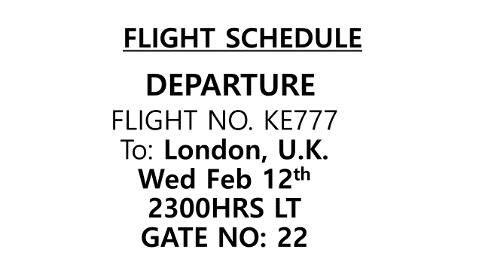 1. The airplane _____________ tonight at 11 P.M.
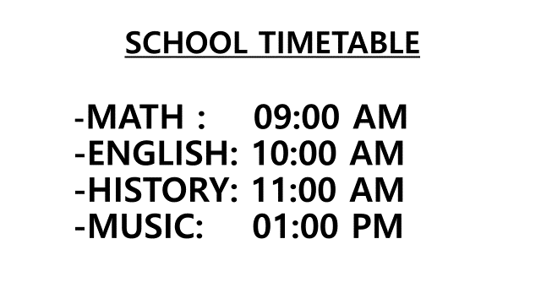 2. When _______ English class _______ tomorrow?
It ______ at 10 o’clock.
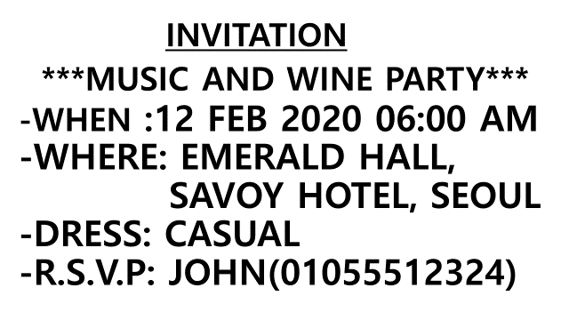 3. The party ____________ at 6 P.M.
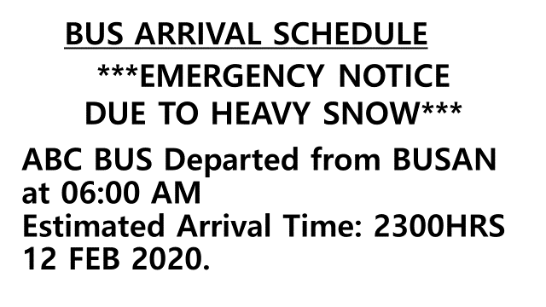 4. The bus ________ at 11 A.M., it _________ at 11 P.M.

Worksheet
Exercise C
Imagine you live in New York. You need to travel 2 cities and be back to
New York . Please make your group’s travel plan with your partners. To practice
the present simple tense please use it as much as possible during your
conversation.
From | To | Flight Schedule | Flight time
New York | London | Every day 4 P.M. | 7 hours
New York | Paris | Every day 2 P.M. | 8 hours

From | To | Flight Schedule | Flight time
London | Paris | Every day 9 A.M. | 1 hour
London | New York | Every day 10 A.M. | 8 hours

From | To | Flight Schedule | Flight time
Paris | New York | Every day 8 A.M. | 9 hours
Paris | London | Every day 11 P.M. | 1 hour

Place | Open | Close
The British Museum | 09:00 AM | 05:00 PM
Tower of London | 10:00 AM | 04:00 PM
Effel Tower | 10:00 AM | 08:00 PM
Louvre Museum | 09:30 AM | 03:30 PM
Notre-Dame de Paris | 01:00 PM | 03:00 PM
Westerminster Abbey | 09:30 AM | 03:30 PM

Answer - Worksheet

Exercise A
Circle correct one.
- Hurry up!. Train (will depart / departs / departed) in 10 minutes.

- She (will have / will be having / has) a piano lesson after school today.

- When (does / will / shall) the meeting begin?

- My sister’s birthday (will be / is / is going to be) on Tuesday next week.

- The musci festival (ends / will end / is going to end) on Friday.

- The next train (comes / is coming / will come) in 10 minutes.

- The exhibition on 15th cetury art (is opening / opens / will open) next weekend.

Answer - Worksheet
Exercise B
Look and write to fill out the blank.
1. The airplane departs/leaves tonight at 11 P.M.
2. When does English class start/begin tomorrow?
It starts/begins at 10 o’clock.
3. The party starts/begins at 6 P.M.
4. The bus does not arrive at 11 A.M., it arrives at 11 P.M.

Board plan
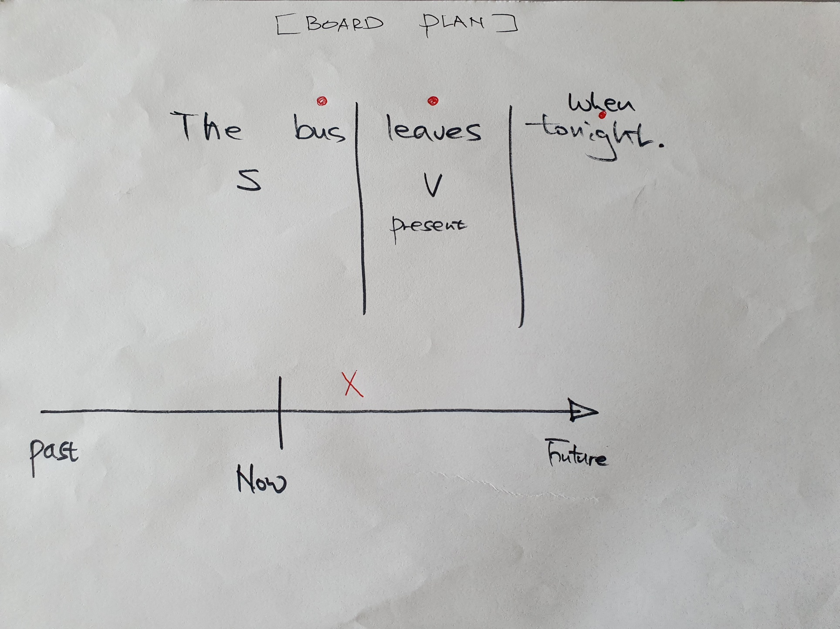
Instructor’s Comments and Assessment
Pros
Cons
Change
Overall Comments
Grade
Above Standard 85%-100% | Standard 70%-84% | Below Standard 69%-0%
Instructor | Student Signature | Date
Taute, David

