Background Information Sheet
Name | Class | Date | Lesson Type | Plan type | Length
Lisa | 203 | 12/2/2020 | Grammar | PPP | 25 min

Lesson
Topic | Present Continuous now
Main Aim | Students will learn the present progressive now.
Secondary Aim | Students will practice their speaking fluency.

Materials and References
Board and board makers (black, red, blue), Reference sheet, worksheets.

Student Profile
Level |  | Lower Intermediate
Age |  | Adults |  | Number of Students | 7
Detail |  | They are all native Koreans. This class consists of 3 mails and 4 females.  This class understands simple learned phrases easily and some new simple phrases containing familiar vocabulary, spoken slowly with frequent repetition. The students can read and write on familiar topics. They need to be relaxed before they will open up to communicate freely.
Assumptions about students’ knowledge as required for this lesson:
- Students are able to understand the situation of being interviewed as used in the lead-in.
- Students have had formal grammar lessons and are familiar with grammatical terms.
- Students know the present simple.
What language difficulties to expect when presenting, and how to deal with it:
Students may confuse the meaning of “now” and “around now”
-> Make a clear visual context of the target language that focuses on the time of speaking and ask appropriate C.C.Qs.
Anticipated Classroom Management Difficulties and their Solutions:
The quantity of new language points to be learned about the present progressive is too much for students to handle in a short 25min lesson. For this lesson I will prepare a sheet of reference form. The remaining new language points can be presented in the next lesson. (e.g. The rule of Verb+ing: run+ing->running etc. / and exceptions: verb that never uses ‘–ing’)
My Personal Aim
- What I hope most to demonstrate in this lesson is the ability to present continuous right now the target language deductively.
Stage Name: Lead-in
Purpose of this stage: To relax both the teacher and students. To focus attention on the lesson. Create a situation for students to experience or think about, and then to elicit the target language.
Materials: board & board pen(black, red, blue)
Timings | Interactions |  | Procedure
1min  10sec. | T-S |  | Hello. Look at me and make a sentence about my action right now.  (I’m dancing now)  Board ‘I am dancing now’
Stage Name: Presentation
Purpose of this stage: Make the students think about the situation. To clarify the meaning, form, and pronunciation features of the target language.
Materials: Form sheet. board, board pens (different colours)
Timings | Interactions |  | Procedure
20 sec  4 min  2min  1 min | T-S  T-S  T-S  T-S |  | CCQs  - Is this happening these days ? (No)  - Is this happening at the time of speaking to you?(Yes)  - Is this happening at the same time when you are looking at me? (Yes)  Form  Board : I’m dancing now  Draw timeline to help students with their understanding.  I am dancing now.  Past Now Future  Is this happening now? Past? Or in future? (Now)  Mark arrow at the time line point ‘Now’ with black marker.  I am dancing now.  ↓  Past Now Future  When does the action start? (Not sure, but just before now.)  Start marking wave line with red pen asking next question 3), just pause drawing  Is this permanent action or temporary action? (Temporary action.)  Keep waving the line but not being long with the red pen.  When did the action finish? (Sometime after now)  Finish marking wave line with red pen.  I am dancing now.  ↓  Past Now Future  Pointing to the board : I  What is the subject? (I)  What is the verb? (am dancing) Write Be-verb + Verb ing’ on the board.  Is it always ‘am’? (No. It depends on the subject)  That’s right. If the subject is ‘He’ what would it be? (is)  And for ‘they’? (are)  You can put object and place after Verb ~ing and ‘now’ for expressing the time of speaking.  How do we make this into a negative sentence? (I am not dancing now)  You may say it in a short way (with gesture)? (I’m not dancing now)  Board I’m not dancing now.  Where is ‘not’ placed? (after Be-verb)  How do we make this a question? (Am I dancing now?)  Board Am I dancing now?  Where is the be-verb? (Before Subject)  And how can we answer this question? (Yes. You are.)  Board Yes, I am. Or, No, I’m not.  Drill  Listen and repeat after me 5 times! (hold up the hand and count to 5)”  Ask a few students for individual drilling.  Which words sound stressed? – (+) ‘dancing’, ‘now’  – (-) ‘not, ‘dancing’  – (?) ‘I’, ‘now’  Use a red colour pen to mark the stress.  Does the intonation go up or down? – (+) down  – (-) down  – (?) up  Use a blue colour pen to mark the intonation at the end.  Hand out a reference form sheet of present continuous now.  This is form of present continuous now.  There can be object or place depends on the situation. Right? (yes)  Check the shorten forms of verb, even a negative form as well.  + Subject + be-verb verb ing (Object, place) (right now)  I am / I’m She/He/It is, She’s/He’s/It’s You/We/They are= You’/We’re/They’re doing playing my homework soccer now.  - Subject + be-verb + not  I am not/I’m not She/He/It is not(=isn’t) You/We/They are not (=aren’t) buying swimming flowers in the pool  ? Be-verb + subject  Am I Is she/he/it Are you/we/they writing having a letter lunch now?
Stage Name: Controlled Practice
Purpose of this stage: students practice working with the form (scrambled sentences, split sentences, select the correct form of the verb, correct incorrect sentences, and change one form into another form). Accuracy must be checked.
Materials: Worksheet.
Timings | Interactions |  | Procedure
20 sec  10 sec  2 min  10 sec  30 sec  1 min | T-S  T-S  S  T  S – S  T - S |  | Instructions. Hold up the worksheet1, point to exercise A.  Exercise A says to complete the blank with present continuous like example No1.  Next one is to change each form using words in parentheses,  You have to make 3 sentences : Positive, negative and Question individually,  Ask ICQs.  Do we write the answers? (Yes.)  Do we work with the partner? (No.)  Do we only do exercise A? (Yes.)  Hand out the worksheets.  Students do exercise A  Monitor the students and when they seem to be finished let them check the answers with their partners.  Check your answer with your partners.  Pair check.  Feedback to check accuracy taking a turn.
Stage Name: Less Controlled Practice
Purpose of this stage: students practice working with the meaning (match a timelines to sentences, choose the sentence that matches a picture, gap-fill a paragraph). Accuracy must be checked.
Materials: List all materials that will be needed in this stage.
Timings | Interactions |  | Procedure
30sec  30sec  2min  1min  1min | T-S  T-S  S  S – S  T - S |  | Instructions.  Hold up the worksheet 2, point to exercise B.  You can see 3 pictures. Then, Describe what they are doing in this picture right now.  Work individually and try to write down more than 3 sentences.  Ask ICQs.  Do we write the answers? (Yes.)  Do we work with the partner?(No)  Do we make just one sentence? (No)  Hand out the worksheet.  “Let’s begin!”  Students do exercise B.  Monitor the students and when they seem to be finished let them check the answers with their partners.  Pair check.  Feedback to check accuracy.
Stage Name: Production – Freer Practice
Purpose of this stage: is to get students to practice the grammar communicatively.
Materials: List all materials that will be needed in this stage.
Timings | Interactions |  | Procedure
1min30sec  3 min  2 min  10 sec | T  S-S  T-S |  | Instructions.  Talk to your partner about present continuous now.  I’ll tell a name of place to each group. Then you will have to talk each other about what you are doing right now at the place as I told.  Tell ‘Amusement park’ to one pair, ‘A Café terrace in Pari’ to another pair, ‘Baseball Park ‘ to the others.  For example, ‘I’m waiting in line to ride a bump car now. What are you doing now?'etc. in amusement park.  You have 3 min.  Students talk to each other using the target language naturally.  Nominate 1 group and speak their talk.  Feedback.
Stage Name: Wrap-up
Purpose of this stage: is to end the lesson on a positive note so that students feel they have achieved progress.
Materials: List all materials that will be needed in this stage.
Timings | Interactions |  | Procedure
1 min.  10 sec  10 sec | T – S  T  T |  | Offer delayed corrections to the previous stage.  You did good job.  Can you all look at the board?  Here are some sentences I heard during your conversations.  Can you tell me how to correct them?”  (e.g. “I playing the guitar now.” -> “I am playing the guitar.”)  Set homework.  Write more than 5 sentences using present continuous now due next class..  Inform students about the topic for the next lesson.  “we are going to learn about present progressive around time .  Good job guys!”  Class dismissed.

Pros
Cons
Change
Overall Comments
Grade
Above Standard 85%-100% | Standard 70%-84% | Below Standard 69%-0%
Instructor | Student Signature | Date
Taute, David

Instructor’s Comments and Assessment

Reference sheet
Form of present progressive now
+ | Subject + be-verb | verb ing | (Object, place) | (right now)
 | I am / I’m  She/He/It is, She’s/He’s/It’s  You/We/They are= You’/We’re/They’re | doing  playing | my homework soccer | now.
- | Subject + be-verb + not
 | I am not/I’m not  She/He/It is not(=isn’t)  You/We/They are not (=aren’t) | buying  swimming | flowers  in the pool
? | Be-verb + subject
 | Am I  Is she/he/it  Are you/we/they | writing  having | a letter lunch | now?

Worksheet 1 : Present Progressive now
Exercise A
- Complete the blank with present continuous like example No1.
Ex. 1) is raining | 2) | 3) | 4)
5) | 6) | 7) | 8)

- Change the sentences to the new form like the below.

(He, drive)  - He is driving now. | He isn’t driving now
 | Is he driving now?

- (She, watch, TV)
.

- (David, wash, his hands)
.

- (They, do, homework)
.

- (You, cut, trees)
.

Worksheet 2 : Present Progressive (now)
Exercise B
Look at these pictures below and make more than 3 sentences what you see in the picture using present progressive right now.
Amy’s dad | Amy’s mom and my brothers  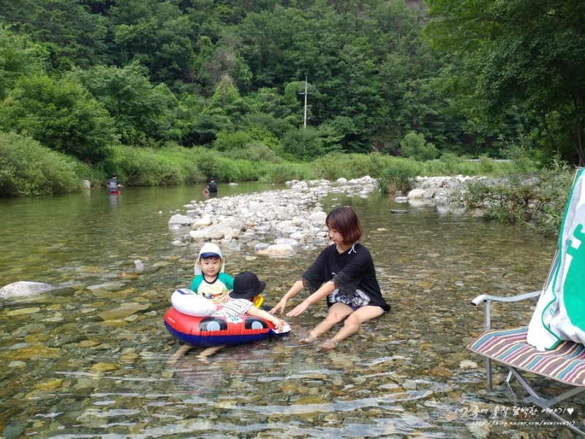
 | Amy

(e.g.) Amy’s family is camping now.

Answer sheet 1: Present progressive
Exercise A
- Complete the blank with present continuous like example No1.
Ex. 1) is raining | 2) is typing | 3) is traveling | 4) is fishing
5) is smiling | 6) is feeding | 7) is acting | 8) is sunbathing

- Change the sentences to the new form like the below.
(He, drive)  - (+)He is driving now. | (-) He isn’t driving now
 | (?) Is he driving now?

- (She, watch, TV)  She is watching TV now. | She isn’t watching TV now.
 | Is she watching TV now?

- (David, wash, his hands  David is washing his hands now. | David isn’t washing his hands now.
 | Is David washing his hands now?

- (They, do, homework)  They are doing (their)homework now. | They are not doing their homework.
 | Are they doing their homework?

- (You, cut, trees)  You are cutting trees now. | You are not cutting trees now.
 | Are you cutting trees now?

Answer sheet 2: Present progressive
Exercise B
Look at these pictures below and make more than 3 sentences what they are doing now in the picture using present progressive right now.
Amy’s dad | Amy’s mom and my brothers
 | Amy

(e.g.) Amy’s family is camping now.
Amy’s dad is grilling meat now. Amy’s mom is playing with her brothers in water.
Amy is having a piece of watermelon now.
(One of her brothers is looking at his older brother now. ) (Youngest brother is smiling now.)
(The other is swimming with a tube now.)

