Background Information Sheet
Name | Class | Date | Lesson Type | Plan type | Length
Daisy | TESOL | Feb.19.2020 | Reading | PPP | 25 min

Lesson
Topic | What is the difference between money and barter?
Main Aim | Students practice their reading comprehension.
Secondary Aim | Students practice their speaking fluency.

Materials and References
A4 size of printed pictures, the text, worksheets board and pens

Student Profile
Level | Lower Intermediate
Age | 8-10 | Number of Students | 7
Detail | Elementary students are all native Korean.  They are experienced spend money and exchange their stuffs with one another.

Anticipated Difficulties and their Solutions:
Computer failure Prepare A4 size of printed pictures and use white board and pens.
Time limit Need a time management.

My Personal Aim
Demonstrate will make the learning as easy and clear to understand as possible.
Demonstrate will be finished in time.

Stage Name: Lead-in
Purpose of this stage: To relax both the teacher and students. To focus attention on the lesson. To lead in to the topic, activating background knowledge – this will help to contextualize the text.
Materials:
Timing | Interaction | Procedure
30 sec  1 min  30 sec | T  T-S/S-S  T-S | Hi everyone!  (Show miming)  “Have you experienced exchange your stuffs with your friend or other people”?  Talk to your partner.  Feedback if appropriate.

Stage Name: Presentation
Purpose of this stage: To pre-teach keywords if necessary, and answer a guiding questions (such as a predicting task, or a specific question). These steps provide extra help for students to comprehend the text.
Materials: Printed pictures, board and pens
Timing | Interaction | Procedure
2 min  30sec  20 sec  1 min  40 sec | T-S  T  S-S  T-S | Pre-teach keywords: Barter, Money  Elicit – Look at this picture. What they are doing?  Students will say “Exchange or Barter”  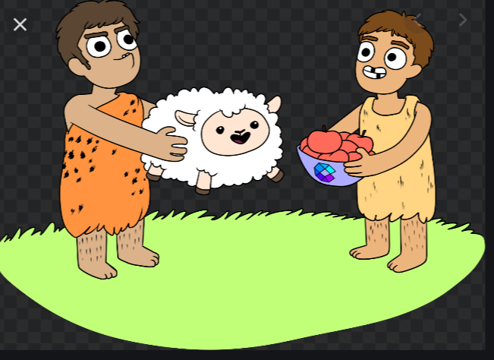  CCQ – check students properly understand the meaning  - Are they give and take? (Yes)  - Are they negotiating with each other? (Yes)  - Can they buying and selling for the money? (No)  Drill - Listen and repeat after me 3 times. (show fingers for 3 times)  Nominate 1 or 2 persons for individual drilling.  Board- Write ‘Barter on the board.  - How many syllables? (2) Bar ter  - Where is the stress? (1st)  - What type of this word? (Verb)  Elicit – Look at this picture. What is this?  Students will say “Money” or “Cash”.  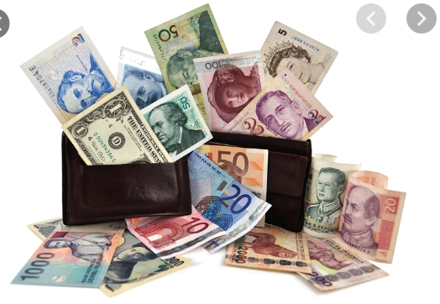  CCQ – check students properly understand the meaning  - Can you use it to buy some food? (Yes)  - Can you help poor people without this? (No)  - If you don’t have it, what are you going to do? (earn money)  Drill - Listen and repeat after me 3 times. (show fingers for 3 times)  Nominate 1 or 2 persons for individual drilling.  Board- Write ‘Money on the board.  - How many syllables? (2) Mon ey  - Where is the stress? (1st)  - What type of this word? (noun)  Guiding Question  - What happened after the invention of money?  Talk to your partners.  Feedback. Nominate a few students to share their ideas.

Stage Name: Practice – Literal Comprehension
Purpose of this stage: is to get students to practice reading for literal detail. They will also practice fast reading (skimming and scanning)
Materials: Worksheet-A
Timing | Interaction | Procedure
30 sec  3 min  1 min  1 min | T  S  S-S  T-S | Instructions. Set the purpose for reading. Hand out worksheets.  “Now I’m going to give you a short article and a worksheet-A.  Please do work individually and answer the questions in exercise A only; don’t turn over the worksheet. You have 3minute!  Students read the whole text for the 1st time, and write answers on the worksheet..  Pair check.  Monitor the students to see which group has right answers or wrong answers.  Feedback to check accuracy.

Stage Name: Practice – Interpretive Comprehension
Purpose of this stage: is to get students to get students to practice interpreting a text correctly This will require more detailed, careful reading, and thinking time to arrive at the correct answer.
Materials: Worksheet-B
Timing | Interaction | Procedure
30 sec  3 min  1 min  2 min | T  S  S-S  T-S | Instructions. Set the purpose for reading. Hand out worksheets.  “Now, turn over the page. This time, please answer the questions in exercise-B.  These questions require more thoughts. Read carefully and write down the answers individually. Do not read exercise 3.  You have 3minunte.  Students read for the 2nd time. Students write their answers down.  Pair check. Monitor.  Feedback to check accuracy.

Stage Name: Production - Applied Comprehension
Purpose of this stage: is for students to practice their speaking fluency on a topic related to the lesson.
Materials: List all materials that will be needed in this stage.
Timing | Interaction | Procedure
30sec  4 min  1 min | T  S-S  T-S | Instructions. Give students a question to discuss in pairs or groups.  Now look at the exercise C. With your partner, talk about any of the questions there. Ask each other a question and take turns.  Students discuss.  Feedback. Students share their ideas with the class.

Stage Name: Wrap-up
Purpose of this stage: is to end the lesson on a positive note so that students feel they have achieved progress.
Materials:
Timing | Interaction | Procedure
1 min | T | Lesson feedback. Tell the class what they did well, and what needs to improve.  Well done everyone!  Which part of the lesson is the most interested?  -SS will say.  What word did you learn today?  - SS will say  Offer delayed corrections to the previous stage.  Set homework.  Inform students about the topic for the next lesson.  Next time, we’ll learn about ‘foreign exchange trade’.

Article- What is the difference between money and barter?
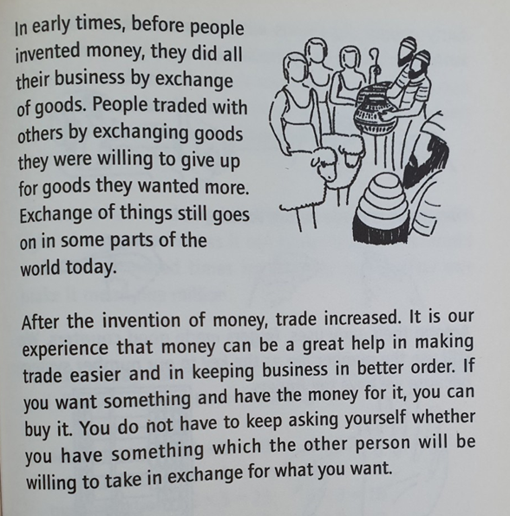

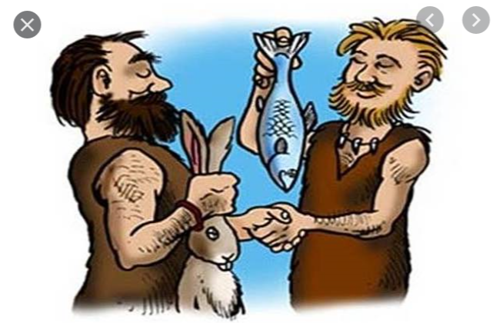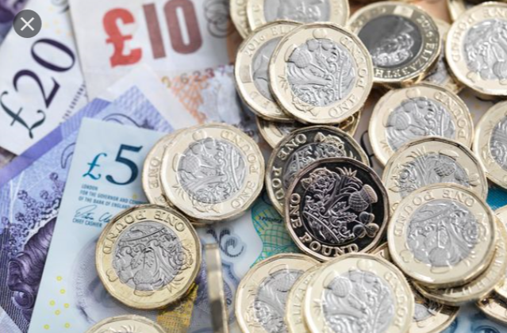

Worksheet-A
What is the difference between money and barter?

Exercise A
Please write down your answer the question.

- What was used before money?

- They did all their business by exchange of goods.

- Why is money more efficient or beneficial than barter ?

- Trade increased.
- Money can be a great help in making trade easier and in keeping business in better order.
- No need to keep asking themselves whether they have something which the other person will be willing to take in exchange for what they want.

Worksheet-B
What is the difference between money and barter?

Exercise B
Please write down your answer the question.

- Why is the use of money better than barter in trade?

- Money: It is convenient to carry
- Money: People can easily exchange commodity or service whatever people wants.
- Barter: It is difficult to find a person who wants to buy what exactly the seller wants to sell.

- Why exchange of things still goes on in some parts of the world today?

- Ppreserve the cultural or cultural events.

Exercise C
Please write down your answer the question.

- If we have to barter, what products can you provide?

- Make fabric and clothes.

- If you suddenly become a supper rich, what will you do fist?

- I will buy huge size of gold.

Instructor’s Comments and Assessment
Pros
Cons
Change
Overall Comments
Grade
Above Standard 85%-100% | Standard 70%-84% | Below Standard 69%-0%
Instructor | Student Signature | Date
Taute, David

