Background Information Sheet
Name | Class | Date | Lesson Type | Plan type | Length
Hong Yeni | TESOL | 2/19/20 | Reading | PPP | 25 min

Lesson
Topic | Barbie Doll
Main Aim | Students will practice on their reading and some thinking
Secondary Aim | Students will be learning some key words and practice fluency.

Materials and References
Reading text, worksheet, board, markers

Student Profile
Level | Under intermediate
Age | 15 | Number of Students | 7
Detail | Students are all from Korea.

Anticipated Difficulties and their Solutions:
Students might have more words they don’t know but due to time limit teacher can only teach key words

My Personal Aim
What I hope most to demonstrate in this lesson is to allow the students to practice more reading and make their thinking ability stronger. Second aim is to make them practice their fluency.

Stage Name: Lead-in
Purpose of this stage: To relax both the teacher and students. To focus attention on the lesson. To lead in to the topic, activating background knowledge – this will help to contextualize the text.
Materials: List all materials that will be needed in this stage.
Timing | Interaction | Procedure
30 sec  1 min  30 sec | T  T-S  S-S  T-S | Hi Guys, today we will be thinking about our childhood.  With your partners, talk about one of your favorite toy/ item from your childhood. Example: teddy bear, robot toy, dolls, Etc…  Students talking  Nominate one student.

Stage Name: Presentation
Purpose of this stage: To pre-teach keywords if necessary, and answer a guiding questions (such as a predicting task, or a specific question). These steps provide extra help for students to comprehend the text.
Materials: List all materials that will be needed in this stage.
Timing | Interaction | Procedure
5 min  10 sec  2 min  50 sec | T-S  T  S-S  T-S | Pre-teach keywords  (Release)  Can anyone tell me about this picture? (it’s a movie)  Good, now look at this (point) ‘in theaters January 17’ what does this mean? (the movie is release on January 17^{th)}  CCQ  Is it something that is available or soon be available? (Yes)  Can the public buy, see and use it once it is out? (Yes)  Repeat after me 3 times  Release x3  Individual drilling  Syllables? (2 re/lease)  Stress? (1^{st)}  Speech? (Verb)  (Represent)  What is this? (Map of Korea)  Very good, look at these (point specific pictures) what do they do? (represent Korea)  CCQ  Is it a sign or a symbol of ‘something’? (Yes)  Is it accepted as a meaning of ‘something’? (Yes)  Repeat after me 3 times  Represent x3  Individual drilling  Syllables? (3 re/pre/sent)  Stress? (1st)  Speech? (verb)  (Rare)  What is this? (limited edition airpod/ gold airpod)  Okay, so it is something that is….? (Rare)  CCQ  Is it common? (No)  Is it unusual? (Yes)  Can you see it often or not often? (not often)  Repeat after me 3 times  Rare x3  Individual drilling  Speech? (Adj)  Guiding Question  Do you know barbie dolls? Talk to your partner about them. Anything you know.  Students talking  Nominate one or two students to share what they have discussed.

Stage Name: Practice – Literal Comprehension
Purpose of this stage: is to get students to practice reading for literal detail. They will also practice fast reading (skimming and scanning)
Materials: List all materials that will be needed in this stage.
Timing | Interaction | Procedure
20 sec  2 min  30 sec  1 min | T  S  S-S  T-S | Instructions.  Guys, now we are going to work on a worksheet. ‘Read the questions carefully and fill in the correct answers.’  Do exercise 1 only.  ICQ  Do you only work on exercise 1? (Yes)  Do you answer exercise 2 when you are done with exercise1? (No)  Students read the whole text for the 1st time, and write answers on the worksheet.  Pair check.  “Now you can compare your answers with your partners.”  Feedback  Nominate one student for each of the answer.  “good, does anyone have a different answer?”
0
Stage Name: Practice – Interpretive Comprehension
Purpose of this stage: is to get students to get students to practice interpreting a text correctly This will require more detailed, careful reading, and thinking time to arrive at the correct answer.
Materials: List all materials that will be needed in this stage.
Timing | Interaction | Procedure
30 sec  4 min  1 min  1 min | T  S  S-S  T-S | Instructions.  “Now we will work on the next exercise. This time it will be little bit more challenging. ‘Read the question carefully and answer the question. Why were barbies dressed in traditional clothes? Support your answers from the text.’  ICQ  Do you need to read again and answer the question? (Yes)  Do you need to support your answers from the text? (Yes)  Students read for the 2nd time. Students write their answers down.  Pair check. Monitor.  “Guys, again compare your answer with your partner. If you have a different answer, try explaining why.  Feedback to check accuracy.  Nominate student for answer.  Ask if anyone else has a different answer.

Stage Name: Production - Applied Comprehension
Purpose of this stage: is for students to practice their speaking fluency on a topic related to the lesson.
Materials: List all materials that will be needed in this stage.
Timing | Interaction | Procedure
10 sec  3 min  2 min | T  S-S  T-S | Instructions. Give students a question to discuss in pairs or groups.  What do you think of spending money on collecting items like rare barbie? (Or any figure)  If you were to design a figure/ doll what would you make it as?  Students discuss.  Feedback. Students share their ideas with the class.  Nominate one or two students to share their ideas.

Stage Name: Wrap-up
Purpose of this stage: is to end the lesson on a positive note so that students feel they have achieved progress.
Materials: List all materials that will be needed in this stage.
Timing | Interaction | Procedure
30 sec | T | Lesson feedback.  Guys you did great today. Everyone know about barbie but I bet some facts are new.  All of you were focused during your reading trying to understand. Exercise 2 was a bit challenging but did great.  Next class, you guys will be reading another topic.  No homework for today.  Class dismissed.

Exercise 1
Read the questions carefully and fill in the correct answer.

- Where did the name “Barbie” come from?

- What was the design of Barbie’s swimsuit?

- When was the “International collection” released?

- What is the name of the highest selling Barbie doll in the history?

- What is Barbie’s full name?

Exercise 2
Read the question carefully and answer the question.

- Why were Barbies dressed in traditional clothes? Support your answer from the text.

Exercise 1
Read the questions carefully and fill in the correct answer.

- Where did the name “Barbie” come from? Ruth’s daughter

- What was the design of Barbie’s swimsuit? Black ad white

- When was the “International collection” released? 1980

- What is the name of the highest selling Barbie doll in the history? Totally hair barbie

- What is Barbie’s full name? Barbie Millicent Roberts

Exercise 2
Read the question carefully and answer the question.

- Why were Barbies dressed in traditional clothes? Support your answer from the text.
Barbie is already popular enough since it is the world’s best selling doll. However, barbies that are dressed in traditional clothes and representing the countries (international collection) are much more expensive and rare. Especially those which have not been removed from their case.

Barbie Doll
Barbie is the world’s best- selling doll. The first Barbie came out in 1959. IT was made by Mattel, Inc. Ruth Handler made the first Barbie doll. Barbie was Ruth’s daughter’s name. The first Barbie doll wore a swimsuit. It was black and white like a zebra. Her hair was in a ponytail with curled bangs. The hair was either blond or brown. In later years Barbie’s hair became colorful and she wore other kinds of clothes.

Because of the popularity of Barbie, many people collect them. In 1980, an “International collection” was released. The dolls were dressed in traditional clothes from the countries the represented. Various other collections have been released through the years. The rare Barbies are very expensive. Dolls which have not been removed from their cases are most valuable.

The highest- selling Barbie doll in history, Totally Hair Barbie, was released in 1992. Totally Hair Barbie featured extra- long hair. It reached from her head down to her toes. This is still one of the most popular dolls. Barbies that are treated with care may one day become valuable collector’s item.

There are interesting facts about Barbie Dolls:
- The first Barbie cost $3.
- Today, more than 1 billion Barbie’s have been sold.
- The Ken doll was named for Ruth and Elliot Handler’s son.
- Barbie’s full name is “Barbie Millicent Roberts.”
- Barbie didn’t have a belly button until 2000.
- Two Barbies are sold very second around the world.

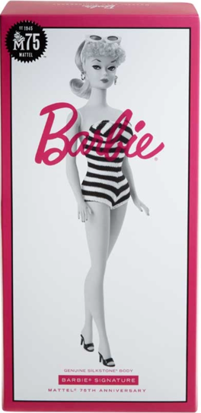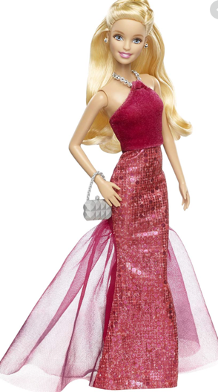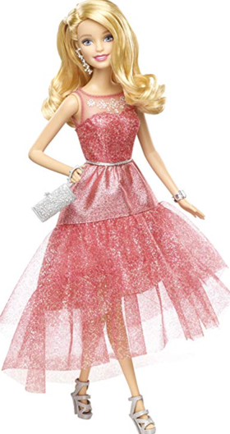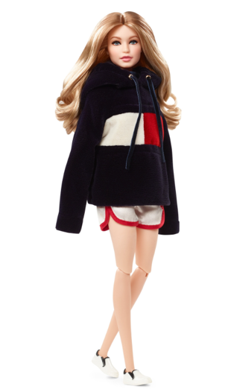
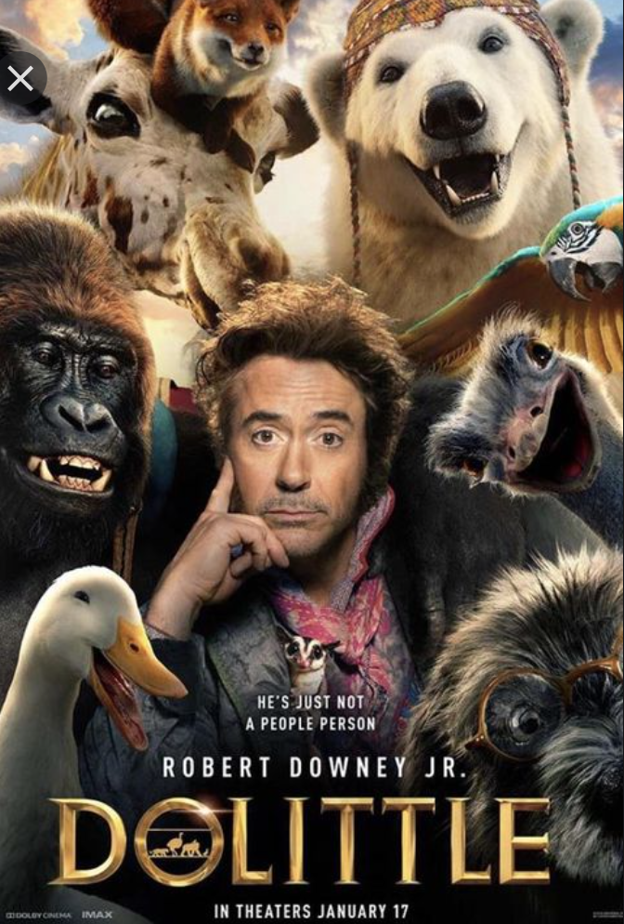
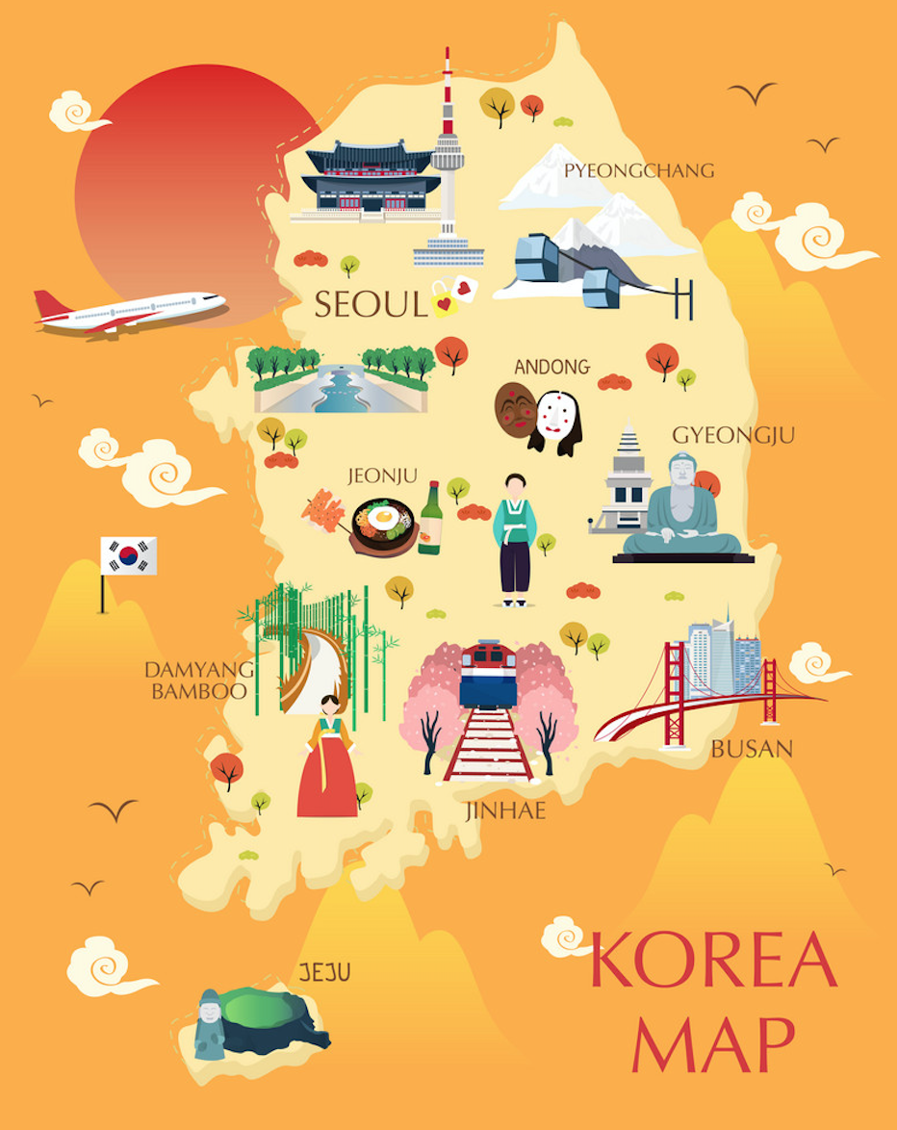

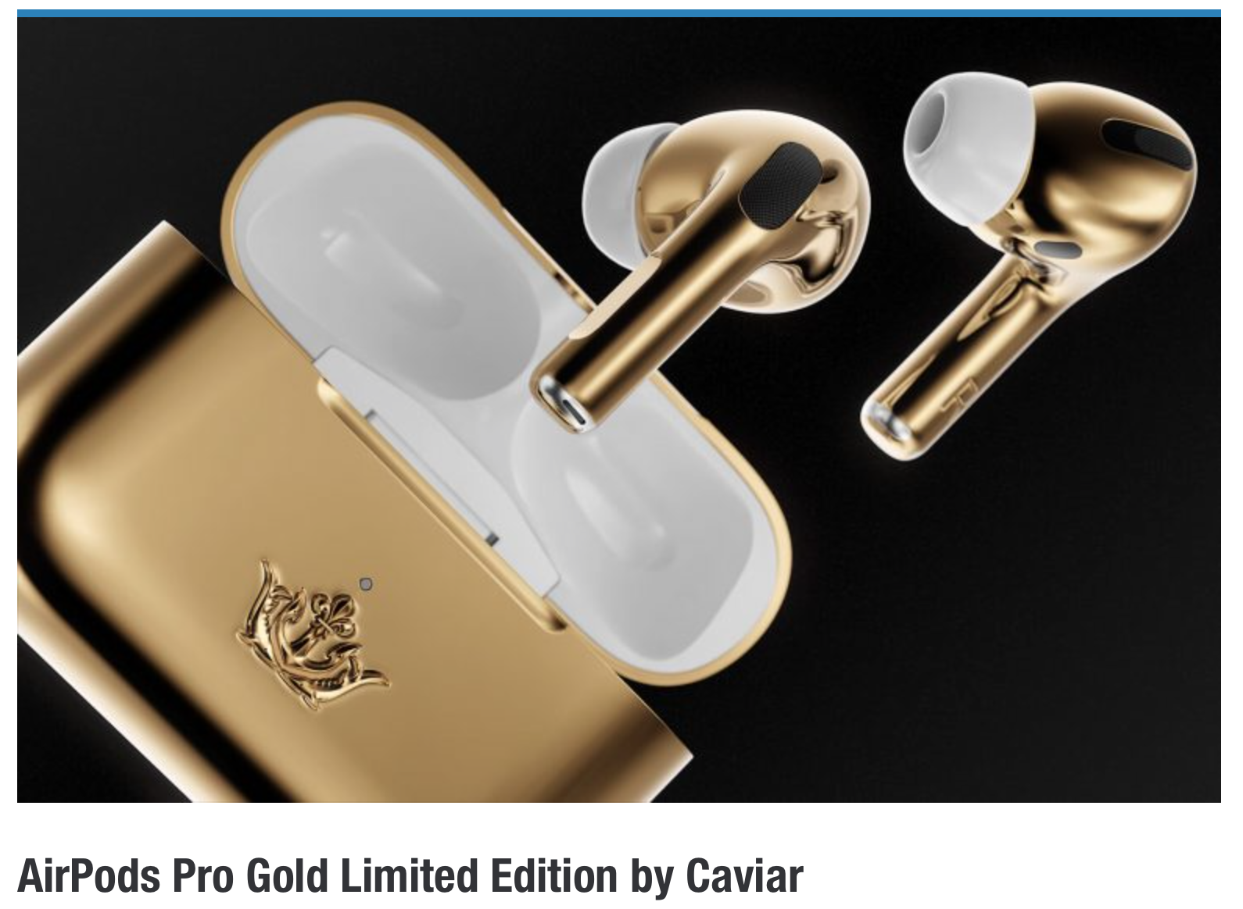
Instructor’s Comments and Assessment
Pros
Cons
Change
Overall Comments
Grade
Above Standard 85%-100% | Standard 70%-84% | Below Standard 69%-0%
Instructor | Student Signature | Date
Taute, David

