Background Information Sheet
Name | Class | Date | Lesson Type | Plan type | Length
Lisa | TESOL | 19/Feb/2020 | Reading | PPP | 25 min

Lesson
Topic | Hackademy
Main Aim | Students will practice their reading comprehension.
Secondary Aim | Students will practice their speaking fluency.

Materials and References
Reference: Junior Reading Tutor(NE 2.1 Level) published by Neungyoule Education
Materials : worksheets, photos, board and board markers(black, blue and red colored)

Student Profile
Level | Low intermediate
Age | Middle school students | Number of Students | 7
Detail | This is for middle school students in an academy. Students can satisfy basic survival needs and very routine academical demands. Students understand simple learned phrases easily and some new simple phrases containing familiar vocabulary, spoken slowly with frequent repetition. They can read and write simple material on familiar topics.

Anticipated Difficulties and their Solutions:
- Some of students can’t understanding rightly -> Make pairs compose to be able to help each other.
- There is probably misunderstood part to some students -> Before reading, Emphasize reading the article with writer’s mind and careful reading comprehension.

My Personal Aim
What I aim to demonstrate is the ability to write out a complete, detailed reading lesson plan.

Stage Name: Lead-in
Purpose of this stage: To relax both the teacher and students. To focus attention on the lesson. To lead in to the topic, activating background knowledge – this will help to contextualize the text.
Materials: List all materials that will be needed in this stage.
Timing | Interaction | Procedure
20 sec  1 min  30 sec | T  S-S  T-S | Hi, Guys.  You must know about the academy award of this year  Talk about any movie awards you are interested in with your partners.  You have 1 min.  Start  Students talk to their partners. Monitor for any use of key words.  Times up.  Could you tell us about yours? Nominate 2 students.  Feedback.

Stage Name: Presentation
Purpose of this stage: To pre-teach keywords if necessary, and answer a guiding questions (such as a predicting task, or a specific question). These steps provide extra help for students to comprehend the text.
Materials: List all materials that will be needed in this stage.
Timing | Interaction | Procedure
2 min  2 min  10 sec  1 min  1 min | T-S  T  T  S-S  T-S | Pre-teach keywords (inventor, director)  1. inventor  Elicit  Look at these pictures. Describe these pictures in one word. (Inventor)  CCQs  1. Do they design something that is not exist? (Yes.)  2. Do they create something? (Yes.)  3. Do they copy something? (No.)  Drill  Listen and repeat 3 times. (Gesture.)  Make each student pronounce..  Board inventor  Write ‘inventor’ on the left of the board.  How many syllables? (3) Mark with a black board pen like ‘inlvenltor’.  Where is the stress? (2nd) Mark with a red pen.  What type of the word is it? (noun)  2. director  Elicit  Look at these pictures and tell me their job.  I say ‘Movie’ and pause with gesture to let Ss say.(director)  CCQs  1. Do they tell actors what to do? (Yes.)  2. Do they make a film? (yes.)  Drill  Listen and repeat 3 times together. (Gesture.)  Nominate 3 individually.  If needed, correct students’ pronunciation.  Board director  Write ‘director’ on the right of the board.  How many syllables? (3) Mark with a black board pen like ‘dilrecltor’.  Where is the stress? (2nd) Mark with a red pen.  What type of the word is it? (noun)  Guiding Question  What part do you think teenagers can easily get influence from when they watch a movie?  Talk to your partner. You have 1 minute.  Students discuss the question with a partner.  Feedback. Nominate a few students to share their ideas.

Stage Name: Practice – Literal Comprehension
Purpose of this stage: is to get students to practice reading for literal detail. They will also practice fast reading (skimming and scanning)
Materials: List all materials that will be needed in this stage.
Timing | Interaction | Procedure
30 sec  2 min  30 sec  30 sec | T  S  S-S  T-S | Instructions. Hand out worksheets.  Now, I’ll give you a reading paper related to a movie award.  When you read, think like a writer of this article.  After you reading, Answer the questions in exercise A individually.  Do not answer exercise B,C  I’ll give you 2 min. .  ICQs.  1. Do we work with partner? (No.)  2. Do we work all exercises? (No.)  Then start now..  Students read the whole text for the 1st time, and write answers on the worksheet.  Times up.  Pair check  Check your answers with your partner.  Take turns to check each pair answer.  Do you guys all agree with the answer? OK.  Feedback to check accuracy.

Stage Name: Practice – Interpretive Comprehension
Purpose of this stage: is to get students to get students to practice interpreting a text correctly This will require more detailed, careful reading, and thinking time to arrive at the correct answer.
Materials: List all materials that will be needed in this stage.
Timing | Interaction | Procedure
30 sec  3 min  30 sec  2 min | T  S  S-S  T-S | Instructions..  Now, Look at the exercise B. Do not turn over.  Please answer the question.  It needs more careful reading. You need to think like this writer you wrote this.  It’s also individual work. I’ll give you 3min.  Start.  Students read for the 2nd time. Students write their answers down.  Pair check. Check your answers with your partner.  Monitor  Ask who wants to share the answer. Are there any different ideas.  If there is need to add more information, let the student talked rightly during pair work tell the answer.  Do you guys all agree with the answer? Good.  Feedback to check accuracy.

Stage Name: Production - Applied Comprehension
Purpose of this stage: is for students to practice their speaking fluency on a topic related to the lesson.
Materials: List all materials that will be needed in this stage.
Timing | Interaction | Procedure
30 sec  5 min  1 min | T  S-S  T-S | Instructions.  It’s time to do exercise C.  Talk to your partner. It’s up to you If you do both questions or do just one question,  You have 5min.  Start  Times up.  Ask who wants to share.  Your answer is interesting.  (Adjust the answer time by making sure if there is time limit or not).  Thanks sharing your answers.  Feedback. Students share their ideas with the class.

Stage Name: Wrap-up
Purpose of this stage: is to end the lesson on a positive note so that students feel they have achieved progress.
Materials: List all materials that will be needed in this stage.
Timing | Interaction | Procedure
30 sec  10 min  20 sec | T-S  T-S  T | Lesson feedback.  You guys looked interested in movie awards.  I’m sure this academy award made you have more attraction.  Offer delayed corrections to the previous stage. (if needed.)  Did you enjoy reading this article? (Yes or no)  I think you guys did great job.  Set homework.  Do the review test of next page.  Inform next lesson  Please read twice next unit with checking words you don’t know.  Students dismissed.

The Hackademy Award

There’s a special kind of award in Hollywood. But it’s not an acting or music award. It’s the Hackademy Award, and it’s an award for smoking. When actors smoke in a movie, they may win the award.
Actors often smoke in movies. Many people think these actors look cool. Then they want to smoke, too Teenagers especially want to be like their favorite stars. When they see actors smoking in a movie, they want to smoke, too.
The inventor of the Hacademy Award is worried about this.
So she meets with movie directors and talks about smoking. She says, “Please don’t show actors smoking in your movies.” But the movie directors don’t change. They answer, “Movie characters smoke because it shows their feelings. Movies without smoking scenes are not natural.” So actors like Johnny Depp, Robert Pattinson, and Catherine Zeta Jones got the Hackademy Award for smoking.

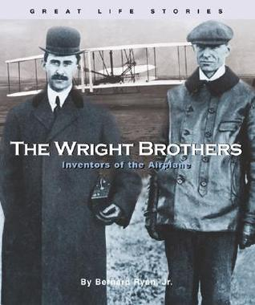 | 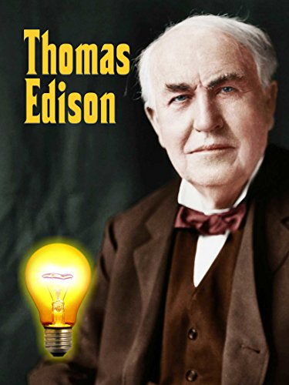

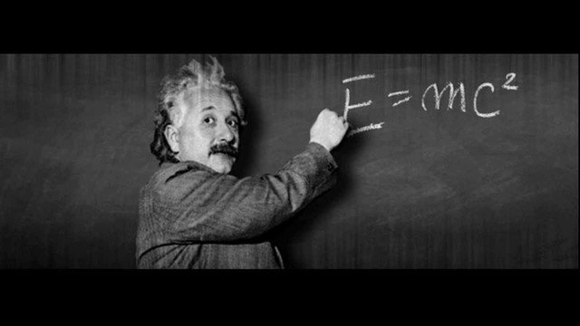

Work Sheet

Exercise A
1. What’s the name of an award for smoking?
2. Who win the award ?
3. Why do teenagers want to smoke when they see actors smoking?
4. Why do not movie directors change their minds in this article?

Exercise B
- What was the inventor’s purpose?
- Why does smoking in movies especially influence teenagers?

Exercise C
1. What do you think which part of ‘Parasite’ can have bad influence to teenagers?
2. Do you think Director Bong can succeed if the movie has no any provocative, violent and smoking scenes.

Answer Sheet

Exercise A)
1. What’s the name of an award for smoking? It is the Hackademy.
2. Who win the award ? An actor who smoke in a movie.
3. Why do teenagers want to smoke when they see actors smoking?
Actors who smoke look cool and teenagers want to be like their favorite stars.
4. Why do not movie directors change their minds in this article?
Because it is natural for actors to smoke in the movie and actors shows their feelings well.

Exercise B)
- What was the inventor’s purpose?
It was not to show the smoking scene because smoking scenes of films affects teenagers and they are so vulnerable to judge their environment yet..
- Why does smoking in movies especially influence teenagers?
Teenagers can be easily influenced from movie stars they like because they go through their period that they learn and follow their movie stars or their idols.

Exercise C)
1. What do you think which part of ‘Parasite’ can have bad influence to teenagers?
2. Do you think Director Bong can succeed if the movie has no any sexual, violent
and smoking scenes.

Instructor’s Comments and Assessment
Pros
Cons
Change
Overall Comments
Grade
Above Standard 85%-100% | Standard 70%-84% | Below Standard 69%-0%
Instructor | Student Signature | Date
Taute, David

