Background Information Sheet
Name | Class | Date | Lesson Type | Plan type | Length
Young(Young Min Kwon) | 203WD | 18th Feb 2020 | Reading | PPP | 25 min

Lesson
Topic | In Search of Nessie
Main Aim | Students will practice their reading comprehension.
Secondary Aim | Students will practice their speaking fluency.

Materials and References
Excerpt from the book “Mysteries of the World”, White board and board markers, worksheets, Pictures.

Student Profile
Level | High Intermediate
Age | Adults | Number of Students | 7
Detail | They are low intermediate level of Korean students. Everyone in the class is very enthusiastic and engages actively in kinesthetic learning. The students are also quite accustomed to pair and group work. They are all office workers and attend to the class after work. They need to be relaxed before they will open up to communicate freely.

Anticipated Difficulties and their Solutions:
-Nervousness at the start of the lesson Check and confirm that all materials are ready (e.g. picture, article to read, worksheets, lesson plan, white board and color markers are ready). Follow teacher’s script and speak slowly. Obtain students’ attention with assured voice and gesture. Time management will be checked by smartphone stopwatch.
-Every student may not have similar reading speed Prepare an appropriate level and length of the text. Also check the level of the questions so that everyone can finish in time. Monitor the students carefully, to make sure every students to stay in focus during the lesson.
-Keywords The students may not know all the words in the text. Teach the students keywords by asking them appropriate CCQs in the presentation stage, so that they can be prepared before reading the text. Also let them be able to do all activities without looking up their dictionary once they understand keywords.

My Personal Aim
What I hope most to demonstrate in this lesson is the ability to
- give good instructions
- be an involver type of teacher in teaching reading comprehension
- monitor students effectively and give proper feedback.

Stage Name: Lead-in
Purpose of this stage: To relax both the teacher and students. To focus attention on the lesson. To lead in to the topic, activating background knowledge – this will help to contextualize the text.
Materials: Picture(Big Foot)
Timing | Interaction | Procedure
10 sec  20 sec  1 min  30 sec | T  T-S  S-S  T-S | Organize seating arrangements, one group of 3 sitting together and the other 2 groups of 2 sitting together, so they can have one or two partners. All can easily see the board.  Greet. Instructions.  Hello, everyone. Attention please.  (Show the picture of Big Foot slow. Give students enough time to see the picture. It is A4 size print)  Do you know what it is? (Big Foot.) What particular word do people use when we describe such creatures? (Monster.)  Do you believe in monsters? Why? Talk to your partners about it. You have 1 min.  Monitor for any use of keywords.  Feedback. Briefly go around the groups and ask the students to share what they talked about.  Tell us about what you and your partners think.

Stage Name: Presentation
Purpose of this stage: To pre-teach keywords if necessary, and answer a guiding questions (such as a predicting task, or a specific question). These steps provide extra help for students to comprehend the text.
Materials: White board, color markers.
Timing | Interaction | Procedure
1 min  1 min  1 min  10 sec  1 min  50 sec | T-S  T-S  T-S  T  S-S  T-S | Pre-teach keywords: eyewitness, splash, ripples  Elicit-eyewitness  If you saw a car accident and you were the only person who actually saw the accident happen, what do people call you in police or in court? (eyewitness)  Listen to various answers from students. If students don’t seem to know the word, tell them the word to save time.  CCQ – Is ‘eyewitness’ related to some crimes, accidents or somethings like that? (Yes.)  Is ‘eyewitness’ someone who saw something? (Yes.)  Can ‘eyewitnesses’ usually describe what they saw? (Yes.)  Drill – Listen and repeat 3 times together. (Gesture)  Nominate 2 or 3 individually.  If needed, correct students’ pronunciation.  Board – Write ‘eyewitness’ on the board.  How many syllables? (3) Mark with a blue pen.  Where is the stress? (1st) Mark with a red pen.  What type? (Noun)  Elicit-splash  I’m sure you all have been to a waterpark when you were young. You probably had great time with you friends when you played in water. When your friends jumped into water, what sound could you hear? (splash)  Listen to various answers from students. If students don’t seem to know the word, tell them the word to save time.  CCQ – Is it a kind of sound? (Yes.)  Is it sound of something hitting liquid? (Yes.)  Is it sound of liquid hitting something? (Yes.)  Drill – Listen and repeat 3 times together. (Gesture)  Nominate 2 or 3 individually.  If needed, correct students’ pronunciation.  Board – Write ‘splash’ on the board.  How many syllables? (1) Mark with a blue pen.  What type? (Noun)  Elicit-ripples  Imagine you throw a stone in a lake. What can you see on the surface of the lake after the stone dives in the lake? (ripples)  Listen to various answers from students. If students don’t seem to know the word, tell them the word to save time.  CCQ – Are they on the surface on a liquid? (Yes.)  Are they waves? (Yes.)  Are they big? (No.)  Are they normally seen in a lake or a pond? (Yes.)  Drill – Listen and repeat 3 times together. (Gesture)  Nominate 2 or 3 individually.  If needed, correct students’ pronunciation.  Board – Write ‘ripples’ on the board.  How many syllables? (2) Mark with a blue pen.  Where is the stress? (1st) Mark with a red pen.  What type? (Noun)  Guiding Question  Have you ever heard of Loch Ness Monster, Nessie? Do you think that Nessie is real? Why?  Talk to your partners about it. You have 1 min.  Students discuss the question with a partners.  Short Feedback.  Feedback. Nominate a few students to share their ideas. Please share your ideas with the class.

Stage Name: Practice – Literal Comprehension
Purpose of this stage: is to get students to practice reading for literal detail. They will also practice fast reading (skimming and scanning)
Materials: Prepared article, Worksheet
Timing | Interaction | Procedure
30 sec  2 min  1 min  1 min | T-S  S  S-S  T-S | Instructions. Set the purpose for reading. Hand out the article and worksheets.  Hold up the article and the worksheet. I’m going to give you a short article and worksheet. Work individually and do Exercise A only. Answer the questions as quickly as possible.  I.C.Q:  What do we do? (Exercise A)  Do you work with your partners? (No.)  Do you do Exercise B, too? (No.)  Hand out the worksheet. You have 2 mins. Now Start.  Students read the whole text for the 1st time, and write answers on the worksheet.  Students do the worksheet individually. Monitor the students to see who has the right answers and who has wrong answers. Also check who is finished.  Time’s up. Please compare your answers with your partners.  Pair check(group check). Monitor.  Feedback to check accuracy.  Ask students for answer, checking if others have the same or different answers. Does anyone else have a different answers? Who agrees with this answer?

Stage Name: Practice – Interpretive Comprehension
Purpose of this stage: is to get students to get students to practice interpreting a text correctly This will require more detailed, careful reading, and thinking time to arrive at the correct answer.
Materials: Prepared article, Worksheet
Timing | Interaction | Procedure
30 sec  3 min  1 min  1 min | T  S  S-S  T-S | Instructions. Set the purpose for reading.  This time answer the question in Exercise B.  This question requires more thoughts. Read carefully and write down the answers individually.  Don’t read Exercise C yet.  I.C.Q:  What do we do now? (Exercise B)  Do you work with your partners? (No.)  Do you do exercise C, too? (No.)  You have 3 mins. Now Start.  Students read for the 2nd time. Students write their answers down.  Students do the worksheet individually. Monitor the students to see who has the right answers and who has wrong answers. Also check who is finished.  Time’s up. Please check your answers with your partners.  Pair check(group check). Monitor.  Feedback to check accuracy. Nominate groups for the answers.  Ask students for answer, checking if others have the same or different answers. Does anyone else have a different answers? Who agrees with this answer?

Stage Name: Production - Applied Comprehension
Purpose of this stage: is for students to practice their speaking fluency on a topic related to the lesson.
Materials: Prepared article, Worksheet
Timing | Interaction | Procedure
30 sec  5 min  1 min  30 sec | T  S-S  T-S | Instructions. Give students a question to discuss in pairs or groups.  Now, turn over your worksheet and do Exercise C.  I.C.Q:  What do we do now? (Exercise C)  Do you work with your partners? (Yes.)  Do you need to write down your answers? (No.)  You have 5 min. Now begin.  Students discuss. Monitor.  Feedback. Students share their ideas with the class.  Go around the groups and ask for short feedback. Please share your group’s talk with you the class.

Stage Name: Wrap-up
Purpose of this stage: is to end the lesson on a positive note so that students feel they have achieved progress.
Materials: Board, Board Markers.
Timing | Interaction | Procedure
1 min | T  T-S | Offer delayed corrections to the previous stage.  Thank you for sharing your thoughts. They were great. Good job.  Mention any errors that were made in the previous stage. If none, move on to the next step.  Lesson feedback. Tell the class what they did well, and what needs to improve.  Does everyone remember the 3 words we learned today? eyewitness, splash, ripples  What does eyewitness mean? What is splash? What are ripples?  (If there is time, let student reply)  Set homework. Inform students about the topic for the next lesson.  No homework today, but you need to pick one of the New Seven Wonders of the world and introduce to the class. Thank you.

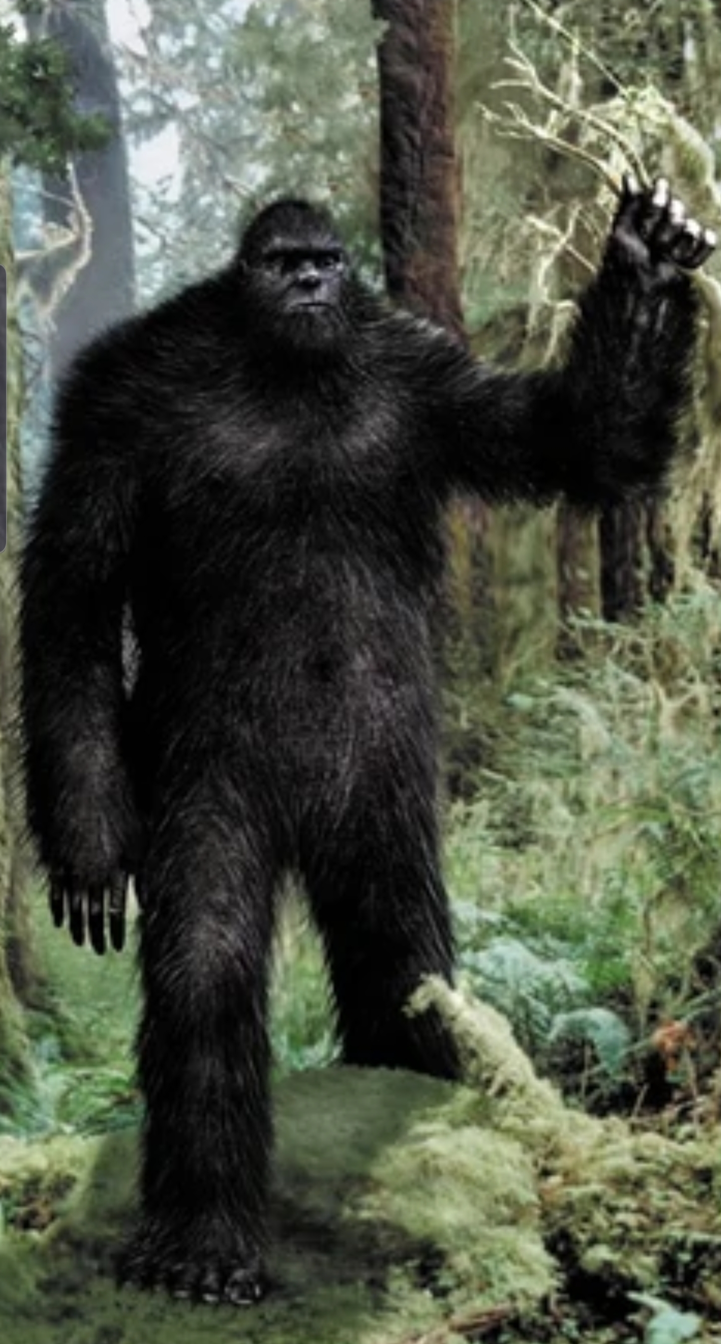
Worksheet
Exercise A : Read the text and answer the questions.
- Why didn’t Dad agree that the story of the Loch Ness Monster was made up?

- What did Dad tie a rope around and toss in the water?

- Why did Beth burst out laughing?

Exercise B : Read the text and answer the question

- With regard to existance of Nessie what can you infer about people’s view from this story?

Worksheet
Exercise C
- Do you think people like mystery stories or scary stories? Why? What kind of mystery stories or scary strories do you know? Talk to your partners about it.

Answer-Worksheet
Exercise A : Read the text and answer the questions.
- Why didn’t Dad agree that the story of the Loch Ness Monster was made up? Because he thought that only some of the evidence was faked, and most of the eyewtiness reports were never proven false.

- What did Dad tie a rope around and toss in the water? A small ham

- Why did Beth burst out laughing? Because her dad tried to fish for Nessie.

Exercise B : Read the text and answer the question

- With regard to existance of Nessie what can you infer about people’s view from this story? People’s view is still in confusion and in controversy because truths and lies about the evidence are mixed and believers and disbelievers are also mixed. In addition, the opinions are also different among scientists because some biologists also tend to support its existence by thinking that it’s a meat-eating dinosaur that has survived.
Text
In Search of Nessie
The sign for Loch Ness made Beth suspicious. When Dad stopped at a boat rental place, she realized what he was up to.
“Dad, the Loch Ness Monster…seriously?”
“Come on, where’s your sense of adventure?”
“It was all lies, Dad-the picture were faked and the stories were made up.”
“No, only some of the evidence was faked, and most of the eyewitness reports were never proven false. Besides, you love boats.”

Beth admitted that was true as she entered the boat. In the center of the lake, Dad tied a rope around a small ham and tossed it in the water. Beth burst out laughing.
“You’re fishing for Nessie?”
“Shhhhh,” Dad hissed, scanning the water with his video camera, “some biologists think it’s a meat-eating dinosaur that has survived.”

Suddenly, the wind blew his hat overboard.
“I got it,” Beth said as she reached over with a fishing pole. There was a large splash behind them. They spun around to see ripples in the water. Dad pulled the rope in. The ham was gone.

They stared, open-mouthed, and then spoke at the same time.
“Was it…?”

Instructor’s Comments and Assessment
Pros
Cons
Change
Overall Comments
Grade
Above Standard 85%-100% | Standard 70%-84% | Below Standard 69%-0%
Instructor | Student Signature | Date
Taute, David

