Background Information Sheet
Name | Class | Date | Lesson Type | Plan type | Length
Minsu Kim | TESOL | 04/04/2020 | Listening | PPP | 25 min
Lesson
Topic | An introduction to a lecture
Main Aim | Students will practice their listening comprehension using an integrated listening model.
Secondary Aim | Students will practice their speaking fluency.
Materials and References
https://learnenglish.britishcouncil.org; PPT; worksheet; board; pens; PC and audio equipment

Student Profile
Level | Intermediate
Age | Teens (13-19) | Number of Students | 3
Detail | This is general English class of which students are highly motivated. The students are all Koreans, and have experienced learning English as a foreign language for at least four years. They are all familiar with pair work and group work, but clear instruction is necessary not for students to get lost. They got accustomed to visual learner mode but there is still much space for their auditory skills to be improved.
Anticipated Classroom Management Difficulties and their Solutions
- The audio equipment could fail bring a set of portable speakers to use with my smartphone; read the script with my voice; print an A4 size picture of my PPT
- Nervousness at the start of the lesson check the equipment is working; to start the lesson, sit down and follow the planned teacher talk.

My Personal Aim
What I aim to demonstrate is the ability to write out a student-centered listening lesson plan, using a text which students are likely to encounter in their school lives.

Stage Name: Lead-in
Purpose of this stage: To relax both the students and the teacher; to increase student talk through the sharing of ideas or experiences; to introduce the topic, or something topic-related.

Materials: PPT1
Time | Interaction | Procedure
30 sec  1 min  30 sec | T  T-S/S-S  T-S | Organize seating arrangements so everyone seating in a circle, and all can see the screen. Show PPT1.  Hi guys, look at this picture and talk to your partner about it. For example, what can you see, who do you think they are, and how do they look. You have one minute.  Gestures for students to begin talking to each other.  Students brainstorm and talk to partners.  Teacher gives feedback if necessary. – “Why do you think so?”
Stage Name: Presentation
Purpose of this stage: To offer any needed help which students may need in order to comprehend the text more easily. This includes teaching from 1 to 4 keywords using the C.C.C. technique, and asking a guiding question which will allow students the opportunity to think of and share ideas they are likely to encounter when listening. This encourages the use of their schemata when comprehending a text.

Materials: PPT2, PPT3
Time | Interaction | Procedure
1 min  1 min  1 min  10 sec  1 min | T-S  T-S  T-S  T  S-S | Pre-teach keywords: associate; absorb; external.  Elicit – Point to PPT2. What can you tell from the picture? (The man looks sad, and the woman looks happy.) Why do you think so? (Because of the colors.) Are those colors and people connected physically? (No.) Then how do you come up with the idea? (Because they are connected in our mind.)  CCQ – Can we say who is happy and who is sad? (Yes.)  Are the emotions and the colors connected physically? (No.)  Are the emotions and the colors connected in our mind? (Yes.)  Drill – Listen and repeat three times together. (Gesture)  Nominate all the students individually. (Gesture)  Board – Write associate in the middle of the board.  How many syllables? (4) Mark with a blue pen.  Where is the stress? (2nd) Mark with a red pen.  Elicit – Point to PPT2. What can you see from the picture? (Sponge and water.) What is happening? (Water goes into the sponge. The sponge drinks water.)  CCQ – Is water a liquid? (Yes.)  Does the sponge go into water? (No.)  Does water go into the sponge then? (Yes.)  Drill – Listen and repeat three times together. (Gesture)  Nominate all the students individually. (Gesture)  Board – Write absorb in the middle of the board.  How many syllables? (2) Mark with a blue pen.  Where is the stress? (2nd) Mark with a red pen.  Elicit – Point to PPT2. What are they doing? (The man looks sad, and the woman looks happy.) Where is the man with a tie? (He is outside the ball.)  CCQ – Is he inside the ball? (No.)  Then is he outside the ball? (Yes.)  Drill – Listen and repeat three times together. (Gesture)  Nominate all the students individually. (Gesture)  Board – Write external in the middle of the board.  How many syllables? (3) Mark with a blue pen.  Where is the stress? (2nd) Mark with a red pen.  Guiding Question  Show PPT3. Talk to your partners. What are they discussing about in the picture?  Students discuss with their partners.

Stage Name: Practice - Literal Comprehension Listening
Purpose of this stage: For students to listen for the first time in order to get the facts. This may include the overall idea or topic of text; to notice who the speakers are; where they are; and perhaps why they are speaking. The responses are short, objective, and are only a surface understanding. This is an accuracy focused stage.

Materials:
Time | Interaction | Procedure
30 sec  2 min  1 min  1 min | T  S  S-S  T-S | Instructions. Set the purpose for listening. Hand out worksheets.  Hold up the worksheet.  Now you are going to listen to a psychology lecture about emotions.  As you listen, you will answer the questions in exercise one only. Not exercise two.  When you catch the answer, write it down below the question while listening.  I.C.Q.- Do you need to write your answers on the worksheets? (Yes.)  Do you write answers while listening or after listening? (While listening.)  Are you doing exercise one and two at the same time? (No.)  Read each question aloud for students and check whether they understand. Hand out the worksheets.  Students listen for the 1st time, and write answers on the worksheet.  Pair check. Compare your answers with your partner. Monitor.  Feedback to check accuracy. Ask students for answers, checking if others have different answers. Are you guys sure with this answer? Does anyone have different ideas? Why do you think so?

Stage Name: Practice - Interpretive Comprehension Listening
Purpose of this stage: Students listen a second time, more carefully, to infer or interpret meaning of the literal facts. This is still an accuracy focused stage – answers need to be checked for accuracy. Students are required to think about the why in order to support their answers. They may need to focus on things like the overall situation, tone of voice, multiple pieces of information, or a single statement to explain the unspoken, intended meaning.

Materials:
Time | Interaction | Procedure
20 sec  3 min  1 min  1 min | T  S  S-S  T-S | Listen again. This time, answer exercise 2, not 1.  These questions are harder than the previous ones, but if you listen carefully, you will find answers. The clues are all in the lecture itself.  Write your answers below the questions.  I will give you some time to think and write after the lecture is finished.  I.C.Q.- Do you write an answer while you are listening? (No.)  Then do you write an answer after listening? (Yes. We will have some time to think and write  after listening)  Read each question aloud for students and check whether they understand.  Students listen for the 2nd time, and write their answers.  Pair check. Monitor. Compare your answers with your partners and check if your answers are the same. Ask why if different.  Feedback to check accuracy.

Stage Name: Production - Applied Comprehension Speaking
Purpose of this stage: For students to practice their speaking fluency. Therefore, this stage should be no less than 5 minutes to allow students to practice. Give them a few questions to help them communicate without intervention from the teacher. This is a fluency-focused stage.

Materials:
Time | Interaction | Procedure
1 min  6 min | T  S-S | Sit in a circle.  Now turn over your worksheets.  Talk to your partners about those questions given.  Keep in mind that there is no correct answer. You can freely talk about the questions. But don’t forget that you have to listen to your partner’s opinions patiently.  You have 8 minutes.  I.C.Q. – Do you need to write answers on the worksheet? (No.)  Students discuss. Monitor from a distance.

Stage Name: Wrap-up
Purpose of this stage: To end the lesson on a positive note. This will give students a sense of accomplishment, encourage students to continue progressing, and realize how to improve in the future. A teacher may also get valuable feedback from students regarding the activities used in the lesson.

Materials:
Time | Interaction | Procedure
2 min | T | Lesson feedback. Tell the class what they did well in detail.  Set homework. For homework, listen to the next 2 minutes of the lecture. Summarize it with no less than 50 words. It is due this Sunday. I will put a notice on the e-class.  Inform students about the topic for the next lesson. We will discuss the theory of flow more in detail.  Dismissed.

Worksheet 1 – An Introduction to A Lecture
Exercise One: Listen and write the answer below each question.
- What is the name of science which looks at how people become happier?
- Who gave an answer on the question: “what makes a happy life?”
- According to Csikszentmihalyi, what makes us happy or sad?
- According to Csikszentmihalyi, when does our happiest moment happen?

Exercise Two: Listen carefully, and write your answers after the lecture is done.
- How can Positive Psychology contribute to a happy life?
- Describe “a state of flow” in your own words based on what is said in the lecture.
Exercise Three: Talk to your partner freely about any of the given questions below. No writing!
- Are you likely to find happiness outside yourself, or inside yourself? Explain why.
- Do you agree with Csikszentmihalyi’s idea that happiness is not caused by external events or things? Why or why not?

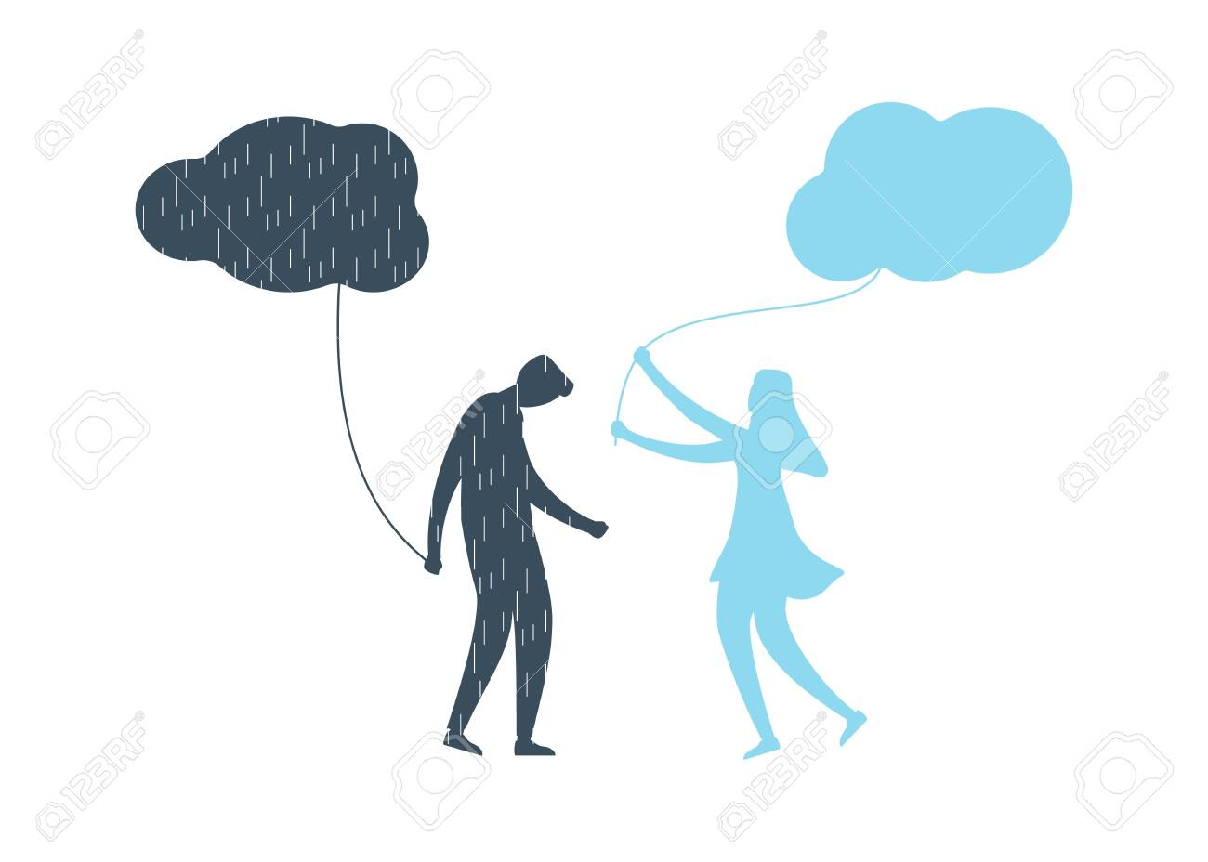
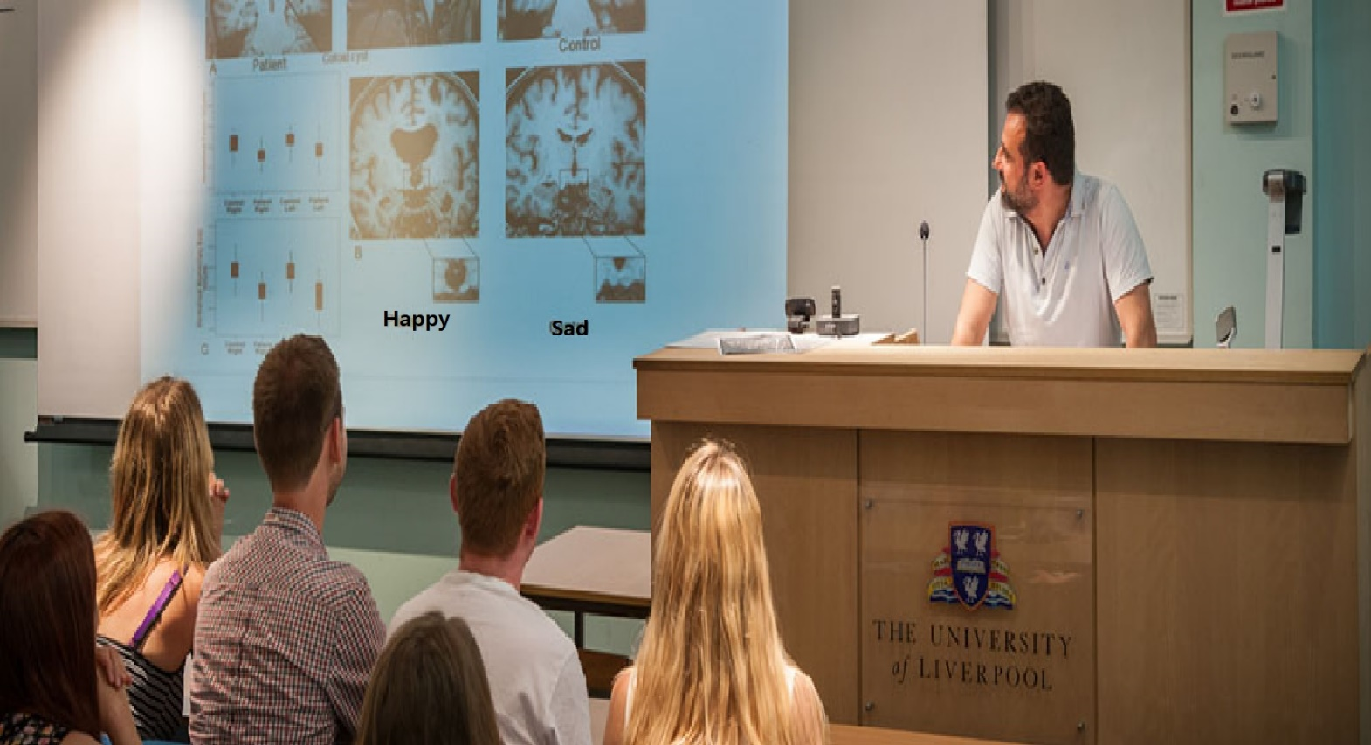
Transcript
(Time: 1 min 41 seconds)

Good afternoon, everyone. Welcome to the first lecture of our new course in Positive Psychology. While some people may associate psychology with looking at what's wrong with us, and at what problems we have, there is much more to psychology than that. Positive psychology, for example, looks at how to help people become happier.
This lecture begins with a question: what makes a happy life?
Now, I'm going to give you one possible answer. A happy life is a life in which you are completely absorbed in what you do. Now, how does this compare with what you and your partner said?
This answer comes from the work of Mihaly Csikszentmihalyi and the theory of flow. Csikszentmihalyi is a psychologist who has spent much of his professional life on the study of what makes people happy and how we can find happiness.
Csikszentmihalyi suggests the theory that happiness is not caused by external events or things that happen to us. Our perception of these things and how we see these events either makes us happy or sad. In other words, if we want happiness, we have to actively look for it. However, this does not mean that we should always look for happiness! Csikszentmihalyi believed that our happiest moments happen when we are in a state of flow.
Answer Sheet – An Introduction to A Lecture
Exercise One: Listen and write the answer below each question.
- What is the name of science which looks at how people become happier?
Positive Psychology
- Who gave an answer on the question: “what makes a happy life?”
Mihaly Csikszentmihalyi
- According to Csikszentmihalyi, what makes us happy or sad?
Our perception of these things and how we see the events
- According to Csikszentmihalyi, when does our happiest moment happen?
When we are in a state of flow.

Exercise Two: Listen carefully, and write your answers after the lecture is done.
- How can Positive Psychology contribute to a happy life?
By helping people look at positive aspects of their lives, rather than negative ones, such as what’s wrong with us, and what problems we have.
- Describe “a state of flow” in your own words based on what is said in the lecture.
It is a state in which people are totally into what they are doing and feel happy.

Instructor’s Comments and Assessment
Pros
Cons
Change
Overall Comments
Grade
Above Standard 85%-100% | Standard 70%-84% | Below Standard 69%-0%
Instructor | Student Signature | Date
Taute, David

